
NOW AVAILABLE FOR MARCH 2018 EXAMINEES

The only reviewer with rationalization for more than 500 questions based on the K to 12 curriculum and NCBTS. Also includes the Technology Integration Matrix.
FREELANCE ONLINE REVIEW | PROFESSIONAL EDUCATION REVIEWER



Read each item carefully and choose the best answer.

- What characterizes the formative development nature of PAST?
- Non- supportive c. rewarding
- Innovative d. self-directed
D – Self-directed
Drawing from the Vision and Mission of the Department of Education, CB-PAST is a comprehensive appraisal system which addresses one of the mandates of the Department as embodied in the RA 9155.The first purpose is formative-developmental in nature which will provide teachers with meaningful activities that encourage their professional learning and growth. The procedure will be supportive, non-threatening, fair, collegial and self-directed within the community of professional learners

- Which are the Job- embedded requirements for teachers and so must continuously develop themselves In these aspects?
- Maintain updated pupil/student school records
- Conducts action research
- Maintains harmonious relationship with stakeholders
- Channels and guide learners
- I,II,II c. II,III,IV
- I,II,III,IV d. I,III, IV
. Answer: B
Job-Embedded Learning (JEL) refers to a process of learning where new knowledge, skills and values are integrated into current job practice resulting in enhanced competencies for the improvement of work performance. It is sometimes referred to as on-the-job learning or workplace learning.

- To ensure high standards of the teacher’s personal and professional and professional development, what tool/instrument was develop by the DepEd for self- assessment?
- TSNA c. KSA
- IPPD d. TPDI

Answer: A – TSNA
The NCBTS-Teacher’s Strengths and Training Needs Assessment (TSNA) Tool is a self-assessment tool that enables teachers to identify their professional strengths and development needs. It is a formative process that encourages teachers in taking personal responsibility of their own growth and professional advancement with the goal of promoting student learning

- Which NCBTS domain creates situations that encourage learners to use high order thinking skills (HOTS)?
- Diversity of learner c. learning environment
- Curriculum d. community linkages
B- Curriculum
Domain 4: Curriculum, a domain that refers to all elements of the teaching-learning process that work in convergence to help students attain high standards of learning and understanding of the curricular goals and objectives. These elements include the teacher’s knowledge of subject matter, teaching-learning approaches and activities, instructional materials and learning resources. Thus after this domain, students are expected to have the basic higher level literacy, communication, numeracy, critical thinking, Communicates clear learning goals that are appropriate for learners, makes good use of allotted instructional time, selects teaching methods, learning activities and instructional materials or resources appropriate to learners and aligned to the objectives of the lesson

- As a community leader, which one may a teacher NOT do?
- Solicits donation from philanthropists in the community
- Plays an active part in the activities of the community
- Supports effort of the community to improve their status in life
- Makes herself aloof to ensure that her decisions will not be influenced by community politics
A - Solicits donation from philanthropists in the community
Code of Ethics Section 5. A teacher shall not engage in the promotion of any political, religious, or other partisan interest, and shall not, directly or indirectly, solicit, require, collect, or receive any money or service or other valuable material from any person or entity for such purposes.

- Teacher Nenita discourages her students to watch TV excessively. The average student spends about twenty-for hours watching television in a week. According to research, hoe is learning effective by TV viewing?
- Shorter attention span
- Enhanced creativity
- Improved thinking ability
- Improved communication skills
A – Shorter attention span
As part of the project, the Health Science students conducted a research-based focus group with the elementary students to determine the issues around screen time. The student’s research found that over exposure to screen time resulted in the second graders exhibiting shorter attention spans in the classroom, a decrease in family time, and nightmares. "Our focus group revealed that the second graders had short attention spans due to screen time over exposure," explained Mia Hulslander, one of the student researchers. "We realized this through the students’ complaints of boredom when they were watching TV and playing video games. They reported never being satisfied with the screen time they were currently watching."

- What is best meaning of collaboration in school?
- It is support for the beginning teacher
- It is identifying mentors among the experienced teachers
- It is working interdependently to analyze practice
- It is working interdependently to determine impact of practice
Answer: C
Collaboration represents a systematic process in which teachers work together interdependently to impact their classroom practice in ways that will lead to better results for their students, for their team and for their school. It is to analyze impact of strategies to determine what worked and what didn't.
- Which is the most essential characteristic of a Total Quality School model?
- Clientele-focused c. Involvement of stakeholders
- Empowerment d. Continuous improvement

Answer: A- Clientele-focused
As Arcaro (2005) stated, five characteristics of Total Quality School are focus on customer, total involvement, measurement, commitment, and continuous improvement. In focus on customer, Bush (2003) pointed out that the school’s aim is to establish customer’s satisfaction by fulfilling their needs towards the institution. Meanwhile, Tjiptono and Diana (2005) described that five fundamental things to focus on customer is by giving tangible proof, providing reliability, being responsive, presenting assurance, and showing empathy. Through tangible proof, school equips itself with facilities and infrastructures as well as extracurricular activities. In addition, reliability will be one of the schools’ efforts to serve the customer well.
Moreover, school assures the customer’s satisfaction by showing respects to them and being dependable. Further, one of school’s ways to empathize the customer is by giving extra attention to them. Thus, Forza and Filippini (1998) stressed that it is utterly important for an organization to pay extra attention to the customers by maintaining the closeness through communication.
There are two types of customers in a school context. Arcaro (2005) emphasized that internal customers in education context are students, students’ parents, teachers, and staffs. Furthermore, society, companies, military, and other organizations are external customers.
- Which is NOT a basic consideration in selecting and evaluating the content of an educational technology tool?
a. Does it match the content?
b. Can it be easily dismantled?
c. Will it motivate and maintain interest?
d. Is there evidence of its effectiveness?
Answer: B. Options A, C and D are all necessary in the selection of the content of the educational tool to be used in the classroom.
- Professor Reyes is thinking of an online learning approach by which content provides links to information at other locations and serves as a focal point for a distance education experience. Which of the following should she use?
a. Teleconferencing
b. Self-paced program
c. Web-based instruction
d. Computer-aided instruction
C- Web-based instruction
Web-based instruction (WBI) is a hypermedia-based instructional program which utilizes the attributes and resources of the World Wide Web to create a meaningful learning environment where learning is fostered and supported.
- Professor dela Cruz would like to create a presentation material for her lesson on the types of computer-assisted instruction. To make her presentation effective, which?
a. Situating tool
b. Informative tool
c. Productivity tool
d. Communicative tool
Answer: C - Productivity tool
Situating Tool  By means of virtual reality (RS) extension systems, the computer can create 3-D images on display to give the user the feeling that are situated in a virtual environment. A flight simulation program is an example of situating tool which places the user in a simulated flying environment.
Constructive Tool- The computer itself can be used for manipulating information, visualizing one's understanding and building new knowledge. The Microsoft Word computer program itself is desktop publishing software that allows users to organize and present their ideas in attractive formats
Productivity tools such as word processors, databases, spreadsheets, and multimedia tools allow for individual expression. People bring information, and ideas to these tools. Individuals use productivity tools to organize, manipulate, shape, and ultimately present ideas in creative new ways.

- Which of the following computer-based instructional materials can be used to learn new concepts?
a. Games
b. Tutorial
c. Simulation
d. Drill and practice

Answer: B- Tutorial
Tutorials can introduce students to the concepts and skills necessary for effective use

- What is at the heart of the Teacher Education Development Program (TEDP)?
A. NCBTS C. IPPD
B. RPMS D. LET

Answer: A – NCBTS
The National Competency-Based Teacher Standards (NCBTS) is at the heart of the Teacher Education Development Program (TEDP). It is the key element of the TEDP. It defines effective teaching as being able to help all types of students learn the different learning goals in the curriculum
- The following are the domains of NCBTS EXCEPT for _____.
A. Tenure of Office C. Curriculum
B. Learning Environment D. Community Linkages

Answer: A - Tenure of Office is not a domain of NCBTS. The complete domains of NCBTS are the following:
a. Social Regard for Learning
b. Learning Environment
c. Diversity of Learners
d. Curriculum
e. Planning, Assessing, and Reporting
f. Community Linkages
g. Personal Growth and Professional Development

- According to Republic Act 4670, the term “teacher” includes _____.

I. Full time teachers
II. Vocational teachers
III. Guidance counselors
IV. Librarian
A. I, II and III C. I and II
B. I, II, III and IV D. III and IV

Answer: B

As used in Republic Act 4670, the term "teacher" shall mean all persons engaged in classroom teaching, in any level of instruction, on full-time basis, including guidance counselors, school librarians, industrial arts or vocational instructors, and all other persons performing supervisory and/or administrative functions in all schools, colleges and universities operated by the Government or its political subdivisions; but shall not include school nurses, school physicians, school dentists, and other school employees.

- During conferences and meetings, Teacher Miguel often introduced himself by saying “I am only a teacher.” This line implies that ____.
A. The teaching profession is insignificant.
B. Teachers receive the lowest salaries.
C. The speaker is a reluctant teacher.
D. The speaker is not proud to be a teacher.
Answer: D
The line that says “I am only a teacher”, especially because of the word “only”, implies that Teacher Miguel is not proud of his profession as a teacher. According to Article IV, Section 1 of the “Code of Ethics for Professional Teachers”, every teacher shall actively insure that teaching is the noblest profession, and shall manifest genuine enthusiasm and pride in teaching as a noble calling.

- Teacher Randy, a Grade-8 Teacher is socially detached from his learners’ parents so as not to be perceived as biased and unfair by other parents especially in selecting the deserving honor students of the class. Is Teacher Randy’s behavior correct?
A. No, a teacher should maintain cordial relations with parents.
B. Yes, it is his personal choice and right as a teacher.
C. Yes, Teacher Randy’s behavior of being socially detached is a good example in order avoid inequalities and being partial to his learners.
D. Yes, provided that such behavior receives approval from the school head.

Answer: A
According to Article IX, Section 1 of the “Code of Ethics for Professional Teachers”, every teacher shall establish and maintain cordial relations with parents, and shall conduct himself to merit their confidence and respect.
- A teacher shall base the evaluation of the learner’s work only in ____.
A. attendance, character, merit and quality of academic performance
B. attendance, beauty, merit and quality of academic performance
C. attendance, merit and quality of academic performance
D. merit and quality of academic performance

Answer: D
According to Article VIII, Section 6 of the Code of Ethics for Professional Teachers, a teacher shall base the evaluation of the learner’s work only in merit and quality of academic performance
- The principal denied the enrolment of 3 foreign students claiming that the school already has 300 foreign students out of the 900 total number of enrolment. Is the principal’s action justified?
- No. Aliens should be given a chance just like the Filipinos
- Yes. They should be enrolled in a school exclusively for aliens.
- No. It is a violation of their right to access education
- Yes. It is granted by the Constitution

Answer: D
Article XIV, Section 4.(1) The State recognizes the complementary roles of public and private institutions in the educational system and shall exercise reasonable supervision and regulation of all educational institutions.
(2) Educational institutions, other than those established by religious groups and mission boards, shall be owned solely by citizens of the Philippines or corporations or associations at least sixty per centum of the capital of which is owned by such citizens. The Congress may, however, require increased Filipino equity participation in all educational institutions.
The control and administration of educational institutions shall be vested in citizens of the Philippines.
No educational institution shall be established exclusively for aliens and no group of aliens shall comprise more than one-third of the enrolment in any school. The provisions of this subsection shall not apply to schools established for foreign diplomatic personnel and their dependents and, unless otherwise provided by law, for other foreign temporary residents. (300 foreign students is already 1/3 of the total population which is 900. To grant the enrolment of 3 more students would violate this provision.)
- Can Lea Salonga be a music teacher even without a license?
a. No. She must take the board exam for teachers before teaching
b. Yes. She can because she is an acknowledged expert in her field.
c. No. Unless she takes 18 units of the professional education subjects.
d. Yes. As long as she is committed to fulfil her functions as a teacher.

Answer: B - Yes. She can because she is an acknowledged expert in her field.

RA 9293, Sec. 2 ...A special permit may also be issued by the Board to a person who has excelled and gained international recognition and is a widely acknowledged expert in his or her respective field of specialization."

- Which one does not appeal to tactile learners?
a. movements activities
b. games
c. group activities
d. posters

Answer: D - Posters
If you are a tactile learner, you learn by touching and doing. You understand and remember things through physical movement. You are a "hands-on" learner who prefers to touch, move, build, or draw what you learn, and you tend to learn better when some type of physical activity is involved.

- If you want to hone your students' metacognitive ability, which is most fit?

a. Drill for mastery
b. Journal writing
c. Debate
d. Brainstorming

Answer: B

Journal writing allows students to reflect on their own thinking.

- With the closeness to direct experience as standard, which one should a teacher choose?
a. Contrived experience
b. Study trip
c. Dramatized experiences
d. Demonstration
Answer: A – Contrived experiences
Contrived experiences are edited copies of reality and are used as substitute for real things when it is not practical or not possible to bring or do
- Which of the following methods would best make learners familiar with the parts and uses of a microscope?
A. Discovery
B. Expository teaching
C. Inductive learning
D. Experimentation

Answer: B - Expository teaching.
Expository teaching is also direct instruction.
Direct instruction is used in teaching procedural knowledge which refers to skills needed in the performance of a task
-ex. focusing the microscope, doing power point presentations, playing basketball, sewing a pair of pajamas

- Two identical beakers A and B are presented to the child. Teacher Sonny pours the liquid from B to C which is taller and thinner than A and B but has equal capacity with B. The teacher asks if the beakers A and C have the same amount of liquid. The child says “NO” and points to C as the beaker that has more liquid. In which cognitive developmental stage is the child?
- Sensorimotor stage
- Concrete operational stage
- Pre-operational stage
- Formal Operational stage

Answer: C – Pre-operational stage
The child is in the level of “Centration” which is under the pre-operational stage. This refers to the tendency of the child to only focus on one aspect of a thing and exclude other aspects. In the given situation, he focused on the aspect of beaker C which is taller than beaker A but did not perceive that Beaker C is narrower. He only focused on the height and not in the capacity.

- You arrange the rows of blocks in such a way that a row of 5 blocks is longer than a row of 7 blocks. If you ask which row has more, Grade 1 pupils will say that it is the row that makes the longer line. Based on Piaget’s cognitive development theory, what problem is illustrated?
- Assimilation problem
- Accommodation problem
- Conservation problem
- Egocentrism problem

Answer: C – Conservation problem.
Just like in #25, the child is still in the Centration level. When he progresses from being a pre-conserver and can judge rightly, then he has achieved the Conservation stage.

- According to R.A. 9155, a school head has two roles, namely administrative manager and ____.
- Health officer
- Instructional leader
- Facilitator
- Guidance counselor

Answer: B – instructional leader
The school head, who may be assisted by an assistant school head, shall be both an instructional leader and administrative manager. The school head shall form a team with the school teachers/learning facilitators for delivery of quality educational programs, projects and services. A core of non-teaching staff shall handle the school’s administrative, fiscal and auxiliary services. (Section 6 of RA 9155)

- After reading and paraphrasing Robert Frost’s Stopping by the Woods on Snowy Evening, Teacher Marko asked the class to share any insight derived from the poem. In which domain in Bloom’s taxonomy of objectives is the term paraphrase?
- Analysis c. Comprehension
- Application d. Synthesis

Answer: C – Comprehension
In blooms taxonomy, insight falls under comprehension level. To form insight is to understand or comprehend.

- When small children call all animals “dogs”, what process is illustrated, based on Piaget’s cognitive development theory?
- Assimilation c. Reversion
- Conservation d. Accommodation

Answer: A- Assimilation
Assimilation is using an existing schema to deal with a new object or situation or to fit an existing schema to a new situation.
Accommodation happens when the existing schema (knowledge) does not work, and needs to be changed to deal with a new object or situation.

- According to Tolman’s theory on purposive behaviorism, learning is goal-directed. What is its implication to teaching?
- Evaluate lessons based on your objective/s
- Set as many objectives as you can
- Stick to your objectives/s no matter what happens
- Make the objective/s of your lesson clear and specific

Answer: A – Evaluate lessons based on objectives

- Here are comments from School Head Carmen regarding her observations on teacher’s practice in lesson planning:
The words “identify,” “tell” and “enumerate” are overused. Many times they make use of non-behavioral terms. Often their lesson objectives do not include value formation and inculcation.
What can be inferred from the School Head’s comments regarding teacher formulated lesson objectives?
- Often lesson objectives are in the low level
- Very often lesson objectives are in the cognitive domain
- Quite often lesson objectives describe teacher’s behavior
- Often lesson objectives are in the psychomotor domain

Answer: B - Very often lesson objectives are in the cognitive domain

- Why is babyhood referred to as a “critical period” in personality development? Because:
- At this time the baby is exposed to many physical and psychological hazards
- Changes in the personality pattern take place
- At this time the foundations are laid upon which the adult personality structure will be built
- The brain grows and develops at such an accelerated rate during babyhood

Answer: C
Babyhood is a hazardous age - among the physical hazards, illness and accidents are the most serious because they often lead to permanent disabilities or to death. Since behaviour patterns, interests and attitude are established during babyhood, serious psychological hazards can result if poor foundations are laid at this time
The potentials for personality development are present at birth. Since no two individuals have the same physical or mental endowment or the same environmental experiences, no two persons will ever develop identical personality patterns. Babyhood is often referred to as a 'critical period' in the development of personality because at this time the foundations are laid upon which the adult personality structure will be built. Factors like constant companion to the child (mother quite often), unfavourable occurrence in the environment (over protection), sex differences, will influence the personality development.
http://www.brainkart.com/article/Babyhood_2000/
- Which one is in support of greater interaction?
- Probing
- Repeating the question
- Not allowing a student to complete a response
- Selecting the same student respondents

Answer: A – Probing
Probing Questions are intended to help the presenter think more deeply about the issue at hand. Probing questions are not just about clarifying specific details; instead, these questions dig much deeper than the surface. An effective probing question helps to get a person to talk about their personal opinions and feelings, and promotes critical thinking.

- After establishing my learning objectives, what should I do to find out what my students already know and what they do not yet know in relation to my lesson objectives in the cognitive domain?
- Give a pretest
- Study the least learned competencies in the National Achievement Test
- Analyze my students’ grades last year
- Interview a sample of my students

Answer: A
Pre-test is a preliminary test

- For lesson clarity and effective retention, which should a teacher observe, according to Bruner’s theory?
- Begin teaching at the concrete level but go beyond it by reaching the abstract
- Use purely verbal symbols in teaching
- Start at the concrete level and end there
- End teaching with verbal symbols

Answer: A - Begin teaching at the concrete level but go beyond it by reaching the abstract

- I want to use a pre-teaching strategy that will immediately engage my students in the content and will enable me to get an insight into how students think and feel about the topic. Which is most appropriate?
- K-W-L chart c. Graphic organizer
- Story boarding d. Document analysis

Answer: A – KWL Chart
K-W-L (Ogle, 1986) is an instructional reading strategy that is used to guide students through a text. Students begin by brainstorming everything they Know about a topic. This information is recorded in the K column of a K-W-L chart. It stands for Know, Want to know and Learned. Or simply What I know, What I want to know, and What I learned.
http://www.nea.org/tools/k-w-l-know-want-to-know-learned.html

- I intended to inculcate in my students the value of order and cleanliness. I begin my lesson by asking them to share their experiences about the dirtiest and the cleanest place they have seen and how they felt about them. From there I lead them to the consequences of dirty and clean home of surroundings. In my lesson development plan, how do I proceed?
- Transductively c. Deductively
- Inductively d. Concretely

Answer: B – Inductively
Inductive Method - inquiry method, problem-solving method, and project method
-indirect, guided and exploratory
-also called indirect instruction
-begin with questions, problems and details and end up with answers, generalization, conclusions
The teacher merely guided the students in formulating the consequences of dirty and clean environment.

- When I teach skills that are critical to the learning of the next topics, what should I employ?
- Direct instruction
- Mastery learning
- Socratic method
- Cooperative learning

Answer: B – Mastery Learning
Mastery learning is used in order to advance an individual’s potential for learning.
In very simple terms, the Mastery in the term stems from a decision on the part of the teacher to take his class through the material being dealt with in such a way that every pupil masters one part before moving on to the next. The advantages of this are obvious. If each pupil understands what he has just been taught, he stands a good chance of understanding the next section.

- I used the gumamela flower, a complete flower, to teach the parts of a flower. Which method did I use?
- Demonstration method
- Type-study method
- Drill method
- Laboratory method

B – Type Study Method
The Type-Study Method is closely akin to inductive method except that only one case is studied. A typical case is taken for detailed examination

- Other than finding out how well the course competencies were met, Teacher Kathy also wants to know her students’ performance when compared with other students in the country. What is Teacher Kathy interested to do?
- Formative evaluation
- Authentic evaluation
- Norm-referenced evaluation
- Criterion-referenced evaluation

C – Norm-referenced evaluation
Norm-referenced tests report whether test takers performed better or worse than a hypothetical average student, which is determined by comparing scores against the performance results of a statistically selected group of test takers, typically of the same age or grade level, who have already taken the exam.

- After a lesson on the atom, the students were asked to work on a physical model of the atom to determine learning. For which group of students is building an atom model intended?
- Interpersonally intelligent
- Kinesthetically intelligent
- Mathematically intelligent
- Linguistically intelligent

Answer: B – Kinesthetically Intelligent
Body-Kinesthetic intelligence enables a person to manipulate objects and fine-tune physical skills. This intelligence promotes the ability to use the body to express emotion, to play a sport, and to create a new invention.

- I want to use a diagram to compare the traditional and authentic modes of assessment. Which one is most fit?
- Affinity diagram
- Tree diagram
- Venn diagram
- Fishbone diagram

Answer: C – Venn diagram
The Venn diagram is a great tool for brainstorming and creating a comparison between two or more objects, events, or people

- Assessment is said to be authentic when the teacher ________.
- Consider students’ suggestion in teaching
- Gives valid and reliable paper-and-pencil test
- Gives students real-life task to accomplish
- Includes parents in the determination of assessment procedures

C - Gives students real-life task to accomplish .
Authentic assessment is a form of assessment in which students are asked to perform real-world tasks that demonstrate meaningful application of essential knowledge and skills -- Jon Mueller

- Computer-assisted instruction is an offshoot of the theory of _____.
- J. Piaget c. B.F. Skinner
- J. Brunner d. J. Watson

Answer: C – BF Skinner
"Computer-assisted (or aided) instruction" (CAI) refers to instruction or remediation presented on a computer. These tools improve instructional qualities. CAI's were also known as CBTs (Computer based training) when they were used to "train" individuals for vocations.
- Much influenced by theories of behaviourism, in 1954 at the University of Pittsburgh, Psychologist B. F. Skinner demonstrated a teaching machine for "reinforcing" - and not just teaching - spelling and arithmetic with a machine. In addition users, as reinforcement, may also access auditory material, listen to a passage as often as necessary then transcribe it. The machine then reveals the correct text. Students may listen to the passage again and again to discover the sources of any error and self-correct themselves.
Developers applied principles of data transmission and reinforcement theory to a variety of educational situations. Skinner used reinforcement theory to downplay the role of punishment in changing behaviour. Instead, he was convinced that behaviour could be altered by simply using positive and negative types of reinforcement. Positive reinforcers presented rewards (good grade or congratulatory comment) after the user achieved a desired behaviour. Negative reinforcers remove aversive stimuli after the user failed to achieve a desired behaviour. Crowder applied these ideas to ‘‘intrinsic programming'' so that a user's responses determined the material to be presented next. The main advantage of intrinsic programming was that it did not waste the time of the fast learner with unnecessary repetition. Its disadvantage was that it required a large amount of content to present even a relatively small amount of material.
http://woulibrary.wou.edu.my/weko/eed502/computerassisted_instruction_cai.html
- When a teacher teaches the idea that it is wrong to think that Filipino lifestyle, products and ideas are inferior to those of other nationalities, he fights against ______.
- Acculturation c. Ethnocentrism
- Xenocentrism d. Culture shock

B – The teacher fights against the idea of Xenocentrism
Xenocentrism is the preference for the products, styles, or ideas of someone else's culture rather than of one's own.

- Teachers often complain of numerous non-teaching assignments that adversely affect their teaching. Does this mean that teachers must be pre-occupied only with their teaching?
- Yes, because teaching is enough full time job
- Yes, if they are given other assignments, justice demands that they be properly compensated
- No, because every teacher is expected to provide leadership in activities for the betterment of the communities where they live and work
- No, they are also baby sitters especially in the pre-school

Answer: B -Yes, if they are given other assignments, justice demands that they be properly compensated
Sec. 13.Teaching Hours. Any teacher engaged in actual classroom instruction shall not be required to render more than six hours of actual classroom teaching a day, which shall be so scheduled as to give him time for the preparation and correction of exercises and other work incidental to his normal teaching duties: Provided, however, That where the exigencies of the service so require, any teacher may be required to render more than six hours but not exceeding eight hours of actual classroom teaching a day upon payment of additional compensation at the same rate as his regular remuneration plus at least twenty-five per cent of his basic pay. (RA 4670)

- My right ends where the rights of others begin. What does this mean?
a. Rights are not absolute
b. Rights are alienable
c. Rights are inalienable
d. Rights are absolute

A. Rights are not absolute
While these are rights which all citizens have and enjoy, they are not absolute. Your rights are subject to the rights of other individuals and in certain instances can be limited.

- In the context of Bruner's principle of knowledge representation, which is the enactive phase of the lesson on fractions?
- Presenting the pizza and cutting it into two and four
- Using the model of fractions
- Writing the fractions ¹/₂, ¹/₄ and ¹/₃ on the board
- Asking the meaning of ¹/₂, ¹/₄ and ¹/₃

Answer: A- Presenting the pizza and cutting it into two and four

Bruner's three modes of representational thought: first the enactive phase, then the iconic phase, and finally the symbolic phase.
Bruner's three stages of development include

Enactive “knowledge is stored primarily in the form of motor responses.” (Alexander 2002). In this stage individuals are learning through motor skills and by experimenting with and learning to manipulate objects. An example would be teaching someone how to play the hand clapping game patty cake. In the game patty cake the motions are learned by doing the motion. It would be very difficult to try to teach someone this game by describe the actions verbally.

Iconic “knowledge is stored primarily in the form of visual images” (Alexander 2002). Human learning is generated by imagery in this stage. The individual is able to generate mental images of events.

In the iconic stage it is very important to present a number of different visual aids to students to supplement teaching material. Examples include images, videos, charts and graphs.
Symbolic “knowledge is stored primarily as words, mathematical symbols, or in other symbol systems” (Alexander 2002).

An example of a teacher using the symbolic stage of instruction may be a teacher who is discussing a concept such as birds and their migration in the different seasons. The teacher may discuss flight, what the birds eat and where the birds migrate to. In this case the teacher is using language (words) to describe the birds, what they eat and their migration.
http://etec512.blogspot.com/2007/10/bruner.html

- The use of drills in the classroom is rooted on Thorndike’s law of:
  - Readiness c. Exercise
  - Effect d. Belongingness

Answer: C – exercise
The second law of learning is the ‘Law of Exercise’, which means that drill or practice helps in increasing efficiency and durability of learning and according to Thorndike’s S-R Bond Theory, the connections are strengthened with trail or practice and the connections are weakened when trial or practice is discontinued. The ‘law of exercise’, therefore, is also understood as the ‘law of use and disuse’ in which case connections or bonds made in the brain cortex are weakened or loosened. Many examples of this case are found in case of human learning. Learning to drive a motor-car, typewriting, singing or memorizing a poem or a mathematical table, and music etc. need exercise and repetition of various movements and actions many times.

- For city-bred students to think that their culture is better than those from the province is a concrete example of ____.
- Ethical relativism c. Cultural relativism
- Ethnocentrism d. Xenocentrism

Answer: B
"Ethnocentrism" is a commonly used word in circles where ethnicity, inter-ethnic relations, and similar social issues are of concern. The usual definition of the term is "thinking one's own group's ways are superior to others" or "judging other groups as inferior to one's own".

- Which is a characteristic of an imperfect type of matching test?
a. An item may have no answer at all
b. An answer may be repeated
c. There are two or more distracters
d. The items in the right and left columns are equal in number

Answer B - An answer may be repeated
In imperfect matching type, the number of premises in column A is not equal to the number of responses in Column B, or the other way around. The response or premise can be used more than one, which means it may be repeated.

- Teacher Kevin has not practiced his profession for the past five years. Can he go back to teaching immediately?
- Yes, if nobody can take his place
- No, unless she has enrolled in refresher course of 12 units
- No
- Yes
Answer: B
Professional teachers who have not practiced their profession for the past five (5) years shall take at least twelve (12) units of education courses, consisting of a least six (6) units of pedagogy and six (6) units of context courses or the equivalent training and number 1 hours to be chosen from a list of courses to be provided by the Board and the Department of Education, before they can be allowed to practice their profession in the country. (RA 9293)
- How does the “humaneness” of the teacher best described when he/she is full interest and enthusiasm in the work of teaching?
- Responsiveness
- Perceptiveness
- Knowledge
- Sensitivity
Answer: D
Research tells us that teachers who are aware of and respond to each child, supportively facilitate the ability of all children in the classroom to explore actively and learn.
Teacher Sensitivity is not about how “nice” or “caring” teachers are; rather, it is about how teachers consistently demonstrate awareness and responsiveness to children’s current academic and emotional abilities and needs.
http://info.teachstone.com/blog/teacher-sensitivity-a-sensitive-coaching-topic
- Using Bloom’s Taxonomy, the highest among the following is:
- Critical Comprehension
- Critical evaluation
- Integration
- Literal comprehension

Answer: C

Bloom’s Taxonomy, particularly the Revised taxonomy, is one of the frameworks applied by the K-12 and its highest is the CREATE level, of which INTEGRATION belongs.
- What does Gagne’s hierarchy theory propose for effective instruction?
a. Be concerned with the socio-emotional climate in the classroom
b. Sequence instruction
c. Teach beginning with the concrete
d. Reward good behavior

Answer: B
Gagne proposed a hierarchy of learning, therefore, a sequence instruction.

- Which statement applies correctly to Edgar Dale’s “CONE of experience”?
a. The farther you are from the base, the more direct the learning experience becomes
b. The farther you are from the bottom, the more direct the learning experience becomes
c. The close you are to the base, the more indirect the learning experience become
d. The closer you are to the base, the more direct the learning experience becomes

Answer: D

Direct Purposeful Experiences (Hands-On Practice)
Concrete reality. At the base of Dale's Cone of Experience, we learn through first-hand participation with responsibility for the outcome:
It is the rich, full-bodied experience that is the bed-rock [sic] of all education. It is the purposeful experience that is seen, handled, tasted, felt, touched, and smelled. It is the unabridged version of life itself—tangible experience, which we commonly refer to as "something you can get your fingers on," "something you can sink your teeth into,"
https://elearningindustry.com/cone-of-experience-what-really-is
- Based on Edgar Dale’s “Cone of Experience,” which activity is farthest from the real thing?
a. Watching demo
b. Video disc
c. Attending exhibit
d. Viewing images

Answer: D
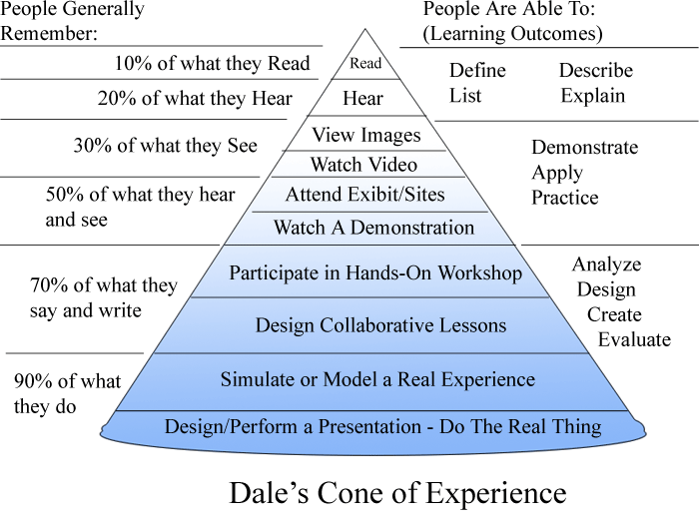
Based on the Cone of Experience, Viewing images is the farthest, followed by B, C and A, respectively.
- The nearest to the real thing according to Edgar Dale’s Cone of Experience is:
- Watching demo
- Viewing images
- Attending Exhibit
d. Hearing and listening
Answer: A
Watching demo is the nearest to the real thing

- For lesson clarity and effective retention, which should a teacher observe, according to Bruner’s theory?
a. Begin teaching at the concrete level but go beyond it by reaching the abstract
b. Use purely verbal symbols in teaching
c. Start at the concrete level and end there
d. End teaching with verbal symbols

Answer: A

Bruner’s Stages of Representation include Enactive (Action-based), Iconic (Image-based) and Symbolic (Language-based). Enactive stage is sometimes called the concrete stage, this first stage involves a tangible hands-on method of learning. Bruner believed that "learning begins with an action - touching, feeling and manipulating" (Brahier, 2009, p. 52). In mathematics education, manipulatives are the concrete objects with which the actions are performed. Common examples of manipulatives used in this stage in math education are algebra tiles, paper, coins, etc. - anything tangible.
iconic (image-based)
Sometimes called the pictorial stage, this second stage involves images or other visuals to represent the concrete situation enacted in the first stage. One way of doing this is to simply draw images of the objects on paper or to picture them in one's head. Other ways could be through the use of shapes, diagrams, and graphs.
symbolic (language-based)Sometimes called the abstract stage, the last stage takes the images from the second stage and represents them using words and symbols. The use of words and symbols "allows a student to organize information in the mind by relating concepts together" (Brahier, 2009, p. 53). The words and symbols are abstractions, they do not necessarily have a direct connection to the information. For example, a number is a symbol used to describe how many of something there are, but the number in itself has little meaning without the understanding of it means for there to be that number of something. Other examples would be variables such as x or y, or mathematical symbols such as +, -, /, etc. Finally, language and words are another way to abstractly represent the idea. In the context of math, this could be the use of words such as addition, infinite, the number three, etc.
https://bruners-stages.wikispaces.com/Bruner%27s+Stages+of+Representation
- With indirect instruction in mind, which does not belong to the group?
a. Lecture-recitation
b. Experiential method
c. Inductive method
d. Discovery method

Answer: A
Lecture – recitation is a form of Direct Instruction which is teacher centered. BCD are all forms of indirect instruction which are student-centered.

- When Teacher Demi presents a set of data then asks the students to enter a conclusion, generalization or a pattern of relationship which method does she use?
a. Process approach
b. Type method
c. Unit method
d. Inductive inquiry method

Answer: D
Inductive/Inquiry method begins with questions, problems and details and end up with answers, generalization, conclusions
- Which questioning technique would be appropriate for inductive lessons?
a. Involve students actively in the questioning process
b. Expect participation only among the more motivated students
c. Use questions requiring only memory responses
d. As a teacher, you ask no questions

Answer: A
Inductive instruction makes use of student “noticing”. Instead of explaining a given concept and following this explanation with examples, the teacher presents students with many examples showing how the concept is used. The intent is for students to “notice”, by way of the examples, how the concept works.

- When necessary conditions are present, the use of inductive method is preferred because:
a. It gives the teacher more time to rest
b. There is greater active participation on the part of the pupils
c. It needs only few instruction materials
d. Academic time is used wisely

Answer: B
Inductive activities are generally more stimulating and require greater student participation.

- If you plan to develop a lesson on using s-verb with the third person singular as subject deductively, what is the first step in your lesson development outline?
a. Give sentences using s-verb form
b. Ask the students about s-verb form and third person singular as subject
c. State the rule on subject-verb agreement for third person as subject
d. Conduct appropriate sentence drill

Answer: C
Deductive method is one in which teacher begins by stating the rule in adding fractions. Then she will give examples. After which, she will give written exercise
- If you make use of the indirect instruction method, you begin your lesson with:
- Guided practice
- A review of previous day’s work
- Advance organizers that provide an overall picture of the lesson
- Independent

Answer: C

Some reviewers say the answer is “a review of previous day’s work.” But take note that the question is how to begin your lesson with an indirect instruction.

Some of the indirect instructional functions are stated here under as summarized by Borich (1988) and Hussen (2000). The instructor:

1. Provides a means of organizing content before instruction. It is to introduce (set) the learning task in advance. It has both psychological (motivation) and cognitive (knowledge) function. The psychological function is mainly to get greater attention of students’ motivation to learn. The cognitive function is set through advance organizers that help students learn meaningfully

2. Provides contextual movement using inductive (specific to general) and deductive (general to specific) methods.

3. Uses examples and non-examples: it is to give examples (real world or tangible examples) and non-examples (ideal world or non-tangible examples) explanations of concepts to promote accurate generalizations.

4. Uses questions to guide the search and discovery process.

5. Encourages students to relate ideas to past learning and use references from their own experience, to seek clarification, and to draw parallels and associations that aid understanding and retention.

6. Permits students to assess the appropriateness of their own responses and if necessary provides guidance.

7. Uses discussion to encourage critical thinking/scrutinizes various ways, to forecast, and to come up with generalization etc/.

http://etd.aau.edu.et/bitstream/123456789/3683/2/ASHENAFI%20ASSEFA.pdf

- By what name is indirect instruction or Socratic methods also known?
a. Questioning method
b. Morrison method
c. Indirect method
d. Mastery learning

Answer: A
The Socratic Method also can be known as maieutics, method of elenchus, elenctic method, or Socratic debate, is a form of cooperative argumentative dialogue between individuals, based on asking and answering questions to stimulate critical thinking and to draw out ideas and underlying presumptions.
- For which lesson objective will a teacher use the direct instruction method?
  - Distinguish war from aggression
  - Appreciate Milton’s Paradise Lost
  - Use a microscope properly
  - Become aware of the pollutants in the environment

Answer: C
Direct instruction is used in teaching procedural knowledge such as in the performance of a task of using a microscope properly.

- To encourage introspection, which teaching method is MOST appropriate?
a. Cognitive c. Process
b. Reflective d. Cooperative learning

Answer: B
Introspection is the examination of one's own conscious thoughts and feelings. In psychology, the process of introspection relies exclusively on observation of one's mental state, while in a spiritual context it may refer to the examination of one's soul. Introspection is closely related to human self-reflection which is the capacity of humans to exercise introspection and the willingness to learn more about their fundamental nature, purpose and essence.

- You choose cooperative learning as a teaching approach. What thought is impressed on your students?
- Interaction is a must, but not necessarily face to-face interaction
- Student’s success depends on the success of the group
- Student’s individuality evaluates how effectively their group worked
- The accountability for learning is on the group not on the individual

Answer: B

The cooperative classroom ties my success to your success. There is no way I can succeed if you fail and there is no way you can succeed if I fail. In the cooperative classroom the achievement focus shifts from the individual to the group. The most refreshing and affirming thing about the cooperative classroom is that when the focus shifts from the individual to the team, individual learning is enhanced, not diminished (Marzano, 2003; Marzano, Pickering, & Pollock, 2001; Slavin, 1995, 1996).

https://www.google.com/search?client=opera&q=cooperative+learning+students+success+depend+on+the+success+of+the+group&sourceid=opera&ie=UTF-8&oe=UTF-8#

- The greatest happiness lies in the contemplative use of the mind”, said Plato. Therefore, let us give more opportunities for our students to do __________.
a. Social interaction c. Role playing
b. Introspection d. Cooperative learning

Answer: B

- Which activity is meant for kinesthetically intelligent pupils?
  - Independent study
  - Individualized study
  - Pantomime
  - Cooperative learning

Answer: B
Learners who possess bodily-kinesthetic intelligence have the ability to work skilfully with objects involving both fine and gross motor skills. They are characterized by a well-developed sense of balance and motor control. In addition, they are skilful at translating intention into action. These learners are most successful by doing.
Activities: Pantomime an activity, task, or chore, Play a sport, Play charades, Act out a scene from a novel, Perform a dance to express an emotion, Learn sign language, Plan and present a puppet show, Go on a nature hike, Go on a scavenger hunt, Exercise

http://www.savilearning.com/QAMI
- When a school decides to work on a thematic curriculum which should be out of the picture?
  - Peer collaboration
  - Integration
  - Team teaching
  - Competition
Answer: D

Thematic learning is a newer concept in pedagogy. It is proved to be a powerful instructional method for integrating various concepts in curriculum by daily life examples and experiences. Thematic learning is geared towards accommodation of interests of individual learners and abilities. Thematic learning techniques fosters teamwork and support in the group since the group is a heterogeneous mixture being taught by a team of two facilitators. Thematic learning comprises teams with varied sizes, and work using problem solving techniques and project methods. The individual is made to progress at one's own pace, and thus develop decision making skill and responsibility.^{[4]} Thematic learning does not have a fixed upper limit. Thematic learning helps in promoting learning with understanding and discourages rote learning

- Which approach makes you think of your thinking?
- Constructivist c. Cognitive
- Metacognitive d. Integrative

Answer: B

Metacognition is thinking about thinking or learning how to learn. It began with John Flavell who is considered as the father in the field.

- One learns Math by building on the Math concepts previously learned. This is an application of:
a. Constructivist c. Physiological
b. Humanist d. S-R

Constructivist view learning as an active process that results from self-constructed meanings. A meaningful connection is established between prior knowledge and the present learning activity.
- Which characterizes a constructivist teaching-learning process?
- Conceptual interrelatedness
- Multiple perspectives
- Authentic assessment
- Passive acceptance of information

Answer: A
Jonassen (1991) notes that many educators and cognitive psychologists have applied constructivism to the development of learning environments. From these applications, he has isolated a number of design principles:
- Create real-world environments that employ the context in which learning is relevant;
- Focus on realistic approaches to solving real-world problems;
- The instructor is a coach and analyzer of the strategies used to solve these problems;
- Stress conceptual interrelatedness, providing multiple representations or perspectives on the content;
- Instructional goals and objectives should be negotiated and not imposed;
- Evaluation should serve as a self-analysis tool;
- Provide tools and environments that help learners interpret the multiple perspectives of the world;
- Learning should be internally controlled and mediated by the learner. (pp.11-12)
http://www.ucs.mun.ca/~emurphy/stemnet/cle3.html

- If a teacher is an advocate of banking concept in Education he or she viewed student as?
- Clear account to be filled up by the teacher
- Dormant account to be activated by the teacher
- Wobble account to be balanced by the teacher
- All of the above

Answer: A

In banking teachers assume students are passive, take all control, determine what will be learned, and “fill” students with pre-selected information. Freire first introduces the “banking” concept of education as being an analogy—the student is a bank and the teacher is the depositor. This concept is what leads to human beings becoming oppressed.

- The following are characteristics of interdisciplinary teaching except:
- Allows learners to see connectedness between things
- Provides learning opportunities in a real-world context
- Eliminates boundaries between content area
d. Discussion from a single perspective
Answer: D
Interdisciplinary instruction entails the use and integration of methods and analytical frameworks from more than one academic discipline to examine a theme, issue, question or topic. Interdisciplinary education makes use of disciplinary approaches to examine topics, but pushes beyond by: taking insights from a variety of relevant disciplines, synthesizing their contribution to understanding, and then integrating these ideas into a more complete, and hopefully coherent, framework of analysis.
- I combined several subject areas in order to focus on a single concept for interdisciplinary teaching. Which strategy did I use?
- Reading-writing activity
- Thematic instruction
- Unit method
- Problem-centered learning
Answer: B

Curriculum integration and thematic teaching are also terms used to describe teaching methods that include interdisciplinary studies.
Jacobs recommends that the development of interdisciplinary units must involve:
- Selecting a focus or thematic topic.
- Generating ideas or connections between related topics.
- Establishing guiding questions for the scope and sequence of the unit.
Designing activities to fulfil the goals of the unit

- Which term refers to the collection of students’ products and accomplishment for a period of evaluation purposes?
a. Portfolio c. Anecdotal record
b. Observation report d. Diary

Answer: A
A portfolio is "a purposeful collection of student work that exhibits the student's efforts, progress and achievements in one or more areas. The collection must include student participation in selecting contents, the criteria for judging merit and evidence of student self-reflection" (Paulson, Paulson & Meyer, 1991, p60).
https://staff.mq.edu.au/teaching/evaluation/resources_evaluation/developing_unit/assess_achievement/

- You want your students to answer the questions at the end of a reading lesson. “What did I learn?”, “What still puzzles me?”, “What did I enjoy, hate and accomplish in the class today?” and “How did I learn from the lesson?”.Which of the following are you asking them to do?
- Work on an assignment
- Make journal entry
- Work on a drill
- Apply what they learned

Answer: B

Journals (also called learning logs or learning diaries) are written by students over a period of time, such as a semester, in order to record and reflect on their personal learning experiences and outcomes. They provide an opportunity for students to express their feelings, thoughts and beliefs about the content and process of learning and themselves as learners using an informal writing style and structure.
https://staff.mq.edu.au/teaching/evaluation/resources_evaluation/developing_unit/assess_achievement/
- If I want to hone my student’s meta-cognitive ability, which is most fit?
- Drill c. Brainstorming
- Debate d. Journaling

Answer; D

Metacognition, the ability to think about your own thinking process, becomes an essential ability for teaching in nowadays schools, where pupils no longer need just information (seen today as perishable goods), but need to be taught how to use the information they get. As students need a more personal approach, a specific feedback according to their own personality traits, both teachers and students are moving towards more formative assessment, new strategies of achieving this are required, one of these being the reflective journal.
http://www.afahc.ro/ro/afases/2014/socio/henter_indreica.pd
- Which of the following statements BEST describes metacognition as a strategy for curriculum augmentation?
- it is learning how to learn and thinking about how one thinks
- it is learning strategies for success
- it is learning through interaction with the environment
- it is learning through computer aided instruction
Answer: A
Metacognition is thinking about thinking, learning how to learn.
- If a reader is vocalizing his thoughts to be able to understand the text, what metacogitive strategy is he using
- Reciprocal teaching
- Think a loud strategy
- Request procedure
- Directed reading thinking activity
Think aloud strategy is also a subvocalization strategy. Research indicates that effective problem-solvers subvocalize; that is they talk to themselves frequently..(Orlich 1994)
Subvocalizing- includes constantly restating the situation, rechecking progress, and evaluating whether one's thinking is moving in an appropriate discussion.
- Ausubel recommends the use of visuals designed to bridge the gap between what the learners already know and what they need to know. Which visual is referred to?
- Pictures
- Concept maps
- Comparison pattern
- Overviews

Answer: B
Concept maps are graphical tools that show relationships between different concepts, ideas, or parts of a whole. They can be used to help students connect new learning to prior learning. These connections are what David Ausubel, an American psychologist, refers to as “meaningful learning” (Novak, 1998). While we can’t force students to learn we can provide the tools to guide them, and concept maps are one of these tools.
http://www.lc2.ca/item/47-concept-mapping-and-meaningful-learning

- Which test item is in the highest level of Bloom’s taxonomy of objectives?
a. Explain how a tree functions in relation to the ecosystem
b. Explain how trees receive nutrients
c. Rate three different methods of controlling tree growth
d. Write a paragraph that observes coherence unity and variety

Answer: D
In the Revised Bloom’s Taxonomy, CREATE is the highest which is Putting elements together to form a coherent whole. That’s what writing a paragraph is. It is generating or producing ideas to form you own based on what you have learned.

- Which objective in the affective domain is in the highest level?
- To resist alcoholism
- To approve of rules agrees upon
- To listen to the narration of identified models
- To relinquish member in a gang
Answer: A
The taxonomy is presented in five stages:
Receiving describes the stage of being aware of or sensitive to the existence of certain ideas, material, or phenomena and being willing to tolerate them. Examples include: to differentiate, to accept, to listen (for), to respond to.
Responding describes the second stage of the taxonomy and refers to a committment in some small measure to the ideas, materials, or phenomena involved by actively responding to them. Examples are: to comply with, to follow, to commend, to volunteer, to spend leisure time in, to acclaim.
Valuing means being willing to be perceived by others as valuing certain ideas, materials, or phenomena. Examples include: to increase measured proficiency in, to relinquish, to subsidize, to support, to debate.
Organization is the fourth stage of Krathwohl’s taxonomy and involves relating the new value to those one already holds and bringing it into a harmonious and internally consistent philosophy. Examples are: to discuss, to theorize, to formulate, to balance, to examine.
Characterization by value or value set means acting consistently in accordance with the values the individual has internalized. Examples include: to revise, to require, to be rated high in the value, to avoid, to resist, to manage, to resolve.
https://sites.educ.ualberta.ca/staff/olenka.bilash/Best%20of%20Bilash/krathwol.html
- Which objective in the affective domain is in the lowest level
- To respond positively to a comment
- To formulate criteria for honesty
- To support viewpoint against abortion
- To accumulate examples of authenticity
Answer: A. Refer to previous number
- Which objective in the psychomotor domain is in the highest level?
- To play the piano skillfully
- To endure fatigue in the entire duration of a game
- To discriminate shapes by touching
- To move hands and legs in a coordinated fashion
Answer: A

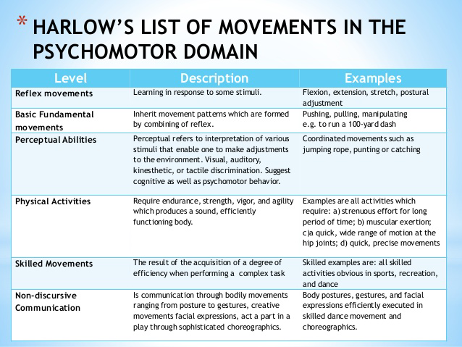

To play the piano skillfully is the highest because it is performed skillfully and with creative execution.

- Which objective in the psychomotor domain is in lowest level?
- To relax the abdominal muscle
- To increase speed as required
- To dance waltz gracefully
- To move in space while remaining in one place
Answer: A
See illustration above.

- With whom is the Cumulative Learning School Model mostly associated?
A. Montessori
B. Gagne
C. Bruner
D. Piaget
Answer: B
Gagné in 1968 proposed the theory of cumulative learning, based on the premise that new learning most of all depends on combining previously acquired and recalled material and skills, but also on the ability of learning transfer. In his own words,
- “There is a specifiable minimal prerequisite for each new learning task. Unless the learner can recall this prerequisite capability… he can not learn the new task

http://teorije-ucenja.zesoi.fer.hr/doku.php?id

- A student has been staring at a puzzle. He/She is figuring out how to solve it and suddenly, an idea flashed in the student’s mind and excitedly she was able to learn how to solve the puzzle. This exemplifies ______.
A. Metacognition
B. Analytical learning
C. Insight learning
D. Trial and error learning

Answer; C

Insight, in learning theory, immediate and clear learning or understanding that takes place without overt trial-and-error testing. Insight occurs in human learning when people recognize relationships (or make novel associations between objects or actions) that can help them solve new problems.
https://www.britannica.com/topic/insight-learning

- If a teacher believes that a child’s mind in TABULA RASA, then the teacher will most likely to engage the students in ______ process for them to learn.
A. Sensory impressions
B. Reflection
C. Reasoning
D. Metacognition

Answer: A
In Locke's philosophy, tabula rasa was the theory that at birth the (human) mind is a "blank slate" without rules for processing data, and that data is added and rules for processing are formed solely by one's sensory experiences. The notion is central to Lockean empiricism.
https://en.wikipedia.org/wiki/Tabula_rasa

- Interpersonal intelligence is best shown by a student who ____.
A. Works on his/her own
B. Keeps interest to himself/herself
C. Seeks out a classmate for help when problem occurs
D. Spends time meditating

Answer: C
Interpersonal intelligence is “people smart. It promotes working in collaboration with others.

- A student is finding it hard to read. When the guidance counselor traced the child’s history, the counselor was able to find out that the student came a dysfunctional family, aside from that, the child was abused and neglected. What could have caused the student’s reading disability?
A. Emotional factors
B. Neurological factors
C. Poor teaching
D. Immaturity

Answer: A
Difficulty in reading can also be linked with emotional factors. Reading difficulty is often associated with intelligence and intellectual factors. Language factors also affect reading performance.
Emotional Factors Failing readers, particularly if they have a long history of failure, often have accompanying emotional problems that impede reading. Emotional problems tend to increase as a youngster moves up through the elementary years and enters adolescence.
Homes that are weighed down by poverty, family instability, and neighborhoods where violence is commonplace increase the likelihood that children will be at risk for school failure. On any given night, the number of homeless children is estimated to be at least 500,000 (U.S. Census Bureau, 2010).
Parents can stimulate their child’s love for reading. Parents who read to children, take them to libraries, and buy books as presents teach children to value reading. When children observe parents who are readers, the parents provide a role model for literacy. Further, the parental role continues to be crucial even after the child enters school.

- A person who is friendly and has a capacity to make people laugh possess:
A. Naturalistic intelligence
B. Intrapersonal intelligence
C. Spatial intelligence
D. Interpersonal intelligence

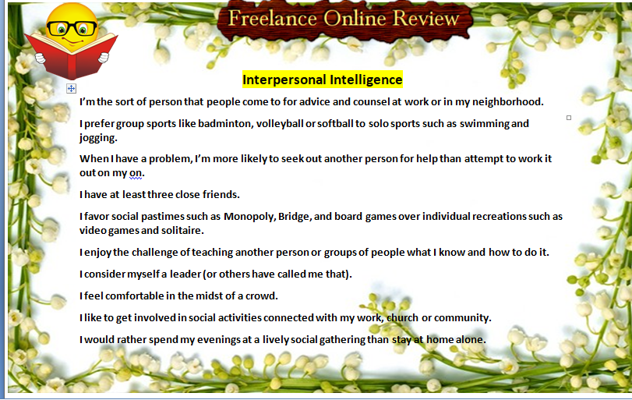

- When is a teacher prejudicial against a learner?
A. When she refuses a pupil with a slight physical disability in class.
B. When she makes a farsighted pupil to sit at the back.
C. When she makes a nearsighted pupil to sit in front.
D. When she considers multiple intelligences in the choice of her teaching strategies

Answer: A

Being prejudicial is unfair or showing bias. Education must be inclusive especially now that we observe the Education for All policy. Hence, any physical disability must never be a standard of admission in the class.

- A teacher only teaches whenever she wants it. What does she lack?
A. Emotional intelligence
B. Competence
C. Integrity and accountability
D. Intelligence

Answer: C

Teachers are accountable towards high learning outcomes. Accountability is the acceptance of responsibility to fulfill a certain obligation or duty.
https://www.slideshare.net/knowellton/module-3-responsibility-and-accountability-of-a-filipino-teacher-25630878

- A group activity wherein one group representative presents the output to the bigger group rather than individual pupils presenting the output is known as:

a. Consensus decision
b. Jury trial
c. Composite report
d. Agenda

Answer: A
The output presented by the representative is the consensus decision of the whole group.
The concept of a jury trial in the classroom setting was used to present and discuss a current, controversial topic.

- Which illustrates vicarious punishment?
a. We feel so bad to a classmate who is punished for being tardy so we convince him go to school on time
b. Out of comparison, we volunteer to get punished in place of a friend
c. We charge to experience our being punished
d. See someone get punished for habitual tardiness. In effect, we are less likely to be tardy

Answer: D
Vicarious punishment occurs when the tendency to engage in a behavior is weakened after having observed the negative consequences for another engaging in that behavior. This is a form of observational learning as described by social learning theory.
They saw the negative consequence of tardiness when someone was punished so they avoided tardiness in order not to be punished.
- What is the basic feature of the latest Performance Appraisal System for teachers (PAST)?
A. Competency base
B. Value Based
C. Knowledge based
D. Practice base

Answer: A
As an appraisal system the CB-PAST adheres to standards of the competency-based performance which is the National Competency-Based Teacher Standards

- Which of the following statements is correct about the domains of educational technology?
a. Design is the production stage while development is the planning stage.
b. Both the design and development are the planning stage.
c. Evaluation is synonymous with implementation.
d. Utilization is the action phase.

Answer: D

- Domain 1 –Design –establishing framework to guide in planning the educational technology
- Domain 2 – Development – using the design or framework, materials are produced and developed
- Domain 3 – Utilization – implementing and using the learning materials to enhance the knowledge and skills of learners. It is also known as the action phase
- Domain 4 – Management – it is applied in the implementation of all the different domains and its effects on the outcomes of learning
Domain – evaluation – monitoring, assessing and giving judgment on the extent of usefulness of learning materials in achieving the expected outcomes.

- Ms. Gomez is planning to integrate technology in her Mathematics class. Which of the following would be the logical steps in doing this?
I. Set the objectives
II. Analyze the learners
III. Utilize the materials with showmanship
IV. Evaluate the performance of the students
a. I, II, III, IV
b. II, I, III, IV
c. I, II, IV, III
d. II, I, IV, III

Answer: B
This is based on the ASSURE which model incorporates Robert Gagne's events of instruction to assure effective use of media in instruction.

A — Analyze learners
S — State standards & objectives
S — Select strategies, technology, media & materials
U — Utilize technology, media & materials
R — Require learner participation
E — Evaluate & revise

- Mrs. Del Prado placed text together with the relevant graphics on the same page in her multimedia presentation. Which principle did she apply?
a. Split attention
b. Spatial contiguity
c. Cost effectiveness
d. Communication effectiveness

Answer: A
Ayres and Sweller (2005) define the split-attention as present, when the
Learner has to divide his attention between different sources and thereby simultaneously has to mentally combine the contents of these sources, like the simultaneous display of text and picture on a computer screen. These sources have to contain appropriate information which is necessary for the learner in order to understand the material which has to be learnt

Spatial Contiguity Principle – People learn better when corresponding words and pictures are presented near rather than far from each other on the page or screen.
http://hartford.edu/academics/faculty/fcld/data/documentation/technology/presentation/powerpoint/12_principles_multimedia.pdf

- Mrs. Olivarez presented real samples of rocks in her General Science class. What principle did she apply?
a. Appropriateness
b. Authenticity
c. Responsiveness
d. Simplicity

Answer: B. Authenticity is the quality of being real or genuine.

- Which of the following technologies provide iconic experiences to students/ children?
a. Video and books
b. Pictures and videos
c. Radio and recording
d. Modules and periodicals

Answer: B
Iconic “knowledge is stored primarily in the form of visual images ” (Alexander 2002).
-Human learning is generated by imagery in this stage. The individual is able to generate mental images of events.
-In the iconic stage it is very important to present a number of different visual aids to students to supplement teaching material. Examples include images, videos, charts and graphs.
- According to RA 9155, which is the heart of the formal educational system?
a. Department of Education
b. Division
c. School
d. Learner

Answer: C

RA 9155, SEC. 2. Declaration of Policy. – It is hereby declared the policy of the State to protect and promote the right of all citizens to quality basic education and to make such education accessible to all by providing all Filipino children a free and compulsory education in the elementary level and free education in the high school level. Such education shall also include alternative learning systems for out-of-school youth and adult learners. It shall be the goal of basic education to provide them with the skills, knowledge and values they need to become caring, self- reliant, productive and patriotic citizens.

The school shall be the heart of the formal education system. It is where children learn. Schools shall have a single aim of providing the best possible basic education for all learners.

- Is an alien qualified to take the Licensure Examination for Teachers?
- Yes, provided that his/her country has reciprocity with the Philippines in the practice of the teaching profession
- Yes, provided he/she is a teacher education graduate
- No, because he/she is not a citizen of the Philippines
- No, because he/she is not a natural born citizen in the Philippines

Answer: A

RA 7836, SEC. 15. Qualification Requirements of Applicants. - No applicant shall be admitted to take the examination unless, on the date of filing of the application, he shall have complied with the following requirements:
a. A citizen of the Philippines or an alien whose country has reciprocity with the Philippines in the practice of the teaching profession;
b. At least eighteen (18) years of age;
c. In good health and of good reputation with high moral values;
d. Has not been convicted by final judgment by a court for an offense involving moral turpitude;
e. A graduate of a school, college or university recognized by the government and possesses the minimum educational qualifications, as follows:

- After 2002, is there another way of obtaining a professional teacher’s license other than passing the LET?
- None
- Yes, by applying for the conversion of one’s Professional Board Examination for Teachers (PBET) passing rating to a license
- Yes, if one has five years of teaching with very satisfactory teaching performance
- Yes, if one has three years of teaching and with a master’s degree

Answer: B
For Conversion of PBET to PRC (Teachers)
- Present required documents to processor at OPT-Application Windows for issuance of Application Form and blank Permanent Examination and Registration Record Card (PERRC).
  - Download Application for Registration Without Examination form
- Pay filing fee at the Cashier. Get Official Receipt.
- Pay metered documentary stamp at the PRC Customer Service Center.
- Submit duly accomplished application form, required documents, PERRC, and Official Receipt to Issuing Officer at OPT-Application Windows for final review of documents and issuance of Filer’s Stub.
- Keep Filer’s Stub for verification and registration purposes.
Notice of Approval/Disapproval will be mailed to you. If you fail to receive your notice on scheduled date, please verify status of your application at OPT-Application Windows.
http://www.prc.gov.ph/registration/?id=3

- Can a licensed professional teacher teach after continuous five years of not practicing the teaching profession?
- Yes
- No, unless he/she has earned 12 units of refresher courses in education
- That depends on the LET rating
- That depends on the GPA in college

Answer: B

RA 9293, Sec. 2. Professional teachers who have not practiced their profession for the past five (5) years shall take at least twelve (12) units of education courses, consisting of a least six (6) units of pedagogy and six (6) units of context courses or the equivalent training and number 1 hours to be chosen from a list of courses to be provided by the Board and the Department of Education, before they can be allowed to practice their profession in the country.

- Learners must be taught to take stand and defend the same after a thorough analysis of issues is an advice form a/an _____
a. Existentialist
b. Progressivist
c. Rationalist
d. Empiricist

EXISTENTIALIST - Individual choice and individual standards rather than external standards are central. Existence comes before any definition of what we are. We define ourselves in relationship to that existence by the choices we make. We should not accept anyone else's predetermined philosophical system; rather, we must take responsibility for deciding who we are. The focus is on freedom, the development of authentic individuals, as we make meaning of our lives. (Essentialists take stand and taking responsibility for their actions.)

https://oregonstate.edu/instruct/ed416/PP2.html

- “Don’t just believe because your teacher said so. You must be able to prove with data that such conclusion is correct” is a thought that comes from the a/an ______
- Rationalist
- Essentialist
- Empiricist
- Pragmatist

Answer: C

Empiricism is a philosophical belief that states your knowledge of the world is based on your experiences, particularly your sensory experiences. According to empiricists, our learning is based on our observations and perception; knowledge is not possible without experience.

- “Why waste so much time copying notes from the board when everything is in the textbook?” is a remark that comes from a ________
- Progressivist
- Empiricist
- Pragmatist
- Utilitarianist

Answer: C
A pragmatist is a person who is guided more by practical considerations than by ideals.
It is pragmatic or practical to use books than spending time in copying.

- When in curriculum decongestion the first subjects that are dropped are philosophy, arts, humanities, and the like on which the philosophy is the curriculum decongestion anchored?
- Existentialism
- Utilitarianism
- Perennialism
- Progressivism

Answer: B

Congestion means overcrowding. In simple terms, there is too much in too little space or time. When there is a curriculum congestion there is an overload. Using a utilitarian principle, only subjects that are of total utility to the students are retained.

Utilitarianism is the idea that the moral worth of an action is solely determined by its contribution to overall utility in maximizing happiness or pleasure as summed among all people. It is, then, the total utility of individuals which is important here, the greatest happiness for the greatest number of people.

- “Every time you meet your students, put your first impression about each of them within brackets and allow them to disclose themselves as they are, is a wise thing to do”, is an advice from a/an ________
- Existential phenomenologist
- Progressivist
- Rationalist
- Pragmatist

Answer: A (See item #110 for Existentialism)

- If you are afraid to be different from the rest even if you are convinced that you are right makes you far from being a/an _________
- Existentialist
- Pragmatist
- Utilitarianist
- Rationalist

Answer: A (See item #110 for Essentialism )

- The reconstructionist philosophy influences classroom instruction today. Teachers act as social engineers and students learn within the classroom as a social laboratory. In line with this, teachers prepare the youth for leadership and life skills. However, mandatory volunteerism often results from this preparation due to the ________
- Increased pressure from administrative and governmental entities
- Emphasis on crediting and integration of civic education with existing curriculum
- Perceived sense of responsibility in the family and community
- Desire to get more funding from civic-oriented organizations
Answer: B

Students are often required to do community-oriented activities to get credit and/or grade. Such motivation runs counter to the reconstructionist philosophy of having the classroom as an avenue to effect social changes even without regard to ratings and assessment.

- Which of the following is provided for in Article XIV of the 1987 Philippine Constitution?
- Academic freedom of teachers and students at all levels
- Mandatory religious education in elementary and high schools
- Protection of intellectual property rights
- Advancement of free and compulsory secondary education

Answer: C

Article XIV encourages the promotion of creative works and the protection of the rights of those who produce such creative, unique and innovative outputs. For option A, academic freedom is enjoyed by higher education only is optional not mandatory. For option D. only elementary education is compulsory.

- Which statement is NOT true of CHED?
- It is in charge of education programs in all levels
- It is governed by commissioners headed by a chairperson
- It supervises both public and private higher education institutions
- It regulates and supervises tertiary education

Answer; A
CHED formulates policies, standards, plans and programs for the development and reform of Philippine higher education in a globalized context

- Which of these goals does NOT achieve global education?
- Expand early childhood care education
- Provide free and compulsory primary education
- Increase adult illiteracy by 50 %
- Promote life skills for young adults

Answer: C

Education for All Goal 4 aims towards “Achieving a 50 per cent improvement in levels of adult literacy by 2015, especially for women, and equitable access to basic and continuing education for all adults
http://unesdoc.unesco.org/images/0022/002224/222407E.pdf

- Modesty has not practiced her teaching profession for the past five years. How many units of education courses should she take before she is allowed to teach?
- 12 units
- 24 units
- 15 units
- 30 units

Answer: A Based on RA 9293

- Mr. Sanchez is always willing to work overtime as requested by his superior due to exigency of the service. What percentage of his regular remuneration after he has completed at least 6 hours of actual teaching should be paid to his as his additional compensation?
- 20%
- 25%
- 30%
- 35%

Answer: B

RA 4670, Sec. 14. Additional Compensation. Notwithstanding any provision of existing law to the contrary, co-curricula and out of school activities and any other activities outside of what is defined as normal duties of any teacher shall be paid an additional compensation of at least twenty-five per cent of his regular remuneration after the teacher has completed at least six hours of actual classroom teaching a day.

1.5 apply the four pillars of learning-learning to know, learning to do, learning to live together, learning to be in responding to the aspirations of the learner and the community

- What is/are true of learning to be?

- Reflects a shift from education goal of economic productivity to a humanistic view of education
- Emphasizes the development of the complete person
- Focuses on the development of reason only
- I only
- III only
- I and II
- I, II and III

The pillar of ‘learning to be’ reflects a shift from an instrumental view of education, as a process one submits to achieve specific aims (e.g. economic productivity), to a humanistic view of education that emphasizes the development of the complete person, in short, learning to be’ (Delors, p.86).
http://www.ibe.unesco.org/cops/Competencies/PillarsLearningZhou.pdf

Acquiring knowledge in a never-ending process and can be enriched by all forms of experience’. ‘Learning to know’ includes the development of the faculties of memory, imagination, reasoning, problem-solving, and the ability to think in a coherent and critical way. It is ‘a process of discovery’, which takes time and involves going more deeply into the information/knowledge delivered through subject teaching. Hence, III is under Learning to know.

- Which statement/s “learning to do” is/are CORRECT?
- Learning to do calls for new types of skills, more behavioral than intellectual
- The material and the technology are becoming secondary to human qualities and interpersonal relationships
- Learning to do implies a shift from skill to competence
- I, II and III
- II and III
- I and II
- I and III

Learning to do
This pillar of learning implies in the first place for application of what learners have learned or known into practices; it is closely linked to vocational-technical education and work skills training. However it goes beyond narrowly defined skills development for ‘doing’ specific things or practical tasks in traditional or industrial economies. The emerging knowledge-based economy is making human work increasingly immaterial. ‘Learning to do’ calls for new types of skills, more behavioral than intellectual. The material and the technology are becoming secondary to human qualities and interpersonal relationship.
Learning to do thus implies a shift from skill to competence, or a mix of higher-order skills specific to each individual. ‘The ascendancy of knowledge and information as factors of production systems is making the idea of occupational skills obsolete and is bringing personal competency to the fore’. Thus ‘learning to do’ means, among other things, ability to communicate effectively with others; aptitude toward team work; social skills in building meaningful interpersonal relations; adaptability to change in the world of work and in social life; competency in transforming knowledge into innovations and job-creation; and a readiness to take risks and resolve or manage conflicts.
http://www.ibe.unesco.org/cops/Competencies/PillarsLearningZhou.pdf

- The classroom is very lively. There are different groups and each group is brainstorming on the topic, healthy lifestyle. Every member has his/her own role to do for the realization of one goal- to make and present a powerpoint presentation of the topic. What pillar of education is exemplified most in the given classroom setting?
- Learning to know
- Learning to do
- Learning to be
- Learning to live together

Learning to live together
In the context of increasing globalization, the Delors Commission places a special emphasis on this pillar of learning. It implies an education taking two complementary paths: on one level, discovery of others and on another, experience of shared purposes throughout life. Specifically it implies the development of such qualities as: knowledge and understanding of self and others; appreciation of the diversity of the human race and an awareness of the similarities between, and the interdependence of, all humans; empathy and cooperative social behavior in caring and sharing; respect of other people and their cultures and value systems; capability of encountering others and resolving conflicts through dialogue; and competency in working towards common objectives

- Which pillar of education is developed most when one prepares and does powerpoint presentation?
- Learning to know
- Learning to do
- Learning to be
- Learning to live together

- Students in the Senior HIgh School (Grades 11 and 12) will select their tracks namely: academic, tech-voc and sports and arts and design. What is the main reason behind this?
- To develop the mastery of knowledge or concepts among students so they can earn their degrees
- To develop mastery of skills among students so that they have chances of employability
- To develop social skills among students so they will be able to adapt easily to their working environment
- To develop their whole personality

The government should pay attention to ensuring that schools, including the senior high schools, will produce students who will be able to immediately find employment when they graduate. This is also to avoid skills or jobs mismatch.

- The International Commission on Education for the 21st century advocates four pillars of learning, namely - learning to know, learning to do, learning to live together and learning to be. Since there are peace and cultural diversity problems in the world and everywhere, which of the four pillars should be given more emphasis in teaching?
- Learning to know
- Learning to live together
- Learning to do
- Learning to be

- When the teacher encourages the students to analyze issues, think critically about information given them, and help develop their skills on their own, which pillar of learning does she try to develop?
- Learning to know
- Learning to live together
- Learning to do
- Learning to be

1.6 Apply ethical principles in the teacher’s professional life and in his/her relationship with other people

- Based on the preamble “teachers are duly licensed professionals who posses dignity and reputation with high moral values as well as technical and professional _”
- Competence
- Proficiency
- Expertise
- Skills

Preamble (Code of Ethics for Professional Teachers)
Teachers are duly licensed professionals who possess dignity and reputation with high moral values as well as technical and professional competence in the practice of their noble profession, and they strictly adhere to, observe, and practice this set of ethical and moral principles, standards, and values.

- Teacher Laida is an elementary grades teacher. She is very active in community activities. Every election time she serves as a member of the election committee. Then, during one election period her uncle ran for mayor. Laida got very much in the election campaign. Is teacher Laida’s action ethical?
- Yes, because she should support her relative
- Yes, because it’s her role to serve the community
- No, because she should be non-partisan
- No, because serving during election time is very dangerous to life

Code of Ethics, Section 5. A teacher shall not engage in the promotion of any political, religious, or other partisan interest, and shall not, directly or indirectly, solicit, require, collect, or receive any money or service or other valuable material from any person or entity for such purposes.

- At Masigasig Elementary School, parents were requested to help during the Brigada eskwela before the opening of classes. Mrs. Pedro the school principal noticed that Ms. Lizardo, a newly hired teacher, was aloof and was not interacting with parents. As the school head, what should Mrs. Pedro do?
- Asks Ms. Lizardo to do other tasks in the office until she is able to adjust
- Request the parents to invite Ms. Lizardo to join them
- Cancel the activity so Ms. Lizardo will do the brigada herself
- Advise Ms. Lizardo to supervise and join the parents in their activities

The Brigada Eskwela Program is a collaborative work of the school and the community especially with parents. Teachers are expected to lead in preparing the school before classes begin, thus Ms. Lizardo should establish good relationships with parents for the purpose.

Code of Ethics, Section 7. Every teacher shall maintain harmonious and pleasant personal and official relations with other professionals, with government officials, and with the people, individually or collectively.

Article IX: The Teachers and Parents (Code of Ethics)
Section 1. Every teacher shall establish and maintain cordial relations with parents, and shall conduct himself to merit their confidence and respect.

- Miss Sanchez engage her learners in activities where they develop writing, critical thinking, problem solving skills and risk taking. Which of these 21st century skills does Miss Sanchez possess?
- Communication skills
- Learning and innovation skills
- Information and technology skills
- Life and career skills

The correct answer is letter B since learning and innovation skills include the C’s namely: creativity, curiosity, and critical thinking problem solving skills. Letter A is incorrect because communication skills include teaming. Collaboration, interpersonal skills and interactive communication. Letter C is incorrect because technology skills include visual, media and scientific.

- After school hours, teacher Manuel leaves school in a hurry to his tutorial work. One of his tutee is a top 10 student in his class. The teacher is paid Php150 per hour for his services. What is wrong with teacher Manuel’s action?
- Receiving additional compensation
- Tutoring after school
- Always in a hurry to leave school
- Tutoring his own student for a fee`

Code of Ethics, Article VIII, Section 5. A teacher shall not accept, directly or indirectly, any remuneration from tutorials other what is authorized for such service.

- Teacher Carmen is a SPED teacher of teacher with behavioral problems. One day, she found one pupil disturbing the rest of the class. Furious of what she saw, she got her eraser and threw it to her pupil who was hit in the forehead. Do you agree with teacher Carmen’s action to discipline her pupil?
- Yes, because she has to correct the misbehavior immediately
- No, because he acted at the height of her anger
- Yes, because the pupil’s behavior is disturbing the class and the teaching process
- No, because a more appropriate technique can be used to control the behavior

Corporal punishment is a prohibited act under DO 40, s. 2012

- Teacher Melvin is a handsome and intelligent high school teacher. Most of the time his student has a crush on him. It so happen that one day, he got attracted to a beautiful and intelligent girl in his class. Should teacher Melvin entertain his feelings toward his students?
- Yes, for as long as it will not affect his focus in teaching
- Yes, he has the right to express his feelings
- No, he should not take advantage of his position as a teacher
- No, the parents will file charge against him

Code of Ethics, Art. VIII, Section 7. In a situation where mutual attraction and subsequent love develop between teacher and learner, the teacher shall exercise utmost professional discretion to avoid scandal, gossip and preferential treatment of the learner

- What does “Living with dignity in all places at all times” as provided for by RA 4670 and article XI of the Code of Ethics include?
- Living together with someone whose marriage has not been legally annulled
- Judicious disbursement of funds entrusted to the teacher and/or administrator
- Inflicting corporal punishment to erring students whose parents consented to such use
- Maintaining a mini “casino” within the community to help the unemployed

Obviously, option B is the only choice which shows a dignified act.

- Which of these can professor Santos do to uphold the highest possible standards of education?
- Buying expensive gadgets to change the poor perception of people about teachers
- Telling people that teaching is the best profession
- Attending seminars once a year
- Continually improving himself/herself personally and professionally

Code of Ethics, Art. IV, Section 3. Every teacher shall participate in the Continuing Professional Education (CPE) program of the Professional Regulation Commission, and shall pursue such other studies as will improve his efficiency, enhance the prestige of the profession, and strengthen his competence, virtues, and productivity in order to be nationally and internationally competitive.

- Mrs. Martin was approached by a parent who had a concern about the grade received by her daughter, Mila comparing it with the grade of Sharon her classmate. Which of these should Mrs. Martin do?
- Record to show the record notebook since it is her personal property
- Show both the record of Mila and her classmate Sharon
- Refuse to show any record without the written approval of the principal
- Show only the record of her daughter Mila

BP 232, Section 9. Right of Students in School - In addition to other rights, and subject to the limitation prescribed by law and regulations, and student and pupils in all schools shall enjoy the following rights:
4. The right of access to his own school records, the confidentiality of which the school shall maintain and preserve.
According to the law, only the student concerned has the right to access his own record. And confidentiality is protected by law. In short, no one has the right to see or access it other than him.

- According to the Professional Code Of Ethics for Professional Teachers, which of these is not a stated quality of a professional teacher?
- Has passion for teaching
- Duly licensed professional
- With high moral values, technical and professional competence
- Possess dignity and reputation

Preamble (Code of Ethics for Professional Teachers)
Teachers are duly licensed professionals who possess dignity and reputation with high moral values as well as technical and professional competence in the practice of their noble profession, and they strictly adhere to, observe, and practice this set of ethical and moral principles, standards, and values.

- Miss Manuad can connect to her students like magnet. Which among these is her personal quality?
- Expert in her subject
- Skilled in the art of teaching
- Repertoire of best teaching methods
- Passion and humor

A teacher should be expected to have a sense of humor. Teachers’ humor connects them with their students like a magnet. They help in merging two worlds –youth and maturity. When they laugh together, young and old, teachers and students, they cease to be conscious of their age difference. They enjoy as a group, thus promote a spirit of togetherness. A clean joke will always elicit rapport in a learning environment.

- A teacher may submit a proper authority any justifiable activities against an associate preferably in writing without violating any right of the individual concern. Which section of the Code of Ethics is referred to in the given situation?
- Article III - Teachers and the Community
- Article IV - Teachers and the Profession
- Article V - Teacher and the Teaching Community
- Article VI - Teacher and Higher Authorities

Code of ethics, Art. III, Section 6. A teacher may submit to the proper authorities any justifiable criticism against an associate, preferably in writing, without violating the right of the individual concerned.

- A good teacher has a good mastery of subject matter, writes good lesson plans, line up exciting activities to make the lesson interesting, and assess her students very well. What teacher qualities are these?
- Moral qualities
- Professional qualities
- Personal qualities
- Social qualities

Professional skills
- excellent teacher practitioner
- knowledge and experience of the mentee‘s new area of work
- knows organisational routines, procedures and policies
- enthusiastic about teaching
- can offer a range of perspectives and teaching and learning techniques
- can make suggestions informed by their own expertise and experience
- can empower the mentee with the knowledge gained from their experience
- can help the mentee to identify practice which meets professional requirements.
http://www.whatishumanresource.com/personal-and-professional-qualities-of-a-mentor

- Matthew Arnold’s ideal person is “the person whose powers are all in balance”. The following have to be developed for a person to become Arnold’s ideal person EXCEPT?
- Head, heart, hands and health
- knowledge , skills, attitude
- Brain, mind, reason
- Cognitive, psychomotor and affective powers

Brain, Mind, Reason are cognitive powers only. No balance

- A person is held responsible for his action because he _______
- Is mature
- Has choice
- Has instinct
- Has reason

Man is responsible for his actions because he has the choice or free will to choose to do it or not.

- Both Muslim and Christian value marriage but the Muslim practice polygamous marriage while the Christian practices monogamous marriage. The polygamous Muslim should be viewed from the viewpoint of a Muslim and not from that of a Christian. What is these called?
- Cultural relativism
- Enculturation
- Acculturation
- Non-rationalism

cultural relativism is the principle that an individual’s beliefs and activities should be understood by others in terms of that individual’s own culture

- The inclusion of the study of Rizal and other national heroes in the school curriculum in order to inculcate the love of country is based on which philosophy?
- Pragmatic
- Existentialist
- Idealist
- Realist

In idealism, the aim of education is to discover and develop each individual's abilities and full moral excellence in order to better serve society. The curricular emphasis is subject matter of mind: literature, history, philosophy, and religion. Teaching methods focus on handling ideas through lecture, discussion, and Socratic dialogue (a method of teaching that uses questioning to help students discover and clarify knowledge). Introspection, intuition, insight, and whole-part logic are used to bring to consciousness the forms or concepts which are latent in the mind. Character is developed through imitating examples and heroes.
https://oregonstate.edu/instruct/ed416/PP2.html

- Which philosophical thought is concerned with the strengthening of liberal education through classical literature in the curriculum?
- Rationalist
- Hedonist
- Humanist
- Stoics

The great intellectual movement of Renaissance Italy was humanism. The humanists believed that the Greek and Latin classics contained both all the lessons one needed to lead a moral and effective life and the best models for a powerful Latin style. They developed a new, rigorous kind of classical scholarship, with which they corrected and tried to understand the works of the Greeks and Romans, which seemed so vital to them.
https://www.loc.gov/exhibits/vatican/humanism.html

1.7 Reflect on the professional teacher’s accountability to learner’s performance and to the teacher’s total involvement in the teaching profession

- Which is the best way of communicating students’ performance to parents?
- Telephone conversation
- Home visits
- Formal written communication
- Parent-teacher conference

A parent-teacher conference, parent-teacherinterview or parents' evening, is a short meeting orconference between the parents and teachers of students to discuss a child's progress at school and find solutions to academic or behavioral problems.

- Which domain in the National Competency-Based Teacher Standards focuses on the idea that teachers serve as positive and powerful role models?
- Learning environment
- Personal growth and professional development
- Social regard for learning
- Diversity of learners

Domain 1: Social Regard for Learning focuses on the ideal that teachers serve as positive and powerful role models of the values of the pursuit of learning and of the effort to learn, and that the teachers’ actions, statements, and different types of social interactions with students exemplify this ideal. There is only one strand under Domain 1. Acts as a positive role model for students. It is therefore expected that graduates of BEEd and BSEd programs who are done with this domain are teachers who have a deep and principled understanding of the learning processes and the role of the teacher in facilitating these processes in their students.

- Mr. Antonio focuses on the importance of providing for a social, psychological and physical environment where all students can engage in the different learning activities and towards attaining high standards of learning. Which domain in the NCBTS did Mr. Antonio satisfy?
- Social Regard for Learning
- Learning Environment
- Diversity of Learners
- Curriculum

Domain 2: Learning Environment focuses on importance of providing for a social and physical environment within which all students, regardless of their individual differences in learning, can engage the different learning activities and work towards attaining high standards of learning. Hence, graduates of the BEEd and BSEd programs after this domain, have a deep and principled understanding of how educational processes relate to larger historical, social, cultural and political processes.

- A student passes a book report poorly written but ornately presented in a folder to make up for the poor quality of book report content. Which Filipino trait does this practice prove?
- “Porma” over substance
- Arts over academics
- Substance over “Porma”
- Art over Science

- By which process do children become participating and functioning members of society by fitting into an organized way of life?
- Assimilation
- Acculturation
- Accommodation
- Socialization

In sociology, 'socialization is the process of internalizing the norms and ideologies of society. Socialization encompasses both learning and teaching and is thus "the means by which social and cultural continuity are attained"

- When the teacher is convinced that it is best to teach students the skill to adapt to change since change is the only thing permanent in this world, he/she subscribes to which philosophy?
- Realism
- Existentialism
- Pragmatist
- Idealism

Pragmatists view the world as process and change

- “Approach every pupil as he/she is without allowing yourself to be influenced by your knowledge of his/her background” is an advice from a/an ______
- Rationalist
- Positivist
- existentialist- phenomenologist
- Existentialist

The existential - phenomenologist’s attitude is one that views human life or anyone from an outside objective point of view

- Which of the following best describe the role of a teacher from a perennialist perspective?
- Expose the learner to up-to-date information about Science and Math
- To reveal the wisdom of the ages such as those contained in the Bible/Koran
- To assist the learner to clarify his/her value priorities through self-analysis
- To give, interpret or analyzes complete information to the student

Perennialists believe that one should teach the things that one deems to be of everlasting pertinence to all people everywhere

- Prof. B presented a lesson on the agreement of the subject and the verb. After the developmental activity, he led the class to arrive at a rule. How did the teacher proceed?
- Inductively
- Deductively
- Deductively then Inductively
- Inductively then Deductively

Answer A. Inductive method begins with questions, problems and details and end up with answers, generalization, conclusions. Inductive instruction makes use of student “noticing”. Instead of explaining a given concept and following this explanation with examples, the teacher presents students with many examples showing how the concept is used.

- Which part of lesson development is concerned with mood setting?
- Application
- Motivation
- Deepening
- Generalization

Answer is B. Motivation is getting the atmosphere for learning

- In which situation is a learner-centered approach to curriculum designing utilized?
- The focus of learning is mastery in terms of content
- Teacher considers learners’ entry knowledge and skills
- The class activity revolves around finding solutions to problems
- Memorization and drill are important learning skills

Answer is B. Learner- centered approach is built upon the learner’s knowledge, skills, previous learnings and potentials. A and D are situations for subject matter where the primary approach is the subject matter and C is problem-centered approach, where learners are directed in resolving problems.

- Which level of knowledge is manifested when a learner is able to answer the question, “What was most confusing to me about the material explored in class today?”
- Factual knowledge
- Conceptual knowledge
- Procedural knowledge
- Metacognitive knowledge

Answer is D. Metacognitive knowledge - knowledge of cognition in general, awareness of knowledge of one’s own cognition, thinking about thinking. Not A because factual knowledge are ideas, specific data or information; nor B conceptual knowledge - facts that interrelate with each other. Not C - because procedural knowledge is about how things work, or step-by-step actions.

- You wanted your students to learn the different bodies of water as a part of your lesson. Which of these objectives is NOT appropriate for your lesson?
- Name the different kinds of bodies of water
- Name ways by which we can protect the bodies of water
- Draw the different kinds of bodies of water
- Go on a field trip to study all the kinds of bodies of water

Answer is D. The first three objectives can be easily attained in a classroom setting. In A, students can name the different bodies of water by showing them video clips or still pictures while B and C objectives can be used in the extension part of the topic. The last objective is difficult to carry out since it involves a lot of money, time and effort on the part of both teacher and the students

- Mrs. Martinez observes that her students answer even when not called, shout “Ma’am” to get her attention, and laugh when someone commits mistakes. What should she do?
- Set the rules for the class to observe
- Send misbehaving students to the guidance counselor
- Involve the whole class in setting rules of conduct for the whole class
- Send a report/letter to the parents about their child’s misbehavior in class

Answer is C. It is more effective if Mrs. Martinez involves her class in setting rules of conduct for the whole class than just the teacher setting rules for the class to observe (Choice A) since the students are the ones setting rules for themselves. In choice A, the teacher is too autocratic. Choices B and D maybe done only if teacher can no longer solve the problem by herself

Many teachers engage their students in establishing overall classroom rules and procedures. For example, you might facilitate a discussion at the beginning of the year about when it is appropriate and not appropriate for students to leave their seats, emphasizing the importance of demonstrating politeness and respect for others. Such a discussion typically involves identifying expected behaviors and procedures for using the pencil sharpener, getting resources and materials from central places in the room, returning materials to shelves, and conferring with other students sitting across the room.

Although there are, of course, some common overall rules that elementary and secondary teachers should establish, rules also vary depending on the age and grade level of students. For example, many elementary school teachers assign specific seats for their students at the beginning of the year. At the secondary level, however, teachers frequently let students sit where they choose as long as their seating choice does not interfere with their learning. Allowing students to choose their own place in the classroom is a sign of respect for their maturity. Students also appreciate this approach, which helps build their support for rules and procedures set by the teacher.
http://www.ascd.org/publications/books/105012/chapters/Module-1@-General-Classroom-Behavior.aspx

- Teacher Raymond, a Social Studies Teacher, wants his grade 7 students to express their opinions, sentiments, and ideas regarding a certain government issue in the national level. Which of the following can he BEST use to facilitate such?
- Forum
- Blog
- E-mail
- Group Messaging

Answer is A. Forum would be the best platform to be used when expressing opinions and ideas. It induces greater interaction among students as compared to the other choices since students in such platform are given the chance to exchange their ideas and opinions instantly. The use of Blogs (choice B), e-mails (choice C), and group messaging (choice D) would be possible yet too difficult to facilitate the exchange of ideas and opinions

- Which of the following situations illustrates the best way of maintaining an atmosphere conductive to learning during the experiment period?
- Handling, distributing and collecting of materials of equipment are routinized
- Experiment tables and chairs are arranged in rows facing the teacher’s table and chair
- Learners carry in class experiments following the procedure quietly and systematically
- Materials needed for experiments are be bought just before using them to avoid wastage

Answer is A. When we develop classroom routines, the opportunity for misbehaviour is lessened because our students know what is expected of them and what they are expected to do. They also help us to avoid “miscalls,” that is, misinterpreting a child’s behaviour as a misbehaviour; for instance, when a child does not know that she (or he) is to sharpen her pencil after the lesson is over, rather than during it, or at least raising her hand and asking for permission. Moreover, if students know the steps necessary to get a particular job done, they are more likely to complete it in an orderly manner.
http://unesdoc.unesco.org/images/0014/001492/149284e.pdf

- Miss Able wants to let her class learn that in the formation of ice cubes, the surrounding surface of the water freezes first before the others and to show that water expands rather than contracts when frozen. Which of the following is the most appropriate teaching strategy for her to use?
- Problem solving
- Laboratory activity
- Investigatory activity
- Teacher demonstration

Answer is B. Laboratory Method is a planned learning activity dealing with original or raw data in the solution of problem. It is a procedure involving first hand experiences with materials or facts derived from investigations or experimentation.

- Good discipline is characterized by _________
- Self-direction
- Giving command
- Unquestioning docility and conformity
- Coercion and punishment

Answer is A. The strongest proof that one has discipline is his/her abilities to direct himself/herself

- To understand better the meaning of sweet, Teacher Arabella gives examples of phrases like sugar is sweet; chocolates are sweet, ripe mangoes are sweet. Teacher Arabella is trying to develop the learner’s ability to derive the meaning of words co-occurring with the unknown word, by making use of which clues?
- Context
- Semantic
- Syntactic
- Presentation

Answer is B. In semantic clues, a word may be directly defined in the context

- Teacher Marie designed a lesson where she wanted her students to design an activity on the effect of changing the temperature of water on the dissolving rate of sugar. Which teaching method is most appropriate for Teacher Marie to use/
- Direct Instruction
- Demonstration
- Inquiry
- Lecture method

Answer is C
Inquiry Method
- core of inquiry is spontaneous and a self-directed exploration
-sometimes termed discovery, heuristic and problem solving
-defined as a teaching method which is modeled after the investigative processes of scientists
-obtaining information through direct experiences
-Investigative
-promotes first hand experience

- Which of the following strategies belong to both expository and exploratory approach?
- Inductive and inquiry
- Deductive and cooperative
- Laboratory and problem-solving
- Lecture discussion and direct instruction

Answer is B. Expository method is deductive/direct method and cooperative approach allows learners to explore. Exploratory approach is one that is indctive/indirect method.

- Mrs. Alonzo, the principal of Mabuhay Elementary School, firmly supports the idea that students have an active role in constructing their own knowledge . Thus, she encouraged her teachers to employ student-centered activities on their classes. What theory of learning does Mrs. Alonzo adhere to?
- Experimental
- Constructivism
- Meta-cognition
- Problem-based

Answer is B. One principle of learning that should guide teaching in the 21st century emphasized by Hammond and colleagues is that "students come to the classroom with prior understanding and experiences and to promote student learning, teachers must address and build upon this prior knowledge. " The constructivist approach is anchored on this.
Constructivist view learning as an active process that results from self-constructed meanings. A meaningful connection is established between prior knowledge and the present learning activity.
The constructive approach is anchored on the belief that every individual constructs and reconstructs meaning depending on past experiences. They continue reflecting and evaluating accumulated knowledge with sn end view of constructing new meanings.

- Mrs. Rivera wants to help her students retain new information learned in Earth Science. Which of the following strategies should she best apply?
- Dramatization
- Discussion
- Mnemonics
- Games

Answer is C. Mnemonics are memory devices that help learners recall larger pieces of information, especially in the form of lists like characteristics, steps, stages, parts, phases, etc.

- Teacher Liza wants to develop interaction among her students in her Math Class. Which of the following teaching methods would she use to yield greater interaction?
- Modeling
- Problem Solving
- Concept teaching
- Discussion

Answer is D. Using multiple representations to communicate mathematical ideas. Students should have multiple opportunities to use a variety of representations to communicate their mathematical ideas, including drawing a picture, writing in a journal, or engaging in meaningful whole-class discussions.

In order to solve meaningful problems, students must be challenged with higher level questions that follow the lower-level questions. Students will find difficulty applying their mathematical ideas or analyzing a mathematical situation if they are not asked higher-level questions in classroom activities and discussions
https://www.andrews.edu/sed/leadership_dept/webinars/presentationdocuments/the_effective_mathematics_classrroom.pdf

Facilitating class discussion is a particularly powerful method for teaching mathematics.
http://earlymath.erikson.edu/5-steps-successful-math-class-discussion/

- Which of the following is NOT a learning benefit gained from Cooperative Learning Approach?
- Students gain from each other’s effort
- All members in a group share a common fate; they either sink or swim together
- Students feel proud when a group member is recognized for his/her achievement
- Each member has the tendency to compete with the other members in the group

Answer is D. Members do not compete with one another but they work hand-in-hand in order to achieve their goal.

- Which of the following teacher actions exemplifies the generative approach of instruction? The teacher ________
- Provides explicit direction and explanations on how to do a task
- Provides opportunities to students to make own linkages to prior knowledge
- Assumes responsibility for linking information with students’ prior knowledge
- Present information in an ordered sequence in which component sub skills are taught directly

Answer is B. The Generative Learning Theory is based on the idea that learners can actively integrate new ideas into their memory to enhance their educational experience. In essence, it involves linking new with old ideas, in order to gain a better understanding of the instructed concepts.

- Which technique of discipline is least professional?
- Personal indignities
- Demerits
- Depriving privileges
- Giving low scores

Answer is A. In disciplining students, teachers must see to it that he/she does it without prejudice and must be free from any personal motive or reason. His/her personal issues must not be brought to school and must not affect the way he/she deals with the students.

- A student is late to school every morning. It would be best for the teachers to ___________
- Punish the students for non-punctuality
- Send the child to the guidance office
- Ask the child for an excuse slip from his parents
- Investigate the student’s home condition

Answer is D. Investigate the student’s home condition by conducting home visitation. The purpose of the visit is to learn about the student's needs, interests, and concerns, and to establish communication and rapport with the parents.

- A bright student asks the teacher a difficult question that the latter cannot answer. The teacher should _______
- Tell the student frankly that she does not know
- Answer the question as best as she can
- Tell the student to look up the question and report the answer to class
- Promise to answer the question at the next session

Answer is A. Don't be afraid to admit you don't know the answer. BUT,tell students that you will seek the answer and let them know.
https://www.unl.edu/gtahandbook/asking-and-answering-questions

- How can a slow learner completely learn a particular skill in school?
- Present to him the lesson once.
- Present to him the lesson twice using the same technique.
- Present to him the lesson thrice or more with varied forms.
- Keep on repeating the lesson for a month.

Answer is C. That is in order for the learner to gain a better understanding of the lesson.

- Which of the following activities must the teacher consider in guiding assignments?
- The teacher motivates the students on the difficult portions of the assigned lessons.
- The method of attacking the assignment is explained.
- The teacher requires that the assignment be properly recorded.
- II only
- II and III
- I only
- I, II and III
Answer is D
Teachers often report that the value of homework is threefold: (1) It helps develop good study habits. (2) It fosters positive attitudes toward school. (3) It communicates to students that learning happens in places outside of school as well as in school.

Designing Effective Homework
To achieve a positive impact on student learning, homework assignments must be well-designed and carefully constructed. Some specific research findings include:
■ Homework is most effective when it covers material already taught. However, giving an assignment on material that was taught the same day is not as effective as an assignment given to review and reinforce skills learned previously.
■ Homework is most effective when it is used to reinforce skills learned in previous weeks or months.
■ Homework is less effective if it is used to teach complex skills.

Characteristics of Good Assignments
When teachers plan homework, they should consider the characteristics listed below. Good homework assignments:
■ Provide clear instructions for students;
■ Can be completed successfully;
■ Are not too long;
■ Can be completed within a flexible time frame;
■ Use information and materials that are readily available;
Reinforce and allow practice of previously taught skills;
■ Are not just unfinished class work;
■ Are interesting to students and lead to further exploration and study;
■ Stimulate creativity and imagination in the application of skills;
■ Encourage students to work cooperatively; and
■ Stimulate home and class discussion
http://files.eric.ed.gov/fulltext/ED516934.pdf

- Why may a technique be successful in one situation but may fail in another?
- Principle vary.
- Techniques depend on principle.
- Instructional situation vary.
- Principles depend on techniques.

Answer is C. Every instructor encounters people and situations which test his or her patience, ingenuity, and self control. Sometimes you may find yourself in a situation in which a simple response will not be sufficient.

- What may cause a poor classroom instruction?
- Adverse Community influence.
- Substandard teaching competence of teachers.
- Wholesome physical conditions of the classroom
- Over supply of teaching-learning aids

Answer is B. A teacher who exudes enthusiasm and competence for a content area may transfer those feelings to the students. In addition, how the teacher relates to the pupils has an impact on the students' experience in the class. But substandard teaching competence leads to a poor classroom instruction.
http://www.ascd.org/publications/books/105156/chapters/Section-II@-Teacher-Responsibilities-and-Teacher-Behaviors.aspx

- How may teachers manifest good time management in school?
- By spending their free time in leisure activities
- By devoting their time in instructional activities
- By engaging in income generating activities
- By socializing with other teachers in the department

Answer is B. When teachers devote their time in instructional activities they construct an environment that supports and facilitates student learning, while enhancing the quality of instructional time and student time-on-task. Engaged time or time on task demonstrate that the more engaged time students have, the higher they achieve.

- There is a district Math contest. What is the best way of selecting the representatives to showcase the human/social functions of school?
- The teacher appoints students to participate.
- The teacher conducts competitive exams in Math to determine the best representative.
- Select Joshua who comes from a poor family yet endowed with mathematical skills.
- Select Mark Dave who ranks second but has the financial capability to pay for tutors.

Answer is B. Option B gives equal opportunity to all.

- Which of the following is the correct practice in handling students’ records?
- Records are kept for safekeeping in filing cabinets.
- Feed backs about children’s performance are given to parents.
- Permanent records are brought home for teachers to accomplish.
- Records are accessible to any interested person to show transparency.
- I and II
- I and III
- III and IV
- I and IV

Answer is A. Option IV is a big NO. It violates the confidentiality principle provided by law.

- What may be best to do when the lesson is done ahead of time allotment?
- Dismiss the class
- Provide filler activities
- Sensitivity
- Discrimination

Answer is B.
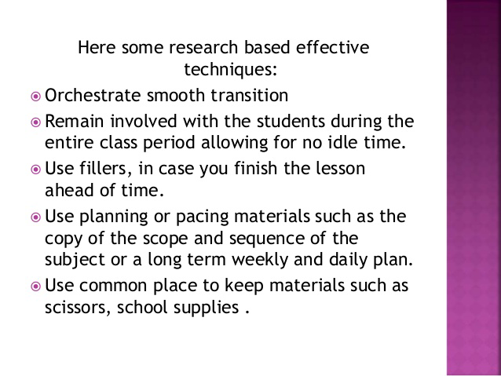
- A teacher who says “girls are emotional and very sensitive while boys are not” is practicing gender ________________ .
- Bias
- Stereotyping
- Sensitivity
- Discrimination

Answr is B. Stereotyping is a fixed, overgeneralized belief about a particular group or class of people

- Teacher X is discussing about suffrage. One of the students asks if it is all right not to exercise it. Select the best option for Teacher X to facilitate the internalization of that concept.
- Teacher X discusses through Power Point presentation all about suffrage.
- Teacher X lets students simulate the election process then discuss the activity.
- Teacher X lets students conduct needs assessment of a community.
- Teacher X lets students make a concept map.

Answer is B. Simulations are instructional scenarios where the learner is placed in a "world" defined by the teacher. They represent a reality within which students interact. The teacher controls the parameters of this "world" and uses it to achieve the desired instructional results. Simulations are in way, a lab experiment where the students themselves are the test subjects. They experience the reality of the scenario and gather meaning from it. If they simulate the election process, they would understand if it is important to exercise it or not.

- Teacher A starts with concrete examples of sentences as contrasted with sentence fragments then asks the class to differentiate sentence fragments from sentences. Which method does Teacher A apply?

- Inductive
- Integrative
- Deductive
- Reflective

Answer is A.
Inductive Method - inquiry method, problem-solving method, and project method
-indirect, guided and exploratory
-also called indirect instruction
-begin with questions, problems and details and end up with answers, generalization, conclusions
-example, teacher will give examples of added similar fraction. Ask the student to studybthe example and ask them to explain how they arrived at the sums. Then ask them to state the rules.
-develops HOTS
While the methods are diametrically opposed, they complement each other. Learner must grow his understanding inductively and apply the principle learned deductively.

- The goal of schools is to make students to become globally competitive . Which of the following school practices may be considered the best in terms of globalization?
- Increase the number of required general education subjects.
- Expose students to different places through field visits.
- Apply collaborative approach in teaching.
- Let students solve a problem collaboratively then present their solutions.

Answer is D. Students must be able to comprehend, problem solve and communicate solutions if they are expected to compete on a global level. The notion that learning involves students as co-creators and collaborative problem-solvers is indeed an important one, and teachers and schools that work to capitalize on the generational characteristics of sharing, researching, evaluating, and collaborating with peers, are more likely to enact and inspire teaching and learning practices that emulate the forms of sharing and social engagement that are flourishing in the 21st century world.

Schools whose curriculum and pedagogy fail to engage our younger generation as active learners and meaning creators are thus not doing justice to a nation’s development, especially when knowledge has become power in a globalized world
https://web.stanford.edu/group/redlab/cgi-bin/materials/Kwek-Innovation%20In%20The%20Classroom.pdf

- Samantha belongs to a poor family but she is endowed with talents and skills. During written examinations she gets very high scores but during recitations she has inferiority complex. Which is the best way of developing her potential?
- Make her a leader and a presenter in group activities
- Develop her self-confidence by forcing her to recite
- Make her a representative in school activities
- Inspire her by showcasing success stories

Answer is A. Unleashing her leadership potential will improve her confidence.

- Which of the following is the correct example of the deductive method of teaching?
- The teacher starts by defining a team then gives examples
- The lesson starts with the study of specific cases and ends with a generalization
- The teacher asks the students to narrate their unforgettable

Answer is A.
Deductive Method - direct method; demonstration
-teacher tells directly what she wants to teach
-example, teacher begins by stating the rule in adding fractions. Then she will give examples. After which, she will give written exercises
-teacher-dominated
-teacher begins with abstract rule, generalization, principle and ends with specific examples and concrete details
-cove inning of the lesson
Disadvantages
-not an active process
-less involvement on the part of learners

- When would demonstration method be most appropriate?
a. there is an oversupply of instructional materials
b. There are observers and wants to find the methods and strategies you use
c. You teach a complicated procedure
d. You would like your students to be actively involved
Answer is C.
Demonstration Method
-employed in presenting lessons that use sophisticated equipment and technical know-how
Particularly useful for showing a process or a complex procedure

Effective Teaching in Higher Education - Google Books Result
https://books.google.com.ph/books?isbn=1134958684
Madeleine Atkins, ‎George Brown - 2002 - ‎Education
The division is not a sharp one for some facilitating methods may be used also ... demonstration and sometimes students need time to absorb the procedures and ... particularlyuseful forshowing a process,a complex procedure, or complicated

- The teacher of the class attended an emergency meeting so the student teacher took over . The students were very noisy and some groups were quarrelling. She talked to them and called their attention but they did not listen. She could no longer control the whole class, what should have been done by the student teacher?
a. Walk out and tell the teacher at the other room of what is going on
b. Give them test in order for them to stop
c. Get their attention by telling a story
d. Give them some group works to present

Answer is C. For example, tell a five-minute story about your first roller coaster ride, and by the time you get to the topic of potential energy, every student will be strapped in and following along.

The inherent mystery in stories draws students into whatever world you create for them. And it keeps them there as they transform your descriptions into moving pictures in their head.

Stories also provide deeply layered context for students, linking their memories, emotions, and viewpoints to your lesson objectives. This makes complex ideas, like potential energy, easier to understand and remember.

Note: Storytelling can do more than just improve attentiveness. In fact, done a certain way, it can be one of your most effective classroom management strategies.
https://www.smartclassroommanagement.com/2011/02/12/how-to-get-students-to-pay-attention/

- ASEAN integration catalyzes the mobility of students. Foreign students come to our universities to develop their knowledge, skills and attitudes so that after their academic program, they will become part of their countries’ workforce. What specific function of school is addressed in this situation?
a. Political
B. Technical – economic
c. Human/social
d. Geographical – environmental

Answer is B. Keywords: “become part of the country’s workforce”

- Teacher’s management style allows students to formulate classroom rules with him/her but makes clear that there are matters which only teacher can make decisions on. Which classroom management is best described?
a. Democratic
b. Autocratic
c. Consultative
d. Assertive

Answer is D. Teachers can also communicate appropriate levels of dominance by exhibiting assertive behavior. Assertive behavior is the ability to stand up for one’s legitimate rights in ways that make it less likely that others will ignore or circumvent them

- Teacher A consults students and parents but she makes the decision. Which classroom management style does Teacher A observe?
A. consultative
b. democratic
c. Laizzes faire
d. assertive

Answer is A

- A democratic teacher will allow the group to make the decision together. Is this correct?
a. No
b. Sometimes
c. Yes
d. Somewhat

Answer is C. - in democratic management style, teacher consults parents, country, etc. and decide together

- In a number of researches on classroom management, of all the variables, classroom management has the largest effect on student achievement. Which can be inferred from the finding regarding classroom management?
a. Students cannot learn in a chaotic, poorly managed classroom
b. Teacher is the single most important factor in the learning of a child
c. The classroom atmosphere is mainly teacher’s creation
d. The effect of the classroom atmosphere on the learner is dependent on the learner
Answer is A
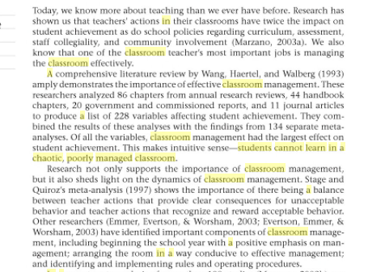
https://books.google.com.ph/books?id=QDwqACGdf0IC&pg=PA160&lpg=PA160&dq=Students+cannot+learn+in+a+chaotic,+poorly+managed+classroom&source=bl&ots=9sgo3rmkSc&sig=YeYecHQ1OhE7EG2a_EYxXZOTNN0&hl=en&sa=X&ved=0ahUKEwjqwoC-gp7XAhUBspQKHUcABxAQ6AEIKjAB#v=onepage&q=Students%20cannot%20learn%20in%20a%20chaotic%2C%20poorly%20managed%20classroom&f=false

- Many researches have identified important components of classroom management, including beginning the school year with a positive emphasis on management, and identifying and implementing rules and operating procedures. How many these components of classroom management be described?
I. reactive
II. preventive
III. proactive
a. II and III
b. I only
c. I, II, and III
d. II only

Answer is A. Reactive classroom management style happens when teacher does something only when the misbehavior has already occurred. Preventive and proactive styles are observed when teacher does something to prevent disruptive behavior from occurring.

- Research indicates that on the average, teachers who have high-quality relationships with their students have 31 fewer discipline problems, rule violations, and related problems over a year’s time than teachers who did not have high-quality relationships with their students. What does this imply?
a. Students contribute most to the classroom atmosphere
b. The quality of teacher-student relationships is the key stone for all other aspects of classroom management
c. Teachers who give way to student’s demand are better in classroom management than those who are stern
d. Teachers who are business-like are not good classroom managers

Answer is B. In a recent meta-analysis of more than 100 studies (Marzano, 2003b), we found that the quality of teacher-student relationships is the keystone for all other aspects of classroom management. In fact, our meta-analysis indicates that on average, teachers who had high-quality relationships with their students had 31 percent fewer discipline problems, rule violations, and related problems over a year's time than did teachers who did not have high-quality relationships with their students.
What are the characteristics of effective teacher-student relationships? Let's first consider what they are not. Effective teacher-student relationships have nothing to do with the teacher's personality or even with whether the students view the teacher as a friend. Rather, the most effective teacher-student relationships are characterized by specific teacher behaviors: exhibiting appropriate levels of dominance; exhibiting appropriate levels of cooperation; and being aware of high-needs students.
http://www.ascd.org/publications/educational-leadership/sept03/vol61/num01/The-Key-to-Classroom-Management.aspx

- Which is/are examples of positive classroom behaviors?
I. Make eye contact with each student
II. Deliberately move toward and stand close to each student during the class period
III. Attribute the ownership of ideas to the students who initiated them
IV. Call on students who do not commonly participate, not just those who respond frequently
V. Provide appropriate wait time for all students to respond to questions regardless of their past performance or your perception of their abilities
a. I, II and III
b. I, III and IV
c. II, III and V
d. I, II, III, IV and V

Answer is D

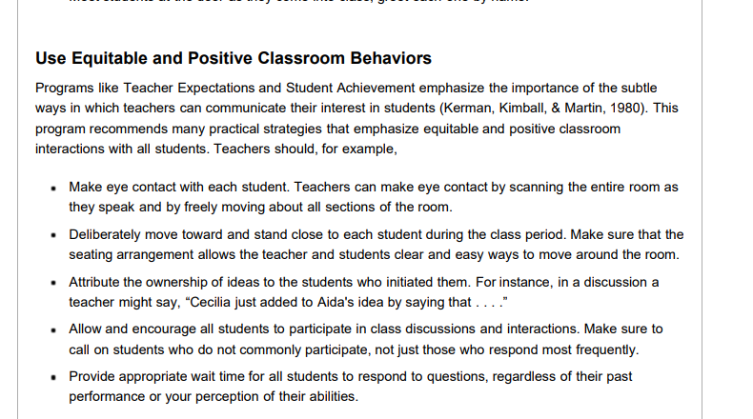
http://web.uvic.ca/~gtreloar/ED-D%20410/Lessons/Class%206%202016%20Support/Classroom%20Management/Building%20Classroom%20RelationshipsThe%20Key%20to%20Classroom%20Management.pdf

- In which phase/s of the lesson would a teacher know if the student learned what was intended for him to learn?
- Comparison and Association
- Generalization and application
- Association and generalization
- Application and evaluation

Answer is D

Herbartian Approach: John Fedrick Herbert (1776-1841)

📍1. Preparation/Instruction: It pertains to preparing and motivating children to the lesson content by linking it to the previous knowledge of the student, by arousing curiosity of the children and by making an appeal to their senses. This prepares the child's mind to receive new knowledge. "To know where the pupils are and where they should try to be are the two essentials of good teaching." Lessons may be started in the following manner: a. Two or three interesting but relevant questions b. Showing a picture/s, a chart or a model c. A situation Statement of Aim: Announcement of the focus of the lesson in a clear, concise statement such as "Today, we shall study the..."

📍2. Presentation/Development: The actual lesson commences here. This step should involve a good deal of activity on the part of the students. The teacher will take the aid of various devices, e.g., questions, illustrations, explanation, expositions, demonstration and sensory aids, etc. Information and knowledge can be given, explained, revealed or suggested. The following principles should be kept in mind. a. Principle of selection and division: This subject matter should be divided into different sections. The teacher should also decide as to how much he is to tell and how much the pupils are to find out for themselves. b. Principle of successive sequence: The teacher should ensure that the succeeding as well as preceding knowledge is clear to the students. c. Principle of absorption and integration: In the end separation of the parts must be followed by their combination to promote understanding of the whole.

📍3. Association comparison: It is always desirable that new ideas or knowledge be associated to daily life situations by citing suitable examples and by drawing comparisons with the related concepts. This step is important when we are establishing principles or generalizing definitions.

📍4. Generalizing: This concept is concerned with the systematizing of the knowledge learned. Comparison and contrast lead to generalization. An effort should be made to ensure that students draw the conclusions themselves. It should result in student's own thinking, reflection and experience.

📍5. Application: It requires a good deal of mental activity to think and apply the principles learn to new situations. Knowledge, when it is put to use and verified, becomes clear and a part of the student's mental make-up.

📍6. Recapitulation/ Evaluation: Last step of the lesson plan, the teacher tries to ascertain whether the students have understood or grasped the subject matter or not. This is used for assessing/evaluating the effectiveness of the lesson by asking students questions on the contents of the lesson or by giving short objectives to test the student's level of understanding; for example, to label different parts on a diagram, etc.

202. In a backward design approach to curriculum and lesson planning, which comes ahead?
- Identifying results desired
- Determining acceptable level of evidence that the intended results were realized
- Designing activities that will make desired results happen
- Clarifying content

Answer is A.
Backward Design is a method of designing educational curriculum by setting goals before choosing instructional methods and forms of assessment. Backward design of curriculum typically involves three stages.
- Identify the results desired (big ideas and skills)
  - What should the students know, understand, and be able to do?
  - Consider the goals and curriculum expectations
  - Focus on the "big ideas" (principles, theories, concepts, point of views, or themes)
- Determine acceptable levels of evidence that support that the desired results have occurred (culminating assessment tasks)
  - What will teachers accept as evidence that student understanding took place?
  - Consider culminating assessment tasks and a range of assessment methods (observations, tests, projects, etc.)
- Design activities that will make desired results happen (learning events)
  - What knowledge and skills will students need to achieve the desired results?
  - Consider teaching methods, sequence of lessons, and resource materials

203. In Understanding by Design (UbD), does developing instructional plan come right after identifying desired results?
- Yes
- No
- It’s the choice of the teacher applying Ubd
- Yes, provided the instructional plan includes an evaluation report

Answer is B. Refer to previous question.
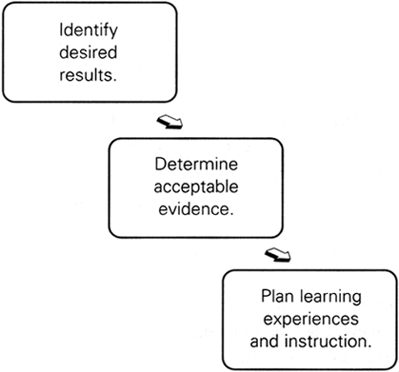

204. Why does Ubd insists on identifying assessment evidence right after identifying desired learning results?
- Teaching is faster that way
- Teaching-learning is more interesting
- Teaching-learning becomes more focused and organized
- It leads to a more comprehensive understanding of content

Answer is C
Stage Two – Determine Acceptable Evidence:
The second stage of backward design has instructors consider the assessments and performance tasks students will complete in order to demonstrate evidence of understanding and learning. In the previous stage, the instructor pinpointed the learning goals of the course. Therefore, they will have a clearer vision of what evidence students can provide to show they have achieved or have started to attain the goals of the course. Consider the following two questions at this stage:
- How will I know if students have achieved the desired results?
- What will I accept as evidence of student understanding and proficiency?
At this stage it is important to consider a wide range of assessment methods in order to ensure that students are being assess over the goals the instructor wants students to attain. Sometimes, the assessments do not match the learning goals, and it becomes a frustrating experience for students and instructors. Use the list below to help brainstorm assessment methods for the learning goals of the course.
- Term papers.
- Short-answer quizzes.
- Free-response questions.
- Homework assignments.
- Lab projects.
- Practice problems.
- Group projects.
- Among many others…
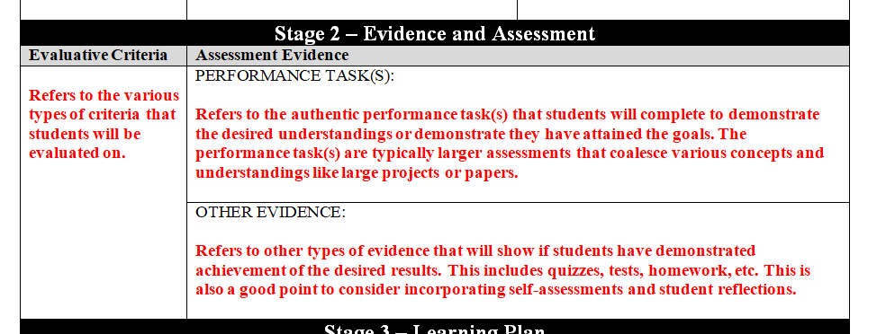

205. Teacher has been constructivist in his approach to lesson planning. What must be the features of his lessons?
- Students are engaged in learning
- Students guide their own learning and meaning-making
- Students keep the learning to themselves
- Students are not encouraged to share their thoughts about a new concept for that calls for much time
- I and III
- II and IV
- I and II
- III and IV

Answer is C

One of the primary goals of using constructivist teaching is that students learn how to learn by giving them the training to take initiative for their own learning experiences.
According to Audrey Gray, the characteristics of a constructivist classroom are as follows:

-the learners are actively involved
-the environment is democratic
-the activities are interactive and student-centered
-the teacher facilitates a process of learning in which students are encouraged to be
-responsible and autonomous

206. Which holds true of a constructivists lesson planning approach?
- Students building their own understanding
- Students not encouraged to venture into sharing thought when not sure
- Raising questions when lesson is not clear since students should research on their own
- Students doing all the teaching-learning process in the presence of a teacher

Asnwer is A. Refer to question # 190 for answer.

207. In a constructivists lesson planning approach, which is UNACCEPTABLE?
- Learners are helped to construct understanding based on what they already know
- Learners confront their understanding in the light of new learning
- Learners accommodate change in their understanding as a result of new understanding
- Learners accept blindly what teacher teachers because she is an authority on the subject

Answer is D. In a constructivist classroom, teachers act as facilitators or guide on the side and not as a sage on the stage. There is active learning and students are not passive learners.

208. If curriculum is planned following the behavioral approach, which sequence is correct?
- Ends with implementing the planned curriculum
- Starts with the setting of objectives and goals
- Learning outcomes are evaluated along goals and objectives set at the start
- Change in behavior indicates the measure of the accomplishments
- I and II
- II and III
- II and IV
- II, III and IV

Answer is D

Behavioural Approach: It is based on the Behavioural Principle, goals and objectives are specified, content and activities are also arranged with learning objectives. Learning outcomes are evaluated in terms of goals and objectives set of beginning. Its main aim is to achieve efficiency. CHANGE IN BEHAVIOUR indicates the measure of the accomplishment.
http://www.jssgoi.com/wp-content/uploads/2016/10/Lectures.pdf

209. If curriculum is planned following the humanistic approach, which feature applies?
- Very child-centered
- Excludes the hidden curriculum
- Downplays the significance of the informal curriculum
- Emphasizes on the child’s cognitive development

Answer is A
Humanistic Approach: It is rooted in the progressive philosophy and follows the child centred movements. It considers the formal or planned curriculum and the informal or hidden curriculum. It considers the whole child and believes that in curriculum the total development of the individual is the prime consideration.

210. A humanistic approach to curriculum planning has the following features, EXCEPT ________
- Recognizes the significance of the hidden and informal curriculum
- Very progressivist because it is child-centered
- Subject matter is not necessary in curriculum planning
- Emphasizes on the child’s holistic development

Answer is C. Please refer to question # 195.

211. When the school applies the systems approach to curriculum planning, what is expected?
- The parts of the school system are considered in terms of how they relate to each other
- Curriculum, instruction and evaluation are the only things that matter in curriculum planning
- The school’s external environment is not taken into consideration
- Only the internal stakeholders are consulted for curriculum planning purposes

Answer is A
System Approach: The whole system is approached by system theory. The whole approach represents line-staff relationship of personnel and represent the way, how the decisions are made. It gives the equal importance to all levels: 1. Administration 2. Counselling 3. Curriculum 4. Instruction 5. Evaluation.

212. In a systems approach to curriculum planning, should external stakeholders be a part?
- No, they are not curricularists
- Yes, they are part of the school system
- Yes, if they are willing
- That depends on the educational attainment of the external stakeholders

Answer is B
Community Involvement in a Systems Approach to Curriculum
Edwards, Clifford H.
High School Journal, 56, 4, 167-73, Jan 73
Current interest in control of schools is a struggle for economic influence rather than genuine educational concerns, and in urban areas is generally a struggle between black and whites. A systems approach, claims author, is an alternative for sharing control and responsibility.
https://eric.ed.gov/?id=EJ072958

213. When one wants children to develop positive attitude toward life and life problems, which approach in curriculum planning is most appropriate?
- Problem-centered approach
- Humanistic approach
- Systems approach
- Child-centered approach

Answer is A
This is the main concept behind project and problem-based learning and is central to twenty-first century pedagogy. With project and problem-based learning, students learn by designing and constructing actual solutions to real-life problems (Cornell University, 2014a).

Research also found that learners who struggle with traditional textbook-and-lecture methods benefited from a project learning approach which was better matched to their learning styles or preferences for working in groups (p. 111). Other comparative studies documented a variety of benefits of project and problem-based learning, such as increased ability to define problems, improved ability to reason using clear arguments and better planning of complex projects. Improvements in motivation, attitudes toward learning and work habits were also found
http://unesdoc.unesco.org/images/0024/002431/243126e.pdf

214. E-learning may either be synchronous or asynchronous? Which applies to synchronous learning?
- It is self-paced
- Participants engage in exchange of ideas or information without being dependent on other participant
- All participants interact at the same time
- It uses technologies such as email, blogs and wikipedias

Answer is C. Synchronous learning refers to a learning event in which a group of students are engaging in learning at the same time. Before learning technology allowed for synchronous learning environments, most online education took place through asynchronous learning methods.

215. Which applies to asynchronous learning?
- It is beneficial to students with health representatives
- It is all participants interact at the same time
- It is self-paced
- It occurs in real time

Answer is C. Asynchronous learning is self-paced, accommodates a busy schedule, allows people to learn at their own pace, provides consistent instruction to very large audience sizes, and is available for review.

216. Teacher Mila’s lesson is on the human digestive system. Which is closest to direct purposeful experience?
- Drawing of the human digestive system
- Video of the human digestive system
- Model of the human digestive system
- Diagram of the human digestive system

Answer is C. A MODEL is a reproduction of real thing in a small scale, or large scale

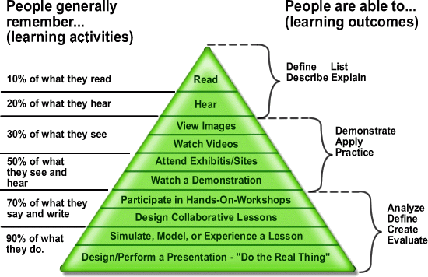
https://ctl.mesacc.edu/blog/edgar-dales-cone-of-experience-2/

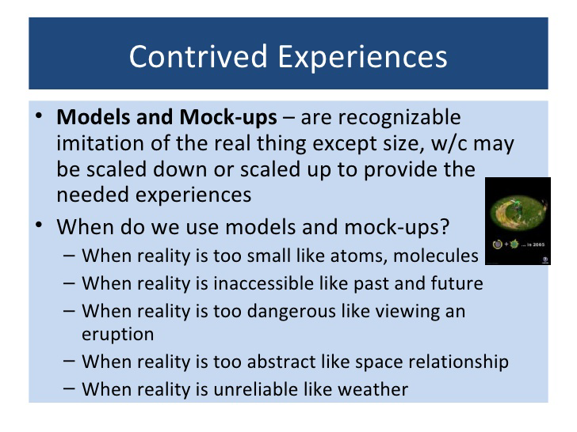
https://www.slideshare.net/tagalogrm/edgar-dales-cone-of-experiences

217. Mr. Ruiz wants to use video presentation to show how seed germination takes place. However, he cannot because he teaches in a far flung school without electricity. What is/are the most concrete way/s of showing the process of seed germination?
- Write notes on the board
- Use drawing of the stages of seed determination
- Describe how germination takes place
- II only
- II and III
- I only
- III only

Answer is B.

218. Mrs. Raquel believes in the benefits and importance of using instructional aids to facilitate student learning. Which must she primarily consider when choosing instructional aids for her class?
- Must induce the element of surprise
- Must be suited to the lesson objective
- Must encourage and sustain student interest
- Must be original and appropriate to the context

Answer is C
Answer to this question according to reviewer is A. So it created a lot of confusion especially during my batch because nobody knew the reason behind. As I did a research, I found out several models used in Instructional Design. And its more likely C.

First is the ARCS Model

- ARCS is an instructional design model developed by John Keller and that focuses on motivation.
- ARCS stands for: Attention, Relevance, Confidence, Satisfaction
This model is particularly important for distance education, since motivation seems to be a key factor that determines if learner's complete their training. Motivation is a diametral responsibility for learners and teachers, and so it has to be boost over the entire learning process respectivly the developing of an learning environment.

2 Basic aspects
The significance of motivation was early developed by some scientists. The implementation of multimedia elements isn't enough to reach permanently motivational goals. So the ARCS Model was developed in the 80s by John Keller, for the systematically boosting of motivational aspects. It contains four main categories.
- Attention - Getting and Holding Learners's Interests and Attention
- Relevance - The learning has to show a kind of usefulness. The learner should reach personal goals.
- Confidence - The user has to espect success and should have the possibility to controll his learning process Self-regulation
- Satisfaction - There has to be attractive acts, rewards, feedback, and Self-Assement.

Attention (perceptual arousal, inquiry arousal, variability)
As in Gagné's model (nine events of instruction) one must gain the learner's attention and keep it. A few pedagogic methods are:
- Provide variety (e.g. in the teaching materials used and within these materials, e.g. see textbook writing tutorial
- Create mystery by presenting interesting case problems.
- Use different methods to instruction
- Engage learners in active participation, e.g. questions, role-play
- Use interesting examples or cases (in particular some that run contrary to learner's expectations)
- Use humor
- Avoid distraction
- Boost inquiry learning
- Short Instructions
- Variate the format of pictures

According to Huang (2006),
the ARCS model is mostly applied as a design guideline for developing effective motivational strategies (Song & Keller, 2001). In addition to the four ARCS components (i.e., attention, relevance, confidence and satisfaction), there are sub-categories attached to each component to facilitate the design process. Small (2000) summarized all four components and sub-categories as follows.
- Attention: perceptual arousal, inquiry arousal and variability;
- Relevance: goal orientation and motive matching;
- Confidence: learning requirements, success opportunities and personal responsibility; and
- Satisfaction: intrinsic reinforcement, extrinsic rewards and equity.
Read more on http://edutechwiki.unige.ch/en/ARCS
Another model is the ADDIE Model

ADDIE Model
The ADDIE model is the generic process traditionally used by instructional designers and training developers. The five phases—Analysis, Design, Development, Implementation, and Evaluation
It is an Instructional Systems Design (ISD) model. Most of the current instructional design models are spin-offs or variations of the ADDIE model; other models include the Dick & Carey and Kemp ISD models. One commonly accepted improvement to this model is the use of rapid prototyping. This is the idea of receiving continual or formative feedback while instructional materials are being created. This model attempts to save time and money by catching problems while they are still easy to fix.
Instructional theories also play an important role in the design of instructional materials. Theories such as behaviorism, constructivism, social learning and cognitivism help shape and define the outcome of instructional materials.
In the ADDIE model, each step has an outcome that feeds into the subsequent step.
Analysis > Design > Development > Implementation > Evaluation

Analysis Phase
In the analysis phase, instructional problem is clarified, the instructional goals and objectives are established and the learning environment and learner's existing knowledge and skills are identified. Below are some of the questions that are addressed during the analysis phase:
* Who is the audience and their characteristics?
* Identify the new behavioral outcome?
* What types of learning constraints exist?
* What are the delivery options?
* What are the online pedagogical considerations?
* What is the timeline for project completion?

Design Phase
The design phase deals with learning objectives, assessment instruments, exercises, content, subject matter analysis, lesson planning and media selection. The design phase should be systematic and specific. Systematic means a logical, orderly method of identifying, developing and evaluating a set of planned strategies targeted for attaining the project's goals. Specific means each element of the instructional design plan needs to be executed with attention to details.
These are steps used for the design phase:
* Documentation of the project's instructional, visual and technical design strategy
* Apply instructional strategies according to the intended behavioral outcomes by domain (cognitive, affective, psychomotor).
* Create storyboards
* Design the user interface and user experience
* Prototype creation
* Apply visual design (graphic design)

Development Phase
The development phase is where the developers create and assemble the content assets that were created in the design phase. Programmers work to develop and/or integrate technologies. Testers perform debugging procedures. The project is reviewed and revised according to any feedback given.

Implementation Phase
During the implementation phase, a procedure for training the facilitators and the learners is developed. The facilitators' training should cover the course curriculum, learning outcomes, method of delivery, and testing procedures. Preparation of the learners include training them on new tools (software or hardware), student registration.
This is also the phase where the project manager ensures that the books, hands on equipment, tools, CD-ROMs and software are in place, and that the learning application or Web site is functional.

Evaluation Phase
The evaluation phase consists of two parts: formative and summative. Formative evaluation is present in each stage of the ADDIE process. Summative evaluation consists of tests designed for domain specific criterion-related referenced items and providing opportunities for feedback from the users.
http://www.instructionaldesign.org/models/addie.html
There is also the ASSURE Model
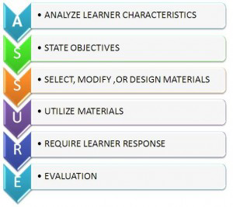
https://educationaltechnology.net/assure-instructional-design-model/

219. Mr. De Castro is planning to integrate technology in his English class. Which of the following would be the logical steps in doing this?
- Set the objectives
- Analyze the learners
- Utilize the materials with showmanship
- Evaluate the performance of the students
- I-II-III-IV
- II-I-III-IV
- I-II-IV-III
- II-I-IV-III

Answer is B. Based on the ASSURE Model.



220. Mrs. Rosario, a Science teacher, would like to make a slide presentation for her lesson on the parts of the cell. Which among the tools should she use to make his presentation effective?
- Situating tool
- Communicative tool
- Informative tool
- Productivity tool

Answer is D

Basic Productivity Tools
Basic productivity tools are computer software programs which allow a user to create specific items quickly and easily as opposed to creating the same items by hand. We learned about three specific productivity tools:
Word Processing. Word Processing is a software program that creates documents using text and/or graphics. An example would be Microsoft Word.
Spreadsheets. Spreadsheets quickly organize numerical information and allows the creator to input formulas into the spreadsheet for easy calculation. An example would be Microsoft Excel.
Databases. Databases allow the user to save collections of information in one easily accessible place. This allows the user to find information about a specific topic much faster versus searching the internet. An example of a database would be Galileo.
Microsoft Office is a common productivity software package which includes Microsoft Word, Excel, and PowerPoint. Pages is the Mac productivity tool equivalent to Microsoft word. Productivity tools are used all over the world by lots of different people for many reasons. Accountants use Excel to create ledgers, teachers use Word to create tests, and Marketers use PowerPoint for presentations and slide shows.

221. Mr. Alejandro is planning to select and evaluate the content of an educational technology tool that he will use in his English class. Which of the following questions should he consider the least?
- Does it match with the content?
- Will it encourage and sustain interest?
- Is there a manifestation of its efficiency?
- Can it be easily dismantled and handled?

Answer is D. Obviously it should be the least of the concerns of the teacher.

222. The following are general rules in creating powerpoint presentations, Except what?
- Use graphics and illustrations to reinforce ideas
- Use animations extensively to catch the students’ attention
- Use bold and italics for emphasis, but don’t overuse them
- Use color, audio and music to stimulate but not to overpower the senses

Answer is B. Use transitions and animations sparingly, and only to add meaning to your slides. Often people add transitions “for fun” and end up just distracting people’s attention. Done well, animations can show relationships between concepts and help support your audience’s attention on your ideas.
https://tedcurran.net/2014/03/27/attention-method-effective-powerpoint-presentations/

223. Teacher Mary wants to develop the higher order thinking skills among the learners; therefore, she must incorporate what skills?
- Using structural analysis
- Classifying and organizing facts
- Using phonetic analysis
- Recognizing basic sight words

Answer is B. It is based on Grace Godells Reading Skills Ladder. Classifying and organizing facts is the highest of the other choices. Take note of this because this also appeared in the September 2016 LET exam.
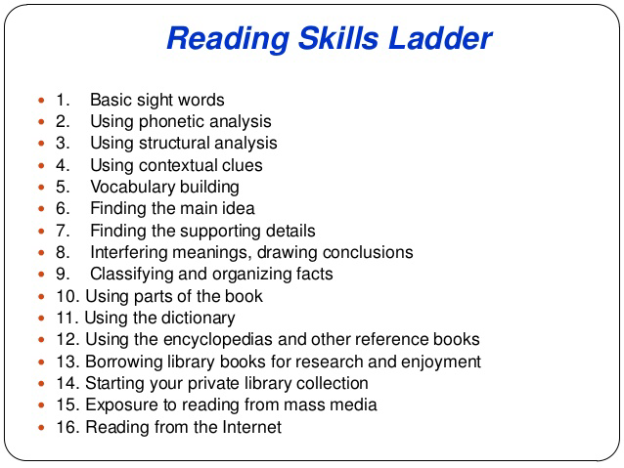

224. While letting her pupils read on the blackboard, Mrs. Reyes, a Grade 1 teacher uses a piece of illustration board to cover the succeeding lines of a passage so that the children focus only on the line being read and then uncovers the next line once they are through reading the first line. Which accurate eye movement does the teacher try to develop?
- Fixation
- Regression
- Return sweep
- Interfixation

Answer is C.
- Return Sweeps Are long slanting lines resulting the quick swinging back of the eyes from one end of the line to the beginning of the next line.
- A comprehensive model of eye movement control in reading will have to take into consideration not only progressive and regressive inter- and intraword saccades, but also the large return sweep saccades that bring the eyes from the end of one line of text to the beginning of another line
- Fixation is the vertical mark when the eyes stop and the film continues to move. Good readers have fewer fixations than poor readers.
- Fixation or visual fixation is the maintaining of the visual gaze on a single location.
- Interfixation is the short horizontal line caused by the eyes which move from one stopping point to another
- Regressions are backward or right-to-left movements made in a reverse direction.

225. How do you write on the chalkboard while busy discussing your lesson in front of the class?
- Face the board while writing and talking
- Right side view as you talk
- Face the class while writing and discussing
- Pause and write on the board

Answer is B. Your students should have a clear, uninterrupted view of the board. Be careful that you don't block learners sitting at the sides of the room. When you write something on the board move away quickly so that students can see what you have.

226. In preparing instructional materials, which kind of graphics is effective on computer screens?
- Graphics with blinking effects
- Graphics with complicated designs
- Simple graphics with corresponding text
- Graphics with light colors

Answer is C. People learn more deeply from words and graphics than from words alone. This assertion can be called the multimedia principle, and it forms the basis for using multimedia instruction—that is, instruction containing words (such as spoken text or printed text) and graphics (such as illustrations, charts, photos, animation, or video) that is intended to foster learning (Mayer, 2009).
https://hilt.harvard.edu/files/hilt/files/background_reading.pdf

227. Which combination promotes legibility on projected materials?
- Light letters against dark background
- Dark letters against light background
- Light letters against light background
- Dark letters against dark background

Answer is B
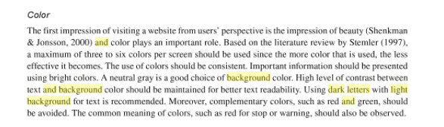

228. What kind of stimuli would help increase the probability that the learner will remember and can produce what was presented in the instructional materials utilized in the classroom?
- Pleasing and simple designs
- Designs with crude details
- Designs with complex ideas
- Designs with rainbow colors

Obviously it’s A

229. Which is the main reason for living a silent space around the edge of a chart?
- Aesthetic purposes
- To increase readability
- To emphasize the content
- It is a rule

Answer is B. Empty space on the slide will enhance readability.
http://www.ncsl.org/legislators-staff/legislative-staff/legislative-staff-coordinating-committee/tips-for-making-effective-powerpoint-presentations.aspx

230. What is the main purpose of using audio-visual aids in teaching?
- To improve the understanding of learners
- To make learning more functional
- To promote the participation of learners
- To get the interest and hold the attention of the learners

Answer is D. A.V.Aids arouses interest and motivates students to learn

231. Which part of the screen of the computer has a strong influence among learners?
- Left half of the screen
- Right half of the screen
- Center of the screen
- Corners of the screen

Answer is A. Research in both page design and screen design generally concurs that the left half of the screen or page has a strong influence on reader attention (Duin, 1988; Niekamp, 1981). Left placement has also been found to speed retrieval and improve readability (Hartley and Burnhill, 1976). It would make sense, therefore, to place an adviser (of whatever modality) on the left side of the screen to maximise its effectiveness. At the same time, most researchers and interface designers agree that a computer screen should be less crowded than even its printed counterpart.
http://www.und.nodak.edu/instruct/rvaneck/bjet_2.pdf

232. Learners learn better when all of their senses are involved. Which activity is classified under direct purposeful experience?
- Tracing places on a map
- Setting the table
- Performing shadow puppets
- Watching sineskwela

Answers is B. Direct, purposeful experiences are our concrete and firsthand experiences that make up the foundation of our learning. These are the rich experiences that our senses bring from which we construct the ideas, the concepts, the generalizations that give meaning and order to our lives. ( Dale, 1969). They are sensory experiences.

233. Which is the purpose of music in a media presentation?
- Provides continuity
- Gives a good background
- To keep the learners alert
- To avoid boredom

Answer is A.
See https://musicog.discoveryspace.ca/sites/default/files/funcmusicmultimedia.pdf for other functions of music in multimedia.
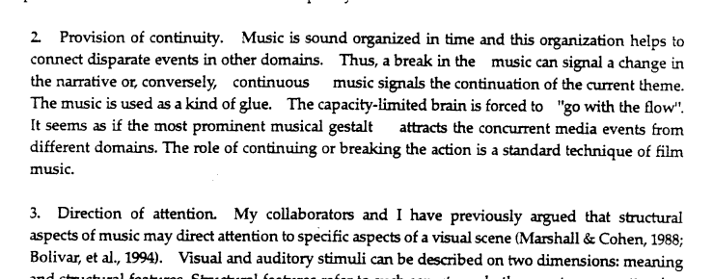

234. To increase the readability of printed media, what kind of letters should be used in long statements or paragraphs?
- Uppercase letters
- Lowercase letters
- Toggle case letters
- Combination of upper and lower case letters

Answer is D

Studies have been conducted on the readability and legibility of all caps text. Scientific testing from the 20th century onwards has generally indicated that all caps text is less legible and readable than lower-case text. So it must be a combination.

235. A fourth grade teacher wanted to show the parts of the heart using a large rubber visual material with all the different parts inside as a heart actually looks. Under which category is this visual aid classified?
- Realia
- Mock-up
- Model
- Picture

Answer is C. A model should be used to give the pupil the concept of the whole object as it actually appears. A mock up, however, does not present to the pupil the actual appearance of the object itself. It is usually “laid out” in a board with each part labelled. It re-arranges the parts, disregards their relative size and emphasizes certain functional relationships instead of being a faithful reproduction of the object as in a model. Models are essentially imitations of the real objects in as many respects as possible except in size.

236. What does a teacher use to show the functioning of a part of a whole?
- Model
- Drawing
- Mock-up
- Realia

Answer is C.
A mock-up is an unscaled replica designed to simplify and clarify the workings of the object. The mock-up, which may be larger or smaller than the real thing, is generally constructed to show the "essential" parts and their functional relationship.

237. Clutter is the enemy of comprehension. How is this applied in PowerPoint presentation?
- Have a clear space
- Keep the number of words to the minimum
- Use large fonts and headlines
- Use bullets not words
- I and II
- I, II and IV
- II and III
- I, II and III

Answer is D
Clutter is the enemy of comprehension. Aside from strong use of images, keep the number of words to the bare minimum. The more your audience is reading the screen, the less it is listening to you. Use large fonts and headlines and don’t be afraid of clear space. Any detailed text that your audience needs to have, put it in a handout.
https://greatspeechconsultancy.wordpress.com/2012/03/09/the-5-primary-principles-of-powerpoint-presentations/

238. Teacher B wants to make use of simulated life condition suitable for animals and plants living on land. Which does she use?
- Terrarium
- Model
- Aquarium
- Poster

Answer is A.
A terrarium (plural: terraria or terrariums) is usually a sealable glass container containing soil and plants, and can be opened for maintenance to access the plants inside.

https://en.wikipedia.org/wiki/Terrarium#/media/File:Regenwaldterrarium.jpg

239. KISS (Keep it Straight and Simple) rule should apply in preparing PowerPoint presentation. How is this principle observed?
- Keywords only
- No sentences
- Never read your slides. Talk freely
- If you use sentences, end with a period
- I and II
- II and III
- II and IV
- I, II and III

Answer is D
KISS
Keep It Straight and Simple. That means…
- Keywords only on your slides.
- Absolutely no full sentences!
- And never read your slides, talk freely.
Remember that your slides are only there to support, not to replace your talk! You want to tell a story, describe your data or explain circumstances, and only give keys through your slides. If you read your slides and if you do it poorly, the audience will feel ashamed for you. Worse, they’ll stop listening and dive into their smartphones instead.

240. Images are key elements of a PowerPoint presentation. However, which should be your reason for not using them?
- Images to reinforce or complement your message
- More images than text in your slide
- Use images to decorate
- Use images to visualize and explain

Answer is B.

241. If one wants to make use of animation in his PowerpOint presentation, which one/s should be remember?
- Make use of good animation to improve understanding
- Use animation sparingly
- Use animations to make the message stick with your audience
- I only
- II and III
- III only
- I, II and III

Answer is D. Use transitions and animations sparingly, and only to add meaning to your slides. Often people add transitions “for fun” and end up just distracting people’s attention. Done well, animations can show relationships between concepts and help support your audience’s attention on your ideas.

242. Teacher John wants to lecture with the help of powerpoint presentation. For effectiveness, which should he consider?
- Audience
- The intended outcome of his lecture
- Principles of powerpoint presentation
- Time of presentation (early morning or early afternoon)
- III and IV
- I, II and III
- I and III
- I, II, III and IV

Answer is B.

243. What does the 6-6 principle in PowerPoint presentation mean?
- 6 lines or less
- 6 words only
- 6 lines only
- 6 words only or less
- II
- III
- II and III
- I and IV

Answer is D. This presentation rule suggests that you should include no more than six words per line and no more than six bullet points per slide.

244. Which principles should be observed to get the most out of games in the classroom?
- Clarify intended learning outcome with the use of the game
- By all means emphasize winning so there is excitement
- Do always with rewards and prizes
- Motivate students to accept failure to succeed
- I and IV
- IV only
- I only
- III and IV

Answer is A. The students must understand the learning outcome and the acceptance of failure because there is essential learning in failures.

245. The more senses that are involved, the better the learning. What does this imply?
- Use visual aids
- Use audio aids
- Use audio-visual aids
- Use multi-sensory aids

Answer is D. Using a multisensory teaching technique means helping a child to learn through more than one sense.

A multi-sensory approach, “also known as VAKT (visual-auditory-kinesthetictactile) implies that students learn best when information is presented in different modalities (Mercer & Mercer, 1993)”. The belief is that students learn a new concept best when it is taught using the four modalities. A multi-sensory approach is one that integrates sensory activities. The students see, hear, and touch.
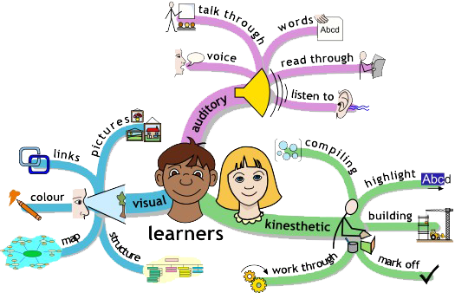
http://www.vkmaheshwari.com/WP/?p=2364

246. Which does Edgar Dale advocate about his Cone of Experience?
- Stick to one learning material one at a time
- If direct experience is not applicable, make use of verbal symbol as substitute
- Begin your lesson by using concrete experience then bring the students to the level of abstract
- Don’t commit the error of using two or more learning materials for one lesson

Answer is C. Essentially, the Cone shows the progression of experiences from the most concrete (at the bottom of the cone) to the most abstract.
https://educapsycho.wordpress.com/2013/03/12/the-role-of-art/

247. In using video for teaching, which activity/ies are a “No-No” to enhance the effectiveness of its use?
- Keep lights off
- In between, stop the video and ask stimulating questions for discussion
- Leave the students to watch the video by themselves
- Watch the video with your students
- III
- IV
- I and III
- I and II

Answer is C. Students must not be left all by themselves. Remember teachers are facilitators and must be guides on the side. Lights must not be turned off too. See rationale on question #233.

248. To ensure effective use of video in the classroom, which appropriate sequence should teachers observe?
- See to it that lights are on during viewing
- Provide a focus for interaction
- Preview program to determine sustainability
- Conduct introductory and culminating activities
- I, II, III and IV
- II, III and IV
- I and II
- I, II and III

Answer is A
Don't leave your audience in the dark.
Description: Teaching and learning should not occur in the dark. Don't turn off the lights during instruction. This does not encourage interactivity and engagement, but instead it makes some people rather sleepy. Additionally, it's difficult to have eye contact and see student reactions in the dark.
Solution: Leave the lights on. In most rooms you can still generally see projected items with the light on. If your room has multiple light switches, just shut off the front lights. If you have windows, close the blinds in the part of the room where you are projecting. If it's really difficult to see with the lights on, get a few lamps for your classroom. Not only will this accomplish the goal, it will add a nice atmosphere to the room.
Advantage: Your students will be more alert, engaged, and likely to participate in the lesson. Teachers can see their students and their students can see one another.
https://theinnovativeeducator.blogspot.com/2010/05/ten-no-nos-of-teaching-with-projector.html

249. For maximum learning, Teacher wants to introduce extension activities after video viewing. Which are examples of extension activities?
- Viewing a second film
- Creative writing
- Long-term projects
- Video-production
- I and III
- I, II and III
- III and IV
- I, II, III, and IV

Answer is D

250. A cluttered chalkboard may confuse your students. Which teacher’s action should follow this thought?
- Write every word
- Don’t write too much
- Avoid writing, if you can
- Use the board only for illustration and drawing purposes

Answer is B. Write only the important and necessary terms.

251. All situations refer to the concepts of curriculum, instruction and assessment. In which case the three not aligned?

Curriculum | Instruction | Assessment
- To identify the different animals found in the garden | The teacher brought all the children to the school garden to observe and list down all the animals that they saw
B. To write an essay on the importance of eating healthy food |  | Each student was made to submit a one-paragraph essay on the importance of eating healthy food and a rubric was used to rate it
C. To differentiate a metamorphic rock from an igneous rock | The teacher asked the students to go to the garden and collect the samples of rock for closer identification and classification
D. To name the different kinds of bodies of water | The teacher presented a video clip of different of bodies of water and asked the students to identify

Answer is C. Bringing them to the garden will be aligned if the objective is to identify metamorphic and igneous rock.

252. The value of the imported goods that enter the country in February 2015 reached $5.326 billion- up to 11.2 % from the $4.7888-billion reported in the same month last year. According to the Philippine Statistics Authority, the growth in import last February was the fastest in 3 months, even though the value of shipments in the first two months of 2015 slightly declined year-on-year.
What is the purpose of the paragraph?
- To explain
- To convince
- To entertain
- To inform

Answer is D. It provides readers with information about the growth in imported goods entering the country.

253. Miss Rosario wrote a learning objective in the affective domain. Which did she write?
- Express a sense of gratitude for one’s strengths and determination to improve on one’s weaknesses
- Retell your most unforgettable experience
- Discuss trends and issues confronting the government
- Enumerate Filipinos whom you consider great heroes

Answer is A.
The affective domain describes learning objectives that emphasize a feeling tone, an emotion, or a degree of acceptance or rejection. Affective objectives vary from simple attention to selected phenomena to complex but internally consistent qualities of character and conscience. We found a large number of such objectives in the literature expressed as interests, attitudes, appreciations, values, and emotional sets or biases. [from Krathwohl et al, 1964 ]
Here are descriptions of each step in the taxonomy, starting at the most basic level. (From Krathwohl's Taxonomy of Affective Domain)
Receiving is being aware of or sensitive to the existence of certain ideas, material, or phenomena and being willing to tolerate them. Examples include: to differentiate, to accept, to listen (for), to respond to.
Responding is committed in some small measure to the ideas, materials, or phenomena involved by actively responding to them. Examples are: to comply with, to follow, to commend, to volunteer, to spend leisure time in, to acclaim.
Valuing is willing to be perceived by others as valuing certain ideas, materials, or phenomena. Examples include: to increase measured proficiency in, to relinquish, to subsidize, to support, to debate.
Organization is to relate the value to those already held and bring it into a harmonious and internally consistent philosophy. Examples are: to discuss, to theorize, to formulate, to balance, to examine.
Characterization by value or value set is to act consistently in accordance with the values he or she has internalized. Examples include: to revise, to require, to be rated high in the value, to avoid, to resist, to manage, to resolve.
https://serc.carleton.edu/NAGTWorkshops/affective/intro.html

254.. In the learning situation described before this item, which would be the best assessment type that Teacher Marie may employ?
- Select-response type
- Construct-response type
- Performance-base type
- Product-base type

Answer is D. An essay expressing gratitude and determination to improve weaknesses is an example of product, a mode of assessment.

255. After discussing a lesson, the teacher gave a 20 item test to determine if the student understood the lesson or not. But only 20% of the students got a passing score and 80% at the bottom. What should the teacher do?
- Proceed to the next topic regardless of the results of the test
- Re-evaluate the test to figure out what might be the problem
- Tell the students of the risk of not listening during the discussion
- Explain the lesson again from the beginning

Answer is B.
Low reliability means that the questions tended to be unrelated to each other in terms of who answered them correctly. The resulting test scores reflect peculiarities of the items or the testing situation more than students’ knowledge of the subject matter. It must be re-evaluated in order to identify the problem.

256. Learning Outcome: distinguish between plant and animal cell
Which item is aligned?
- Draw a plant and an animal cell. Label each part
- Distinguish between a plant cell and an animal cell
- By means of s Venn Diagram, compare the plant and animal cell
- Describe a plant and animal cell

Answer is B.

For questions 242-247, you may refer to the following notes:
Align Assessments with Objectives
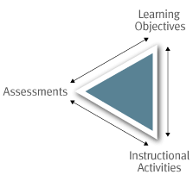
Assessments should provide us, the instructors, and the students with evidence of how well the students have learned what we intend them to learn. What we want students to learn and be able to do should guide the choice and design of the assessment. There are two major reasons for aligning assessments with learning objectives. First, alignment increases the probability that we will provide students with the opportunities to learn and practice the knowledge and skills that will be required on the various assessments we design. Second, when assessments and objectives are aligned, “good grades” are more likely to translate into “good learning”. When objectives and assessments are misaligned, many students will focus their efforts on activities that will lead to good grades on assessments, rather than focusing their efforts on learning what we believe is important.
There are many different types of activities that can be used to assess students’ proficiency on a given learning objective, and the same activity can be used to assess different objectives. To ensure more accurate assessment of student proficiencies, it is recommended that you use different kinds of activities so that students have multiple ways to practice and demonstrate their knowledge and skills.
When deciding on what kind of assessment activities to use, it is helpful to keep in mind the following questions:
- What will the student’s work on the activity (multiple choice answers, essays, project, presentation, etc) tell me about their level of competence on the targeted learning objectives?
- How will my assessment of their work help guide students’ practice and improve the quality of their work?
- How will the assessment outcomes for the class guide my teaching practice?
This table presents examples of the kinds of activities that can be used to assess different types of learning objectives, and the ways that we can analyze or measure performance to produce useful feedback for teaching and learning. The categorization of learning objectives is taken from the revised Bloom’s Taxonomy.
Type of Learning Objective | Examples of Types of Assessment | How to Measure
Remember  Students will be able to:  - recall  - recognize | - Objective Test items that require students to recall or recognize information:  - Fill-in the Blank  - Multiple Choice items with question stems such as, “what is a…”, or “which of the following is the definition of)  - Labeling diagrams  - Reciting (orally, musically, or in writing) | - Accuracy – correct vs number of errors  - Item Analysis (at the class level, are there items that had higher error rates? Did some items result in the same errors?)
Understand  Students will be able to:  - interpret  - exemplify  - classify  - summarize  - infer  - compare  - explain | Papers, oral/written exam questions, problems, class discussions, concept maps, homework assignments that require (oral or written):  - Summarizing readings, films, speeches, etc.  - Comparing and/or contrasting two or more theories, events, processes, etc.  - Classifying or categorizing cases, elements, events, etc., using established criteria  - Paraphrasing documents or speeches  - Finding or identifying examples or illustrations of a concept, principle | Scoring or performance rubricsthat identify critical components of the work and discriminates between differing levels of proficiency in addressing the components
Apply  Students will be able to:  - execute  - implement | Activities that require students to use procedures to solve or complete familiar or unfamiliar tasks; may also require students to determine which procedure(s) are most appropriate for a given task. Activities include:  Problem sets, performances, labs, Prototyping, Simulations | Accuracy scores, Check lists, Rubrics, Primary Trait Analysis
Analyze  Students will be able to:  - differentiate  - organize  - attribute | Activities that require students to discriminate or select relevant from irrelevant parts, determine how elements function together, or determine bias, values or underlying intent in presented materials. These might include:  Case studies, Critiques, Labs, Papers, Projects, Debates, Concept Maps, | - Rubrics, scored by instructor, juries, external clients, employers, internship supervisor, etc.  - Primary Trait Analysis
Evaluate  Students will be able to:  - check  - critique | A range of activities that require students to test, monitor, judge or critique readings, performances, or products against established criteria or standards. These activities might include:  Journals, Diaries, Critiques, Problem Sets, Product Reviews, Case Studies. | - Rubrics, scored by instructor, juries, external clients, employers, internship supervisor, etc.  - Primary Trait Analysis
Create  Students will be able to:  - generate  - plan  - produce | Research projects, musical compositions, performances, essays, business plans, website designs, prototyping, set designs | - Rubrics, scored by instructor, juries, external clients, employers, internship supervisor, etc.  - Primary Trait Analysis

257. Learning Outcome: Dance Tango to the tune of “La Cumparista”
Which test item is aligned?
- Dance Tango as the music, “La Cumparista” is played
- Enumerate the steps of tango in order
- Trace the history of Tango
- Do you like tango ? why or why not?

Answer is A. Assessments should provide the instructors, and the students with evidence of how well the students have learned what we intend them to learn. In order for the teacher to evaluate whether the student has learned to dance Tango as the music La Cumparista is played, the latter must perform the dance itself.

https://www.cmu.edu/teaching/assessment/howto/basics/objectives.html

258. Learning Outcome: Construct Valid test item
Which test item is aligned?
- Formulate a valid test item for this learning outcome: “the students must be able to supply the correct end or tag question
- Is this test item valid for the learning outcome, “the students must be able to supply the correct end or tag question”
- What is meant by a valid test item? Give an example
- Is a valid test item reliable? Why or Why not?

Answer is A.

259. Learning Outcome: Use the correct tense of verb in sentences
Which test is aligned ?
a. I (am going, go) to school everyday
b. Conjugate the verb “lie”
c. Is the verb used in this sentence correct? The criminal alluded the police
d. Birds (fly, flies)

Answer is A.

260. Learning outcome: Draw a conclusion from observations
Which item is aligned?
a. Do you have adequate observations for you to be able to draw a conclusion? Why or Why not?
b. What conclusion can you draw on the basis of your observation?
c. Is your conclusion valid? Why or Why not?
d. Can one do observation without a drawing conclusion? Explain your answer?

Answer is B.

261.. Learning Outcome: Take a stand on the issue on same sex marriage and defend the same Which item is aligned?
a. Do you favor same sex marriage? Why or Why not?
b. Is same sex marriage according to the Bible?
c. Is there any advantage of same sex marriage?
d. Why was same sex marriage introduced?

Answer is A. To make a stand is to make a choice.

261. Learning Outcome: Draw implications of research findings on lifestyle diseases
Which item is aligned?
a. What may be inferred from the research findings presented?
b. Are the research findings conclusive? Why or Why not?
c. What are lifestyle diseases? Do they affect people at a young age?
d. What does research say about lifestyle diseases? Do you agree? Why or Why not?

Answer is A. When you make an inference, you connect the dots from the known to the unknown, from the stated to the unstated. An inference is a logical conclusion based on an analysis of objects, sensations, events, facts, and ideas that seems likely in light of what is known. We draw inferences even from implied facts, implication.
http://www.butte.edu/departments/cas/tipsheets/thinking/inferences.html

262. Teacher C wants to develop in her students the skill to draw generalization from a given data, how will Teacher C proceed?
a. Inductively
b. Deductively
c. Intuitively
d. Reflectively

Answer is A

What is deductive instruction?
A deductive approach to instruction is a more teacher-centered approach. This means that the teacher gives the students a new concept, explains it, and then has the students practice using the concept. For example, when teaching a new grammar concept, the teacher will introduce the concept, explain the rules related to its use, and finally the students will practice using the concept in a variety of different ways.
According to Bob Adamson, “The deductive method is often criticized because: a) it teaches grammar in an isolated way; b ) little attention is paid to meaning; c) practice is often mechanical.” This method can, however, be a viable option in certain situations; for example, when dealing with highly motivated students, teaching a particularly difficult concept, or for preparing students to write exams.

What is inductive instruction?
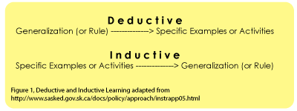
In contrast with the deductive method, inductive instruction makes use of student “noticing”. Instead of explaining a given concept and following this explanation with examples, the teacher presents students with many examples showing how the concept is used. The intent is for students to “notice”, by way of the examples, how the concept works.
Using the grammar situation from above, the teacher would present the students with a variety of examples for a given concept without giving any preamble about how the concept is used. As students see how the concept is used, it is hoped that they will notice how the concept is to be used and determine the grammar rule. As a conclusion to the activity, the teacher can ask the students to explain the grammar rule as a final check that they understand the concept.
https://sites.educ.ualberta.ca/staff/olenka.bilash/Best%20of%20Bilash/inductivedeductive.html

263. Teacher D wants to develop in his students the skill to derive rule on subject – verb agreement from given examples. With which will he start his lesson?
a. State the rule
b. Define subject and verb
c. Identify the subject and the verb in sentences
d. Give at least 10 examples of sentences that show subject – verb agreement

Answer is D. Use inductive method. Refer to previous question.

264. Teacher wants to show the TLE students how to use the sewing machine. What teaching method will he employ?
a. Inductive
b. Demonstration
c. Lecture
d. Inquiry

Answer is B. When using the demonstration model in the classroom, the teacher, or some other expert on the topic being taught, performs the tasks step-by-step so that the learner will eventually be able to complete the same task independently. The eventual goal is for learners to not only duplicate the task, but to recognize how to problem-solve when unexpected obstacles or problems arise. After performing the demonstration, the teacher’s role becomes supporting students in their attempts, providing guidance and feedback, and offering suggestions for alternative approaches.
http://www.learnnc.org/lp/pages/5181

265. In Section 2, Declaration of Policy, of RA 10533, it is said that the “State shall broaden the goals of High School education for College preparation, vocational and technical career opportunities as well as creative arts, sports, and entrepreneurial employment. Is the K to 12 aligned to this goal?
a. Yes, it offers academic track, sports, arts and design, tech-voc and livelihood track
b. No, it lacks entrepreneurial track
c. It depends on which track the students will pursue
d. Partly

Answer is A.

WHAT IS K TO 12 PROGRAM?
The K to 12 Program covers Kindergarten and 12 years of basic education (six years of primary education, four years of Junior High School, and two years of Senior High School [SHS]) to provide sufficient time for mastery of concepts and skills, develop lifelong learners, and prepare graduates for tertiary education, middle-level skills development, employment, and entrepreneurship

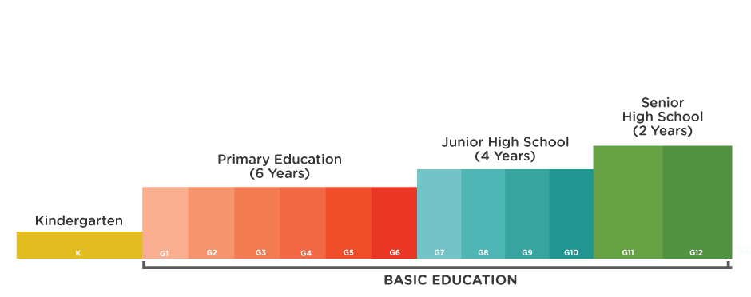

GEARING UP FOR THE FUTURE (SENIOR HIGH SCHOOL)
Senior High School is two years of specialized upper secondary education; students may choose a specialization based on aptitude, interests, and school capacity. The choice of career track will define the content of the subjects a student will take in Grades 11 and 12. SHS subjects fall under either the Core Curriculum or specific Tracks.

CORE CURRICULUM
There are seven Learning Areas under the Core Curriculum. These are Languages, Literature, Communication, Mathematics, Philosophy, Natural Sciences, and Social Sciences. Current content from some General Education subjects are embedded in the SHS curriculum.

TRACKS
Each student in Senior High School can choose among three tracks: Academic; Technical-Vocational-Livelihood; and Sports and Arts. The Academic track includes three strands: Business, Accountancy, Management (BAM); Humanities, Education, Social Sciences (HESS); and Science, Technology, Engineering, Mathematics (STEM).
Students undergo immersion, which may include earn-while-you-learn opportunities, to provide them relevant exposure and actual experience in their chosen track.

TVET (TECHNICAL VOCATIONAL EDUCATION & TRAINING) NATIONAL CERTIFICATE
After finishing Grade 10, a student can obtain Certificates of Competency (COC) or a National Certificate Level I (NC I). After finishing a Technical-Vocational-Livelihood track in Grade 12, a student may obtain a National Certificate Level II (NC II), provided he/she passes the competency-based assessment of the Technical Education and Skills Development Authority (TESDA).
NC I and NC II improves employability of graduates in fields like Agriculture, Electronics, and Trade.
http://www.officialgazette.gov.ph/k-12/

266. Section 3 of RA 10533 states that “basic education shall be delivered in languages understood by the learners ….” How is this implemented in the K to 12 curriculum?
Mother tongue is used as a medium of instruction from _______
a. Grades 1 to 3
b. Grades 1 to 4
c. Grades 1 to 5
d. Grades 1 to 6

Answer is A.
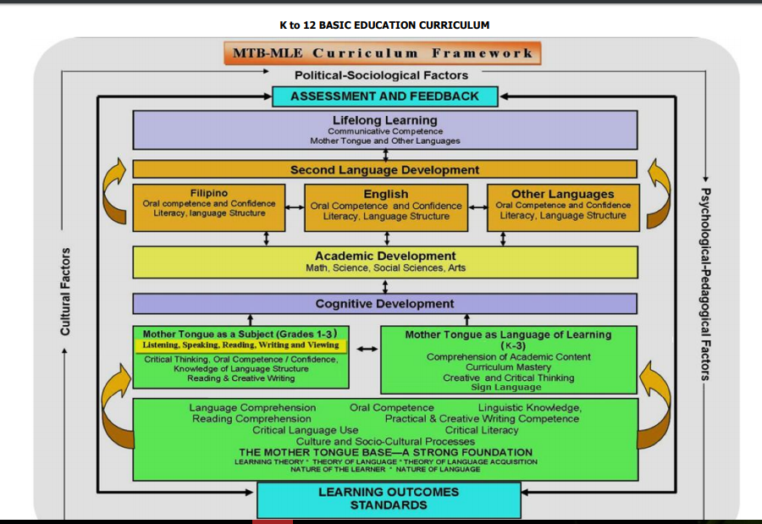

http://www.deped.gov.ph/sites/default/files/Final%20Mother%20Tongue%20Grades%201-3%2001.21.2014_.pdf

267. Section 5 of RA 10533 states that “the curriculum shall be contextualized and global”. How is this implemented?
I. Encouragement of schools to produce learning materials locally
II. Inclusion of 21st Century skills
III. Allowing schools to localize and indigenize materials
a. I only
b. II only
c. II and III
d. I, II and III

Answer is D

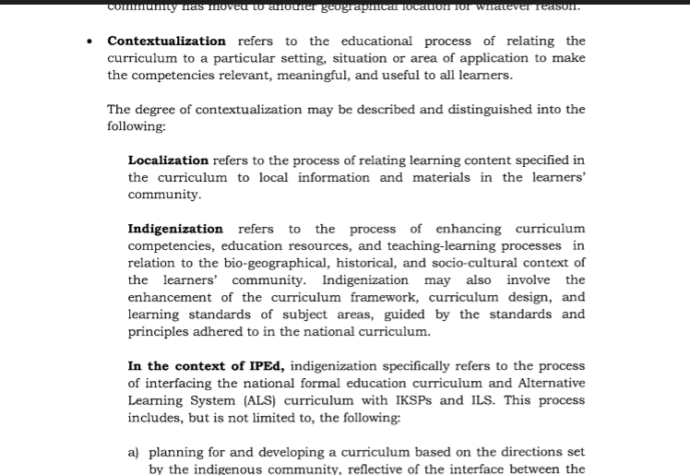
See Deped Order 32, s. 2015 for details on Contectualization

268. Which is a proof of constructive alignment?
a. The intended learning outcomes are aligned to the learning activities and performance task
b. The aspiration of parents are aligned to program goals
c. The aspirations of the community are aligned to the teaching-learning activities of the school
d. The goals of the students are aligned to curriculum goals

Answer is A

In constructive alignment, we start with the outcomes we intend students to learn, and align teaching and assessment to those outcomes. The outcome statements contain a learning activity, a verb, that students need to perform to best achieve the outcome, such as “apply expectancy-value theory of motivation”, or “explain the concept of … “. That verb says what the relevant learning activities are that the students need to undertake in order to attain the intended learning outcome. Learning is constructed by what activities the students carry out; learning is about what they do, not about what we teachers do. Likewise, assessment is about how well they achieve the intended outcomes, not about how well they report back to us what we have told them or what they have read.
http://www.johnbiggs.com.au/academic/constructive-alignment/

269. Teacher wants her students learn how to live in collaboration with others. Which teaching-learning activities will be aligned?
a. Academic contests
b. Project-Based Learning
c. Reporting
d. Games

Answer is B

We know this word as a 21st century skill and something that is essential for facilitating deep, authentic experiences within project based learning. Undoubtedly, the ability to work in a team to create and produce is one of the most important traits desired by today’s world. As we create generations of students that need to be prepared for the unknown and rapidly advancing technology, teachers must discover ways to manage the collaborative process.

One of the first things we learn as practitioners of project based learning is the idea of the team contract to help facilitate effective collaboration and prevent problems from arising between team members
http://www.gettingsmart.com/2016/05/managing-collaboration-in-the-pbl-classroom/

270. A school wants to make its students globally aware. Which one/s will it do?
- Make students feel ethnocentric
- Encourage feeling of xenocentrism
- Justify genocide
- Make students understand other’s perspective and culture

Answer is D. Culture is relative and students must be made to understand and respect diversity.
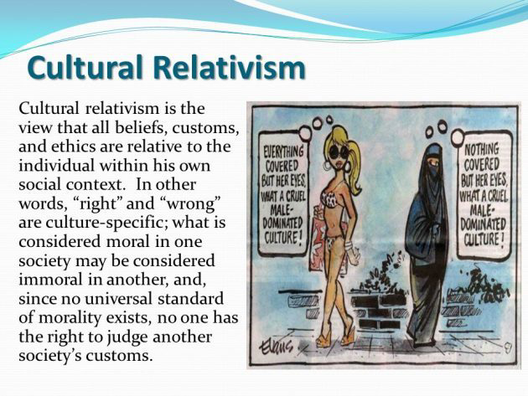
271. If teachers are serious with developing critical thinking and problem solving skills among Math students, which practices should be observed?
- Make students memorize formula
- Let your students focus on algorithmic problem solving
- Direct students to make sense of problems and solve them
- Emphasizes on answers and not on how they solve the problem

Answer is C. To think critically is to follow a clear line of logical steps and reasoning. To solvecritical thinking problems, math teachers should model the way they think when solving a problem. Students can internalize a set of questions to ask that will help them think their way to a solution.

272. Schools want students to imbibe the spirit of collaboration. Which teaching-learning technique is most fit?
- Cooperative
- Self-directed
- Independent
- Supervised

Answer is A. Only option A is an interactive instruction that addresses learners’ need to be active in their learning and interact with others including their teachers and peers. Interactive methods of teaching include brainstorming, debates, cooperative learning, interviewing, small group discussion, whole class discussion, etc.

273. With meaningful learning as curricular goal, which teaching-learning activity is aligned?
- Constructivist
- Drill
- teaching-to -the-test
- Conditioning

Answer is A –Constructivist
The K to 12 curriculum views learners as active constructors of knowledge. This means that in planning lessons, teachers should provide learners with opportunities to organize or re-organize their thinking and construct knowledge that is meaningful to them (Piaget 1950). This can be done by ensuring that lessons engage and challenge learners and tap into the learners’ zone of proximal development (ZPD) or the distance between the learners’ actual development level and the level of potential development (Vygotsky 1978). Vygotsky (1978) suggests that to do this, teachers can employ strategies that allow collaboration among learners, so that learners of varying skills can benefit from interaction with one another.

274. If schools wants students to become self-directed learners, which strategy should they employ?
- Cognitive
- Drill
- Metacognitive
- Conditioning

Answer is C. Metacognition is the process of reflecting on and directing one's own thinking.

275. Teacher P wants students to monitor their own learning. Which teaching behavior of Teacher P will be of help?
- Providing students with a clear scoring rubric
- Keeping the learning outcomes to herself
- Challenging students by giving difficult tasks
- Leaving the students to help themselves

Answer is A. Self-assessment is a valuable tool as it gives students the ability to really consider their learning and equally as importantly, share that understanding with the teacher. In order for students to monitor their own learning, a teacher may provide them a scoring rubric.
Below is a example of a self assessment rubric.
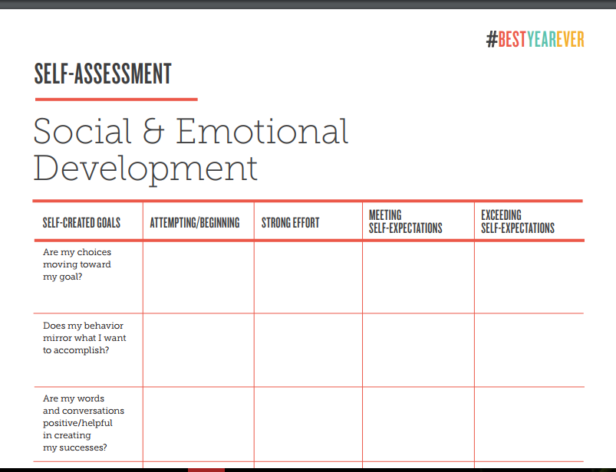
https://www.edutopia.org/pdfs/blogs/edutopia-desautels-SEL-rubric.pdf

276. Teacher Q wants his students to become critical thinkers. Which teaching practice is/are aligned?
- Using situational multiple choice tests
- Rote memorization of facts, formula
- Determining flaw of reasoning in an argument
- I only
- II only
- I and III
- II and III

Answer is C. Critical thinking is a process that involves asking appropriate questions, gathering and creatively sorting through relevant information, relating new information to existing knowledge, re-examining beliefs and assumptions, reasoning logically, and drawing reliable and trustworthy conclusions. Critical thinking calls for persistent effort to apply theoretical constructs to understanding the problem, consider evidence, and evaluate methods or techniques for forming a judgement. The cognitive skills of analysis, interpretation, inference, explanation, evaluation, and of monitoring and correcting one’s own reasoning are at the heart of critical thinking. (Source: Seel 2012). Attributes such as curiosity and flexibility and a questioning attitude are closely related to critical thinking. Increasingly referred to as a key competence/competency and 21st century skill.
http://www.ibe.unesco.org/en/glossary-curriculum-terminology/c/critical-thinking

277. “I identify and evaluate variety of curriculum materials under a given theme or topic then I select what seems appropriate for what I want to do in the classroom.”
Whose statement is this?
- Teachers
- Learners
- Principal
- Parents

Answer is A.
Teaching is a complex activity that involves careful preparation and planning objectives and activities on an hourly, daily, and weekly basis. In addition, long-term planning ensures coverage of curriculum across a marking period, semester, and year. Further, effective educators demonstrate high expectations for students and select strategies to propel the students' learning. Beyond planning and preparation of materials, effective organizing for instruction also involves the development of a conscious orientation toward teaching and learning as the central focus of classroom activity.

278. “I like most the activities where we experienced solving cases.” Whose statement is this?
- Teachers
- Learners
- Principal
- Parents

Answer is B. These are learning experiences that learners encountered inside the classroom.

279. “I have to make sure that the infrastructure for ICT in this school will be improved for this year.” Whose statement is this?
- Teachers
- Learners
- Principal
- Parents

Answer is C. School principals are the key leaders in our educational system. They are responsible of carrying out the school vision and mission. School Principals play integral roles in making schools function smoothly. They are involved in all aspects of the school’s operation. They are the leaders responsible in providing leadership in the development and implementation of all educational programs and projects in the school. They play a vital role in achieving the government’s aim to provide quality basic education.

280. Teacher R’s lesson for grade 3 is on the history of the town. There is no existing reference material in the library. Who can be tapped?
- The elders in the community
- The students
- The non-academic employees in school
- The supervisors of DepEd

Answer is A
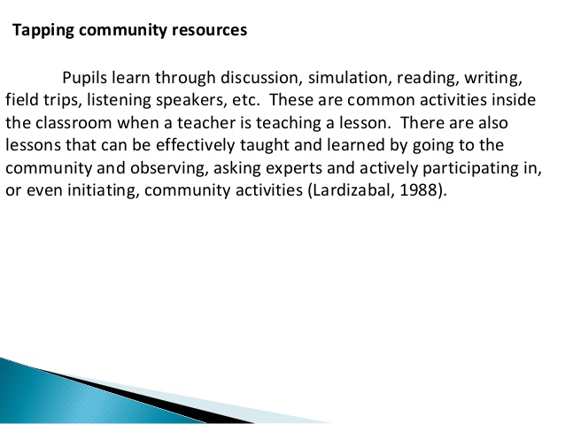
https://www.slideshare.net/ubdmath2010/school-community-partnership

281. Who sees to it that policies and guidelines on Mother Tongue-Based Multi-lingual Education are implemented by teachers?
- Parents
- Teachers
- Students
- School head

Answer is D. RA 9155 provides that the school head, who may be assisted by an assistant school head, shall be both an instructional leader and administrative manager. A school head must see to it that school curriculum is implemented and must be accountable for higher learning outcomes.

282. Who is supposed to facilitate teaching by making teachers aware of references and other materials available for their teaching?
- Parents
- Supervisor
- Office staff
- School head with the library/ Learning Resource Center staff

Answer is D. Refer to previous question.

283. How can parents and community come in to help in the delivery of the curriculum?
- allowing schools to make use of facilities in the community e.g. basketball court for P.E
- Allowing schools to visit relevant historical spots in the community
- Ensuring that children are given home supervision for study
- I and II
- II and III
- I, II and III
- I and III

Answer is C. Parents and community form part of the stakeholders of curriculum. There are many stakeholders in education each of whom needs to play his role effectively in order to help all our children learn better and reach their fullest potential. The pupils, parents, teachers, administrators, and community have the ultimate aim of helping all our children achieve the desired outcomes of education.
Here are 5 concrete ways that parents can support 21st century learning – both in school and beyond, for even the youngest learners:
Model good citizenship. Whether making sure to vote in local elections, supporting your community, or just paying attention to what’s happening in the news, talk about what you do, and why it’s important with your child. (Here are some ideas from Generation Nation).
Make decisions about responsible digital practices together. Talk with your child about ways to behave safely and responsibly in the digital world, how to judge the accuracy and bias of online news and set expectations about digital devices. (Here are some ideas from Common Sense Media and Connect Safely)
Make learning other languages and cultures a priority. The best time to expose kids to other cultures is between the ages of 7 and 12, but learning other languages builds extra connections in the brain, and may set your child up for success in more ways than one. (Check out this great resource from Edutopia on 21st century learning.)
Support your child’s school. Advocate for your child, and for your child’s teachers. Ask questions about how your school embeds the 4Cs into the learning day. Share resources you find with other parents. If you think your school is doing a fantastic job preparing kids for 21st century learning, work, and citizenship – nominate them for the P21 Exemplar program! If you are in the DC area, consider getting a Nifty Fifty presenter for your school.
Make connections to afterschool activities. Many of the best 21st century learning opportunities are available outside of school and probably already exist in your community! Prioritize 21st century skills and citizenship when choosing extra-curricular and out-of-school activities to reinforce problem solving, communication, collaboration and creativity skills. Take advantage of programs at local libraries, summer camps, and boys & girls clubs. (Here are some other ideas from EdLeader21)
http://www.gettingsmart.com/2015/05/5-ways-parents-can-encourage-21st-century-learning/
284. Truancy is getting to be a problem in School B. students cut classes after recess or after morning class. How can parents and community help?
- By serving as teacher aide
- By serving as “security guards” to check on truant students
- By serving as storyteller in class to make more interesting
- By researching on why there is truancy

Answer is B. Parents may act as guards of their children, keep track of their attendance and must exercise necessary measure to ensure their children are in school. Parents must take active role in the education of their children.

285. Whose primary duty is it to help classroom teachers teach to the best of their ability?
- Students
- School head
- Parents
- DepEd Superintendent

Answer is B. RA 9155 provides the following duties of the school heads.

Consistent with the national educational policies, plans and standards, the school heads shall have authority, accountability and responsibility for the following:
(1) Setting the mission, vision, goals and objectives of the school;
(2) Creating an environment within the school that is conducive to teaching and learning;
(3) Implementing the school curriculum and being accountable for higher learning outcomes;
(4) Developing the school education program and school improvement plan;
(5) Offering educational programs, projects and services which provide equitable opportunities for all learners in the community;
(6) Introducing new and innovative modes of instruction to achieve higher learning outcomes;
(7) Administering and managing all personnel, physical and fiscal resources of the school;
(8) Recommending the staffing complement of the school based on its needs;
(9) Encouraging staff development;
(10) Establishing school and community networks and encouraging the active participation of teachers organizations, non-academic personnel of public schools, and parents-teachers-community associations;
(11) Accepting donations, gifts, bequests and grants for the purpose of upgrading teachers’/learning facilitators’ competencies, improving and expanding school facilities and providing instructional materials and equipment. Such donations or grants must be reported to the appropriate district supervisors and division superintendents; and
(12) Performing such other functions as may be assigned by proper authorities.

286. The class of Mr. Tan read about successful gardening project undertaken by a certain Grade VI class in a certain barangay. After coming from that day, Nano went around their backyard and found out that there was an available space and decided to plant some camote tops. What level of comprehension does Nano demonstrate?
A. Literal
B. Interpretive
C. Applied
D. Critical

Answer is C. Applied

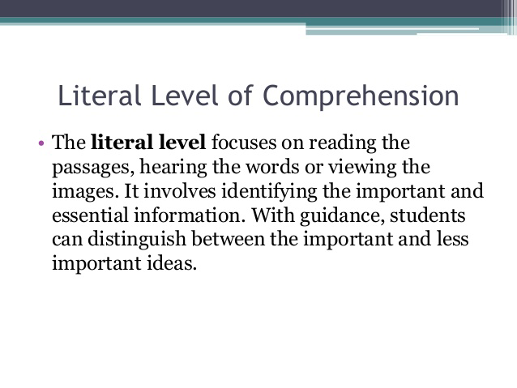
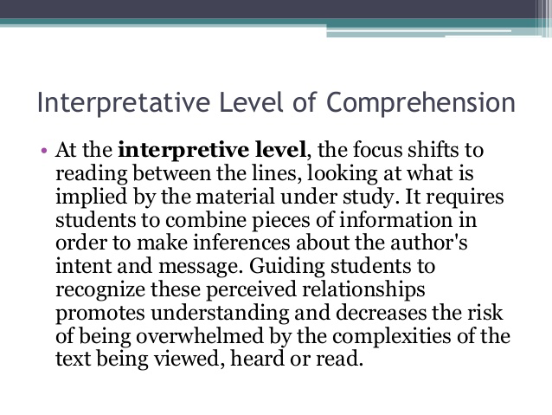
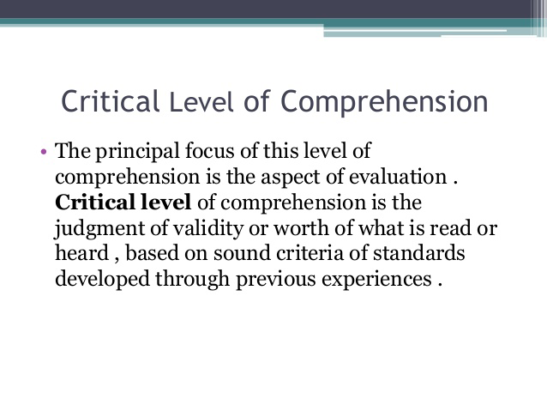
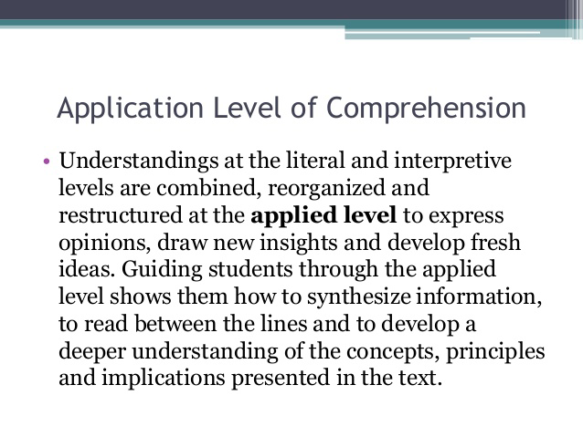
https://www.slideshare.net/lighterthanblue/comprehensio

287. Which statement is TRUE about teaching vocabulary?
A. All vocabulary can be taught directly.
B. Learners learn indirectly all the vocabulary they need.
C. Learners should be taught as many vocabulary as they can.
D. Vocabulary can be taught directly and indirectly.

Answer is D

Although a great deal of vocabulary is learned indirectly, some vocabulary should be taught directly. Direct instruction helps students learn difficult words, such as words that represent complex concepts that are not part of the students' everyday experiences. Direct instruction of vocabulary relevant to a given text leads to a better reading comprehension.
Direct instruction includes providing students with specific word instruction and teaching students word-learning strategies.
Indirect vocabulary learning refers to students learning vocabulary when they hear and see words through conversations with adults, through being read to, and through reading on their own.
Direct vocabulary learning refers to students learning vocabulary through explicit instruction in both individual words and word-learning strategies. Direct vocabulary instruction aids in reading comprehension. Two examples of direct vocabulary instruction include: specific word instruction and word learning instruction.
http://www.readingrockets.org/article/vocabulary-introduction

288. A limited vocabulary is a setback to efficient reading. What does this statement imply about the learner?
A. Be equipped with certain skills to attack unfamiliar words.
B. Master all lexical items in one language.
C. Know how to use the dictionary in locating meanings.
D. Disregard unfamiliar words he/she meets.

Answer is A. Text-attack skill: interpret text as a whole, using clues like cohesion, rhetorical structure
https://www.eduhk.hk/ele/ss/17-18/Sem3_notes.pdf

289. Biology, the science that deals with the study of life, is an important subject. This sentence illustrates the use of which CLUE in order for the reader to get the meaning of the word biology?
A. Experience
B. Appositive
C. Explanation
D. Comparison and contrast

Answer is B

An appositive is a word or phrase that defines or explains an unfamiliar word that comes before it. Example: At night you can see constellations, or groups of stars, in the sky.
http://ms.pleasantvilleschools.com/ourpages/auto/2012/1/6/46553892/Context%20Clues--Types%20of%20Clues%20_%20Tips.pdf

290. What do learners make use of when they visually examine words to discover component parts like impossible which is made up of im + possible, which lead to pronunciation and meaning?
A. Structural analysis
B. Syntactic clues
C. Context clues
D. Presentation clues

Answer is A. Structural analysis is dividing words into parts to discover what an unknown word means. Many words contain a root, a prefix, and/or a suffix. A root word is a word that does not have a prefix or a suffix and is the base or core that can't be reduced into a smaller word form.

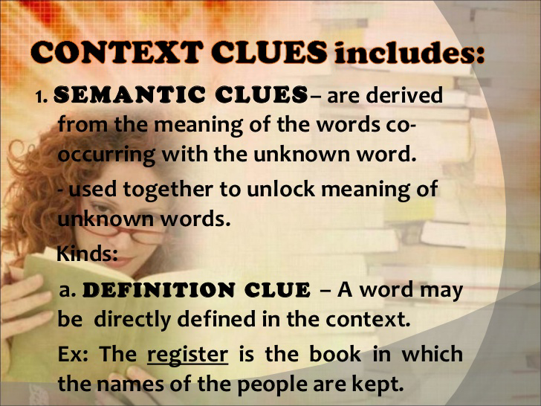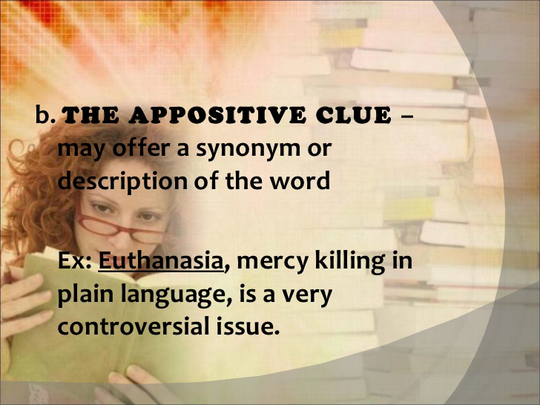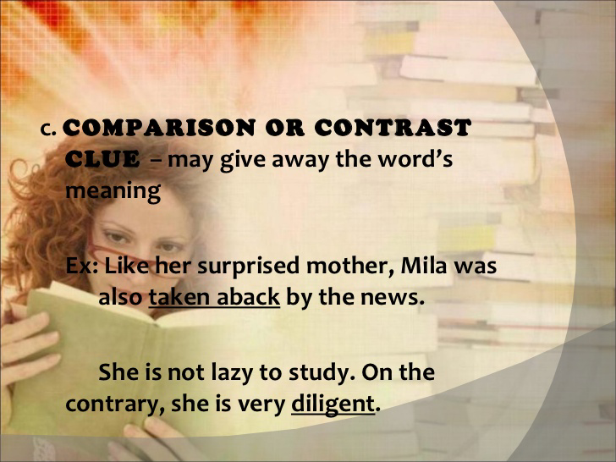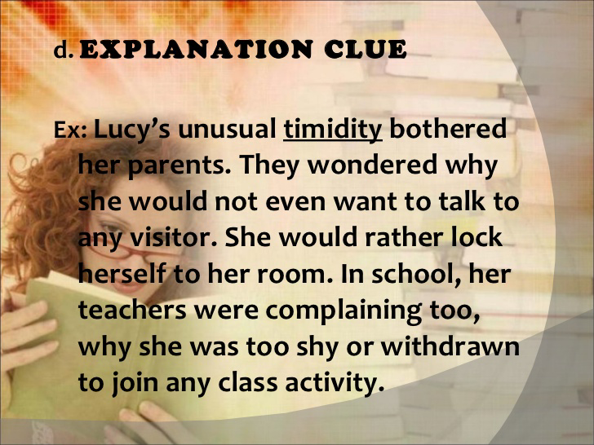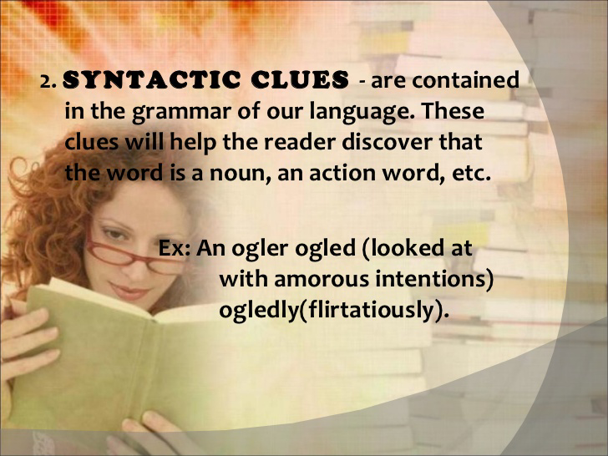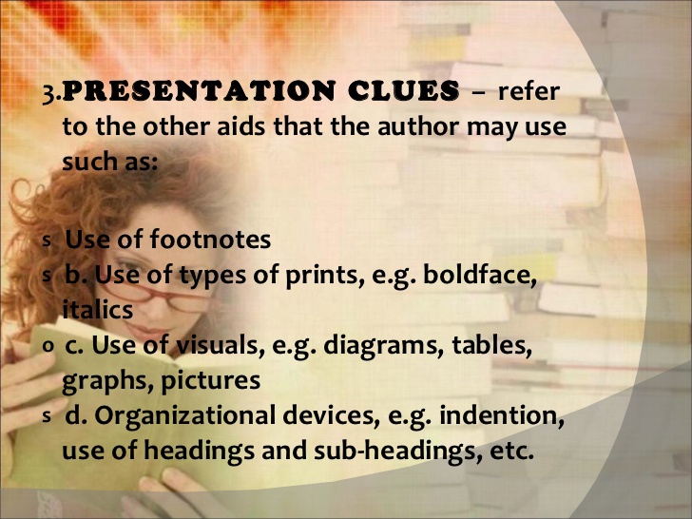
https://www.slideshare.net/dollyted/using-context-clues

291. Gerry lacks originality and imagination in his speech. The words he uses and his speech patterns reveal a dull, unquestioning mind. How may Gerry’s speech be describe?
A. Inarticulate
B. Banal
C. Haggard
D. Pessimistic

Answer is B. Banal is defined as lacking in originality as to be obvious and boring.

292. Which of the following is NOT a characteristic of a good question?
A. The wording is brief and clear.
B. It leads to other questions.
C. It is self-answering.
D. It is thought-provoking.

Answer is C. Self-answering questions don’t pose any challenge at all. It does not make students think critically and creatively.

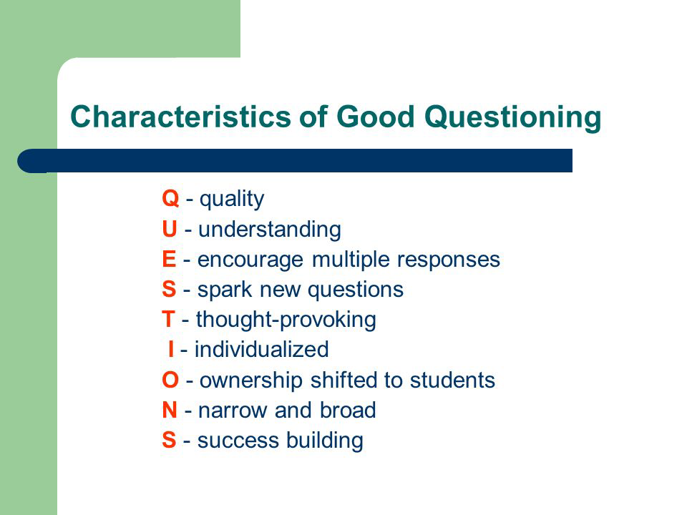

See also https://www.ncbi.nlm.nih.gov/pmc/articles/PMC3776909/

293. A reader uses metacognition when she__________.
I. Previews the text and makes predictions
II. Makes connections to personal experience or other texts
III. Asks clarifying questions

A. I,II and III
B. II and III
C. I and II
D. II only

Answer is A.
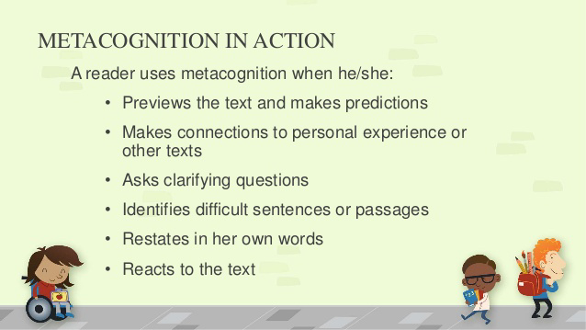
https://www.slideshare.net/ronaldsuplidojr/teaching-reading-metacognition

294. A reader uses metacognition when she ___________.
I. Identifies difficult sentences or passages
II. Restates a sentence/passage in her own words
III. Reacts to the text

A. I only
B. III only
C. II only
D. I,II and III

Answer is D. Refer to previous question.

295. Which of the following is /are examples of “thinking stems,” or sentence starters that can prompt reflective thinking?
I. “I’m thinking…”
II. “I’m wondering…”
III. “From this chapter, I learned…”
IV. “From what I read, I realize…”

A. I,II and IV
B. II,III and IV
C. I,II and III
D. I, III and IV

Answer is A. Launching sequence for metacognition includes concrete experiences, wordless picture books, a graphic organizer, and easy-to-obtains tools (in this case, free paint chips from your local home improvement store) to help students to become metacognitive about their reading. She also includes “thinking stems” or sentence starters that can prompt reflective thinking such as “I’m thinking ….”, “I’m wondering ….” or “I’m noticing …”

296. Which can promote critical thinking and creativity in reading classroom?
I. Graphic organizers
II. Brainstorming
III. Convergent questions

A. I only
B. II only
C. II and III
D. I and II

Answer is D- Research tells us that there five main curriculum features crucial to advancing critical thinking and creativity in reading classrooms - meta-cognitive skills, graphic organizers, brainstorming and outlining, teacher-led conferences, and drawing. The main components that enhances these five significant features is a cooperative learning environment where student’s understanding is developed through peer collaboration.
http://www.gettingsmart.com/2012/11/reading-curriculum-critical-thinking-creativity-for-understanding/

297. Which may help establish creativity in reading?
I. Writing experience stories together as a group
II. Playing listening-and-seeing games
III. Writing imaginative stories o poems

A. I,II and III
B. II and III
C. I and II
D. I and III

Answer is A. Creativity in reading may be established in several ways by writing experience stories together as a group, by playing listening and-seeing games, by dramatizing pictures and plays, and by writing imaginative stories or poems.
http://scholarworks.wmich.edu/cgi/viewcontent.cgi?article=3019&context=reading_horizons

298. Seeing that Mike likes to listen to stories of wonders and miracles and about the idealization of history, Teacher Alyssa includes such stories in their reading class. What factor of reading does Teacher ALyssa consider?
- Cognitive ability
- Maturity of reading
- Physical ability
- Interest in reading

Answer is D. Reading interest, referred to the potential excitement a reader perceives when contemplating reading (in order to be able to learn new information) (Thomas, 2001).

299. “You may bring the horse to the water but if it does not like to drink, it will not do so.” These saying is explained by what similar situation?
- When she goes to bookstore, Gina buys some books and then reads them all
- There are many books in the Lisa’s home but she prefers playing games than reading books
- Every night, Tina’s mom reads stories to her before she goes to sleep
- Every time she receives a book as her gift, Eloisa eagerly turns to pages and reads them

Answer is B.

300. Chona’s mother guides her in a acquiring functional listening and speaking vocabulary and initiates activities using concrete objects and regularly tells stories to her. What kind of reader will likely become of Chona?
- Disabled
- Proficient
- Slow
- Impatient

Answer is B
Proficient readers exhibit certain qualities and use certain strategies in developing proficiency as discussed in professional journal articles and other educational resources. Proficiency is defined as the ability to construct meaning from text at a reading level higher than the students' age. . The research showed the following six universal qualities displayed by proficient readers: understanding the purposes of reading, applying prior knowledge, processing the structures of print, self-monitoring, applying strategies, and reading meaningful text. The strategies examined were metacognition, preparation, organization, elaboration, summarization, and prediction.
https://www.dominican.edu/…/ab…/madaliennepeters/proficiency
But the ability to read and write does not develop naturally, without careful planning and instruction. Children need regular and active interactions with print. Specific abilities required for reading and writing come from immediate experiences with oral and written language. Experiences in these early years begin to define the assumptions and expectations about becoming literate and give children the motivation to work toward learning to read and write. From these experiences children learn that reading and writing are valuable tools that will help them do many things in life.
The single most important activity for building these understandings and skills essential for reading success appears to be reading aloud to children (Wells 1985; Bus, Van Ijzendoorn, & Pellegrini 1995). High-quality book reading occurs when children feel emotionally secure (Bus & Van Ijzendoorn 1995; Bus et al. 1997) and are active participants in reading (Whitehurst et al. 1994). Asking predictive and analytic questions in small-group settings appears to affect children's vocabulary and comprehension of stories (Karweit & Wasik 1996). Children may talk about the pictures, retell the story, discuss their favorite actions, and request multiple rereadings. It is the talk that surrounds the storybook reading that gives it power, helping children to bridge what is in the story and their own lives (Dickinson & Smith 1994; Snow et al. 1995). Snow (1991) has described these types of conversations as "decontextualized language" in which teachers may induce higher-level thinking by moving experiences in stories from what the children may see in front of them to what they can imagine.
http://www.readingrockets.org/…/learning-read-and-write-wha…

301. Which of these DOES NOT belong to the external factors that affect reading as point of reference?
- Parents
- Financial rewards
- Peers
- Enjoyment of reading

Answer is D. It is springs out from internal motivation.

302. A student who likes reading Science-Based books and is encourage by parents to do so would usually be more scientific-minded and logical. Which phrase proves that the student is intrinsically motivated to read?
- Encourage by parents
- Loves reading science-based books
- Be more scientific-minded
- Be more logical

Answer is B
Intrinsic motivation refers to behavior that is driven by internal rewards. In other words, the motivation to engage in a behavior arises from within the individual because it is naturally satisfying to you.Intrinsic motivation involves engaging in a behavior because it is personally rewarding; essentially, performing an activity for its own sake rather than the desire for some external reward.

Examples of actions that are the result of intrinsic motivation include:
- In each of these instances, the person's behavior is motivated by an internal desire to participate in an activity for its own sake.

Extrinsic motivation occurs when we are motivated to perform a behavior or engage in an activity to earn a reward or avoid punishment.

Examples of behaviors that are the result of extrinsic motivation include:
- Studying because you want to get a good grade
- Cleaning your room to avoid being reprimanded by your parents
- Participating in a sport to win awards
- Competing in a contest to win a scholarship
In each of these examples, the behavior is motivated by a desire to gain a reward or avoid an adverse outcome.

303. If a pupil is unable to read proficiently while others around him/her can, over time his/her belief in his/her ability to read will be negatively impacted (Solheim 2011). Based on this research finding, which factor contributes to the pupil’s reading problem?
- Working memory
- Reading strategy
- Self-efficacy
- Reading disability

Answer is C. Perhaps one of the greatest problems in education today is not illiteracy, but aliteracy (Cramer and Castle, 1994). Aliteracy has been defined as a "lack of the reading habit; es pecially, such a lack in capable readers who choose not to read" (Harris and Hodges, 1981, p. 11).

However, if we truly cherish the idea of transforming our students into lifelong readers, then specific reading skills and strategies might not be the place to begin.

A broad definition of self-efficacy can be stated as the power to produce an effect (Lacour and Wilkerson, 1991). To be more specific, Henk and Melnick (1995) cite Bandura's def inition which describes perceived self-efficacy as a person's judgments of his or her ability to successfully participate in an READING HORIZONS, 1996, volume 36, #3 197 activity and the effect this perception has on future activities. In other words, students with positive self-efficacies feel in control of their learning situation and believe they have the capabilities necessary to succeed.

304. Good readers make use of effective reading strategies. Which are examples of effective reading strategies?
- Predicting
- Inferring
- Summarizing
- Visualizing
- I, II, III
- I, III, IV
- II, III, IV
- I, II, III,Iv

Answer is D. Research has identified a common set of strategies that support successful reading: activating background knowledge, summarizing, predicting and checking predictions, clarifying, asking questions and finding answers, visualizing or imaging, drawing inferences and making connections. (Rosenshine et al. 1996); Gambrell and Koskinen, 2002; National Reading Panel, 2000; Gambrell and Bales, 1986; Hansen & Pearson, 1983).
https://www.districtadministration.com/sites/districtadministration/files/sites/districtadministration/files/resources/improving_reading_3.pdf

305. Which is the ideal home environment for children to develop love for reading?
- Parents model reading behaviors
- Access to reading resources
- Family places high values on literacy
- Parents buy reading materials and display them in the bookcase
- II and III
- I, II and III
- I and II
- II, III and IV

Answer is B. Option D is irrelevant.

306. Researches on reading found out that “Children who like to read and think they are good readers read more often than their less positive counterparts and have higher reading achievements.” What does this imply?
- children ‘s reading inability must be address as early as possible
- Home must be filled with sophisticated reading materials; and this is good for them
- Children must be enrolled in preschools that are highly academic in orientation
- Children must not be hurried to learn how to read

Answer is A. It's important to note that struggling readers will often have problems in multiple areas. For example, children who have problems with phonemic awareness almost always have problems in word decoding and phonics; children with fluency problems usually have comprehension weaknesses; and a weak vocabulary also impacts comprehension. Please read through all of the sections of Target the Problem! to understand these different factors.
http://www.readingrockets.org/helping/target

307. Which factor relates to the high reading achievement?
- rich home literacy environment
- Reading enjoyment
- Confidence in reading
- High student IQ
- I and II
- I, II and III
- III and IV
- II, III and IV

Answer is B. It was hypothesized that success in reading begins with support in the home, as measured by parents’ attitudes toward reading, parents’ own reading behaviors, early home literacy activities, and the presence of children’s books in the home. A supportive home environment can help prepare students for school, based on parents’ reports of their children’s early literacy skills. These home supports for literacy were predicted to relate to aspects of reading motivation, including reading behaviors, student attitudes, and self-concept. This combination of a rich home literacy environment, reading enjoyment, and confidence in reading were hypothesized to ultimately relate to high reading achievement, as measured by the PIRLS assessment.
http://www.iea.nl/sites/default/files/irc/IRC2010_Kennedy_Trong.pdf

The Progress in International Reading Literacy Study (PIRLS) is an international comparative assessment that measures student learning in reading. Since 2001, PIRLS has been administered every 5 years.
https://nces.ed.gov/surveys/pirls/

308. Which statement/s on motivation is/are TRUE?
- Motivation is not necessarily something that learners bring to school
- Motivation can arise from environmental condition at school
- Teachers motivate students to learn and behave in ways that promote their long-term success and productivity
- II only
- I and II
- III only
- I, II and III

Answer is D. Motivation is not necessarily something that learners bring to school; it can also arise from environmental conditions at school. When we talk about how the environment can enhance a learner’s motivation to learn particular things or behave in particular ways, we are talking about situated motivation (Paris & Turner, 1994; Rueda & Moll, 1994). In the pages to come, we’ll find that as teachers, we can do many things to motivate students to learn and behave in ways that promote their long-term success and productivity.
https://www.education.com/reference/article/motivation-affects-learning-behavior/

309. Which are effects of motivation on learners?
- Direct their behavior towards particular goals
- Increases their persistence in activities
- Leads to learners’ increase effort and energy
- I and II
- I and III
- II and III
- I, II and III

Answer is D.

How Motivation Affects Learning and Behavior
Motivation has several effects on students’ learning and behavior.
- Motivation directs behavior toward particular goals. As we discovered in Chapter 10, social cognitive theorists propose that individuals set goals for themselves and direct their behavior accordingly. Motivation determines the specific goals toward which learners strive (Maehr & Meyer, 1997; Pintrich et al., 1993). Thus, it affects the choices students make—for instance, whether to enroll in physics or studio art, whether to spend an evening completing a challenging homework assignment or playing videogames with friends.
- Motivation leads to increased effort and energy. Motivation increases the amount of effort and energy that learners expend in activities directly related to their needs and goals (Csikszentmihalyi & Nakamura, 1989; Maehr, 1984; Pintrich et al., 1993). It determines whether they pursue a task enthusiastically and wholeheartedly or apathetically and lackadaisically.
- Motivation increases initiation of and persistence in activities. Learners are more likely to begin a task they actually want to do. They are also more likely to continue working at it until they’ve completed it, even if they are occasionally interrupted or frustrated in the process (Larson, 2000; Maehr, 1984; Wigfield, 1994). In general, then, motivation increases students’ time on task, an important factor affecting their learning and achievement (Brophy, 1988; Larson, 2000; Wigfield, 1994).
- Motivation affects cognitive processes. Motivation affects what learners pay attention to and how effectively they process it (Eccles & Wigfield, 1985; Pintrich & Schunk, 2002; Pugh & Bergin, 2006). For instance, motivated learners often make a concerted effort to truly understand classroom material—to learn it meaningfully—and consider how they might use it in their own lives.
- Motivation determines which consequences are reinforcing and punishing. The more learners are motivated to achieve academic success, the more they will be proud of an A and upset by a low grade. The more learners want to be accepted and respected by peers, the more they will value membership in the “in” group and be distressed by the ridicule of classmates. To a teenage boy uninterested in athletics, making or not making the school football team is no big deal, but to a teen whose life revolves around football, making or not making the team may be a consequence of monumental importance.
- Motivation often enhances performance. Because of the other effects just identified—goal-directed behavior, effort and energy, initiation and persistence, cognitive processing, and the impact of consequences—motivation often leads to improved performance. As you might guess, then, students who are most motivated to learn and excel in classroom activities tend to be our highest achievers (A. E. Gottfried, 1990; Schiefele, Krapp, & Winteler, 1992; Walberg & Uguroglu, 1980). Conversely, students who have little interest in academic achievement are at high risk for dropping out before they graduate from high school (Hardré & Reeve, 2003; Hymel et al., 1996; Vallerand, Fortier, & Guay, 1997).
- https://www.education.com/reference/article/motivation-affects-learning-behavior/

310. Which metacognitive processes enhance learning?
- Monitoring progress as one learns
- Adjusting strategies if they are perceived ineffective
- Goal setting
- I only
- III only
- II only
- I, II and III

Answer is D. By communicating that learning ability can be improved, teachers can emphasize how monitoring their thinking during learning will help students to:
- Set learning goals
- Choose the most effective learning strategies
- Reflect on what they know and what they need to find out
- Adjust strategies accordingly
- Learn from experience
The topic of metacognition can seem quite abstract -- a complex concept for students to embrace. But it is worth the effort to develop a metacognitive mindset in setting goals for learning and in monitoring progress toward achieving those goals. For teachers empowering students to think about their thinking with the aim of improving learning, it can be truly inspiring when they see the resulting changes in students' motivation, resilience, and learning gains.
A 2014 study by Veenman and colleagues suggests that metacognition, or "cognition about cognition," may account for some 40 percent of the variation in learning achievement across a range of outcomes. One of the major benefits of guiding students to become more metacognitive is in the context of goal setting and the impact on their motivation when they take charge of learning goals.
https://www.edutopia.org/blog/inspiring-progress-toward-learning-goals-donna-wilson-marcus-conyers

311. Metacognitive processes favorably influence learning. Which does NOT belong to the metacognitive processes?
- Self-reflection
- Self-responsibility and initiative
- Goal setting
- Remembering

Answer is D. Meta-cognitive learning is knowing what to learn and how to learn. It consists of two basic processes occurring simultaneously: (1) monitoring your progress as you learn, and (2) making changes and adapting your strategies if you perceive you are not doing so well. It’s about self-reflection and initiative, as well as goal setting and time management.

312. Research says that students’ motivation is likely to vary as a function of age, culture, gender and socio-economic background. What does this imply?
- There is no single best method in motivating learners
- Preschoolers are easier to motivate than high school students
- Boys are more difficult to motivate than girls
- Children from deprived homes are less motivated than children from affluent homes

Answer is A. Each child is an individual, so there is no one method that works on all of them.

313. Research says that students develop greater efficacy for a learning a task when they see others like themselves performing the task successfully. This means that students must be exposed to models ______________________
- Of their age
- Who come from similar cultural background
- With similar socio-economic background
- I and II
- II and III
- I only
- I, II and III

Answer is D. Other things equal, people are more likely to be persuaded by those they see as similar to themselves in age, cultural background, and lifestyle, among other characteristics.
https://ctb.ku.edu/en/table-of-contents/participation/promoting-interest/principles-of-persuasion/main

314. Which elements must be present for goal setting to be an effective motivational tool?
- Goal acceptance
- Specificity
- Challenge
- Performance monitoring
- Performance feedback
- I, II and III
- I, III, IV and V
- III, IV and V
- I, II, III, IV and V

Answer is D. Locke and Latham's goal setting theory states that several conditions are particularly important in successful goal achievement. These include goal acceptance and commitment, goal specificity, goal difficulty, and feedback (O'Neil & Drillings, 1994). These conditions have been extended and edited by other researchers, such as Kenneth Blanchard and Spencer Johnson's SMART goals, which are conditions that are necessary to make goals effective. Without feedback people are unaware of their progression or regression; it also becomes difficult to gauge the level of effort required to pursue the goal effectively (Sorrentino, 2006).
https://wikispaces.psu.edu/display/PSYCH484/6.+Goal+Setting+Theory

315. Without being told by his groupmates, a student went to the laboratory stock room to get materials needed for the group experiment. What kind of motivation does the student manifest?
- Extrinsic
- External
- Intrinsic
- Positive

Answer is C. When someone is intrinsically motivated, he does something without external inducement.

316. In the formal operation stage, which is/are adolescents capable of doing to solve a problem?
- Formulate hypotheses
- Systematically test hypotheses
- Reason out
- I,II and III
- I and II
- II only
- III only

Answer is A. According to Piaget, formal thinking involves four major aspects
1. introspection- thinking about thought
2. abstract thinking- going beyond the real to what is possible
3. logical thinking- being able to consider all important facts and ideas to form correct conclusions
4. hypothetical reasoning - formulating hypothesis and examining the evidence for them
Thinking of children turns into that of adolescents
Adolescents are able to use prepositional logic, they are able to reason, systematize their ideas, construct theories and test them scientifically and logically
http://umich.edu/~psycours/350/jaeckelj/amyb12.htm

317. Which refers to the act of a learner who reflects on his/her own thinking?
- Metacognition
- Scaffolding
- Hemispheric function
- Perception

Answer is A.
Metacognition refers to higher order thinking which involves active control over the cognitive processes engaged in learning. Activities such as planning how to approach a given learning task, monitoring comprehension, and evaluating progress toward the completion of a task are metacognitive in nature. Because metacognition plays a critical role in successful learning, it is important to study metacognitive activity and development to determine how students can be taught to better apply their cognitive resources through metacognitive control.

"Metacognition" is often simply defined as "thinking about thinking." In actuality, defining metacognition is not that simple. Although the term has been part of the vocabulary of educational psychologists for the last couple of decades, and the concept for as long as humans have been able to reflect on their cognitive experiences, there is much debate over exactly what metacognition is. One reason for this confusion is the fact that there are several terms currently used to describe the same basic phenomenon (e.g., self-regulation, executive control), or an aspect of that phenomenon (e.g., meta-memory), and these terms are often used interchangeably in the literature. While there are some distinctions between definitions (see Van Zile-Tamsen, 1994, 1996 for a full discussion), all emphasize the role of executive processes in the overseeing and regulation of cognitive processes.

The term "metacognition" is most often associated with John Flavell, (1979). According to Flavell (1979, 1987), metacognition consists of both metacognitive knowledge and metacognitive experiences or regulation. Metacognitive knowledge refers to acquired knowledge about cognitive processes, knowledge that can be used to control cognitive processes. Flavell further divides metacognitive knowledge into three categories: knowledge of person variables, task variables and strategy variables.
http://gse.buffalo.edu/fas/shuell/cep564/metacog.htm

318. Teacher who promote psychosocial development in the classroom create an environment where each child feels appreciated and is comfortable with learning new things and building relationships with peers without fear. How does the teacher create this environment?
- Incorporates life skills in lessons to increase confidence and self-sufficiency
- Gives continuous feedback on work that has been completed to eliminate uncertainty.
- Provides considerable frrr experiments to encourage development of independence
- Provides physical and academic activities that develop diligence and self-confidence
- I,II, III and IV
- I,II,III
- I,II
- IV only

Answer is A
Using Psychosocial Development in the Classroom
"Teachers who apply psychosocial development in the classroom create an environment where each child feels appreciated and is comfortable with learning new things and building relationships with peers without fear" (Tamara , 2010, para. 1). Teaching Erikson’s theory at the different grade levels is important to ensure that students will attain mastery of each stage in Erikson's theory without conflict. There are specific classroom activities that teachers can incorporate into their classroom during the three stages that include school age children. The activities listed below are just a few suggested examples that apply psychosocial development.
At the preschool level, teachers want to focus on developing a hardy personality. Classroom examples that can be incorporated at the Preschool level are as follows:
1. Find out what students are interested in and create projects that incorporate their area of interest.
2. Let the children be in charge of the learning process when participating in a classroom project. This will exhibit teacher
appreciation for the areas of interest of the students as well as confidence in their ability.
3. Make sure to point out and praise students for good choices.
4. Offer continuous feedback on work that has been completed.
5. Do not ridicule or critize students openly. Find a private place to talk with a child about a poor choice or behavior. Help
students formulate their own alternate choices by guiding them to a positive solution and outcome.
6. When children experiment they should not be punished for trying something that may turn out differently than the teacher
planned.
7. Utilize physical activity to teach fairness and sportsmanship.
Teachers should focus on achievement and peer relationships at the elementary level. Classroom examples that can be incorporated at the Elementary level are as follows:
1. Create a list of classroom duties that needed to be completed on a scheduled bases. Ask students for their input when
creating the list as well sas who will be in charge of what.
2. Discuss and post classroom rules. Make sure to include students in the decision making process when discussing rules.
3. Encourage students to think outside of their day-to-day routine by role plaing different situations.
4. Let students know that striving for perfection is not as important as learning from mistakes. Teach them to hold their head
high and move forward.
5. Encourage children to help students who may be having trouble socially and/or academically. Never allow any
child to make fun of or bully another child.
6. Build confidence by recognizing success in what children do best.
7. Provide a variety of choices when making an assignment so that students can express themselves with a focus on their
strengths.
8. Utilize physical activity to build social development and to help students appreciate their own abilities as well as the abilities of
others.
During the middle and high school years, building identity and self-esteem should be part of a teacher's focus. Classroom examples that can be incorporated at the Middle School and High School level are as follows:
1. Treat all students equally. Do not show favoratism to a certain group of students based on gender, race, academic ability or
socioeconimic status.
2. Incorporate guest speakers and curriculum activities from as many areas as possible so as to expose students to many career
choices.
3. Encourage students to focus on their strengths and acknowledge them when they exhibit work that incorporates these
strengths.
4. Encourage students to develop confidence by trying different approaches to solving problems.
5. Incorporate life skills into lesson planning to increase confidence and self-sufficiency.
6. Utilize physical activity to help relieve stress, negative feelings and improve moods.
https://erikerikson.wikispaces.com/Classroom+Examples

319. Which of the following NOT belong to cognitive factors affecting learning?
- Intelligence
- Memory
- Health
- Reason

Answer is C. Cognitive factors refer to characteristics of the person that affect performance and learning. These factors serve to modulate performance such that it may improve or decline. These factors involve cognitive functions like attention, memory, and reasoning (Danili & Reid, 2006).
https://link.springer.com/referenceworkentry/10.1007%2F978-1-4419-1005-9_1116

320. Noncognitive processes related to learning and aging include the following EXCEPT what?
- Motivation
- Health
- Loss of speed
- intelligence
- I only
- IV
- I and II
- III

Answer is D. Intelligence is a cognitive process while options A, B and C are not.

321. Which can help minimize memory deficit in learning?
- Using cues
- Establishing learning conditions that reduce interference
- Using advanced organizers
- I only
- II only
- I and II
- I,II and III

Answer is D.

Cognitive factors affecting learning
(a) intelligence and aging, and
(b) memory and learning processes.

Noncognitive processes related to learning and aging are discussed in terms of
(a) motivation,
(b) loss of speed,
(c) health, and
(d) education.

Minimizing memory deficits involves
(a) using cues,
(b) establishing learning conditions that reduce interference and result in adequate time to respond, and
(c) using advance organizers.

Minimizing noncognitive factors affecting learning involves
(a) using the discovery method of teaching,
(b) reducing anxiety, and
(c) limiting the use of evaluation.
http://www.tandfonline.com/doi/abs/10.1080/0360127780030403?journalCode=uedg20

322. Which characterize successful learners?
- Active
- Goal-directed
- Self-regulating
- Assume personal responsibility for contributing to their own learning.
- I and II
- III and IV
- II, III and IV
- I,II,III and IV

Answer is D. Learning in schools emphasizes the use of intentional processes that students can use to construct meaning from information, experiences, and their own thoughts and beliefs. Successful learners are active, goal-directed, self-regulating, and they assume personal responsibility for contributing to their own learning.
https://www.lsu.edu.ph/application/files/2414/6916/4485/Vol._15_No._1.pdf

323. which is/are the effect/s of motivation on students’ learning and behavior?
- Directs behavior toward particular goals.
- Leads to increased effort and energy
- Increase initiation of and persistence in activities
- I,II
- I only
- II and III
- I,II and III

Answer is D
How Motivation Affects Learning and Behavior
1. Motivation directs behavior toward particular goals.
2. Motivation leads to increased effort and energy.
3. Motivation increases initiation of and persistence in activities.
4. Motivation affects cognitive processes.
5. Motivation determines which consequences are reinforcing and punishing.
6. Motivation often enhances performance.
https://www.education.com/reference/article/motivation-affects-learning-behavior/

324. What are most likely the behaviors of intrinsically motivated learners?
- Are engaged in classroom activities
- Tackle assigned tasks willingly and are eager to learn classroom material
- More likely to achieve at high levels
- I,II and III
- I and II
- II and III
- I,II and III

Answers: A/D
Learners are most likely to show the beneficial effects of motivation when they are intrinsically motivated to engage in classroom activities. Intrinsically motivated learners tackle assigned tasks willingly and are eager to learn classroom material, more likely to process information in effective ways (e.g., by engaging in meaningful learning), and more likely to achieve at high levels. In contrast, extrinsically motivated learners may have to be enticed or prodded, may process information only superficially, and are often interested in performing only easy tasks and meeting minimal classroom requirements (A. E. Gottfried, Fleming, & Gottfried, 2001; Reeve, 2006; Schiefele, 1991; Tobias, 1994).
https://www.education.com/reference/article/motivation-affects-learning-behavior/

325. To construct useful representations of knowledge and to acquire the thinking and the learning strategies necessary for continued learning success across the life span, students must generate and pursue personally relevant goals. This implies that teachers must__________.
- Show the relevance of lesson to students’ goals.
- Share their personal goals with students.
- Group students according to type of goals.
- Segregate students without goals in order not to influences others

Answer is A. As students get older, they are increasingly reminded of the importance of good grades (extrinsic motivators) for promotion, graduation, and college admission, causing them to focus their efforts on earning high grade point averages. Furthermore, they become more cognitively able to set and strive for long-term goals, and they begin to evaluate school subjects in terms of their relevance to such goals, rather than in terms of any intrinsic appeal.

326. Successful learners use strategies thinking in their approach to learning, reasoning problem solving, and concept learning. They understand and can use a variety of strategies to help them reach learning and performance goals and to apply their knowledge in novel situations. They also continue to expand their repertoire of strategies by reflecting on the methods they use to see which work well for them.
Which processes of successful learners are described above?
- Cognitive
- Imaginative
- Metacognitive
- Creative

Answers are C
Strategic thinking is 4th of the 14 Learner-Centered Psychological Principles and is a cognitive and metacognitive factors. However, the process of reflecting is a a metacognitive process.

When students are metacognitive, they can take a step back and observe their thinking. Sometimes this is called the reflective process.
https://www.teachthought.com/learning/5-strategies-teaching-students-use-metacognition/

Metacognition refers to higher order thinking which involves active control over the cognitive processes engaged in learning. Activities such as planning how to approach a given learning task, monitoring comprehension, and evaluating progress toward the completion of a task are metacognitive in nature.
http://gse.buffalo.edu/fas/shuell/cep564/metacog.htm

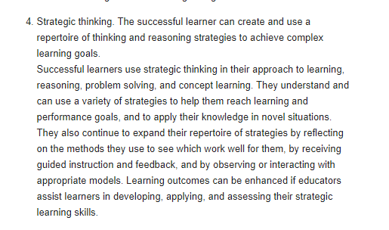
References:
http://www.cdl.org/articles/learner-centered-psychological-principles/
https://www.apa.org/ed/governance/bea/learner-centered.pdf

327. Which are proofs that students are engaged in a metacognitive process?
- Reflect on how they think and learn
- Set responsible learning or performance goals
- Select potentially appropriate learning strategies or methods, and monitor their progress toward goals
- I and II
- I and III
- II and III
- I,II and III

Answer is D
Thinking about thinking. Higher order strategies for selecting and monitoring mental operations facilitate creative and critical thinking. Successful learners can reflect on how they think and learn, set reasonable learning or performance goals, select potentially appropriate learning strategies or methods, and monitor their progress toward these goals. In addition, successful learners know what to do if a problem occurs or if they are not making sufficient or timely progress toward a goal. They can generate alternative methods to reach their goal (or reassess the appropriateness and utility of the goal). Instructional methods that focus on helping learners develop these higher order (metacognitive) strategies can enhance student learning and personal responsibility for learning.

328. Which are proofs that students are engaged in metacognitive process?
- Know what to do if a problem occurs
- Sense if they are not making sufficient or timely progress toward a goal
- Generate alternative methods to reach their goal
- I and II
- I and III
- II and III
- I, II and III

Answer is D
Successful learners can reflect on how they think and learn, set reasonable learning or performance goals, select potentially appropriate learning strategies or methods, and monitor their progress toward these goals. In addition, successful learners know what to do if a problem occurs or if they are not making sufficient or timely progress toward a goal. They can generate alternative methods to reach their goal (or reassess the appropriateness and utility of the goal). Instructional methods that focus on helping learners develop these higher order (metacognitive) strategies can enhance student learning and personal responsibility for learning.
https://www.apa.org/ed/governance/bea/learner-centered.pdf

329. Cultural or group influence on students can impact on leaders’ motivation, orientation toward learning, and ways of thinking. Which proves this?
- The authoritarianism in Filipino homes contributes to docile children.
- Learners with above average IQ are more motivated than those with below average IQ.
- Children who are products of interracial marriage are better motivated for learning.
- Children with weak biological make u are unmotivated for learning.

Answer is A. Authoritarianism contributes to docile (submissive) children.
Authoritarian parenting: this type of parenting is charecterized by efforts by parents to control judge and shape, the attitudes and behaviors of their children according to rigid standards of conduct. These parents usually value obedience and favor harsh, forceful measures, including physical punishment, to ensure that children comply with their rules. These parents discourage verbal give –and-take, believing that children should accept their word for what is right. Thus, authoritarian parents are high in demandingness and low in responsiveness. These parents set rules, and expect that children are to obey these rules because the parents say so. Preschoolers from authoritarian homes have low levels of self-control and independence, and they tend to be aggressive, anxious, and resistant to correction. (Baumrind 1971; Kochanska & Askan 1995).
http://citeseerx.ist.psu.edu/viewdoc/download?doi=10.1.1.474.1140&rep=rep1&type=pdf

330. A student once said: ‘’ I don’t like to recite because my barkada who is not academically performing sarcastically laughs at me’. What does this point to?
- Group influence can impact on a student’s orientation toward learning
- Cognitive factors influence a student’s attitude towards class participation.
- The impact of group influence on a student’s thinking is the student’s choice.
- A student has the tendency to put blame on a factor outside himself for non-performance.

Answer is A. Cultural or group influences on students can impact many educationally relevant variables, such as motivation, orientation toward learning, and ways of thinking.
https://www.apa.org/ed/governance/bea/learner-centered.pdf

331. Which is/are usual behaviors of extrinsically motivated learners?
- Have to be enticed or prodded
- May process information only superficially
- Often interest in performing only easy tasks
- Meet only minimal classroom requirements
- I and II
- II and III
- II,III and IV
- I,II,III and IV

Answer is D. Extrinsically motivated learners may have to be enticed or prodded, may process information only superficially, and are often interested in performing only easy tasks and meeting minimal classroom requirements (A. E. Gottfried, Fleming, & Gottfried, 2001; Reeve, 2006; Schiefele, 1991; Tobias, 1994).
https://www.education.com/reference/article/motivation-affects-learning-behavior/

332. which are characteristics of successful learners?
- Independent
- Goal-directed
- self -regulating
- Assume personal responsibility for contributing to their own learning
- I,II,III and IV
- III and IV
- I and II
- I,II and IV

Answer is A.
Successful learners are
active,
goal-directed,
self-regulating, and
assume personal responsibility for contributing to their own learning.
https://www.apa.org/ed/governance/bea/learner-centered.pdf

333. Which statement/s is/are TRUE of the social influences of learning?
- Learning can be enhanced when the learner has an opportunity to interact and to collaborate with others on instructional tasks.
- Learning settings that allow for social interactions and that respect diversity, encourage flexible thinking and social competence
- In interactive and collaborative instructional contexts, individuals have an opportunity for perspective taking and reflective thinking.
- I only
- I and II
- I only
- I,II and III

Answer is D.
Social influences on learning. Learning is influenced by social interactions, interpersonal relations, and communication with others. Learning can be enhanced when the learner has an opportunity to interact and to collaborate with others on instructional tasks. Learning settings that allow for social interactions, and that respect diversity, encourage flexible thinking and social competence. In interactive and collaborative instructional contexts, individuals have an opportunity for perspective taking and reflective thinking that may lead to higher levels of cognitive, social, and moral development, as well as self-esteem. Quality personal relationships that provide stability, trust, and caring can increase learners' sense of belonging, self-respect and self-acceptance, and provide a positive climate for learning. Family influences, positive interpersonal support and instruction in self-motivation strategies can offset factors that interfere with optimal learning such as negative beliefs about competence in a particular subject, high levels of test anxiety, negative sex role expectations, and undue pressure to perform well. Positive learning climates can also help to establish the context for healthier levels of thinking, feeling, and behaving. Such contexts help learners feel safe to share ideas, actively participate in the learning process, and create a learning community.
https://www.apa.org/ed/governance/bea/learner-centered.pdf

334. Quality personal relationships that provide stability, trust, and caring can increase learners’__________.
- Sense of belonging
- Self-respect
- Self-acceptance
- I,II and III
- II and III
- I and II
- I and III

Answer is A. Quality personal relationships that provide stability, trust, and caring can increase learners' sense of belonging, self-respect and self-acceptance, and provide a positive climate for learning.
https://www.apa.org/ed/governance/bea/learner-centered.pdf

335. Which qualities of personal relationship create positive climate?
- Stability
- Trust
- Caring
- Clandestine
- I,II and IV
- III and IV
- I,III and IV
- I,II and III

Answer is D. Quality personal relationships that provide stability, trust, and caring can increase learners' sense of belonging, self-respect and self-acceptance, and provide a positive climate for learning.
Clandestine is characterized by secrecy and no openness and therefore not a positive climate.

336. Being , a preschooler, insists on getting noodles for himself from the serving dish each time his family attends a gathering, even though he usually drops pasta on the floor. When his mother tries to assist him, he brushes his mother off and insists on doing it himself. In the context of Erikson’s psychosocial development theory, what stage of psychosocial development best describes Bing’s behavior?
- Trust vs. Mistrust
- Initiative vs. Guilt
- Industry vs. Inferiority
- Autonomy vs. Shame and Doubt

Answer is D. Autonomy versus shame and doubt is the second stage of Erik Erikson's stages of psychosocial development. This stage occurs between the ages of 18 months to around age 2 or 3 years. According to Erikson, children at this stage are focused on developing a greater sense of self-control.

337. When a child says that the sun is sleeping at night, the child is in the pre-operational stage, particularly __________.
- Animism
- Centration
- Egocentrism
- Reversibility

Answer is A. Animism. This is the belief that inanimate objects (such as toys and teddy bears) have human feelings and intentions. By animism Piaget (1929) meant that for the pre-operational child the world of nature is alive, conscious and has a purpose.

338. Which principles is/are in accordance with Tolman’s theory of sign learning?
- Learning is always purposive and goal-directed.
- Learners select the shortest or easiest path to achieve a goal.
- Learning is aquired through meaningful behavior
- I,II and III
- I and II
- II only
- III only

Answer is A. Tolman's theorizing has been called purposive behaviorism and is often considered the bridge between behaviorism and cognitive theory. According to Tolman's theory of sign learning, an organism learns by pursuing signs to a goal, i.e., learning is acquired through meaningful behavior.

Principles
- Learning is always purposive and goal-directed.
- Learning often involves the use of environmental factors to achieve a goal (e.g., means-ends-analysis)
- Organisms will select the shortest or easiest path to achieve a goal.
http://www.instructionaldesign.org/theories/sign-theory.html

339. Lutz and Huitt (2004) said that the one of the most important skills a student should have in the 21st century is the ability to get along with a wide variety of people. What should a teacher do to address this in a classroom setting?.
- Provides students hands-on and minds-on activities.
- Incorporate teaching strategies that aid cognitive development.
- Use teaching strategies that promote social interaction in the classroom.
- Provide activities that can enhance students’ ability to talk and share ideas.

Answer is C. Although Piaget stated that each type of knowledge occurs throughout the different stages of cognitive development, researcher Lev Vygotsky identified social interaction as the framework for all learning and development (Lutz & Huitt, 2004). “The primary focus of Vygotsky and his colleagues, however, was on dyadic and small group forms of sociality, that is forms which fall under the heading of what we shall term social interactional processes” (Wertsch & Bivens, 1992, p. 37).
https://www.bakeru.edu/images/pdf/SOE/EdD_Theses/Zamzow_Vanessa.pdf

340. Until where does scaffolding encourage children to discover and learn?
- Within their level only
- Above their level but with help from the teacher
- Below their level to avoid frustration
- Above their level independently

Answer is B. Scaffolding encourage children to discover and learn above their level but with the help from the teacher.

341. Kenn likes to go to school. He enjoyed school on day 1. Which theory explains this?
- Metacognitive theory
- Behaviorist theory
- Cognitive theory
- Gestalt theory

Answer is B. Behaviorism is a branch of psychology that, when applied to a classroom setting, focuses on conditioning student behavior with various types of behavior reinforcements and consequences called operant conditioning. There are four types of reinforcement: positive reinforcement, negative reinforcement, presentation punishment and removal reinforcement, and each can be applied effectively to get your students to behave in the classroom. The child enjoyed the first day and so he is conditioned to like to go to school.

342. Learning is viewed as collections of responses to external stimuli. Whose thought is this?
- Metacognitivist
- Behaviorist
- Cognitivist
- Gestalt theorist

Answer is B. Behaviorism is a worldview that operates on a principle of “stimulus-response.” All behavior caused by external stimuli (operant conditioning). All behavior can be explained without the need to consider internal mental states or consciousness.

343. Learners are information processors. Whose thought is this?
- Metacognitivist
- Behaviorist
- Cognitivist
- Gestalt theorist

Answer is C. Cognitivism was a response to behaviorism, which cognitivists said neglected to explain cognition. Cognitive psychology derived its name from the Latin cognoscere, referring to knowing and information, thus cognitive psychology is an information-processing psychology derived in part from earlier traditions of the investigation of thought and problem solving.

344. Which view of learning led to the shift from the knowledge-acquisition to knowledge-construction metaphor?
- Metacognitivist
- Constructivist
- Cognitivist
- Gestalt theorist

Answer is B

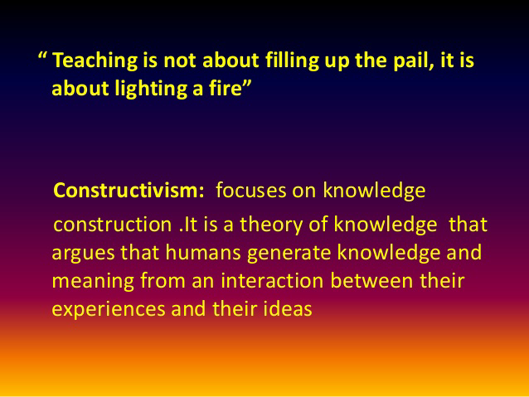
https://www.slideshare.net/laralundang/constructivism-knowledge-construction-concept-learning

345. Teaching should shift from knowledge transmission to knowledge construction. From what does this advice come?
- Metacognitivist
- Behaviorist
- Constructivist
- Cognitivist

Answer is C.
Constructivism as a paradigm or worldview posits that learning is an active, constructive process. The learner is an information constructor. People actively construct or create their own subjective representations of objective reality. New information is linked to to prior knowledge, thus mental representations are subjective.
https://www.learning-theories.com/constructivism.html

346. Which one correctly and completely explains Bandura’s reciprocal determinism?
- A person’s behavior, environment, and personal qualities all reciprocally influence each other
- A person’s behavior and environment reciprocally influence each other
- A person’s behavior and personal qualities all reciprocally influence each other
- A person’s behavior is not reciprocally influence by environment

Answer is A
Reciprocal determinism is the theory set forth by psychologist Albert Bandura which states that a person's behavior both influences and is influenced by personal factors and the social environment. Bandura accepts the possibility that an individual's behavior may be conditioned through the use of consequences.

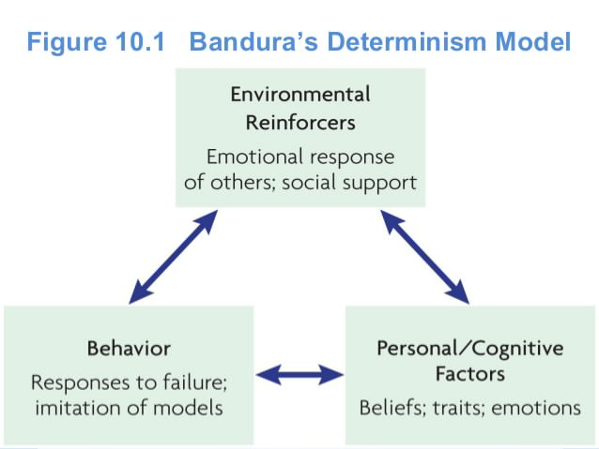
http://affiliatemarketinghelp.tk/triadic-reciprocal-determinism-example-222483.html

347. Who perceive learners not as passive recipients of information, but as constructors of knowledge as they interact with the environment and as they reorganize their mental structures?
- Metacognitivist
- Behaviorist
- Constructivist
- Cognitivist

Answer is C. Constructivism provides different views of learning. Learners are no longer passive recipients and reproducers of information. Learners are active constructors of their own conceptual understanding, and active meaning makers interacting with the physical and social world. The design of learning environment based on constructivist view of learning emphasizes the integration of three types of human experiences (Vygotsky, 1978): historical experience, e.g. the traditions and practices of a culture, social experience, and adaptation experience, in which people engage in active adaptation, changing the environment.
http://www.personal.psu.edu/wxh139/construct.htm
348. Which is NOT true of behaviorists?
- Free will plays as role in a person’s development
- Learning is shaped by stimuli in the environment
- Rewards reinforce good behaviors
- Learners are passive recipients

Answer is A. Skinner, a behaviorist psychologist, claimed that "free will is but an illusion"; that is, all actions are brought on as a direct result of conditioning, be it operant or classical.
http://www.online-literature.com/forums/showthread.php?51813-BF-Skinner-Does-free-will-exist

349. Which statement is TRUE of behaviorist?
- They focus solely on students’ observable behaviors as the indicators of learning
- They believe that students play an active role in the learning process
- They believe that helping students work with others to meet common goal is an important part of teaching
- They look at knowledge as something constructed by synthesizing ideas with prior knowledge
Answer is A. Skinner was quick to dismiss internal processes as irrelevant, claiming only observable behavior matters (this is a basic tenet of behaviorist psychology).

350. The successful learner can link new information with existing knowledge in meaningful ways. Who subscribe to such thought?
- The behaviorist
- The cognitivist
- The social-cognitivist
- The constructivist

Answer is D. Construction of knowledge (Constructivist). The successful learner can link new information with existing knowledge in meaningful ways.
https://www.apa.org/ed/governance/bea/learner-centered.pdf

351. Jerome Bruner and Edgar Dale agree that for effective teaching-learning, teachers should begin with the
---------
- Concrete
- Abstract
- Symbolic
- Ionic

Answer is A. The organizing principle of the Cone was a progression from most concrete experiences (at the bottom of the cone) to most abstract (at the top).

352. Jerome Bruner and Edgar Dale advise teachers to ____ for effective teaching-learning
- Dwell only on the concrete
- Move from the concrete to the abstract
- Move from the abstract to the concrete
- Dwell only on the abstract

Answer is B. Refer to the previous question.

353. Which of these DOES NOT belong to the Bronfenbrenner’s microsystem as a factor on human development?
- Family
- School
- Peers
- Local politics

Answer is D

Bronfenbrenner’s Ecological Systems Theory
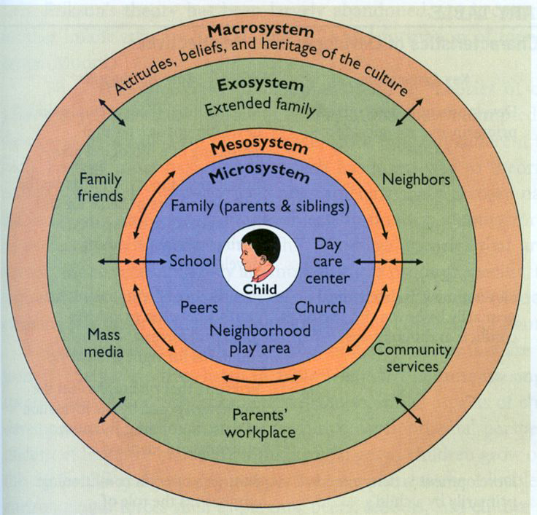
https://www.pinterest.com/explore/urie-bronfenbrenner/

The microsystem – this is the layer closest to the child and contains the structures with which the child has direct contact. The microsystem encompasses the relationships and interactions a child has with her immediate surroundings (Berk, 2000). Structures in the microsystem include family, school, neighborhood, or childcare environments. At this level, relationships have impact in two directions - both away from the child and toward the child. For example, a child’s parents may affect his beliefs and behavior; however, the child also affects the behavior and beliefs of the parent. Bronfenbrenner calls these bi-directional influences, and he shows how they occur among all levels of environment. The interaction of structures within a layer and interactions of structures between layers is key to this theory. At the microsystem level, bi-directional influences are strongest and have the greatest impact on the child. However, interactions at outer levels can still impact the inner structure.

The mesosystem – this layer provides the connection between the structures of the child’s microsystem (Berk, 2000). Examples: the connection between the child’s teacher and his parents, between his church and his neighborhood, etc.

The exosystem – this layer defines the larger social system in which the child does not function directly. The structures in this layer impact the child’s development by interacting with some structure in her microsystem (Berk, 2000). Parent workplace schedules or community-based family resources are examples. The child may not be directly involved at this level, but he does feel the positive or negative force involved with the interaction with his own system.

The macrosystem – this layer may be considered the outermost layer in the child’s environment. While not being a specific framework, this layer is comprised of cultural values, customs, and laws (Berk, 2000). The effects of larger principles defined by the macrosystem have a cascading influence throughout the interactions of all other layers. For example, if it is the belief of the culture that parents should be solely responsible for raising their children, that culture is less likely to provide resources to help parents. This, in turn, affects the structures in which the parents function. The parents’ ability or inability to carry out that responsibility toward their child within the context of the child’s microsystem is likewise affected.

The chronosystem – this system encompasses the dimension of time as it relates to a child’s environments. Elements within this system can be either external, such as the timing of a parent’s death, or internal, such as the physiological changes that occur with the aging of a child. As children get older, they may react differently to environmental changes and may be more able to determine more how that change will influence them.
http://www.floridahealth.gov/alternatesites/cms-kids/providers/early_steps/training/documents/bronfenbrenners_ecological.pdf

354. Of the five different levels of environment in Bronfenbrenner’s ecological theory, which is the closest to the learner and the most influential?
- Microsystem
- Mesosystem
- Macrosystem
- Exosystem

Answer is A because the microsystem is the immediate environment of the child.

355. Which is an example of a child’s mesosystem that does NOT work favorably for the child?
- The child is not in good terms with his peers
- There is so much hostility at home
- The child’s parent and teacher are at odds
- The child is sickly

Answer is C. The mesosystem – this layer provides the connection between the structures of the child’s microsystem (Berk, 2000). Examples: the connection between the child’s teacher and his parents, between his church and his neighborhood, etc.

356. Which is an example of a child’s exosystem that does not work favorably for the child?
- A child gets bullied in school
- Mother gets a job promotion and so has less time for supervision of her child’s homework
- The teacher plays favorites
- The child is asthmatic

Answer is B. Parent’s workplace is one of the structures on exosystem.

357. The anxiety of a child whose father belongs to the army increases every time his father leaves for duty. This proves that child’s environment, particularly ____________, affects a child’s development
- Microsystem
- Exosystem
- Macrosystem
- Chronology system

Answer is C. Macrosystem structures include attitudes (child’s anxiety).

358. A Filipino masters degree graduate is surprised to know that he cannot proceed to the doctorate program applied for in Louvain, Belgium because of the short ten-year basic education. Based on Bronfenbrenner’s theory, to which system in the environment can this be attributed?
- Mesosystem
- Exosystem
- Macrosystem
- Chronology system

Answer is C. Macrosystem includes the cultures belief systems and ideology.

359. Based on his ecological theory, which would be statements from Bronfenbrenner?
- Recognize that the school cannot work in isolation
- Schools must connect with communities
- Create situation where kids are more a part of the community
- I and II
- I, II and III
- II and III
- I and III

Answer is B. This theory looks at a child’s development within the context of the system of relationships that form his or her environment. Bronfenbrenner’s theory defines complex “layers” of environment, each having an effect on a child’s development. This theory has recently been renamed “bioecological systems theory” to emphasize that a child’s own biology is a primary environment fueling her development. The interaction between factors in the child’s maturing biology, his immediate family/community environment, and the societal landscape fuels and steers his development. Changes or conflict in any one layer will ripple throughout other layers. To study a child’s development then, we must look not only at the child and her immediate environment, but also at the interaction of the larger environment as well.
http://www.floridahealth.gov/alternatesites/cms-kids/providers/early_steps/training/documents/bronfenbrenners_ecological.pdf

360. What is an implication of Bandura’s findings that children learn social behavior such as aggression through the process of observation learning?
- Avoid children exposure to media violence
- Stop showing violence in media
- Apply reverse psychology by exposing children to media violence
- Let children watch media violence only with supervision of parents

Answer is A. Rowell Heusmann is a psychology from the University of Michigan who proposed that, “If you’re exposed to violence, you’re more likely to catch it (Swanson, 2015).” Accordingly, this statement relates to Albert Bandura’s Observational Theory, also known as Social Learning Theory – SLT (1970). The lesson commentary defines SLT as, “watching someone else perform a behavior, then the observer performs a similar behavior in a similar situation (L.5 Commentary).”
https://sites.psu.edu/aspsy/2017/02/10/banduras-observational-theory-influences-violent-behavior-through-observation-imitation-factors/

361. Learning is incorporating and hierarchically organizing new material into one’s cognitive structures. Which theory is explained?
- Bandura’s social learning theory
- Ausubel’s subsumption theory
- Bronfenbrenner’s bio-ecological
- Piaget’s cognitive theory

Answer is B
Ausubel assumed a model of cognitive organization that supposed “the existence of a cognitive structure that is hierarchically organized in terms of highly inclusive conceptual traces under which are subsumed traces of less inclusive sub-concepts as well as traces of specific informational data” (1962, p. 216). Ausubel et al. (1978) later described three learning processes by which new knowledge is assimilated into existing cognitive structure:

1. Subordinate learning (there are two types):

In derivative subsumption, new information is linked to superordinate idea A and represents another case or extension of A. The critical attributes of the concept A are not changed, but new examples are recognized as relevant. (p. 68)

In correlative subsumption, new information y is linked to idea X, but is an extension, modification, or qualification of X. The critical attributes of the subsuming concept may be extended or modified with the new correlative subsumption. (p. 68)

2. Superordinate learning:

In superordinate learning, established ideas a1, a2, and a3 are recognized as more specific examples of new idea A and become linked to A. Superordinate idea A is defined by a new set of critical attributes that encompass the subordinate ideas. (p. 68)

3. Combinatorial learning:

In combinatorial learning new idea A is seen as related to existing ideas B, C, and D but is neither more inclusive nor more specific than ideas B, C, and D. In this case, new idea A is seen to have some criterial attributes in common with preexisting ideas. (p. 68)
https://principlesoflearning.wordpress.com/dissertation/chapter-3-literature-review-2/the-cognitive-perspective/subsumption-theory-david-p-ausubel-1962/

362. According to Ausubel’s subsumption theory, meaningful learning takes place when new material or relationships can be derived from the existing structure. Information can be linked to other concepts or information to create new interpretations or meaning. Which process is explained?
- Correlative subsumption
- Derivative subsumption
- Advanced subsumption
- Delayed subsumption

Answer is B. Refer to the previous question.

363. How do you proceed in the teaching process based on Ausubel’s subsumption theory?
- Present the most general ideas of a subject first and then progressively differentiate in terms of detail and specificity
- Proceed from specifics to the general
- Proceed from the abstract to the concrete
- Proceed from the concrete to the abstract

Answer is A. Ausubel’s “major principle of organization” is “progressive differentiation” whereby “the most general and inclusive ideas of the discipline are presented first. Then they are progressively differentiated in terms of detail and specificity” . Three variables determine the extent to which assimilation through progressive differentiation is possible:
(a) available subsumers,
(b) discriminability, and
(c) stability and clarity of subsumers.
https://principlesoflearning.wordpress.com/dissertation/chapter-3-literature-review-2/the-cognitive-perspective/subsumption-theory-david-p-ausubel-1962/

364. In what ways is/are Ausubel’s advance organizers a big help to learners?
- Help learners use their personal experiences and content knowledge to learn new information
- Help learners remember what they see
- Help learners acquire and integrate content into a new language
- I only
- I and II
- II and III
- I, II and III

Answer is D.
Using advance organizers...
• fosters student engagement.
• activates students’ background knowledge.
• alerts students to what will be taught during the lesson.
• assists the students in maintaining focus during the remainder of the lesson.
• connects new information to prior knowledge enabling students to better understand and retain the new concepts.
• improves test scores and the ability to recall information.

Four Types of Advance Organizers

- Expository organizers simply explain the new content in familiar terms.
- Narrative organizers present new information in a story format using familiar terms.
- Skimming consists of previewing readings that will occur later in the lesson, paying special attention to headings, bold print, etc.
- Graphic Organizers are visual connections between previously learned material and the new material.
https://www.ecu.edu/cs-educ/TQP/upload/ISLES-S-Organizers-Procedural-Aug2014.pdf

An 'advance organizer is a cognitive instructional strategy used to promote the learning and retention of new information

“ An advance organizer is information that is presented prior to learning and that can be used by the learner to organize and interpret new incoming information (Mayer, 2003)

“ An advance organizer is not an overview, but rather a presentation of information (either verbal or visual) that are "umbrellas" for the new material to be learned.” Advance Organizers, retrieved 19:35, 2 October 2006 (MEST).
http://edutechwiki.unige.ch/en/Advance_Organizer

365. Which does Tolman’s term of latent learning mean?
- Learning that is hidden and not told
- Learning which is not manifested at the time of learning but which manifests later when a suitable motivation and circumstances appear
- Secretive learning that is not expressed
- Mental learning that is not made explicit

Answer is B. According to Tolman, learning which is not apparent in the learner’s behavior at the time of learning, but which manifests later when a suitable motivation and circumstances appear.

Even though the idea of latent learning was not unique to Tolman, he developed it further.

Tolman was the only psychologist who didn’t accept the stimulus-response theory. He believed that reinforcement wasn’t always required for learning to occur. His argument was that behavior was mainly cognitive, and even coined the term cognitive map.
https://www.psychestudy.com/behavioral/learning-memory/latent-learning

366. A recent study of a group of LET results reveals that those who took the Licensure Exams for Teachers right after year of graduation had higher chances of passing than those who postponed taking the LET after year of graduation. Which of Thorndike’s laws explains this?
- Exercise
- Frequency
- Recency
- Contiguity

Answer is C. The principle of recency states that things most recently learned are best remembered

Thorndike Laws of Learning

Readiness
Readiness implies a degree of concentration and eagerness. Individuals learn best when they are physically, mentally, and emotionally ready to learn, and do not learn well if they see no reason for learning. Getting students ready to learn, creating interest by showing the value of the subject matter, and providing continuous mental or physical challenge, is usually the instructor’s responsibility. If students have a strong purpose, a clear objective, and a definite reason for learning something, they make more progress than if they lack motivation. In other words, when students are ready to learn, they meet the instructor at least halfway, simplifying the instructor’s job.

Exercise
The principle of exercise states that those things most often repeated are best remembered. It is the basis of drill and practice. It has been proven that students learn best and retain information longer when they have meaningful practice and repetition. The key here is that the practice must be meaningful. It is clear that practice leads to improvement only when it is followed by positive feedback.
The human memory is fallible. The mind can rarely retain, evaluate, and apply new concepts or practices after a single exposure. Students do not learn complex tasks in a single session. They learn by applying what they have been told and shown. Every time practice occurs, learning continues. These include student recall, review and summary, and manual drill and physical applications. All of these serve to create learning habits. The instructor must repeat important items of subject matter at reasonable intervals, and provide opportunities for students to practice while making sure that this process is directed toward a goal. But in some or many cases, there is no need for regular practice if the skill is acquired once. For instance if we have learnt cycling once, we will not forget the knowledge or skill even if we aren't exercising it for a long time.

Effect
The principle of effect is based on the emotional reaction of the student. It has a direct relationship to motivation. The principle of effect is that learning is strengthened when accompanied by a pleasant or satisfying feeling, and that learning is weakened when associated with an unpleasant feeling. The student will strive to continue doing what provides a pleasant effect to continue learning. Positive reinforcement is more apt to lead to success and motivate the learner, so the instructor should recognize and commend improvement. Whatever the learning situation, it should contain elements that affect the students positively and give them a feeling of satisfaction. Therefore, instructors should be cautious about using punishment in the classroom.

Primacy
Primacy, the state of being first, usually creates a strong and durable impression. Things learned first are usually learned easily and remain, without effort, in the mind of the student. For the instructor, this provides an ideal strategy for successfully teaching the most important fundamentals of a subject; simply starting with these fundamentals and avoiding information of secondary importance will exercise the law of primacy to help consolidate the fundamentals quickly and for the long term. For the student, it means that learning must be right. “Unteaching” wrong first impressions will cause confusion unless the correct version is presented logically and carefully with effort devoted to explaining why the first version is incorrect or inferior.
The student's first experience should be positive, functional, and lay the foundation for all that is to follow. What the student learns must be procedurally correct and applied the very first time. The instructor must present subject matter in a logical order, step by step, making sure the students have already learned the preceding step. If the task is learned in isolation, is not initially applied to the overall performance, or if it must be relearned, the process can be confusing and time consuming. Preparing and following a lesson plan facilitates delivery of the subject matter correctly the first time.

Recency
The principle of recency states that things most recently learned are best remembered. Conversely, the further a student is removed time-wise from a new fact or understanding, the more difficult it is to remember. For example, it is fairly easy to recall a telephone number dialed a few minutes ago, but it is usually impossible to recall a new number dialed last week. The closer the training or learning time is to the time of actual need to apply the training, the more apt the learner will be to perform successfully.

Intensity
The more intense the material taught, the more likely it will be retained. A sharp, clear, vivid, dramatic, or exciting learning experience teaches more than a routine or boring experience. The principle of intensity implies that a student will learn more from the real thing than from a substitute. For example, a student can get more understanding and appreciation of a movie by watching it than by reading the script. Likewise, a student is likely to gain greater understanding of tasks by performing them rather than merely reading about them. The more immediate and dramatic the learning is to a real situation, the more impressive the learning is upon the student. Real world applications that integrate procedures and tasks that students are capable of learning will make a vivid impression on them.
In contrast to practical instruction, the classroom imposes limitations on the amount of realism that can be brought into teaching. The instructor needs to use imagination in approaching reality as closely as possible. Classroom want to draw a person, you need to have the materials with which to draw, and you must know how to draw a point, a line, a figure and so on until you reach your goal, which is to draw a person.instruction can benefit from a wide variety of instructional aids, to improve realism, motivate learning, and challenge students. Instructors should emphasize important points of instruction with gestures, showmanship, and voice. Demonstrations, skits, and role playing do much to increase the learning experience of students. Examples, analogies, and personal experiences also make learning come to life. Instructors should make full use of the senses (hearing, sight, touch, taste, smell, balance, rhythm, depth perception, and others).

Freedom
The principle of freedom states that things freely learned are best learned. Conversely, the further a student is coerced, the more difficult is for him to learn, assimilate and implement what is learned. Compulsion and coercion are antithetical to personal growth. The greater the freedom enjoyed by individuals within a society, the greater the intellectual and moral advancement enjoyed by society as a whole.
Since learning is an active process, students must have freedom: freedom of choice, freedom of action, freedom to bear the results of action—these are the three great freedoms that constitute personal responsibility. If no freedom is granted, students may have little interest in learning.

Requirement
The law of requirement states that "we must have something to obtain or do something." It can be an ability, skill, instrument or anything that may help us to learn or gain something. A starting point or root is needed; for example, if you

367. A student remembers Jose Rizal’s birthday because it is one day before his birthday. How does Thorndike explain this? Bonds between stimulus and response are strengthened by _____
- Recency
- Frequency
- Contiguity
- Contrast

Answer is C. The Law of Exercise summarises that the effects of the three classical conditioning variables of recency, frequency and contiguity strengthen the bond between stimuli and responses.

Later in his career, after experimenting with human subjects, rather than animals, Thorndike concluded that the Law of Exercise does not affect learning as he'd first believed, as he'd found that repetition was a poor vehicle of human learning (Lefrancois, 2000).
http://www.massey.ac.nz/~wwpapajl/evolution/assign2/JR/et_open.html

Contiguity is the principle that when two ideas or psychologically perceived events have once occurred in close association, they are likely to occur in close association again, the subsequent occurrence of one tending to elicit the other.

368. How is the Grade 1 to 10 Curriculum of the K to 12 implemented if it follows Bruner’s spiral curriculum?
- Revisiting basic ideas over and over
- Building upon the basic ideas and elaborating on them to the level of full understanding and mastery
- Teaching the same basic ideas but teaching them in increased depth and breadth across the grades
- Teaching one subject per grade level, followed by another subject in the next level without repeating what was already taught
- I, II and III
- II and IV
- I and IV
- I and III
Answer is A.
Spiral Progression Approach
• As learning progresses, more and more details are introduced
• While at the same time they are related to the basics which are reemphasized/rediscovered many times for connection and mastery Spiral Progression
• Basic principles are introduced in the first grade and are rediscovered in succeeding grades in more complex forms
• Concepts are introduced at an early age and re-taught in succeeding years in an increasingly sophisticated fashion
http://pacu.org.ph/wp2/wp-content/uploads/2014/07/The-Spiral-Progression-Approach-in-K-to-12-Dr-Brenda-Corpuz.pdf

369. How do behaviorists explains forgetting?
- Gradual cessation of a response as a result of passage of time
- No repetition of the behavior for a time
- Learning not meaningful
- III
- II
- I and II
- I, II and III

Answer is C. Forgetting – (see also extinction)- gradual cessation of a response as a result of passage of time with no repetition of the behavior during this time.
https://malkhamaristantonio.wordpress.com/2013/07/15/learning-theories-glossary/

370. Which thought on learning belongs to Vygotsky?
- Learning always occurs and cannot be separated from a social context
- Create a collaborative community of learners
- Social contexts involves tasks that build on each person’s language, skills, and experience shaped by each individual’s culture
- I only
- II only
- II and III
- I, II and III

Answer is D
Social learning theories help us to understand how people learn in social contexts (learn from each other) and informs us on how we, as teachers, construct active learning communities. Lev Vygotsky (1962), a Russian teacher and psychologist, first stated that we learn through our interactions and communications with others. Vygotsky (1962) examined how our social environments influence the learning process. He suggested that learning takes place through the interactions students have with their peers, teachers, and other experts. Consequently, teachers can create a learning environment that maximizes the learner's ability to interact with each other through discussion, collaboration, and feedback. Moreover,
Vygotsky (1962) argues that culture is the primary determining factor for knowledge construction. We learn through this cultural lens by interacting with others and following the rules, skills, and abilities shaped by our culture.

In essence, Vygotsky recognizes that learning always occurs and cannot be separated from a social context. Consequently, instructional strategies that promote the distribution of expert knowledge where students collaboratively work together to conduct research, share their results, and perform or produce a final project, help to create a collaborative community of learners. Knowledge construction occurs within Vygotsky's (1962) social context that involves student-student and expert-student collaboration on real world problems or tasks that build on each person's language, skills, and experience shaped by each individual's culture" (Vygotsky, 1978, p. 102).
https://jan.ucc.nau.edu/lsn/educator/edtech/learningtheorieswebsite/vygotsky.htm

371. What is referred to as the zone of proximal development?
- Zone of potential development
- Zone of actual development
- The difference what a learner can do independently and what he can accomplish with the help of a “more knowledgeable other”
- The distance between the actual developmental level as determined by independent problem solving and the level of potential development
- I and II
- III and IV
- II and III
- II, III and IV

Answer is B. The ZPD is the difference between what a learner can do without help and what a learner can do with help. Vygotsky (1978:86) defines ZPD as "the distance between the actual developmental level as determined by independent problem solving and the level of potential development as determined through problem solving under adult guidance, or in collaboration with more capable peers"
http://www.scielo.org.za/scielo.php?script=sci_arttext&pid=S0256-01002013000200011

372. Which of these does not belong with teacher scaffolds in minds?
- Direct and indirect explanations
- Modeling
- Highlighting of strategies
- Highlighting student’s failure

Answer is D. The identification of at risk students and the development of programmes to prevent their failure are necessary components of educational reform in universities (Donnelly, 1987).

373. The difference what a learner can do without help and what he or she can do with help is the zone of ______
- Actual development
- Potential development
- Proximal development
- Differentiated development

Answer is C. Refer to previous questions.

374. Which theory asserts that learners generate knowledge and meaning from an interaction between their experiences and their ideas?
- Constructivism
- Social reconstructionism
- Behaviorism
- Metacognition

Answer is A. Constructivism is basically a theory which is based on observation and scientific study, about how people learn. It says that people construct their own understanding and knowledge of the world, through experiencing things and reflecting on those experiences (Bereiter, 1994). When we encounter something new, we have to reconcile it with our previous ideas and experience, maybe changing what we believe, or maybe discarding the new information as irrelevant. In any case, we are active creators of our own knowledge.

375. When is physical growth is fastest?
- Infancy
- Adolescence
- Early childhood
- Late adolescence

Answer is A. The rate of physical growth during infancy is one of the fastest of the postnatal lifespan.

376. To what does Piaget’s cognitive theory that the ability to determine that a certain quantity will remain the same despite adjustment of the container shape or apparent size refer?
- Conservation
- Assimilation
- Conversion
- Accommodation

Answer is A. Conservation refers to the ability to determine that a certain quantity will remain the same despite adjustment of the container, shape, or apparent size.

377. Jason often wears a headphone while working with his school projects in the school campus. When asked why, he said he just wants to stay focused with his work. What kind of learner is Jason?
- Global and Intrapersonal
- Global and Interpersonal
- Analytical and Intrapersonal
- Analytical and Interpersonal

Answer is C. (Intrapersonal) Learning Style. If you have a solitary style, you are more private, introspective and independent. You can concentrate well, focusing your thoughts and feelings on your current topic. You are aware of your own thinking, and you may analyze the different ways you think and feel.

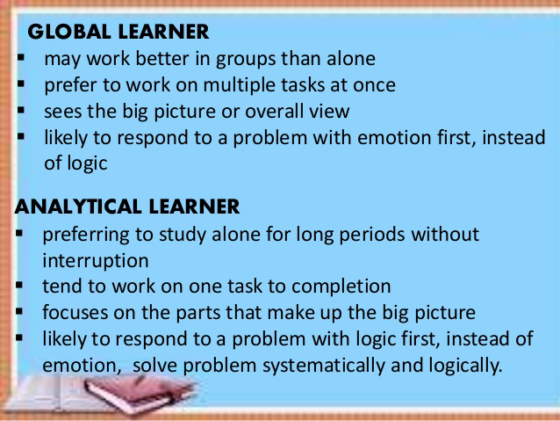

An

378. What ability does a child demonstrate if he can tell that the number of elements in the group is the same regardless of how the group is arranged in space as shown in the illustrations below.
Set A. ooooo Set B. o o o
ooooo o o oo
ooo

- Centration
- Conservation
- Reversibility
- Seriation

Answer is B. Conservation refers to the ability to determine that a certain quantity will remain the same despite adjustment of the container, shape, or apparent size.

379. Well-liked children can read and respond to peer’s emotions better than children who are not well liked. Whose research application is this?
- Bronfenbrenner’s ecological theory
- Erikson’s psychosocial theory of development
- Kohlberg’s stages of moral development
- Vygotsky’s sociocultural theory

Answer is B. According to Erikson, the child develops social relationships to others. In the Identity vs. Role Confusion (adolescence, 13–19 years) the adolescent is newly concerned with how they appear to others.

380. Which of the following conditions most likely brings about a classroom climate that is business-like yet non-threatening?
- Student leaders list the names of noisy classmates
- The authoritarian teacher is in full control of the classroom
- The teacher assigns student leaders who will check class attendance
- Rules, limits and expectations are made clear during the first day of classes

Answer is D. A business-like yet non-threatening classroom is one that has rules made clear on the first day of classes.

381. A child with a hearing loss is likely to have language delay as well. What does this prove?
- Physical development is very important
- Physical growth interacts with cognitive development
- Speech is easily influenced by other aspects
- Normal development is difficult to attain

Answer is C. Speech is affected by several factors like genetic and home environment factors. Example, Some parents are introverts and are very quiet at home. They seldom take the initiative to communicate with their children. Due to the lack of study models and persons to talk to, children will definitely have a slower development in speech. Nutrients and diseases also affect speech. If the child suffers from malnutrition, his or her speech development will be impaired. Some diseases, especially the ones that impact the brain, can have a negative impact on the speech development.
https://www.babyment.com/childcare.php?children=Factors-that-affect-speech-development-of-your-child

382. In early childhood, the pre-operational stage, centration is proven by children’s lack of conservation. This means that children _____
- Are able to understand that changing a substance’s appearance does not change its basic properties
- Exhibit primitive reasoning
- Are not able to distinguish their perspective from other’s perspective
- Believe that objects have lifelike qualities

Answer is B. In the Pre-Operational stage, intelligence is intutitive. The Pre-operational Stage is split into two substages: the symbolic function substage, and the intuitive thought substage. The symbolic function substage is when children are able to understand, represent, remember, and picture objects in their mind without having the object in front of them. The intuitive thought substage is when children tend to propose the questions of “why?” and “how come?” This stage is when children want the knowledge of knowing everything. The Intuitive Thought sub-stage occurs between 4 and 7. Children tend to grow very curious and ask many questions; they begin the use of primitive reasoning. What is true to the above question is that centration exhibits primitive reasoning.

Centration is the act of focusing all attention on one characteristic or dimension of a situation, whilst disregarding all others.

Conservation is the awareness that altering a substance's appearance does not change its basic properties. (Option A is conservation)

Option C is Egocentrism. Option D is animism.

383. One limitation of pre-operational thought is the believe that non-living objects have life-like qualities. What does this imply to teachers?
- correct children when their drawings are far from reality, e.g blue sun
- Evaluate children’s fanciful drawings as poor
- Discourage children from drawing something far from reality
- Accept children’s drawing as they are; this is a characteristics of children in the pre-operational thought

Answer is D. Children of preoperational stage are very imaginative and they learn from that.

384. Research says that children use primitive speech more when tasks are difficult, after they have made errors and when they are not sure how to proceed. What does this imply?
- Insist on silence or no talking rule when children are occupied with a task
- Allow children to engage in private talk while taking the written test
- Encourage children to do private talk to improve their performance
- I and II
- I and III
- II and III
- I, II and III

Answer is B. Since primitive speech occurs when children are doing a difficult task, silence must be observed when they are occupied with a task. They must also be engaged in private tlk to improve their performance.

385. According to Vygotsky, children construct knowledge through social interaction. What does this imply for children’s learning? This means that children should be given ______
- Chance to explore their world
- Opportunity to learn with skilled peers or teachers
- Questions to ponder on
- Books to read

Answer is B. Social interaction is made possible by establishing relationships with others.

386. According to Piaget, children construct knowledge by transforming, organizing and reorganizing previous knowledge. What does this imply for learning?
- Let children explore their world and discover knowledge
- Give children experts as guide
- Equip them with learning materials
- Give them adequate reward

Answer is A. After many years of observation, Piaget concluded that intellectual development is the result of the interaction of hereditary and environmental factors. As the child develops and constantly interacts with the world around him, knowledge is invented and reinvented.
http://www.sk.com.br/sk-piage.html

387. In Bruner’s three-tiered learning, which is action-based?
- Enactive learning
- Iconic learning
- Inactive learning
- Symbolic learning

Answer is A. Enactive “knowledge is stored primarily in the form of motor responses.” (Alexander 2002).
-In this stage individuals are learning through motor skills and by experimenting with and learning to manipulate objects.
- enactive stage appears first. This stage involves the encoding and storage of information. There is a direct manipulation of objects without any internal representation of the objects. (http://study.com/academy/lesson/jerome-bruners-theory-of-development-discovery-learning-representation.html)

388. Based on Kohlberg’s theory, what is the level of moral development shown when children generally do what is right in order to come up with their parents and teachers’ expectations of a good child?
- Conventional
- Formal
- Post-conventional
- Pre-conventional

Answer is A. Moral reasoning is based on the approval of others, law and order - Conventional morality

Kohlberg's Stages of Moral Development
Level 1 - Pre-conventional morality
At the pre-conventional level (most nine-year-olds and younger, some over nine), we don’t have a personal code of morality. Instead, our moral code is shaped by the standards of adults and the consequences of following or breaking their rules.
Authority is outside the individual and reasoning is based on the physical consequences of actions.
• Stage 1. Obedience and Punishment Orientation. The child/individual is good in order to avoid being punished. If a person is punished, they must have done wrong.
• Stage 2. Individualism and Exchange. At this stage children recognize that there is not just one right view that is handed down by the authorities. Different individuals have different viewpoints.

Level 2 - Conventional morality
At the conventional level (most adolescents and adults), we begin to internalize the moral standards of valued adult role models.
Authority is internalized but not questioned and reasoning is based on the norms of the group to which the person belongs.
• Stage 3. Good Interpersonal Relationships. The child/individual is good in order to be seen as being a good person by others. Therefore, answers relate to the approval of others.
• Stage 4. Maintaining the Social Order. The child/individual becomes aware of the wider rules of society so judgments concern obeying the rules in order to uphold the law and to avoid guilt.

Level 3 - Post-conventional morality
Individual judgment is based on self-chosen principles, and moral reasoning is based on individual rights and justice. According to Kohlberg this level of moral reasoning is as far as most people get.
Only 10-15% are capable of the kind of abstract thinking necessary for stage 5 or 6 (post-conventional morality). That is to say most people take their moral views from those around them and only a minority think through ethical principles for themselves.
• Stage 5. Social Contract and Individual Rights. The child/individual becomes aware that while rules/laws might exist for the good of the greatest number, there are times when they will work against the interest of particular individuals.
The issues are not always clear cut. For example, in Heinz’s dilemma the protection of life is more important than breaking the law against stealing.
• Stage 6. Universal Principles. People at this stage have developed their own set of moral guidelines which may or may not fit the law. The principles apply to everyone.
E.g. human rights, justice and equality. The person will be prepared to act to defend these principles even if it means going against the rest of society in the process and having to pay the consequences of disapproval and or imprisonment. Kohlberg doubted few people reached this stage.
https://www.simplypsychology.org/kohlberg.html
See also https://www.cs.umb.edu/~hdeblois/285L/Kohlberg'sMoralStages.htm

389. Which of the following laws states that we tend to fill the gaps in figures as we perceive them?
- Law of Proximity
- Law of Closure
- Law of Similarity
- Law of Pragnanz

Answer is B. The law of closure refers to the mind’s tendency to see complete figures or forms even if a picture is incomplete, partially hidden by other objects, or if part of the information needed to make a complete picture in our minds is missing. For example, if part of a shape’s border is missing people still tend to see the shape as completely enclosed by the border and ignore the gaps. This reaction stems from our mind’s natural tendency to recognize patterns that are familiar to us and thus fill in any information that may be missing.


The Gestalt law of proximity states that "objects or shapes that are close to one another appear to form groups". Even if the shapes, sizes, and objects are radically different, they will appear as a group if they are close


The principle of similarity states that, all else being equal, perception lends itself to seeing stimuli that physically resemble each other as part of the same object, and stimuli that are different as part of a different object. This allows for people to distinguish between adjacent and overlapping objects based on their visual texture and resemblance. Other stimuli that have differenfeatures are generally not perceived as part of the object


Law of Good Continuation (Law of Continuity)When there is an intersection between two or more objects, people tend to perceive each object as a single uninterrupted object. This allows differentiation of stimuli even when they come in visual overlap. We have a tendency to group and organize lines or curves that follow an established direction over those defined by sharp and abrupt changes in direction

Law of Common Fate. When visual elements are seen moving in the same direction at the same rate (optical flow), perception associates the movement as part of the same stimulus. For example, birds may be distinguished from their background as a single flock because they are moving in the same direction and at the same velocity, even when each bird is seen—from a distance—as little more than a dot. The moving 'dots' appear to be part of a unified whole. Similarly, two flocks of birds can cross each other in a viewer's visual field, but they will nonetheless continue to be experienced as separate flocks because each bird has a direction common to its flock.


The principle of good form refers to the tendency to group together forms of similar shape, pattern, color, etc. Even in cases where two or more forms clearly overlap, the human brain interprets them in a way that allows people to differentiate different patterns and/or shapes. An example would be a pile of presents where a dozen packages of different size and shape are wrapped in just three or so patterns of wrapping paper, or the Olympic Rings.

https://en.wikipedia.org/wiki/Principles_of_grouping

390. Lutz and Huit (2004) in their study on cognitive development and constructivism, said that, “Educators must activate previous experiences and knowledge in order to effectively present new information in a context that students can readily process.” What does this statement implies?
- Learning is cumulative
- Drill and review are important in the teaching-learning process
- The teacher must connect his/her lesson to student’s past experiences for meaning and understanding
- The teacher must incorporate appropriate teaching strategies in order to aid cognitive development effectively

Answer is C. Based on the study of Lutz and Huitt (2004) on the developmental theories of Dewey, Piaget, Vygotsky, and Bruner that provide the basis for the educational application of constructivism, Piaget believed that there are four distinct cognitive stages of development which all children go through in specific order. Each stage has a distinct characteristics. It is implied then that timing and readiness of a student for a particular lessons are important in the teaching-learning process. One way to do is activating previous experiences and knowledge or giving a review in order to connect previous lessons to the present lesson.
Regardless of the theory, the result is the same: educators must activate previous experiences, knowledge, and learning strategies in order to effectively present new information in a context that students can readily process.
http://www.edpsycinteractive.org/papers/cogdev.pdf

391. Greeno (1989) said that thinking is the result of the interaction between the individual and the environment. WHich of the theories of development support/s the idea of Greeno?
- Erikson’s psychological theory of development
- Kohlberg’s stages of moral development
- Piaget’s stages of cognitive development
- Vygotsky’s sociocultural theory
- III only
- I and III
- III and IV
- I, II, III and IV

Answer is C.
Greeno (1989), a leading proponent of situated learning, proposes that thinking is a result of interaction between the individual and the environment. Greeno argues that person/environment interactions are of such a complexity as to make attempts to discover generalized cognitive processes quite irrelevant. Rather he suggests a need to study how a student’s innate abilities are used to develop knowledge and thinking competencies through interaction with specific environments. This position suggests that the information processing model may be adequate to explain current understandings of how memory operates, but it does not fully describe or predict differences in cognitive development. Situated models like Greeno’s serve to highlight an ecological model for cognitive development that focuses on how individuals construct meaning from interactions with their environments (Huitt, 2003).

While John Dewey, Jean Piaget, Lev Vygotsky, and Jerome Bruner they may disagree as to the emphasis on the individual or environment, they would all recognize the importance of studying person/environment interactions.
http://www.edpsycinteractive.org/papers/cogdev.pdf

392. What is the teaching-learning application of Greeno’s statement that thinking is a result of the interaction between the individual and the environment?
- Social interaction plays a role in learning
- Collaborative approach should be used in the classroom
- Teacher should provide hands-on activities
- visual/instructional materials should be used in teaching
- I and II only
- III and IV
- I, II and III
- I, II, III and IV

Answer is D. All the choices promote learner’s interaction with his/her environment.

393. Teacher Rose begins a lesson on basic dance position by demonstrating the arms and feet position in slow motion and physically guiding her students through the correct movements. As her students become more skillful, she just gives verbal instruction. With Vygotsky’s theory in mind. What does Teacher Rose do?
- Guide participation
- Peer interaction
- Apprenticeship
- Scaffolding

Answer is D. In education, scaffolding refers to a variety of instructional techniques used to move students progressively toward stronger understanding and, ultimately, greater independence in the learning process. The term itself offers the relevant descriptive metaphor: teachers provide successive levels of temporary support that help students reach higher levels of comprehension and skill acquisition that they would not be able to achieve without assistance. Like physical scaffolding, the supportive strategies are incrementally removed when they are no longer needed, and the teacher gradually shifts more responsibility over the learning process to the student.

Scaffolding is widely considered to be an essential element of effective teaching, and all teachers—to a greater or lesser extent—almost certainly use various forms of instructional scaffolding in their teaching. In addition, scaffolding is often used to bridge learning gaps
http://edglossary.org/scaffolding/

394. Based on Freud’s theory, which operates when Mario lends his bicycle to his friend Julius who was crying for it?
- Ego
- Superego
- Id
- Id and Ego

Answer is B. The super-ego is observable in how someone can view themselves as guilty, bad, pathetic, shameful, weak, and feel compelled to do certain things.

Id, Ego and Superego
Saul McLeod published 2007, updated 2016
Perhaps Freud's single most enduring and important idea was that the human psyche (personality) has more than one aspect. Freud (1923) saw the psyche structured into three parts (i.e., tripartite), the id, ego and superego, all developing at different stages in our lives. These are systems, not parts of the brain, or in any way physical.
According to Freud's model of the psyche, the id is the primitive and instinctual part of the mind that contains sexual and aggressive drives and hidden memories, the super-ego operates as a moral conscience, and the ego is the realistic part that mediates between the desires of the id and the super-ego.
Although each part of the personality comprises unique features, they interact to form a whole, and each part makes a relative contribution to an individual's behavior.
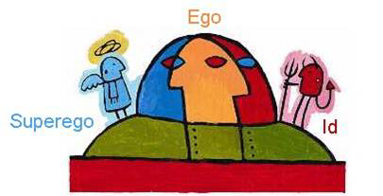

The id (or it)
The id is the primitive and instinctive component of personality. It consists of all the inherited (i.e., biological) components of personality present at birth, including the sex (life) instinct – Eros (which contains the libido), and the aggressive (death) instinct - Thanatos.
The id is the impulsive (and unconscious) part of our psyche which responds directly and immediately to the instincts.
The personality of the newborn child is all id and only later does it develop an ego and super-ego.
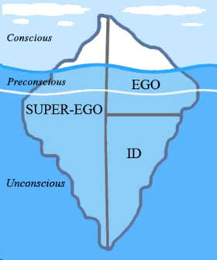
The id remains infantile in its function throughout a persons life and does not change with time or experience, as it is not in touch with the external world. The id is not affected by reality, logic or the everyday world, as it operates within the unconscious part of the mind.
The id operates on the pleasure principle (Freud, 1920) which is the idea that every wishful impulse should be satisfied immediately, regardless of the consequences. When the id achieves its demands, we experience pleasure when it is denied we experience ‘unpleasure’ or tension.
The id engages in primary process thinking, which is primitive, illogical, irrational, and fantasy oriented. This form of process thinking has no comprehension of objective reality, and is selfish and wishful in nature.

The Ego (or I)
The ego is 'that part of the id which has been modified by the direct influence of the external world.'
(Freud [1923], 1961, p. 25)
The ego develops to mediate between the unrealistic id and the external real world. It is the decision-making component of personality. Ideally, the ego works by reason, whereas the id is chaotic and unreasonable.
The ego operates according to the reality principle, working out realistic ways of satisfying the id’s demands, often compromising or postponing satisfaction to avoid negative consequences of society. The ego considers social realities and norms, etiquette and rules in deciding how to behave.
Like the id, the ego seeks pleasure (i.e., tension reduction) and avoids pain, but unlike the id, the ego is concerned with devising a realistic strategy to obtain pleasure. The ego has no concept of right or wrong; something is good simply if it achieves its end of satisfying without causing harm to itself or the id.
Often the ego is weak relative to the headstrong id, and the best the ego can do is stay on, pointing the id in the right direction and claiming some credit at the end as if the action were its own.
Freud made the analogy of the id being a horse while the ego is the rider. The ego is 'like a man on horseback, who has to hold in check the superior strength of the horse.'
(Freud, 1923, p.15)
If the ego fails in its attempt to use the reality principle, and anxiety is experienced, unconscious defense mechanisms are employed, to help ward off unpleasant feelings (i.e., anxiety) or make good things feel better for the individual.
The ego engages in secondary process thinking, which is rational, realistic, and orientated towards problem-solving. If a plan of action does not work, then it is thought through again until a solution is found. This is known as reality testing and enables the person to control their impulses and demonstrate self-control, via mastery of the ego.
An important feature of clinical and social work is to enhance ego functioning and help the client test reality through assisting the client to think through their options.

The Superego (or above I)
The superego incorporates the values and morals of society which are learned from one's parents and others. It develops around the age of 3 – 5 during the phallic stage of psychosexual development.
The superego's function is to control the id's impulses, especially those which society forbids, such as sex and aggression. It also has the function of persuading the ego to turn to moralistic goals rather than simply realistic ones and to strive for perfection.
The superego consists of two systems: The conscience and the ideal self. The conscience can punish the ego through causing feelings of guilt. For example, if the ego gives in to the id's demands, the superego may make the person feel bad through guilt. The ideal self (or ego-ideal) is an imaginary picture of how you ought to be, and represents career aspirations, how to treat other people, and how to behave as a member of society.
Behavior which falls short of the ideal self may be punished by the superego through guilt. The super-ego can also reward us through the ideal self when we behave ‘properly’ by making us feel proud.
If a person’s ideal self is too high a standard, then whatever the person does will represent failure. The ideal self and conscience are largely determined in childhood from parental values and how you were brought up.
https://www.simplypsychology.org/psyche.html

395. Prof. Pacis measures learning by the outward expression of new behaviors only such as ability to solve math ease. Which such theory does she apply?
- Cognitivism
- Social learning theory
- Behaviorist theory
- Multiple intelligence

Answer is C. Behaviorism refers to a psychological approach which emphasizes scientific and objective methods of investigation. The approach is only concerned with observable stimulus-response behaviors, and states all behaviors are learned through interaction with the environment.
The behaviorist movement began in 1913 when John Watson wrote an article entitled 'Psychology as the behaviorist views it,' which set out a number of underlying assumptions regarding methodology and behavioral analysis:
BASIC ASSUMMTION
All behavior is learned from the environment:
Behaviorism emphasizes the role of environmental factors in influencing behavior, to the near exclusion of innate or inherited factors. This amounts essentially to a focus on learning.
We learn new behavior through classical or operant conditioning (collectively known as 'learning theory').
Therefore, when born our mind is 'tabula rasa' (a blank slate).
https://www.simplypsychology.org/behaviorism.html

396. On which principle is your conviction based if you provide positive reinforcement whenever a learner performs an acceptable behavior on her own?
- Cognitivism
- Behaviorism
- Constructivism
- Psychoanalytic

Answer is B. One of the assumptions of behaviorist thought is that free will is illusory, and that all behavior is determined by the environment either through association or reinforcement.
http://www.innovativelearning.com/teaching/behaviorism.html

397. What does maturationist theory advance?
- Development is a product of maturation and learning as these two constantly interact one another?
- Development is a biological process that occurs automatically on predictable, sequential stage overtime
- Sociocultural factors should provide the basis for the education of young children
- The child’s environment shapes learning behavior

Answer is B. The maturationist theory was advanced by the work of Arnold Gessell. Maturationists believe that development is a biological process that occurs automatically in predictable, sequential stages over time (Hunt, 1969).
http://www.kenpro.org/papers/childhood-theory.htm

398. What does the environmentalist theory advanced by JOhn Watson, B.F SKinner and Albert Bandura assume?
- Children are active participants in the learning process
- Children initiates most of the activities required for learning and development
- Learning and development occur when young children interact with the environment
- The child’s environment shapes learning behavior

Answer is D. Theorists such as John Watson, B.F. Skinner, and Albert Bandura contributed greatly to the environmentalist perspective of development. Environmentalists believe the child's environment shapes learning and behavior; in fact, human behavior, development, and learning are thought of as reactions to the environment. This perspective leads many families, schools, and educators to assume that young children develop and acquire new knowledge by reacting to their surroundings.

399. What is a characteristic common among preschoolers where they give human quality to non-human things?
- Egocentrism
- Animism
- Association
- Projection

Answer is B. Animism is the belief that inanimate objects (such as toys and teddy bears) have human feelings and intentions. By animism Piaget (1929) meant that for the pre-operational child the world of nature is alive, conscious and has a purpose.

400. What is the systematic manner of providing the right amount of assistance to the learner to effectively acquire a skill?
- Scaffolding
- Guidance
- Counseling
- Tutoring

Answer is A. Scaffolding refers to a variety of instructional techniques used to move students progressively toward stronger understanding and, ultimately, greater independence in the learning process. The term itself offers the relevant descriptive metaphor: teachers provide successive levels of temporary support that help students reach higher levels of comprehension and skill acquisition

401. According to Piaget, children construct knowledge by transforming, organizing and reorganizing previous knowledge. What does this imply for learning?
- Let children explore their world and discover knowledge
- Give children experts as guide
- Equip them with learning materials
- Give them adequate reward

Answer is A.
According to Piaget, learning is an active rather than passive process. Experience, including the errors made therein, enables the construction of new knowledge, which involves two complementary processes: assimilation and accommodation.. In cognitive constructivist theory, information is valued as tools for problem solving rather than as plain facts isolated from real contexts. The Piagetian concept about knowing argues that knowledge cannot be “told”, “spoon-fed”, “given” or “poured”. Rather, teachers ought to provide opportunities for students to develop understanding through exploration and co-construction of knowledge.
https://ayeshapenuela.files.wordpress.com/2013/07/module-9-constructivist-theories.pdf

402. Which characterize autistic children?
- Repetitive behaviors
- Difficulty in social interactions
- Showing more interest in objects than on people
- I and II
- I, II and III
- I and III
- II and III

Answer is B. Autism spectrum disorders (ASD) are characterized by social-interaction difficulties, communication challenges and a tendency to engage in repetitive behaviors. By 8 to 10 months of age, many infants who go on to develop autism are showing some symptoms such as failure to respond to their names, reduced interest in people and delayed babbling.
https://www.autismspeaks.org/what-autism/symptoms

403. Young develop on their executive and sustained attention. What are indicators of executive functioning?
- Inhibiting a strong tendency that is incorrect
- Shifting attention to another topic/item
- Waiting longer to get a more attractive reward
- I, II and III
- I and III
- I and II
- II and III
Answer: A
The most widely known framework of executive function was proposed by Miyake et al., (2000). They viewed executive function as a general control mechanism that modulates cognition, with a focus on three executive functions:
(a) inhibition of prepotent responses,
(b) updating and monitoring of working memory representations, and
(c) shifting between mental sets. Inhibition is the deliberate, controlled suppression of prepotent responses.
Updating requires individuals to dynamically monitor and code incoming information based on relevance to the task and then revise the content held in working memory by replacing no longer relevant information with updated relevant information. Shifting between mental sets (task switching) involves the ability to engage and disengage from tasks and also the ability to perform a new operation in the face of proactive interference or negative priming.

Children gradually become more able to suppress automatic responses 18 during the preschool years in terms of the length of time that they can suppress their automatic responses. This ability is usually assessed using simple response inhibition tasks. For example, in the delay of gratification paradigm, children are asked to choose whether they want to get a reward now or wait longer for a bigger reward.
https://repository.asu.edu/attachments/158052/content/Yang_asu_0010E_15275.pdf

404. Research says that children learn words best in contexts that are meaningful. What does this imply to the teaching-learning process?
- Teach words in integrated contexts
- Teach new words in isolation from other lessons for greater focus
- Retain out-of-context classroom drills
- Reduce the number of new words taught for mastery

Answer is A. (See also the next question)
One important finding from research suggests that vocabulary learning never stops (Smith, 1998); it is a natural and lifelong phenomenon. Vocabulary learning is a continual process of encountering new words in meaningful and comprehensible contexts (Harmon, et al. 2009).
https://education.illinoisstate.edu/downloads/casei/AV-4-2a%20%20article%20%20teaching%20vocabulary%20across%20the%20curric.pdf

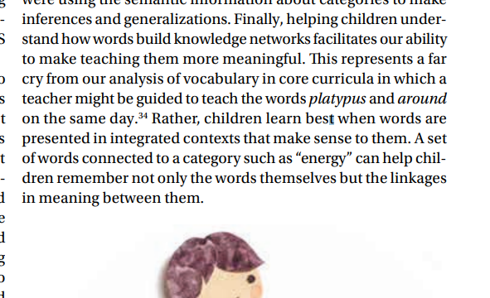
https://pdfs.semanticscholar.org/80c1/04dea2fe181d4bb3d79649396e0e99e47828.pdf

405. Research says that children learn words better in responsive and interactive contexts than in passive contexts. What is an implication of this finding in the teaching-learning process?
- Let them talk as they experience turn-taking opportunities
- Ask them to socialize with adults
- Give them scaffolding necessary for optimal word learning
- I, II and III
- II and III
- I and II
- I and III

Answer: A
Kathy Hirsh-Pasek and Roberta Golinkoff (Harris, Golinkoff, & Hirsh-Pasek, 2012; Hirsh-Pasek & Golinkoff, 2013) emphasize six key principles in young children's vocabulary development:

- Children learn the words they hear most often. They learn the words that they encounter when interacting with parents, teachers, siblings, peers, and also from books. They especially benefit from encountering words that they do not know.
- Children learn words for things and events that interest them. Parents and teachers can direct young children to experience words in contexts that interest the children; playful peer interactions are especially helpful in this regard.
- Children learn words best in responsive and interactive contexts rather than passive contexts. Children who experience turn-taking opportunities, joint focusing experiences, and positive, sensitive socializing contexts with adults encounter the scaffolding necessary for optimal word learning. They learn words less effectively when they are passive learners.
- Children learn words best in contexts that are meaningful. Young children learn new words more effectively when new words are encountered in integrated contexts rather than as isolated facts.
- Children learn words best when they access clear information about word meaning.
Children whose parents and teachers are sensitive to words the children might not understand and provide support and elaboration with hints about word meaning learn words better than when parents and teachers quickly state a new word and don't monitor whether children understand its meaning.
- Children learn words best when grammar and vocabulary are considered. Children who experience a large number of words and diversity in verbal stimulation develop a richer vocabulary and better understanding of grammar. In many cases, vocabulary and grammar development are connected.
https://www.reddit.com/r/Parenting/comments/40hc6f/how_do_you_talk_to_your_toddler/

406. . One research-based principle of child development is “early experiences have strong effects on children’s development and learning.” what is an implication of this to teaching-learning?
- Enrich early childhood with favorable experiences
- Teach them academic lessons as early
- Enroll them in preschool
- Assist their development by bringing them to tutorial centers

Answer: A
Research says that early interactions don’t just create context, they directly affect the way that the brain is “wired.” For instance, children who experienced extreme stress in early life are at greater risk of developing cognitive, behavioral and emotional difficulty. Thus, they must be enriched with favorable experiences only.
See https://www.unicef.org/dprk/ecd.pdf

407. One study revealed that co-parenting influenced young children’s effortful control above and beyond separate maternal and parental parenting. What does this imply?
- Solo parenting is ideal
- Father and mother should jointly raise a child
- Undermining of the other parent puts a child at risk for problems
- I and II
- I, II and III
- I and III
- II and III

Answer: D
In families characterized by multiple parents, one aspect of the family context within which father-child and other important relationships are nested is the coparenting relationship, or the relationship between adults in the family as parents. According to family systems theory (e.g., Minuchin, 1974), the coparenting relationship is a central element of family life, influencing parental adjustment, parenting, and child outcomes (Feinberg, 2003).

Coparenting can be defined as joint parenting within a family context and reflects the extent to which parents do (or do not) cooperate as a team in raising their children (Feinberg). Coparenting behavior is exemplified by undermining (hostility, competition) and supportive (warmth, cooperation) elements of interaction (Belsky, Putnam, & Crnic, 1996).
https://www.ncbi.nlm.nih.gov/pmc/articles/PMC3274773/

408. . Studies on delinquent students recommend effective parenting style for adolescents?
- Authoritative
- Authoritarian
- Neglectful
- Laizzes faire

Answer: A
Adolescents who viewed their parents as authoritative were reported less likely to have tried alcohol compared to adolescents who viewed their parents as authoritarian and neglectful.
file:///C:/Users/admin/Downloads/413-1-420-1-10-20130110%20(1).pdf

409.. Which strategies have been proven to increase children’s creative thinking?
- Encourage brainstorming
- Encourage internal motivation
- Guide children to take intellectual risks
- I and III
- I and II
- I, II and III
- I and III

Answer: C
Strategies for Children's Creative Thinking
1) Brainstorming
2) Provide Environments to stimulate creativity
3) Don't over control students
4) Encourage Internal motivation
5) Build Children's confidence
6) Guide Children to be persistent delay gratification
7) Encourage children to take intellectual risks
8) Introduce Children to creative people.
https://quizlet.com/167321372/chapter-8-intelligence-flash-cards/

410. Researchers have found that executive functioning is a better predictor of school readiness rather than IQ. what is an implication of this to the teaching-learning process?
- Strengthen executive functioning among learners
- Ignore executive functioning among learners
- Shape IQ with puzzles
- Do practice test to develop IQ

Answer A It is crucial that we develop good executive function in our children as early as possible. In fact, according to neuroscientist Philip Zelazo, frontal lobe executive function in childhood is a better predictor of school readiness than IQ. Let’s look at the brain to get a broad understanding and then examine what parents and teachers can do.
https://thinkersbox.com/childhood-thinking-skills-affect-life-outcomes/

411. Which dimensions of executive functioning are most important ot children’s cognitive development?
- Self-control
- Working memory
- Flexible thinking
- I and II
- I, II and III
- I and III
- II and III

Answer: B
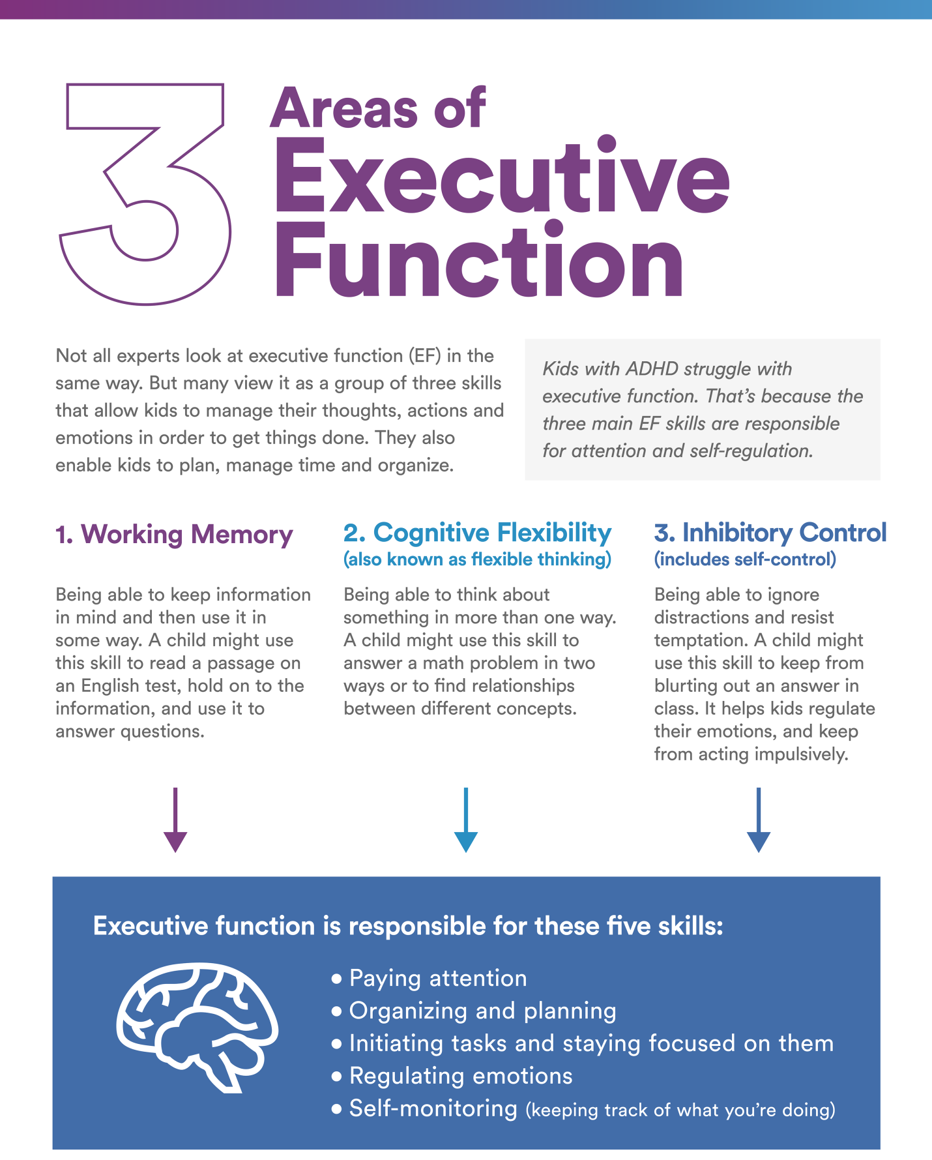
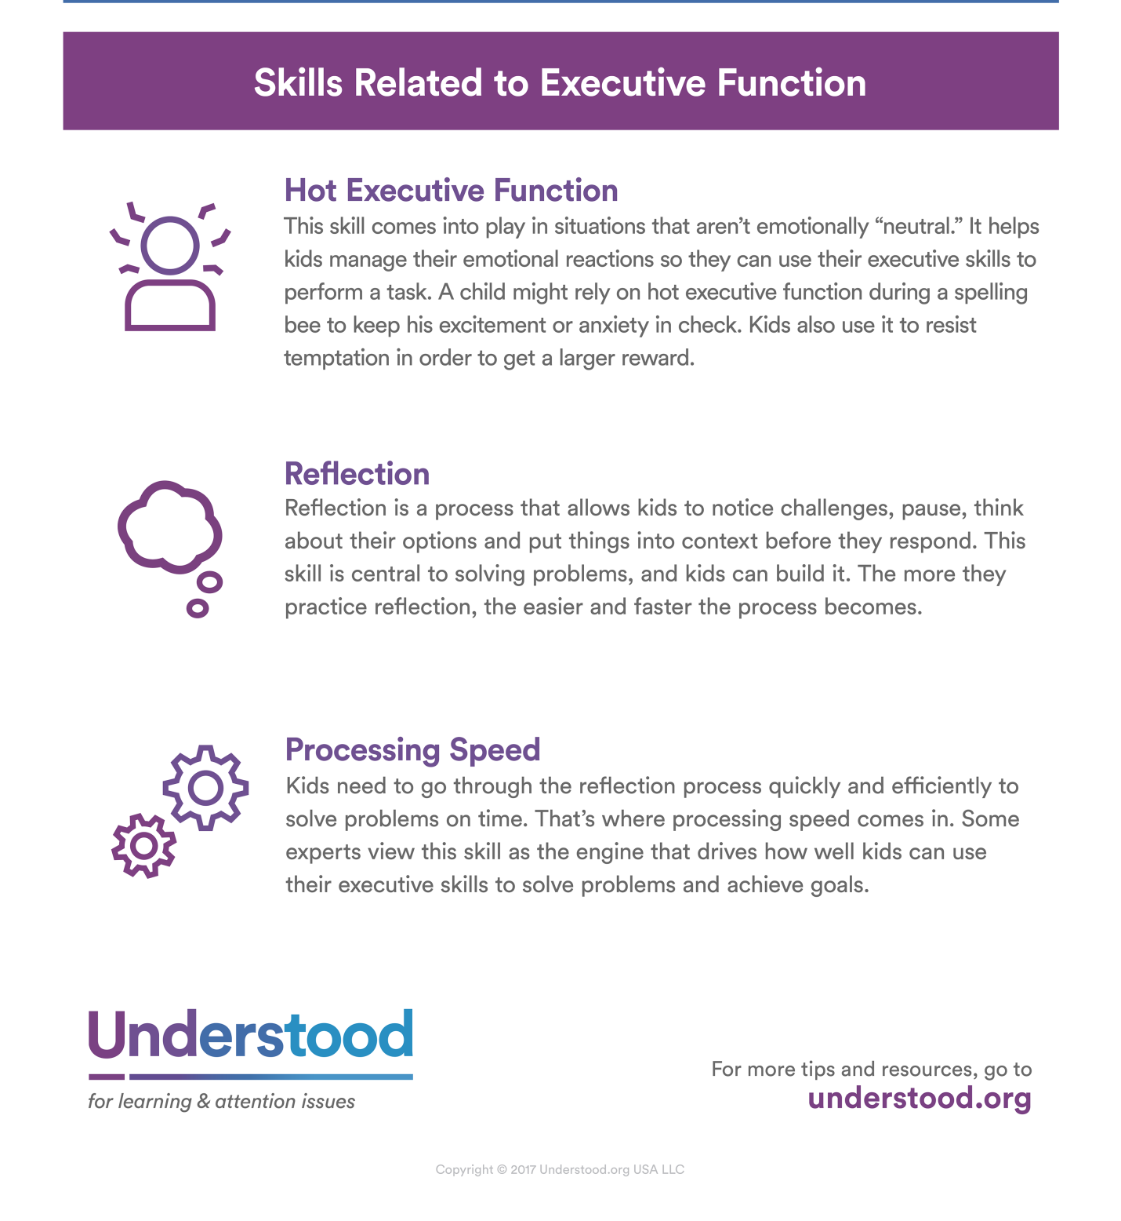
https://www.understood.org/en/learning-attention-issues/child-learning-disabilities/executive-functioning-issues/3-areas-of-executive-function

412. Research found out that children with low IQ who received full time, year-round child care long with medical and social work services had improved IQ and sustained the improved IQ compared with those who received same medical and social services but no child care. What does this point?
- Prevention rather than remediation is important in counteracting a deprived early environment’s effect on IQ
- Modifications in environment can change IQ scores considerably
- It is important to consider the types of environments for children
- I and II
- I, II and III
- II and III
- I and III

Answer: B
Researchers believed that modifications in environment can change students IQ scores -although genetic endowment may always influence a person's intellectual ability, the environmental influences and opportunities we provide children and adults make a difference Environmental Influences was found that middle-income professional parents were much more likely to communicate with their young children than welfare-income parents
-how much the parents communicated with their children in the first 3 years was correlated with the child's Standford-Binet IQ score -the more parents communicated with their children, the higher the children's IQ
-schooling also influences intelligence -large groups of children that have been deprived of formal education for an extended period of time, results in lower intelligence
-IQ scores have been increasing so fast that a high percentage of people regarded as having average intelligence at the beginning of the century would now be considered below average intelligence -this may be due to increasing levels of education attained by a much greater percentage of the world's population, or to other environmental factors such as the explosion of information to which people are exposed -this worldwide increase in intelligence is known as the Flynn Effect
-many low-income parents have difficulty providing an intellectually stimulating environment for their children -efforts to counteract a deprived early environment's effect on intelligence emphasize prevention rather than remediation
-research on early interventions conclude that: -high-quality child care centre-based interventions are associated with increases in children's intelligence and school achievement -the interventions are most successful with poor children and children whose parents have little education -the positive benefits continue through adolescence, but are not as strong as in early childhood -the programs that continue into middle and late childhood have the best long-term results Creating Culture-Fair Tests -culture-fair tests are tests of intelligence that are intended to be free of cultural bias
https://slideblast.com/physical-and-cognitive-development-in-middle-and-late-childhood-_5987dd861723dda9eb1fa637.html

413. Research found out that children have the highest self-esteem when they perform competently in domains that are important to them. Therefore, it is important that children should be _________
- Encourage to identify and value areas of competence
- Challenged to do difficult learning tasks
- Made to understand that academic competence is the only form of competence
- I only
- II and III
- I and II
- III only

Answer: A
Research by Susan Harter discusses how interventions must occur at the level of the causes of self esteem if children’s self esteem is to improve significantly. Children have the highest self esteem when they perform competently in domains that are important to them. Therefore, children should be encouraged to identify and value areas of competence. As an educator we can help guide students to explore their strengths and provide ample opportunities for students to achieve academic success. Success in activities that students deem inportant will help to boost their self esteem. For example, if a student is good in math, you can ask him to help you add up the scores of a test or chart the answers to a group project. Another example is to ask a student to model or demonstrate a solution that was correctly answered in the homework because you felt that she had a clear understanding of the problem and would like for her to share her knowledge with the rest of the class.
http://maxweber.hunter.cuny.edu/cgi-bin/eres/bbreadreply.pl?EDSPC715_MCINTYRE!1014!5!5

414. How should one care for children after a disaster?
- Encourage children to talk about any disturbing feeling reassuring them that such feelings are normal after a stressful event
- Discourage children to talk any disturbing feeling for this may only make things worse
- Do not allow children to retell the events for them not to be reminded of the event
- Make children understand that a disaster is God’s will and there is nothing we can do about it

Answer: A
Encourage children to share feelings. Try a simple question such as, “How are you feeling today?” Follow any conversations about the recent event with a favorite story or a family activity to help kids feel more safe and calm. http://childmind.org/wp-content/uploads/Child-Mind-Intitute-Parents-Guide-Traumatic-Event.pdf

What can caregivers do to help children when disasters occur?
1. Reassure children of their safety and security
2. Allow children to retell events and be patient in listening to them
3. Encourage children to talk about any disturbing or confusing feelings, reassuring them that such feelings are normal after a stressful event
4. Protect children from re-exposure to frightening situations
5. Help them make sense of what happened

415. What is the educational implication of the research finding that participation in extracurricular activities is associated with positive academic and psychological outcomes?
- Schools should organize quality varied extracurricular activities for students
- Schools should promote a balance of academic and extracurricular activities for its students
- Students should be encouraged to compensate for their poor academic performance by taking leadership roles in extracurricular activities
- I and III
- II and III
- I and II
- I only

Answer is C
Research indicates that participation in extracurricular activities affects students’ academic performance. The data revealed that, according to the students surveyed, playing sports, watching television, and participating in community service improves academic performance, while playing a musical instrument does not improve academic performance. Therefore, it was concluded that extracurricular activities affect academic performance and that the effect depends on the specific activities in which the student is involved.
Along with understanding the benefits of being involved in extra-curricular activities, students and parents may wish to consider how to balance academics and activities to have a positive impact on adolescents.

416. Case A: Teacher X asked her kindergarten pupils to draw the picture of their families. After the activity, she collected the children’s drawing and one of these caught her attention. Madeline’s drawing showed two families, one with a father, and one with just a mother. She interviewed Madeline about her drawing and found that her parents are separated and both already have their own families. Madeline is living with her grandmother. During the lunchbreak; Teacher X shared her discovery with her co-teachers. Was Teacher X’s action acceptable?
- Yes, other teachers should also know about Madeline
- No, the information is confidential
- Yes, it is a way of helping the child
- No, she should not be biased

Answer: B. The identity or other information that may reasonably identify the pupil, student or learner shall be kept confidential. (DO 22, s. 2012 - Adoption of the Unique Learner Reference Number)

417. Sunny Kindergarten School has an open admission policy, however, the school administers a diagnostic test during the first two weeks of classes to find out the pupil’s strengths and weaknesses. What is the purpose of this practice?
- Screen pupils who can proceed to the grades
- Determined who will be admitted to school
- Identify those who would be needing special help
- Suit the lesson to the ability of the pupils

Answer: C
Diagnostic assessment is used to identify a student'sneeds and abilities and the student's readiness to acquire the knowledge and skills outlined in the curriculum expectations.

http://www.edu.gov.on.ca/extra/eng/ppm/ppm155.pdf

418. A classroom environment that fosters learning is for the development of students’ growth mindset. Which is an indicator of a growth mindset?
- Learners believe that their learning is intelligence is simply an inborn trait and can’t be changed
- Learners believe they can develop their intelligence over time
- Learners believe that intelligence is inherited and they have nothing to do with it
- Learners believe that a favorable home and school learning environment cannot change mindset

Answer: B
After studying the behavior of thousands of children, Dr. Dweck coined the terms fixed mindset and growth mindset to describe the underlying beliefs people have about learning and intelligence. When students believe they can get smarter, they understand that effort makes them stronger. Therefore they put in extra time and effort, and that leads to higher achievement.
The illustration below shows that intelligence may be developed over time.
https://www.mindsetworks.com/science/
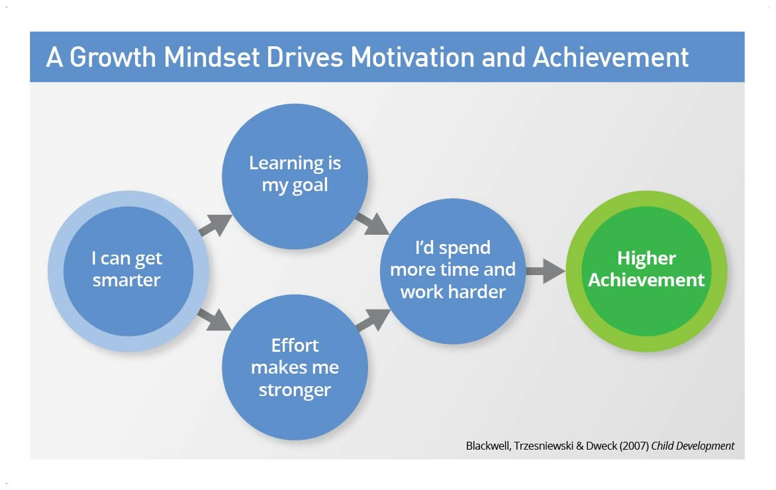

419. In the context of growth mindset, which does/do NOT belong?
- “Right answer” approach
- “One-size-fits-all” approach
- Mistake or a problem is a learning opportunity
- I and III
- III only
- II and III
- I and II

Answer: D
It has been shown that individuals with a growth mindset for learning see mistakes as opportunities to learn and improve, whereas for fixed-minded individuals mistakes indicate lack of ability. http://file.scirp.org/Html/7-6901870_69884.htm

420. Which should a teacher have more in class to create growth mindset?
- Nurturing learners’ sense of independence and self-efficacy
- Look down on inquiry and theory-building as these time-consuming
- Not welcome mistakes or problems
- I only
- III only
- II only
- II and III

Answer: A
By allowing children to explore and access "supports" in their environment we are providing them the opportunity to develop their Growth Mindset, (a) embrace a challenge, (b) learn from their mistakes, (c) try different strategies, (d) problem solve, and (e) build their self-efficacy (the belief in their own abilities and capabilities) and agency (the knowledge that they are in control of their actions) (Carter, 2010).
A child's strong sense of independence, self-efficacy, and agency (indicators of a GM) can be heard in common toddler statements like: "I can do it"; "I want to do it myself"; "Let me do it".
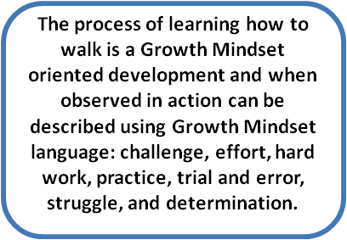
https://blog.mindsetworks.com/entry/nurturing-a-growth-mindset-in-early-learners-across-the-developmental-continuum-leads-to-school-readiness

421. Which should a teacher encourage to build a growth mindset in class?
- Sense of wonder
- Inquiry
- “Right answer” consciousness
- I only
- I and II
- II only
- I, II and III

Answer: B
Four child development and early learning milestones (there are many more) as natural opportunities to nurture a growth mindset in early learners:
(a) learning to walk,
(b) a child's sense of independence, self-efficacy and agency,
(c) a child's inquiry (wonders and questions), and
(d) school readiness.
https://blog.mindsetworks.com/entry/nurturing-a-growth-mindset-in-early-learners-across-the-developmental-continuum-leads-to-school-readiness

422. To create a favorable atmosphere, competition should be avoided at all cost. If there is an element of competition it is _______
- Part of a game
- Self-competition against standards set
- Within the same gender
- I and II
- II and III
- I only
- I, II and III

Answer: A
You should only compete with one person: yourself

This perspective is what people mean by healthy competition. The most important part of competing against yourself is the ability to set your own values and metrics. You choose the goals that fit you best, and what you really want to compete on — and what you don’t.
Sometimes you lose ( just like in a game) but you move forward. You might do worse than you did before. Some days, it’s just enough not to take a step backward. And others, when you least expect it, you bound forward.
https://medium.com/the-mission/you-should-only-compete-with-one-person-yourself-dfc8eb864f3c

423. Which is/are characteristics of a culturally responsive teaching?
- Cross disciplines and cultures to engage learners while respecting their cultural integrity
- Accommodates the dynamic mix of race, ethnicity, class, gender, region, religion and family that contributes to every student’s cultural identity
- Presents some cultures to be superior than others to improve inferior cultures
- I and III
- III only
- II only
- I and II

Answer: D
“A pedagogy that crosses disciplines and cultures to engage learners while respecting their cultural integrity. It accommodates the dynamic mix of race, ethnicity, class, gender, region, religion, and family that contributes to every student’s cultural identity. The foundation for this approach lies in theories of intrinsic motivation” (Wlodkowski & Ginsberg, 1995).
https://educonnections.org/tag/bemore/

Their framework recommends that teachers (1) establish inclusion, (2) develop positive attitudes, (3) enhance meaning, and (4) engender competence. Among the most effective strategies for culturally responsive teaching: discussion groups; writing groups, peer teaching, learning contracts, cooperative groups, projects and problems, narrative evaluations, credit/no credit systems, and student/teacher/parent conferences.
http://www.ascd.org/publications/educational-leadership/sept95/vol53/num01/abstract.aspx#A_Framework_for_Culturally_Responsive_Teaching

424. If a teacher works on an intrinsic motivation framework to help develop intrinsic motivation among learners, which motivational conditions form apart?
- Establishing inclusion- creating a learning atmosphere in which students and teachers feel respected by and connected to one another
- Developing attitude - creating a favorable disposition toward the learning experience through personal relevance and choice
- Enhancing meaning - creating challenging, thoughtful learning experiences that include student perspectives and values
- Engendering competence - creating an understanding that students are effective in learning something they value
- I and II
- I, II and III
- III and IV
- I, II, III and IV

Answer: D
Based on theories of adult learning and intrinsic motivation, and the assumption that learning and culture are inseparable, the Motivational Framework for Culturally Responsive Teaching is a “holistic and systemic representation of four intersecting motivational conditions” that educators can create or enhance: establishing inclusion, developing attitude, enhancing meaning, and engendering competence (Wlodkowski & Ginsberg, 2010, p. 114).

Establishing inclusion is the first motivational condition. It entails creating an atmosphere in which learners feel respected and connected to each other and to the content they about to learn. Inclusion should be established at the beginning of the lesson or learning event. “Our experience suggests,” say Wlodkowski and Ginsberg (2010), “that establishing a sense of community within an intensive source should be a primary goal for the first class session” (p. 61). Strategies used to address this condition help establish a climate of respect and community in which learners will feel more included, connected, safe, and comfortable; and in turn, their intrinsic motivation will be more likely to emerge. Some of the strategies that should be used to establish inclusion includes class introductions and multidimetional sharing where student see what they have in common and share their expectations, goals, and past experience. Other strategies include clarifying course goals and learning outcomes and connecting content and assignments to learners’ personal and professional lives.

The second motivational condition is developing attitude. This too should be incorporated at the beginning of the lesson or learning event. Since one cannot force, cajole, or even convince a student to like learning, this condition is concerned with treating adult learners in such a way that will “help them build positive attitudes towards their learning and themselves as learners” (Wlodkowski, 2008, p. 172). A big part of this is presenting the subject matter so that learners see how it is relevant to their personal lives and work. Strategies that should be used to develop positive attitudes include scaffolding complex learning, use of relevant models, making assessments fair and clear, and helping students plan for their work, both in terms of effort and time.

The third condition, enhancing meaning, refers to creating engaging and challenging learning experiences that include the learner’s perspectives and values. This condition strives to gain and sustain the learner’s attention, and then convert that attention to deeper engagement, interest, and meaning. Strategies to meet these goals should be implemented throughout the learning experience and may overlap with other strategies used for other conditions. Some of the strategies for enhancing meaning include using a variety of modalities to present content, presenting learning activities in a clear and accurate manner, relating course activities to learners’ individual interests and concerns, and using examples and concept maps. Activities such as case studies, role playing, and simulation should be used to make content relevant and evoke critical discussion. Other possible activities include the use site visits and internships.

The final condition, engendering competence, can also be incorporated throughout the learning experience. In general, however, it should primarily come at the end. This condition involves providing opportunities for learners to demonstrate that they have effectively learned something that is of value and relevant to the real world. Assessment does not equal competence; however, it does “exerts a powerful motivational influence on adults because it is the socially sanctioned educational procedure to communicate about their competence” (Wlodkowski, 2008, p. 312). For assessment to be intrinsically motivating for adults it has to mirror an authentic work or life situation. In addition to making assessments authentic, other strategies that can be built into the course design include making assessment tasks and criteria clearly known to student in advance and fostering the intention to transfer learning.
https://www.uwplatt.edu/files/TTC/Accelerated/kahrhoffjahna.pdf

425. At the start of a new term, Teacher Z wants to familiarize students with active research methods. She will use such methods throughout the semester, and she knows from previous experience that many students view research as abstract, irrelevant and oppressive of work. She randomly assigns students to small groups. She encourages them to discuss any previous experiences they may have had in doing their research as well as their expectations and concerns for the course. Each group then shares its experiences, expectation, and concerns and records them on the chalkboard. In this manner, she is able to understand her student’s perspectives and to increase their connection to one another and herself.
Which technique did Teacher Z employ to create a favorable climate?
- She established inclusion
- She promised not to make research work oppressive
- She makes clear that only positive learning experiences should be shared in the group
- She grouped the students according to ability

Answer: A Refer to the notes in the previous question.

426. Teacher Z explains that most people are researchers much of the time and she asks the students what they would like to research among themselves. After a lively discussion, the class decides to investigate and predict the amount of sleep some members of the class had the previous night.
How may the intrinsically motivating experiences in the class be described?
- Students make a choice
- Students freely discuss among themselves
- Teachers warns them on difficult researches
- I only
- I and II
- II and III
- I, II and III

Answer: B. Intrinsic motivation arises from inside the individual. The teacher need not tell tell them.

427. Increasing latency periods when questioning students helps create a positive learning atmosphere. Which practice contradicts this principle?
- Quickly give up on a student who is struggling with a response
- Make a conscious effort to extend the length of wait time before student can give a response
- Call only on students with hands raised so as not waste time waiting
- Answer the question yourself if no student can answer your question

Answer: A

Increasing latency (Kerman et al., 1980) is another technique you can use to communicate that you have positive expectations for a student. Latency is the amount of time that elapses between the moment you give a student a response opportunity and the moment you terminate the response opportunity.

Kerman and colleagues (1980) explain that the amount of time we give to students to answer questions is directly related to the level of expectation we have for them. We give more time to students when we have confidence in their ability to answer a question. Conversely, we give less time to students in whom we have little confidence. When you quickly give up on a student who is struggling with a response, it is clear to everyone in the classroom that you don't expect him or her to come up with the right answer. In addition, when you give up on a student who initially struggles with a response, the student realizes that all he or she needs to do to “get off the hook” is respond to your question with a confused expression or blank stare. What you will find when you make a conscious effort to extend the length of latency you allow for low-achieving students is that these students will begin to pay more attention, become more actively involved in discussions, and minimize their behavior issues. One thing you can do is ask a teaching peer to observe your instruction and chart the length of the latency periods you are giving each student from the time you ask the question until you move on to another student. It is especially interesting to find out which students get longer latency periods from you. http://www.ascd.org/publications/books/105124/chapters/Developing_Positive_Teacher-Student_Relations.aspx

428. Develop positive classroom pride is one way of creating positive learning climate. Which practice contributes to the development of a positive classroom pride?
- Display student work
- Reinforce students verbally
- Be proud of the class’s achievements
- I and II
- I and III
- II and III
- I, II and III

Answer: D
Strategies to Develop Positive Classroom Pride

1. Display student work
2. Positively reinforce students verbally
3. Show off the class’s achievements
4. Speak to the accomplishments of all your students
5. Be sincere in your pride in your students
6. Look for opportunities for students to be proud in all areas
7. Develop parental pride in student accomplishments
8. Develop pride in improvement in addition to pride in excellence
http://courseweb.ischool.illinois.edu/~bjmason2/Discipline.htm

429. Which is the impact of the following classroom management practices: develop parental pride in student accomplishments; be sincere of your pride in your students; and look for opportunities for students to be proud in all areas?
- Positive classroom pride
- Students’ pride and arrogance
- Students’ feeling of overconfidence
- Student’s distorted self-image

Answer: A
Strategies to Develop Positive Classroom Pride

1. Display student work
2. Positively reinforce students verbally
3. Show off the class’s achievements
4. Speak to the accomplishments of all your students
5. Be sincere in your pride in your students
6. Look for opportunities for students to be proud in all areas
7. Develop parental pride in student accomplishments
8. Develop pride in improvement in addition to pride in excellence
http://courseweb.ischool.illinois.edu/~bjmason2/Discipline.htm

430. To build strong and healthy relationship in class which should be out of the picture?
- Criticizing
- Listening
- Befriending
- Blaming
- I and IV
- II and III
- I and II
- I and III

Answer: A. Criticizing and blaming do not promote healthy classroom environment.

431. Confucius once said: “All men are pretty much alike; it is only by culture that they are set apart.” Which thought in this quotation contributes to learning environment that is bias free?
- That all people are basically the same and therefore everyone deserves respect
- That all people are basically the same; they just differ in the way they live such as dressing, eating, speaking
- That it is just men, women excluded, who are basically the same
- I only
- I and II
- III only
- I, II and III
Answer: B. Statement III is prejudicial. It portrays inequality or bias.

432. An atmosphere that is favorable for learning ensures that what a student learns, how he or she learns it, and how the students demonstrates what he or she has learned is a match for that student’s readiness level, interests, and preferred mode of learning. Which instruction is referred to?
- Differential
- Differing
- Differentiated
- Different

Answer: C
Differentiated instruction is an approach to teaching in which educators actively plan and adjust for students’ differences so that instruction suits and supports all students’ strengths and needs. It is the process of ensuring that what a student learns, how he or she learns it, and how the student demonstrates what he or she has learned is a match for that student’s readiness level, interests, and preferred mode of learning. There can be differentiation of content, process, product, and learning environment.
http://inservice.ascd.org/differentiated-instruction-works-how-and-why-to-do-di/

433. In a favorable learning environment, which competition promotes learning?
- Between boys and girls
- Within members of the same gender
- For academic honors
- Against standards set

Answer: C
Healthy competition is a competition against oneself (against one’s standards set) You should only compete with one person: yourself

This perspective is what people mean by healthy competition. The most important part of competing against yourself is the ability to set your own values and metrics. You choose the goals that fit you best, and what you really want to compete on — and what you don’t.
Sometimes you lose ( just like in a game) but you move forward. You might do worse than you did before. Some days, it’s just enough not to take a step backward. And others, when you least expect it, you bound forward.

In short, do not compete for academic honors alone or else you would be competing with others. Rather compete with yourself and set your standards on reaching that goal of academic excellence.
https://medium.com/the-mission/you-should-only-compete-with-one-person-yourself-dfc8eb864f3c

434. For a positive learning environment it is good to make clear that an individual’s beliefs and activities should be understood by others in terms of that individual’s own culture. Which concept is explained?
- Ethical relativism
- Individual differences
- Cultural relativism
- Cultural sensitivity

Answer: C
Cultural relativism is the idea that a person's beliefs, values, and practices should be understood based on that person's own culture, rather than judged against the criteria of another.

435. Gender stereotypes do not contribute to a positive learning atmosphere. The following are proofs of gender stereotype in class EXCEPT _______
- Boys are asked to solve word problems because they are “naturally” good at math
- Girls help with the cleaning up of the classroom as they are expected to be more inclined to do housework
- Girls and boys do the same activities in the Subject Edukasyong Pantahanan at Pangkabuhayan
- Girls are encouraged to be soft spoken and home bound playing with dolls and kitchen toys while boys are encouraged to be aggressive by playing outside with cars and guns

Answer: C
Gender stereotypes are preconceived ideas whereby females and males are arbitrarily assigned characteristics and roles determined and limited by their gender. Only option C do not portray stereotyping since it views boys and girls as equals.

436. For a favorable learning climate, ethnocentrism should be out of the picture. What does this mean?
- Learners should be discouraged from competing against one another
- No one should think that he/she is better than other individuals for reasons based solely on his/her inheritance
- Impress on the learners’ minds that some people are better or worse than them through no fault of their own
- No one should accept that other’s culture is better than his/hers

Answer: B
Ethnocentrism is defined as a belief in the superiority of one’s own group. For a favorable learning climate, no one should think that he/she is better or superior than others.

437. One group of four students was making sounds in the room while Teacher B was grading papers during silent reading. He did not know which group was making the sounds, so he warned the students that they would be inside for recess if it went on. The offending students knew he did not know who it was, so they kept it up to test the waters. Mr. B announce to the entire class that if he heard noises one more time, the whole class would be in for recess, regardless of who it was. The other students were very upset, and one expressed, “That’s not fair”. Was Teacher B’s decision fair?
- Yes, because the class seemed not to have cooperated to stop the misbehavior
- Yes, to give a lesson to all
- No, it was unfair to punish the whole class for the misdemeanor of one
- No, but that was the only way to show to the class he means business

Answer: C

Collective punishment is not allowed. If the statement only means to threaten, still it is not allowed. It is a form of negative discipline.
UNESCO publication “Embracing Diversity: A Toolkit for Creating Inclusive, Learning-Friendly Environments” (ILFE Toolkit) is a specialized booklet intended to help teachers, school administrators, and education officials to effectively manage students in the classroom by giving nonviolent ways to deal with behavioural challenges positively and pro-actively. It presents positive discipline tools that are concrete alternatives to such punishment practices as caning, spanking, pinching, threatening, pleading, bribing, yelling, commanding, name-calling, forced labour, and other even more humiliating actions.

Negative discipline is a form of punishment meant to control a student’s behaviour, but oftentimes it involves only short verbal commands or statements and does not lead to an outright, often severe penalty, such as being hit or painfully humiliated. Teachers who do not use corporal punishment may use negative discipline approaches instead. But like corporal punishment, these also can cause children to become angry and aggressive or have low self-esteem. Negative strategies include:
Commands – “Sit down and be quiet!” “Write 100 times, ‘I will not waste my time on meaningless tasks’.”
Forbidding statements – “Don’t do that!”
Explosive, angry statements – “You’re in more trouble than you know.”
Criticizing statements – “Is that the best you can do!”
Threatening statements – “If you don’t stop talking, I’ll send you to the Principal’s office.”
Belittling statements – “When will you ever learn to write well?”

, we use these negative strategies, as well as corporal punishment, when we are angry or frustrated. Yet, there are a variety of positive ways to deal with anger and frustration. Some teachers tell their children, “I need a moment to calm down; I am very angry right now.” Others calm down by counting to 10 or by leaving the room for several minutes. Some teachers describe their feelings to their students to help them understand what annoys them. The children then learn what not to do and why. They might do it again, but they are responsible for their actions and will have to deal with the consequences.

http://www.deped.gov.ph/sites/default/files/page/2016/POSITIVE%20DISCIPLINE%20IN%20EVERYDAY%20TEACHING%20-%20A%20Primer%20for%20Filipino%20Teachers.pdf

438. Prof. A taught her Mathematics class about addition of fractions. She administered as assessment tool to give her feedback so she can help the students learn more. Whar form of assessment was given?
- Summative
- Formative
- Peer
- Self

Answer: B
Formative assessment has a developmental purpose and is designed to help learners learn more effectively by giving them feedback on their performance and on how it can be improved and/or maintained (QAA, 2006, p35).

439. The class of Mr. San Juan was asked to provide feedback on each other’s learning. Which form of assessment was used?
- Summative
- Formative
- Peer
- Self

Answer: C
Peer assessment, or self-assessment, is a process whereby students or their peers grade assignments or tests based on a teacher's benchmarks. The practice is employed to save teachers time and improve students' understanding of course materials as well as improve their metacognitive skills.

440. The TLE class of Prof. Bellin was taught on how to take measurement for a pair of pants. An assessment was administered by Prof. Bellin to express judgment on the student’s skill on measurement of pants. What form of assessment was administered?
- Performance
- Formative
- Peer
- Self

Answer: A
Performance assessment, also known as alternative or authentic assessment, is a form of testing that requires students to perform a task rather than select an answer from a ready-made list.

441. The class of Miss Reyes belongs to a fast learners’ group. She gave activities for each to develop personal responsibility. Which activity was utilized?
- Independent learning
- Cooperative learning
- Competitive learning
- Evaluative learning

Answer: A
Independent learning is when students take responsibility for their own learning. An independent learner will tend to be self-directed and self reliant. They are aware of their own strengths as learners and areas of weakness. They connect the learning within the classroom to the real world and can set their own goals. They tend to be intrinsically motivated by making progress in learning and can reflect on their own progress.

442. After the students have been exposed to the activities, they were asked to evaluate their own learning with the use of a scoring rubric. What evaluation tool was used?
- Peer
- Self
- Formative
- Summative

Answer: B
Self-evaluation is looking at your own progress, development and learning to determine what has improved and what areas still need improvement.

443. A test was given to the students by Mr. Lapid to determine what the students already know about the subject before he taught. Which did he give?
- Peer
- Self
- Pretest
- Posttest

Answer: C
A pretest is a preliminary test administered to determine a student's baseline knowledge or preparedness for an educational experience or course of study.

444. Mrs. Dy is doing an assessment of learning. Which of the following questions would she likely consider?
- Have the students already achieved the intended outcomes?
- Do the students have the prerequisite skills?
- Which tasks are students handling satisfactorily?
- What grade should I assign to each student?

Answer: Option D is an assessment of learning. Options A and B are assessment as learning. Option C is an assessment for learning.

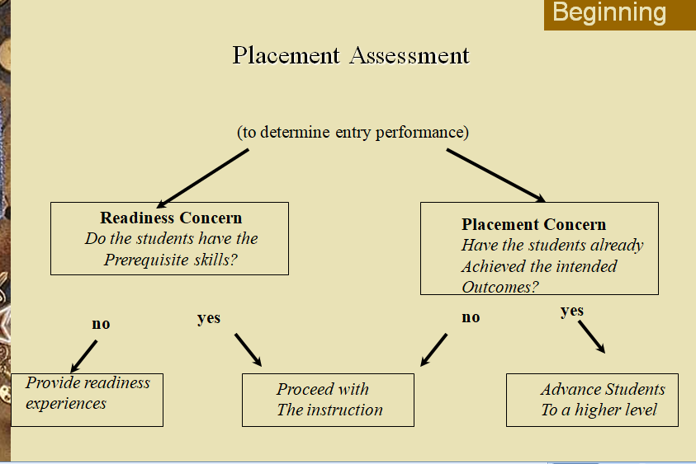

During Instruction:
Formative and Diagnostic Assessment
- During Instruction, ask yourself as teacher:
  - On which learning tasks are the students progressing satisfactorily? On which learning tasks do the students need help?
    - Formative assessments: measure student mastery by measuring
      - The intended outcomes of the UNIT of instruction
      - Using the results to improve learning (not give grades, necessarily)
      - May involve assessment of a product - writing, portfolios, videos,art, music, welding,speech.
  - Which students are having such sever learning problems that they need remedial work?
    - Diagnostic assessments: Focus on a common source of error for students in a learning process. Tests with slight variations between them that indicate where the student’s learning is a problem for them.
    - For example, you would ask yourself:
    - Are students having trouble adding because they don’t know certain number combinations, or because they can’t carry a number?
    - Are students struggling with German because of inadequate vocabulary or because they do not grasp the elements of grammar?

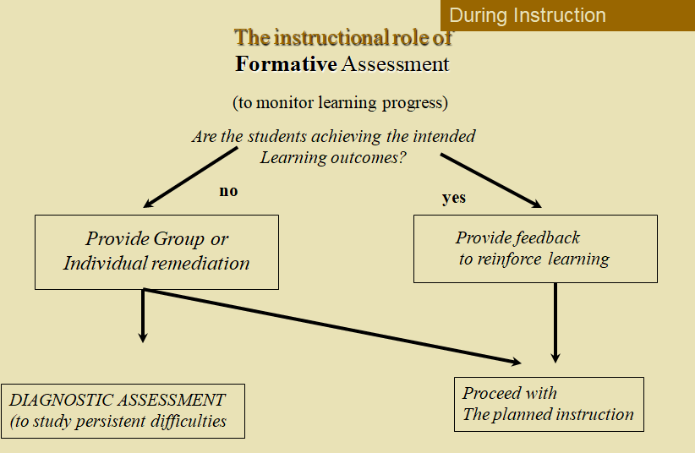

Assessment at the End of Instruction

- Ask yourself, as teacher:
  - Which students have mastered the learning tasks to such a degree that they should proceed to the next course or unit of instruction?
  - What grade should be assigned to each student?
Summative Assessment: Occurs at the end of instruction for the purpose of certifying mastery or assigning grades.
- Is also part of the course redesign.

445. What does an achievement test measure?
- Capacity for future learning
- Educational and vocational aptitude
- Quality and quantity of previous learning
- Quality and quantity of previous teaching

Answer: C
Any test that is intended by its developer to reflect the amount of learning that has occurred in the past can be considered an achievement test

446. Miss Eugenio would like to cover a wide variety of objectives in the quarterly examination in her English class lesson on subject-verb agreement. Which of the following types of test is the most appropriate?
- True-False
- Multiple choice
- Matching
- Essay
Answer: B
Multiple choice questions have several advantages. They lend themselves to covering a broad range of content and assessing a wide variety of learning objectives.
https://ii.library.jhu.edu/tag/multiple-choice-questions/

447. Which purpose of evaluation distinguishes it from measurement?
- Determine the effectiveness of the teacher’s teaching.
- Compare individual’s performance with national standards.
- Determine the extent of relative attainment of moral and ethical values.
- Interpret measured performance in terms of certain criteria of acceptability and adequacy.

Answer: D
Broadly conceived, classroom assessment involves two major types of activities: collecting information about how much knowledge and skill students have learned (measurement) and making judgments about the adequacy or acceptability of each student's level of learning (evaluation).

What is Assessment?

Broadly conceived, classroom assessment involves two major types of activities: collecting information about how much knowledge and skill students have learned (measurement) and making judgments about the adequacy or acceptability of each student's level of learning (evaluation). Both the measurement and evaluation aspects of classroom assessment can be accomplished in a number of ways. To determine how much learning has occurred, teachers can, for example, have students take exams, respond to oral questions, do homework exercises, write papers, solve problems, and make oral presentations. Teachers can then evaluate the scores from those activities by comparing them either to one another or to an absolute standard (such as an A equals 90 percent correct). Throughout much of this chapter we will explain and illustrate the various ways in which you can measure and evaluate student learning.

Measurement

Measurement is the assignment of numbers to certain attributes of objects, events, or people according to a rule-governed system. For our purposes, we will limit the discussion to attributes of people. For example, we can measure someone's level of typing proficiency by counting the number of words the person accurately types per minute or someone's level of mathematical reasoning by counting the number of problems correctly solved. In a classroom or other group situation, the rules that are used to assign the numbers will ordinarily create a ranking that reflects how much of the attribute different people possess (Linn & Gronlund, 1995).

Evaluation

Evaluation involves using a rule-governed system to make judgments about the value or worth of a set of measures (Linn & Gronlund, 1995). What does it mean, for example, to say that a student answered eighty out of one hundred earth science questions correctly? Depending on the rules that are used, it could mean that the student has learned that body of knowledge exceedingly well and is ready to progress to the next unit of instruction or, conversely, that the student has significant knowledge gaps and requires additional instruction.

Why Should We assess Students' Learning?

This question has several answers. We will use this section to address four of the most common reasons for assessment: to provide summaries of learning, to provide information on learning progress, to diagnose specific strengths and weaknesses in an individual's learning, and to motivate further learning.

Summative Evaluation

The first, and probably most obvious, reason for assessment is to provide to all interested parties a clear, meaningful, and useful summary or accounting of how well a student has met the teacher's objectives. When testing is done for the purpose of assigning a letter or numerical grade, it is often called summative evaluation since its primary purpose is to sum up how well a student has performed over time and at a variety of tasks.

Formative Evaluation

A second reason for assessing students is to monitor their progress. The main things that teachers want to know from time to time is whether students are keeping up with the pace of instruction and are understanding all of the material that has been covered so far. For students whose pace of learning is either slower or faster than average or whose understanding of certain ideas is faulty, you can introduce supplementary instruction (a workbook or a computer-based tutorial program), remedial instruction (which may also be computer based), or in-class ability grouping (recall that we discussed the benefits of this arrangement in Chapter 6). Because the purpose of such assessment is to facilitate or form learning and not to assign a grade, it is usually called formative evaluation.

Diagnosis

A third reason follows from the second. If you discover a student who is having difficulty keeping up with the rest of the class, you will probably want to know why in order to determine the most appropriate course of action. This purpose may lead you to construct an assessment (or to look for one that has already been made up) that will provide you with specific diagnostic information.
https://college.cengage.com/education/pbl/tc/assess.html

448. Prof. de Leon plans to do assessment FOR learning, then she should plan how to _______.
- Provide feedback to help students improve their work
- Certify students’ achievement
- Assess strengths and weaknesses of students
- Align instruction to learning needs of students
- I, II and III only
- I, II and IV only
- I, III and IV only
- II, III and IV only

Answer: C. Refer to the table on the previous number. Options I, III and IV are assessments which monitor the progress of the students. Option D is summative in nature.

449. Who among the teachers below did a diagnostic assessment?
- Miss Lopez who administered an achievement test to the Grade 7 students
- Mr. Verdadero who gave a quiz before starting the next chapter on Psychology
- Mr. Agarpao who gave a journal writing activity immediately after discussion to determine the outcome of instruction
- Mrs. Bayang who gave a 10- item test to find out the specific concepts in which the students are encountering difficulty.

Answer: D (refer to the table above)
Diagnostic assessment is done to find out the difficulty which the student is encountering and to assist the student to cope with the said difficulty.

450. What should Dr. Mina do to ensure the suitability of her assessment tool?
- Provide more items with similar content.
- Pay attention to scoring procedures.
- Match test items to instructional objectives.
- Make the test instruction clear.

Answer: C
Aligning the objectives of the assessment and the instrument A key element when choosing a learning assessment instrument is its suitability for the objectives of the assessment. This alignment is crucial because it affects the usefulness of the information to be obtained. If the alignment is low, the assessment results will yield little or limited information (Center for Assessment and Research, James Madison University, 2014). Therefore the instrument’s purpose, content and target population must be reviewed to ensure that they are aligned to the assessment’s purpose
https://publications.iadb.org/bitstream/handle/11319/6758/How%20to%20select%20an%20instrument%20for%20assessing%20student%20learning.pdf?sequence=4

451. Who among the faculty members below was able to ensure fairness in his/her criterion-referenced test?
- Mr. Abuan constructed a test composed of all true or false questions.
- Mr. Bitanga used the objectives for the unit as guide in constructing the test.
- Mrs. Enrique involved students in the design and construction of the test.
- Mr. Valenzuela made twenty questions but asked his students to answer only ten of their choices.

Answer: B
Tests must be aligned to the instructional objectives.

452. Mr. Agpaoa is designing a performance assessment for his class if Filipino. Which of the following should he first consider to come up with a really valid test?
- A set of standards to determine what students know and can do
- A set of criteria on which to base quality of performance
- The rubric which will define the level of performance of students
- Specific task that students are required to do

Answer: A
Performance assessment can provide impetus for improving instruction, and increase students' understanding of what they need to know and be able to do. In preparing their students to work on a performance task, teachers describe what the task entails and the standards that will be used to evaluate performance. This requires a careful description of the elements of good performance, and allows students to judge their own work as they proceed.
https://www2.ed.gov/pubs/OR/ConsumerGuides/perfasse.html

453. Which of the following items appropriately measure/s the specified skill below?
Objective: Explain why test reliability is necessary but not a sufficient condition for test validity.
- Explain the difference between test validity and reliability.
- Can a test be valid without being reliable? Explain why?
- Why must a test be reliable to be valid?
- Discuss how a test can be reliable without being valid.
- I, II and III only
- II, III and IV only
- I, II and IV only
- I, II and III only

Answer: B
What must be assessed should be aligned to the objective.

454. Who gave the most authentic assessment task for the instructional objective ‘Solve word problems involving operations with fractions’.
- Mrs. Domingo who required her students to solve a set of problems on operations with fractions.
- Mr. Pastor who asked his students to construct a word problem given a number sentence involving operations on fractions and then solve the problem they have constructed.
- Mr. Ildefonso who asked students to construct any word problem on operations with fractions then formed pairs, exchanged problems and helped each other solve the problems.
- Mrs. Padaong who required her students to construct any word problem involving operations on fractions and then show how to solve them.

Answer: C
Performance assessments are often termed “authentic” assessments because they ask students to perform tasks in a real-world-like context – for a specific purpose and audience under realistic constraints. Since they require students to actively apply knowledge and skills in an unprompted, novel situation, authentic assessments can reveal the highest possible level of student mastery.

455. Which is the first consideration in selecting specific type of test to be used when constructing a test?
- Characteristics of the group
- Desired learning outcomes
- Nature of the subject matter
- Purpose of the test

Answer: D
Construction of a valid test begins with a test purpose. You need to be able to identify the three components of a test purpose, both when presented with a well-defined purpose, and when presented with a general description of a test
https://cehs01.unl.edu/aalbano/intromeasurement/mainch4.html

456. Which of the following is observed in a class doing authentic assessment? The students __________.
- Perform tasks that demonstrate meaningful application of essential skills
- Are required to apply knowledge and skills they have learned in a written test
- Demonstrate understanding by answering essay questions
- Create presentation to demonstrate certain competencies and skills
- II and IV
- I and IV
- I, II and III
- II, III and IV

Answer: B
Performance assessments are often termed “authentic” assessments because they ask students to perform tasks in a real-world-like context – for a specific purpose and audience under realistic constraints.

457. Mrs. Rasos wants to test her students’ knowledge of the different places in the Philippines, their capital and their products. So she gave an essay test. If you were the teacher will you do the same?
- No, the giving of objective test is more appropriate than the use of essay.
- No, such method is inappropriate because essay is difficult.
- Yes, essay test can measure more than what the other tests can measure.
- Yes, essay is the best in measuring any type of knowledge.

Answer: A
Objective tests are very good at examining recall of facts, knowledge and application of terms, and questions that require short text or numerical responses.

458. Mrs. Agno is doing a performance - based assessment of the day’s lesson. Which of the following will most likely happen?
- Students are evaluated in one sitting
- Students do an actual demonstration of their skill
- Students are evaluated in the most objective manner
- Students are evaluated based on varied evidence of learning

Answer: B

459. Which of the following is an administrative use of tests?
- Assigning marks
- Grouping learners for instruction
- Assisting leaders to set educational and vocational goals
- Developing adequate basis for pupil’s promotion and retention

Answer: D
Tests whether it be a performance, written or oral, are factors upon which the teacher base his/her identification of who among the students are making or not making adequate progress towards achieving the standards set.

460. Jillian showed a video in her class about the life in an urban poor community. She wants to determine how the video changed students’ thoughts about the life of these underprivileged people. What technique is appropriate for this?
- Role play
- Reflection log
- Observation
- Likert scale

Answer: B
A reflection log is essentially a log or diary that contains regular entries by the student, detailing their experiences and emotions with regard to their learning process.

461 Teacher C wants to know if her literature students have gained mastery of authors and their corresponding literary work, their nationalities, and the type of their literacy work. Which test can best assess this?
- True-False type
- Completion type
- Multi-matching type
- Essay

Answer: C
Matching type test is useful in measuring factual information as well as relationships between two things, ideas or concepts.

462. Considering the tests were found to have poor psychometric status, psychologists recommend that __________
- Variety of tests be used when assessing children
- Observations or interviews be used instead of tests
- It is better to administer tests for assessment
- Tests be supplemented by other assessment methods

Answer: D.

It is recommended that tools such as psychometric tests are never used alone. It is usual to have at least two assessment methods combined, predominantly because combining assessment methods can significantly enhance the validity achieved

Psychometrics is concerned with the objective measurement of skills and knowledge, abilities, attitudes, personality traits, and educational achievement. Some psychometric researchers focus on the construction and validation of assessment instruments such as questionnaires, tests, raters' judgments, and personality tests.

463. Which assessment task is aligned to this learning outcome?
Use appropriate multimedia resources that accompany language
A. Written test - what are examples of appropriate multimedia resources that accompany language?
B. Written test - which of the following is an appropriate multimedia resource for a lesson on adjectives?
- 5-minute video on adjectives
- A 10-minute lectures on adjectives taken from youtube
- Worksheets with accompanying video
- Videotaped conversation of students using adjectives
C. Written test - why is there need to use appropriate multimedia that accompany language?
D. Performance test - students demonstrate the use of appropriate multimedia resource that accompanies language?

Answer: D because the objective requires the performance of the task.

464. This is a learning outcome: apply the four pillars of learning in responding to the aspirations of the learner and the community?
Which assessment task is aligned?
- Study community programs organized by school and evaluate whether they respond to community need
- Research on and present findings on ways to apply the four pillars of learning
- Give examples on how you can apply the four pillars of learning to respond to a community need
- Based on observations, develop a video presentation on how schools that you benchmarked respond to aspirations of a community

Answer: C
By giving your own examples, you are generating ideas on how to apply the pillar of learning. It’s thinking out of the box.

465. Which assessment task is aligned to this outcome?
Analyze the socio-cultural factors that affect learning?
- Essay test
- Multiple choice test
- Completion test
- Matching type of test

Answer: A
Essay test because it allows one to freely express his own ideas and there is freedom of response. It reflects the extent of the learner’s knowledge and ability to use higher order thinking skills especially in the making of his analysis.

466. Here is a learning outcome: interpret assessment results. How should this be assessed?
- Ask the question: Is the mean okay?
- Ask the question: Is the test okay?
- Present data on score distribution, mean, standard deviation then ask the students to interpret the meaning of the data
- Ask: Is there a need to interpret data? Why?

Answer: C
To interpret the assessment result, the data must be analyzed.

467. By means of a diagram, compare a plant and an animal cell. How should this be assessed?
- Give a tabular comparison of a plant and an animal cell
- By means of a Venn Diagram, compare a plant and an animal cell
- Draw a plant and an animal cell. Compare them
- Compare a plant and an animal cell

Answer B. A Venn diagram is a great tool for brainstorming and creating a comparison between two or more objects, events, or people.

Here is a template of an analytic rubric to assess this outcome: defend a research paper successfully.
Criteria | Poor | Meets Expectation | Goes beyond  Expectation | Excellent
1.Mastery of the research
2.

Answer Questions Nos. 453-457.

468. Which should be one of the criteria?
- Quality of answers to questions
- Quality of paper
- Adherence to required format
- Quality of questions raised by the panel

Answer: A
To assess the research paper the quality of answers to questions must be included in the criteria.

469. Are the levels of the criteria acceptable?
- No
- Yes
- “Goes beyond expectation” may be removed
- Add “very poor” to make levels very complete

Answer: A
RUBRIC EVALUATION LEVELS

LEVEL 5 Excellent.
Level 5 work clearly differentiates itself. The work meets and/or surpasses all of the criteria of the assignment. The content is exceptional with thorough exploration of ideas, outstanding critical thinking, and superb control of writing. Ideas are original, thoughtful and/or imaginative. Spelling, punctuation, or grammar errors are nonexistent. Level 5 works demonstrates the ability to think critically, research independently, and communicate effectively.

LEVEL 4 Good.
Level 4 work demonstrates an ability to pursue ideas and suggestions presented in class and work with extra effort to meet the criteria of the assignment. Content is good. Writing demonstrates better than average quality. Conventions are good and demonstrate an understanding and utilization of writing process. Above average quality of work and attention to detail are shown.

LEVEL 3 Developing.
Level 3 work fulfills the criteria of the assignment but often lacks aptitude. Content is sufficiently developed but doesn’t demonstrate the necessary effort needed to excel. Writing lacks thoughtful and original ideas as well as attention to details. Work demonstrates process but not a notable competence.

LEVEL 2 Poor.
Level 2 work is lacking in many or most areas that show any understanding of the criteria of the assignment. The work demonstrates an unsound, unoriginal, or unimaginative thinking and/or support. In terms of content, the writing demonstrates an overall lack of understanding of form and execution. Problems may include lack of interest, procrastination, poor planning and poor craft.

LEVEL 1 Unacceptable.
Level 1 work shows no overall understanding of the assignment on many levels. Work shows a severe lack of interest. Work is so substandard that the paper holds few if any redeeming characteristics. (Level descriptions, in part, taken from Introduction to Rubrics: An Assessment Tool to Save Grading Time, Convey Effective Feedback, and Promote Student Learning by Dannelle D. Stevens and Antonia J. Levi.)
https://www.goodwin.edu/pdfs/gen-ed/research-paper-rubric-guide.pdf

470. What can be an additional criterion against which the defense of the research paper can be assessed?
- The inclusion of the exhaustive related literature
- Ability to connect/integrate one part of the research paper to other parts to explain a point
- Number of pages
- Recency of references

Answer: B
Option B demonstrates an excellent research paper. It indicates that the researcher really knows the content of his/her work as shown by the ability to connect parts or explain a point.

471. What is an advantage of a 4-point scale rubric?
- It is easier to choose because there are only four alternatives to choose from
- The student is assessed four times
- There is no column for undecided and so everyone has to make a choice
- It is better than 5 options

Answer: C (Haven’t found reference for this yet. But answer is verified by NCBTS Based reviewer of Lorimar)

472. If you have to re-label the levels of criteria, which can be substitute for poor?
- Meets expectations only a little
- Meets expectations only very little
- Does not expectations
- Never meets expectations

Answer: C (Haven’t found reference for this yet. But answer is verified by NCBTS Based reviewer of Lorimar)

473. For ease of correction, Teacher B’s answers to his True-False test follow this pattern: T,F,T,F,T,F,T,F,T,F,T,F. Is this in accordance with guiding principles in test construction?
- No
- Yes, to facilitate checking
- Yes, provided the number of items is at least twenty
- It depends on the developmental stage of the examinees

Answer: A
Sequences of T/F responses must be randomized. Discernible pattern must be avoided.

474. Here are completion test items: 1. The process by which plants manufacture their food is __________. 2. Water from the roots rise to the tip of the leaf by way of the ________.
What is faulty with the test items?
- They are extremely difficult questions for Grade 6
- The second question suggest the answer to the first
- The length of the blanks suggest the answer
- They are recall items

Answer: C.
In a completion test, sufficient space must be provided but don’t suggest the answer by the lengths of the blank. Make the lengths of the blanks uniform.

475___________ is a part of speech that describes a verb and an adjective. What is wrong with this completion test item?
- It is extremely easy
- It is pure recall
- The blank is at the beginning of the sentence
- The sentence is quite short

Answer: C
The blank should always at the end of the stem in a completion test.

Here is a multiple choice of test. Study it then answer questions Nos. 461-469.
Col. 1 Col. 2
- Noun A. denotes action or being
- Pronoun B. describes a noun or pronoun
- Short “a” sound C. man
- Sentence D. name of a person, place or thing
- Verb E. takes the place of a noun
- Adjective F. expresses a complete thought
- Past tense of think G. thought
- Paragraph H. asks a question
- Period I. made up of sentences
- Interrogative sentence J. end punctuation mark of a declarative sentence

476. What is wrong with the test?
- There is no distracter
- There are too many distracters
- The sentences vary in length
- There is a foil

Answer: A
There is no distracter. What is presented on the table is a matching type test with premises and responses on the other side.

477. Are the items in the proper columns?
- No
- Yes
- Somewhat
- Where to put the items is the teacher’s choice?

Answer: A
The premises (questions which are longer than the answers) should be in column 1 numbered 1,2,3 and so on.
The options (answers) should be in Column 2 marked with the letters of the alphabet.

478. Is there a distracter?
- Yes
- None
- Period
- No need for a distracter

Answer: B There is no distracter as it is only for a multiple choice test wherein there is one correct answer and the rest are distracters.

479. How can you improve on the aforementioned test?
- Add more items
- Reduce the items
- Be consistent. Put in column 1 the questions or what are asked for and in column 2 the answers
- Transfer the first five items of column 2 to column 1

Answer: C (Stated previously)

480. Are the items homogenous?
- Yes
- Yes, they are all lessons in the English language
- No
- Only for three items

Answer: No
If you match parts of speech with their meaning then just focus on that.

481. Can the items be answered by a process of elimination?
- Yes
- No
- Only for the last 3 items
- Yes, if the examinee know the meaning of the words

Answer: A
The number of options must be more than the number of the premises so that answers cannot be arrived by the process of elimination.

482. What is/are wrong with the test items?
- The items are heterogeneous
- The test can be answered by mere process of elimination
- It has no foil
- The items are placed in the wrong columns
- I and III
- I, II and III
- II and III
- I, II, III and IV

Answer: D. (refer to the previous questions)

483. What is/are WRONG with the test item/s?
- The items are homogeneous.
- The direction is not clear and specific.
- It has a distracter
- Its number of items is limited.

Answer: B. Direction is not complete

484. Which is one way of improving the test item/s?
- Alphabetize the options.
- Alphabetize the stems.
- Make the items heterogeneous.
- Change some of the options.

Answer: A. The options must be arranged alphabetically.

485. Here is a True-False test: Base on the research findings, girls usually develop earlier
than boys. What is faulty with the test item?
- It makes use of a specific determiner, ‘’usually’’.
- The word ‘’usually’’ gives clue to the answer.
- It is a sweeping statement.
- It is an opinionated statement.
- I and IV C. I and II
- III and IV D. I and III

Answer: C
Absolute words restrict possibilities. It implies the statement must be true 100%.

486. Which is an improved version of this True-False test item? With mandatory kindergarten and grades 1 to 12, the Philippines has one of the best, if not the best educational system in the world.
A. According to Columnist Cruz, with mandatory Kindergarten and Grades 1 to 12,
the Philippines has one of the best, if not the best, educational system in the world.
B.The K to 12 program makes the Philippine educational system one of the best in the world.
C. The K to 12 program makes the Philippine educational system one of the longest in
the world.
D. The K to 12 program makes the Philippine educational system the longest and
the best in the world.

Answer: A
In constructing a true or false test, include background, qualifications, and context as necessary: “According to….,”

487. A multiple choice test has been analyzed. The analysis shows that option A among other options B,C and D was not at all chosen by the examinees. What does this imply?
- A was the correct answer.
- A was not an effective distracter.
- A was a plausible option.
- A was a very effective distracter.

Answer: B. It is not an effective distracter because no one chose it.

Study this item then answer the question.

The Philippines Qualifications Framework _______________________.

- describes qualifications standards per level of the Philippine educational system
- is in accordance with the ASEAN Qualifications Reference Framework
- is the President’s education reform
- is on the top of the Ten-Point Education Agenda for the President

488. What is WRONG with the test item?
A. The stem has no question.
B. It is an opinionated statement.
C. It is an extremely difficult item.
D. All options are correct.

Answer: D. A stem must have only one correct answer.

Answer in the reviewer is A. However based on research, a stem may be in question form or completion form. Please the link.

Stem Construction Rules: • State the stem in either question form or completion form. • When using a completion form, don’t leave a blank for completion in the beginning or middle of the stem.
https://facultyinnovate.utexas.edu/sites/default/files/writing-good-multiple-choice-exams-fic-120116.pdf

489. Which assessment task is aligned to this outcome in the domain of procedural knowledge: Enumerate the steps in focusing the microscope in order.
- Performance test-Show the steps in focusing the microscope by focusing the microscope scored with rubric.
- Written test- why do we have to follow the steps in focusing the microscope?
- Performance test- Focus the microscope; you will be evaluated with the use of a checklist.
- Written test- Enumerate the steps in focusing the microscope in order.

Answer: D

490. Which assessment task is aligned to the outcome in the psychomotor domain? Focus the microscope under the low power and the high power objectives.
- Performance test- Lecture on the steps in focusing the microscope scored with rubric
- Written test- Why do we have to follow the steps in focusing the microscope?
- Performance test- Focus the microscope; you will be evaluated with the use of a rubric
- Written test- Enumerate the steps in focusing the microscope in order
Answer: C.

PROFED TEST 3

1.1 Determine ways and means to ensure high standards of the teacher’s personal and professional development.

1. To ensure high standards of teacher's personal and professional development, one must refer to the qualification standards to the PQF? What does PQF stand for?
- Philippine Quality Framework
- Philippine Qualifications Framework
- Philippine Qualifications Focus
- Philippines Qualification Framework
2. For the continuing professional development seminar of the Bachelor of Education graduate to meet the standards, the outcome/s should be in accordance with which level in the Philippine Qualifications Framework?
- Level 4
- Level 5
- Level 6
- Level 7
3. For the continuing professional development seminar of the graduate in the Masters level to meet the standards, the outcome/s should be in accordance with which level in the Philippine Qualifications Framework?
- Level 4
- Level 5
- Level 6
- Level 7
4. For the continuing professional development seminar of the graduate in the doctorate level to meet standards, the outcome/s should be in accordance with which level in the Philippine Qualifications Framework?
- Level 4
- Level 5
- Level 6
- Level 7
5. Why should continuing professional development be in accordance with the Philippine Qualifications Framework (PQF)?
Because the PQF ………………. For each level of the Philippine education system
- States the assessment task
- States the qualification standards
- Describes the attributes of a graduate
- Lays down the industry requirements
6. Should the planning of continuing professional development program consider the ASEAN Qualifications Reference Framework?
- No, continuing professional development is required only in the Philippines
- Yes, for professionals to be globally competitive
- Not necessarily, it is enough that continuing professional development programs abide by PQF standards
- That depends on the profession concern
7. The Philippines has the National Competency-Based Teachers Standards. Should these be taken into consideration in the planning and conduct of professional teacher’s continuing professional development programs?
- Definitely yes
- Maybe
- Not necessarily
- No, the PQF is the only one to be considered

1.2 Describe the roles and the responsibilities of the teacher in the local and the local communities

8. According to PRC Revised Guidelines for Continuing Professional Development (Resolution No. 2013-774, every professional teacher is required proof of ________ continuing professional development units for renewal of professional identification card every three years.

- 36
- 45
- 30
- 48
9. Which is/are the characteristic of quality professional development?
- Sustained
- Lifelong
- Self-directed
- I and II
- II and III
- III only
- I, II and III
10. Which is/are teacher’s responsibility/ties?
- Ensure that assessments always supports learning and is based on a wide range of evidence
- Plan, design and carry out assessment as an ongoing part of learning and teaching and periodically use specific assessments, tests or examination as appropriate
- Involve learners fully in assessment and help them to understand what is expected
- I, II and III
- II and III
- I and II
- II only
11. Which role do teachers play when they help their colleagues by sharing instructional resources such as websites and readings?
- Subject expert
- Community leader
- Resource provider
- Instructional material custodian
12. When his fellow science teachers share their frustration with students’ poorly written lab reports, Joe suggests that they invite several English teachers to recommend strategies for writing instruction. With two English teachers, the Science teachers examine a number of lab reports together and identify strengths and weaknesses. The English teachers share their strategies they use in their classes to improve student’s writing.
Which role do the English teachers play in this case?
- Curriculum specialist
- Curriculum designer
- Instruction specialist
- Curriculum evaluator
13. When teachers lead other teachers to agree on standards, follow the adopted curriculum, use common pacing charts, and develop shared assessments, which role do they play?
- Curriculum specialist
- Curriculum designer
- Instruction specialist
- Curriculum evaluator
14. When teachers serves as role models, acclimate new teachers to a new school and advise new teachers about instruction, curriculum, procedure, practices and politics. WHich role do they play?
- Principal
- Mentor
- Department head
- expert
15. Teacher A, an experienced teacher, takes a great deal of time and expertise and makes a significant contribution to the development of a new professional. WHich is his role?
- Principal
- Mentor
- Department head
- expert
16. DepED A Child-and-Community-Centered Education System (ACCES) describes the learner-centered education that teachers ought to provide. Which one does NOT describe learner-centered education?
- Culture-responsive
- Ethnocentric
- Environmentally safe
- culture-sensitive
17. In a faculty meeting, Peter expresses a concern that teachers may be treating some students differently from others. Students who come to him for extra assistance have shared their perspectives, and Peter wants teachers to know what students are saying. As colleagues discuss reasons for low student achievement, Peter challenges them to explore data about the relationship between family socioeconomic status and discipline referrals in the school. When a teacher begins to point fingers at students, he encourages them to examine how they can change his instructional practices to improve student engagement and achievement. Teacher Peter plays the role of a ______
- Learner
- Expert
- Curriculum designer
- Catalyst for change
18. At every team of faculty meeting, Lilian identifies something new that she tries to apply in her classroom. Her willingness to explore new strategies is infectious. Other teachers, encouraged by her willingness to discuss what works and what doesn’t, begin to talk about their teaching and how it influences student learning. As a teacher, she shows that she is/an _________.
- Instruction expert
- Curriculum planner
- Catalyst for change
- learner
19. Which role do teacher-leaders play?
- Shape the culture of their schools
- Improve student learning
- Influence practice among their peers
- I and II
- I, II and III
- II and III
- II only
20. DepED Child-and-Community-Centered Education System (ACCES) describes the learner-centered education that teachers ought to provide. Which one does not describe learner-centered education?
- Learning-focused
- Developmental stage-appropriate
- Gender-sensitive
- exclusive
21. Macrina, the 10th grade language arts team leader, facilitates a team of her colleagues as they look at the result of the most recent sample, a teacher designed assessment given to all incoming 10th grades students. Macrina guides teachers as they discuss strength and weaknesses of students’ learning writing performance as a group, as individuals, by classrooms, and in disaggregated clusters by race, gender and previous school. Then they plan instruction on the basis of these data.
Which role do teacher Macrina plays?
- Principal
- Data coach
- Department head
- expert
22. Teachers have an important role to play in peace education. How can they contribute to genuine peace?
- By creating a learning environment where both teachers and students teach and learn from one another through equitable dialogue
- By combining lessons with practical application towards societal transformation
- By analyzing issues in a holistic way that accounts for the past, present and future, and includes the personal, local and global levels
- By promoting values such as compassion, equality, interdependence, diversity, sustainability and nonviolence
- I, II, III,IV
- I, II, III
- I,II
- I only
23. In her report to UNESCO, LEARNING: The Treasure Within, Jacques Delors strongly recommended that all education reform be conducted in the spirit and essence of sustainable development and called for the full-fledged pursuit of reorienting education to attain sustainability. Considering his/her influence on learners, which is the most fitting and significant response from a professional teacher?
- Integrate concepts in Education for Sustainable Development (ESD) in lessons
- Create a separate subject on ESD
- Make ESD his/her thesis/dissertation problem
- Serve as lecturer on ESD for all groups in the community
24. With which kind/s of interaction is the goal of global or international education where Filipino teachers play a part?
- Thinking, perceiving, communicating, and behaving in new and different ways with people from many different backgrounds
- Expecting people to think, perceive, communicate and behave in the same ways that Filipinos do
- Making people adopt Filipino beliefs and practices as these are highly positive
- I only
- II only
- III only
- I, II and III
25. Who is a global teacher?
- A graduate of a degree in a university outside the country
- Competent in the use of information and communication technology
- Able to teach learners from diverse groups and cultures
- Knows how to speak different foreign languages

1.3 Analyze the historical, economic, socio-cultural, geographical, environmental, political, and socio-psychological factors that influence the school as an agent of change and the teacher as a facilitator of learning

26. Which is the main objective of the Educational Service Contracting Scheme, or ESC?
- To decongest public secondary schools by “contracting” the excess capacities of private high schools through the provision of subsidies for students, who otherwise, would have gone to the public schools
- To enter into a contract with public schools students to stay and complete schooling or else pay their own tuition fees
- To fill up the private schools with students or else go bankrupt and close
- To enter into an agreement with parents to send their children to school or else they get penalized
27. GASTPE os one proof of public-private partnership for government to give access to quality education. What does GASTPE mean?
- Government Assistance to Students and Teachers in Private Education
- Government Assistance for Scholarship and TEaching in Private Education
- Government Assistance to Students’ and TEachers’ Scholarships in Private Education
- Government Assistance to Selected Students and Teachers in Private Education
28. Which is the proof of a public-private partnership for government to give access to quality secondary education?
- Mobile teacher
- Open high school
- Education service contracting scheme
- Itinerant teacher
29. Which does Education Service Contracting Scheme point to ?
- The complementary roles of public and private institutions in the educational system
- The sufficiency of the public schools system
- The independence of the private school system from the public school system\
- The sufficiency of the private school system
30. What is true about ALternative Delivery Models (ADMs) ?
- Address the learning needs of the marginalized pupils and those learners at risk of dropping out
- Help learners overcome social and economic constraints in their schooling
- Simplify curriculum for students at risk of dropping out
- I only
- II only
- II and III
- I and II
31. What does e-IMPACT as an alternative delivery mode mean?
- Instructional Management by Parents, COmmunity, and TEachers
- Instructional Management by People, Community, and teachers
- Instructional Management by Parents, Cooperation with Teachers
- Instructional Management by Parenting, Community and Team building
32. On which principles is the IMPACT system based?
- The children are active participants in the learning process
- Encourage and develop in the children the skill to learn independently and eventually become self- and lifelong learners
- Education is viewed as socializing process and learning training. Group learning is, thus, the primary mode of learning
- I, II and III
- I and II
- II and III
- III only
33. Which modes of delivery apply to the e-IMPACT system?
- Programmed Teaching
- Peer-group learning
- Individual Study
- I, II and III
- I and III
- II and III
- III only
34. Which is TRUE of Open High School Program?
- Recommend for “ Students at Risk of Dropping Out” who permanently cannot attend regular classes
- Falls under the alternative learning system
- Falls under the informal system
- Open to all students who are interested

Here are some provisions of R.A 10533, The Enhanced Basic Education Act of 2013. Read them then answer Nos. 35-19.

“Make Education learner-oriented and responsive to the needs, cognitive and cultural capacity, the circumstances and diversity of learners, schools and communities through the appropriate languages of teaching and learning, including mother tongue as a learning resource.”
“Basic Education shall be delivered in languages understood by the learners as the language plays a strategic role in shaping the formative years of learners …..”
“The curriculum shall be culture-sensitive ……”
“The curriculum shall be flexible enough to enable and allows the schools to localize indigenize and enhance the same based on their respective educational and social contexts. The production and development of locally produced teaching materials shall be encouraged and approval of these materials shall be devolve to the regional and division education units.”

35. If the school act as an agent of change, what is it expected to do?
- Implements a curriculum that will perpetuate the entire culture of the community
- Supplants the community culture with a new one perceive to be superior to the community culture
- Enhances curriculum by localizing and indigenizing it with the help of community
- Let teachers indigenize curriculum on their own
36. Schools should be culture-sensitive. Which is an indicator of cultural sensitivity?
- Knowing that differences exist between cultures
- Labeling cultural practice as right or wrong
- Identifying which is best better or worse cultural practice
- Labeling cultural practice right or wrong in the light of the organizational goals
37. The aforecited provisions of RA 10533 make clear that schools should be _______
- Community-centered
- LGU-centered
- Church-centered
- parents-centered
38. Which is/are way/s by which schools can be learner-centered, according to the aforementioned provisions of RA 10533?
- Using mother tongue as language of instruction
- By making the curriculum flexible and responsive to community needs
- By indigenizing curriculum
- I only
- I and III
- I and II
- I, II and III
39. Which is/are NOT implied in the aforementioned provisions of RA 10533?
- That schools be independent of the community
- That schools be community centered
- That schools be flexible
- That community partner with schools
40. In a Knowledge-Based Economy, schools can act as agents of changes by _________
- Engaging itself in transmissive education
- Equipping learners with lifetime skills such as knowledge retrieval, comprehension, application and utilization
- Giving the learners the latest updates in education
- II only
- III only
- I only
- II and III
41. For teachers to serve as facilitators of learning, according to Kendall’s and Marzano’s new taxonomy, in which order should learners go through these processes?
- Cognitive
- Self-system
- Metacognitive
- I, III and II
- II, III and I
- I, II and III
- II, I and III
42. What question does the learner ask at the self-system processing?
- What has this lesson has to do with me?
- Why did I not learn this at first?
- How should I do this to be sure of results?
- What is the best way to arrive at solution?
43. What question/s does the learner ask at the metacognitive level processing?
- What does this lesson has to do with me?
- Why did I not learn this at first?
- How should I do this to be sure of results?
- What is the best way to arrive at the solution?
- II, III and IV
- I, III and IV
- I, II, III
- I only
44. Which is a progressive approach in transforming education that holistically critiques shortcomings, failures, and discriminatory practices in education?
- Transformative education
- Peace education
- Multicultural education
- Values education
45. To enable learners to respond to the demands of the present world, which should schools do?
- Teach application-Based, creative, critical, and innovative thinking
- Teach information and concepts
- Offer a mix curriculum
- Prepare students for the present
46. The role of a teacher changes in a learner-centered environment. Which among the following circumstances is NOT included in the paradigm shift?
- Is viewed as a support, collaborator, and coach for students as they learn to gather and evaluate information for themselves
- Actively encourages individuals to use their personal knowledge and skills to create unique solutions to problems
- Is viewed as the primary source of information who continually directs it to students
- Participates at times as one who may not know it all but desires to learn
47. Which is an offshoot of the pillar of learning to live together?
- Students learn how to care for the environment
- Students learn how to understand others and appreciate diversity among people
- Schools show concern for what happens to learners after they leave school
- Schools celebrate United Nations Week
48. Which is NOT true about globalization?
- It affects all countries, some more favorably than the others in terms of economic growth, national sovereignty, and cultural identity
- It seeks to explain the integration of economies and societies around the world as they are knit together by travel, language, values and ideas, labor and financial flows, communication and technology
- It is one the most dominant forces facing education in the 21st century
- As advanced by the ASEAN Heads of States it has three distinct pillars: economic, socio-cultural, and political community
49. Which of the following skills should be required of children and youth to master the greatest challenges regardless of national origin or cultural upbringing?
- Higher-order cognitive and interpersonal skills
- Psychomotor skills
- Social and spiritual skills
- Emotional and leadership skills
50. What does the statement “With the advent of Information and Communication TEchnology, learning has become borderless” mean?
- Information acquisition and dissemination as well as delivery of Education all over the globe has been made with ICT
- Boundaries and limitations are set in relation to acquisition of knowledge and education
- Teaching and learning today are expensive and unaffordable
- The use of internets, modern laptops, tablets, i-phones and other gadgets have borders

NOTE: Profed Test 3 was taken from NCBTS based reviewer. Answers are verified.



WHAT IS THE PHILIPPINE QUALIFICATIONS FRAMEWORK PQF)? (This topic came out of the LET Sept. 2016)
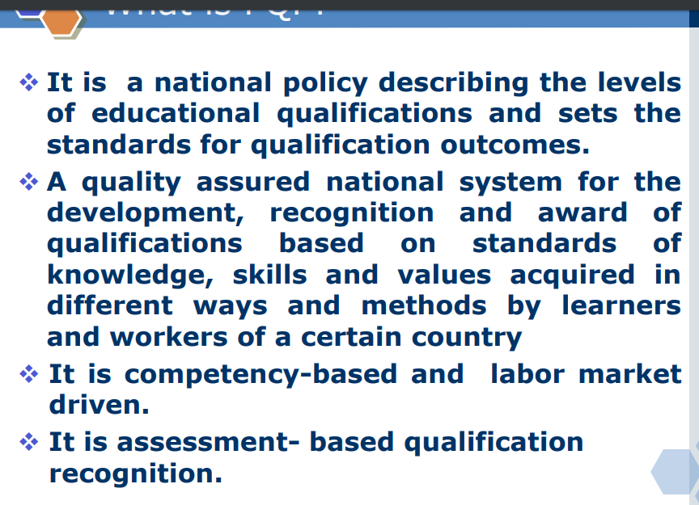

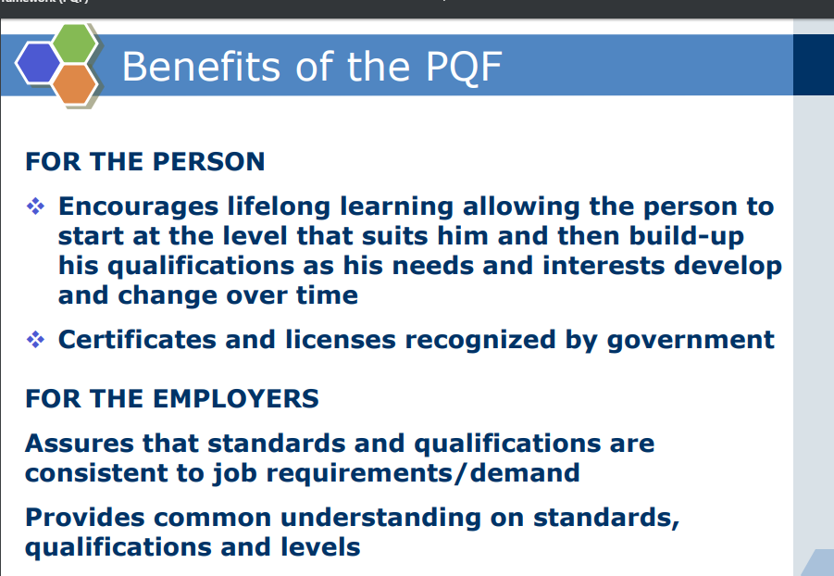
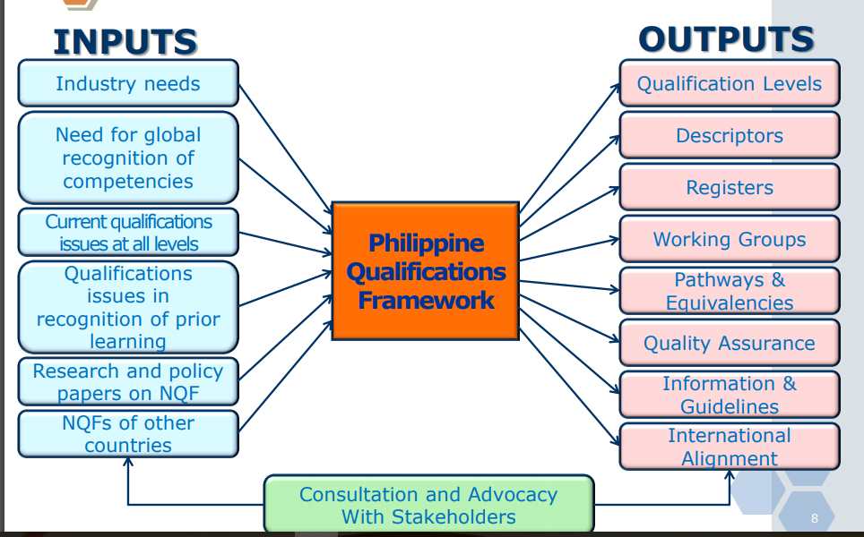

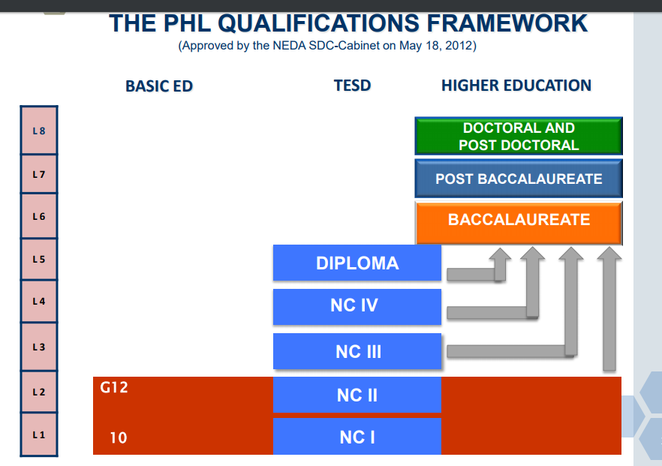

References:
http://www.unescobkk.org/fileadmin/user_upload/apeid/NQF/Philippine.pdf
http://ceap.org.ph/upload/download/20138/2723637531_1.pdf

Question #8


For question # 11-15, 17-18, 21 please refer to the following:

Ten Roles for Teacher Leaders
Cindy Harrison and Joellen Killion
The ways teachers can lead are as varied as teachers themselves.
Teacher leaders assume a wide range of roles to support school and student success. Whether these roles are assigned formally or shared informally, they build the entire school's capacity to improve. Because teachers can lead in a variety of ways, many teachers can serve as leaders among their peers.
So what are some of the leadership options available to teachers? The following 10 roles are a sampling of the many ways teachers can contribute to their schools' success.

1. Resource Provider
Teachers help their colleagues by sharing instructional resources. These might include Web sites, instructional materials, readings, or other resources to use with students. They might also share such professional resources as articles, books, lesson or unit plans, and assessment tools.
Tinisha becomes a resource provider when she offers to help Carissa, a new staff member in her second career, set up her classroom. Tinisha gives Carissa extra copies of a number line for her students to use, signs to post on the wall that explain to students how to get help when the teacher is busy, and the grade-level language arts pacing guide.

2. Instructional Specialist
An instructional specialist helps colleagues implement effective teaching strategies. This help might include ideas for differentiating instruction or planning lessons in partnership with fellow teachers. Instructional specialists might study research-based classroom strategies (Marzano, Pickering, & Pollock, 2001); explore which instructional methodologies are appropriate for the school; and share findings with colleagues.
When his fellow science teachers share their frustration with students' poorly written lab reports, Jamal suggests that they invite several English teachers to recommend strategies for writing instruction. With two English teachers serving as instructional specialists, the science teachers examine a number of lab reports together and identify strengths and weaknesses. The English teachers share strategies they use in their classes to improve students' writing.
3. Curriculum Specialist
Understanding content standards, how various components of the curriculum link together, and how to use the curriculum in planning instruction and assessment is essential to ensuring consistent curriculum implementation throughout a school. Curriculum specialists lead teachers to agree on standards, follow the adopted curriculum, use common pacing charts, and develop shared assessments.
Tracy, the world studies team leader, works with the five language arts and five social studies teachers in her school. Using standards in English and social studies as their guides, the team members agree to increase the consistency in their classroom curriculums and administer common assessments. Tracy suggests that the team develop a common understanding of the standards and agrees to facilitate the development and analysis of common quarterly assessments.

4. Classroom Supporter
Classroom supporters work inside classrooms to help teachers implement new ideas, often by demonstrating a lesson, coteaching, or observing and giving feedback. Blase and Blase (2006) found that consultation with peers
enhanced teachers' self-efficacy (teachers' belief in their own abilities and capacity to successfully solve teaching and learning problems) as they reflected on practice and grew together, and it also encouraged a bias for action (improvement through collaboration) on the part of teachers. (p. 22)
Marcia asks Yolanda for classroom support in implementing nonlinguistic representation strategies, such as graphic organizers, manipulatives, and kinesthetic activities (Marzano et al., 2001). Yolanda agrees to plan and teach a lesson with Marcia that integrates several relevant strategies. They ask the principal for two half-days of professional release time, one for learning more about the strategy and planning a lesson together, and the other for coteaching the lesson to Marcia's students and discussing it afterward.

5. Learning Facilitator
Facilitating professional learning opportunities among staff members is another role for teacher leaders. When teachers learn with and from one another, they can focus on what most directly improves student learning. Their professional learning becomes more relevant, focused on teachers' classroom work, and aligned to fill gaps in student learning. Such communities of learning can break the norms of isolation present in many schools.
Frank facilitates the school's professional development committee and serves as the committee's language arts representative. Together, teachers plan the year's professional development program using a backmapping model (Killion, 2001). This model begins with identifying student learning needs, teachers' current level of knowledge and skills in the target areas, and types of learning opportunities that different groups of teachers need. The committee can then develop and implement a professional development plan on the basis of their findings.

6. Mentor
Serving as a mentor for novice teachers is a common role for teacher leaders. Mentors serve as role models; acclimate new teachers to a new school; and advise new teachers about instruction, curriculum, procedure, practices, and politics. Being a mentor takes a great deal of time and expertise and makes a significant contribution to the development of a new professional.
Ming is a successful teacher in her own 1st grade classroom, but she has not assumed a leadership role in the school. The principal asks her to mentor her new teammate, a brand-new teacher and a recent immigrant from the Philippines. Ming prepares by participating in the district's three-day training on mentoring. Her role as a mentor will not only include helping her teammate negotiate the district, school, and classroom, but will also include acclimating her colleague to the community. Ming feels proud as she watches her teammate develop into an accomplished teacher.

7. School Leader
Being a school leader means serving on a committee, such as a school improvement team; acting as a grade-level or department chair; supporting school initiatives; or representing the school on community or district task forces or committees. A school leader shares the vision of the school, aligns his or her professional goals with those of the school and district, and shares responsibility for the success of the school as a whole.
Joshua, staff sponsor of the student council, offers to help the principal engage students in the school improvement planning process. The school improvement team plans to revise its nearly 10-year-old vision and wants to ensure that students' voices are included in the process. Joshua arranges a daylong meeting for 10 staff members and 10 students who represent various views of the school experience, from nonattenders to grade-level presidents. Joshua works with the school improvement team facilitator to ensure that the activities planned for the meeting are appropriate for students so that students will actively participate.

8. Data Coach
Although teachers have access to a great deal of data, they do not often use that data to drive classroom instruction. Teacher leaders can lead conversations that engage their peers in analyzing and using this information to strengthen instruction.
Carol, the 10th grade language arts team leader, facilitates a team of her colleagues as they look at the results of the most recent writing sample, a teacher-designed assessment given to all incoming 10th grade students. Carol guides teachers as they discuss strengths and weaknesses of students' writing performance as a group, as individuals, by classrooms, and in disaggregated clusters by race, gender, and previous school. They then plan instruction on the basis of this data.

9. Catalyst for Change
Teacher leaders can also be catalysts for change, visionaries who are “never content with the status quo but rather always looking for a better way” (Larner, 2004, p. 32). Teachers who take on the catalyst role feel secure in their own work and have a strong commitment to continual improvement. They pose questions to generate analysis of student learning.
In a faculty meeting, Larry expresses a concern that teachers may be treating some students differently from others. Students who come to him for extra assistance have shared their perspectives, and Larry wants teachers to know what students are saying. As his colleagues discuss reasons for low student achievement, Larry challenges them to explore data about the relationship between race and discipline referrals in the school. When teachers begin to point fingers at students, he encourages them to examine how they can change their instructional practices to improve student engagement and achievement.

10. Learner
Among the most important roles teacher leaders assume is that of learner. Learners model continual improvement, demonstrate lifelong learning, and use what they learn to help all students achieve.
Manuela, the school's new bilingual teacher, is a voracious learner. At every team or faculty meeting, she identifies something new that she is trying in her classroom. Her willingness to explore new strategies is infectious. Other teachers, encouraged by her willingness to discuss what works and what doesn't, begin to talk about their teaching and how it influences student learning. Faculty and team meetings become a forum in which teachers learn from one another. Manuela's commitment to and willingness to talk about learning break down barriers of isolation that existed among teachers.

Roles for All
Teachers exhibit leadership in multiple, sometimes overlapping, ways. Some leadership roles are formal with designated responsibilities. Other more informal roles emerge as teachers interact with their peers. The variety of roles ensures that teachers can find ways to lead that fit their talents and interests. Regardless of the roles they assume, teacher leaders shape the culture of their schools, improve student learning, and influence practice among their peers.

Retrieved from:
http://www.ascd.org/publications/educational-leadership/sept07/vol65/num01/Ten-Roles-for-Teacher-Leaders.aspx

Question #16, 20 (LET Sept. 2017)
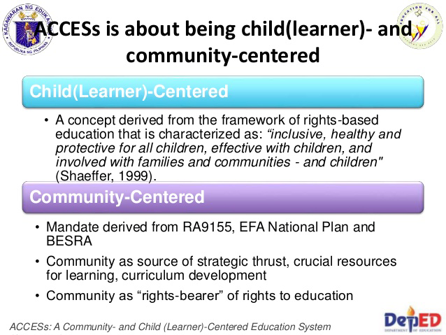
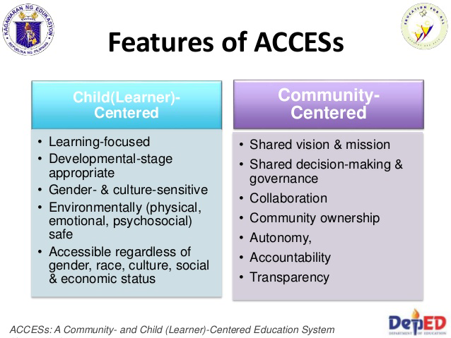
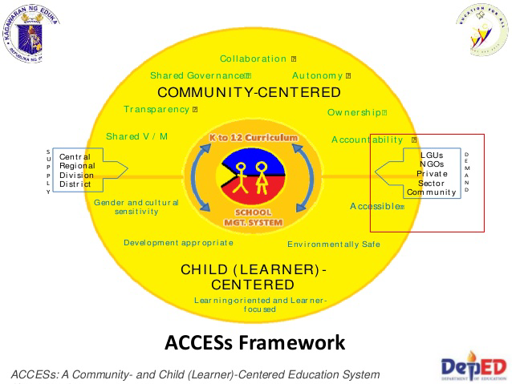
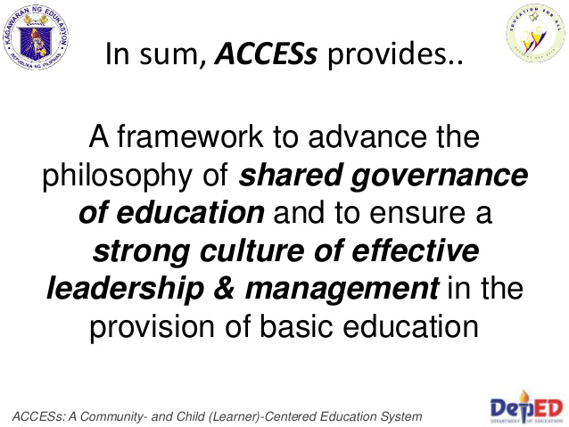
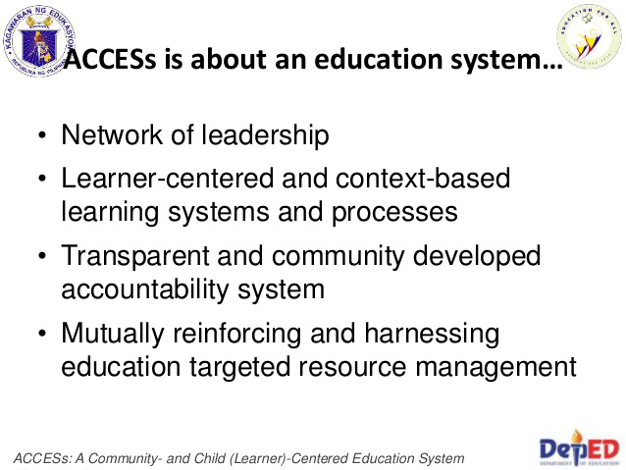
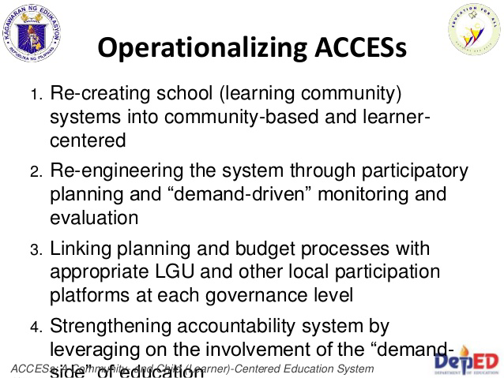
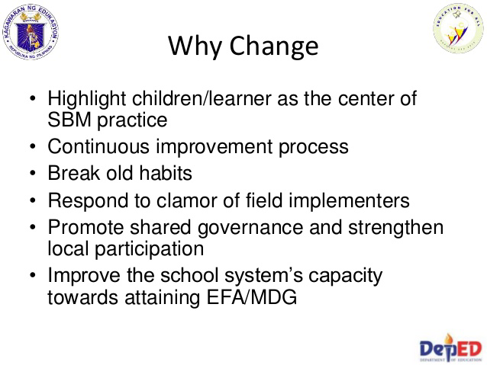
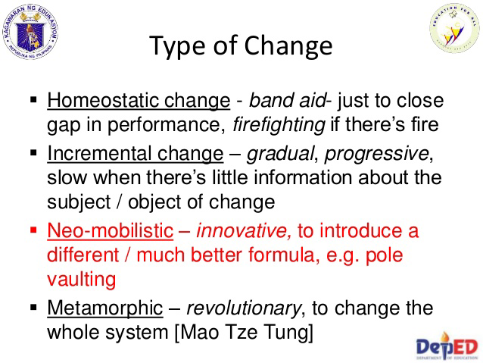
https://www.slideshare.net/leoveno/acce-ss-and-the-revised-sbm
Question # 22

https://books.google.com.ph/books?id=1NckCwAAQBAJ&pg=PA99&lpg=PA99&dq=teachers+peace+education+equitable+dialogue&source=bl&ots=DTt7AR4NHY&sig=Vb6mn22JU30OgpS8NwCwiSdUb9s&hl=en&sa=X&ved=0ahUKEwijmp3glvrWAhUSv5QKHQntCtQQ6AEIPDAD#v=onepage&q=teachers%20peace%20education%20equitable%20dialogue&f=false

KEY PRINCIPLES OF PEACE EDUCATION
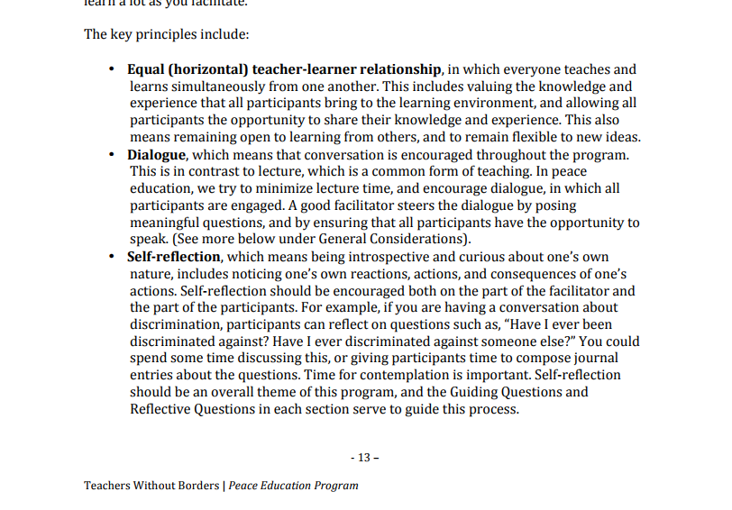

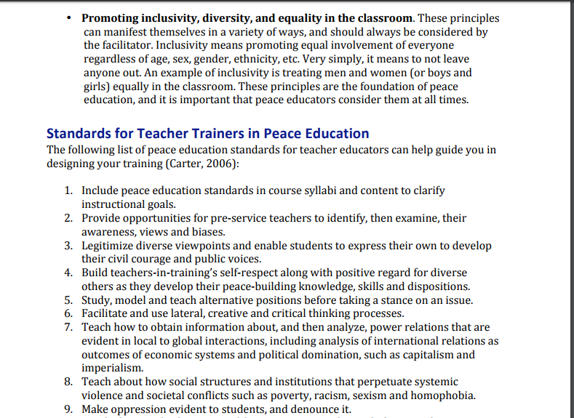
http://www.achva.ac.il/sites/default/files/achvafiles/r%26d/institute/rd/PEP%20Curriculum%20FINAL%20-%20Sep2011%20Revision.pdf
Question # 23.
Professional development in education Empowering educators must be central to any professional development initiative. Educators are important agents for change within education systems. Effective educational transformation is dependent upon educators being motivated to bring about change, as well as being capable of and supported in doing so. Provide training and education in ESD for those in management and leadership positions in educational institutions. Leadership and management are key determinants of success in educational transformation at the institutional level. Initial teacher education institutions should consider the Competences and identify where they might best be integrated into their programmes. As many educators form their views about what it means to be an educator during initial teacher education, this is a critical area for action.
https://www.unece.org/fileadmin/DAM/env/esd/ESD_Publications/Competences_Publication.pdf
Question # 25

Multicultural Education: A Challenge to Global Teachers - SlideShare
https://www.slideshare.net/.../multicultural-education-a-challenge-to-global-teachers

Aug 3, 2014 - This is from the book The Teaching Profession Chapter 3 Lesson 2. ... Diversity ofLearners and “the major goal of multicultural education is to ... students coming from diverse cultural, social- class, racial and ethnic groups
Question # 26
In Educational Service Contracting (ESC), the government and a private school may enter into a contract for the purpose of accommodating students in said private school. The government pays the tuition and other school fees of students who cannot be accommodated in public schools because of lack of teachers, space or facilities, or similar reasons. The scheme may also be applicable in communities where there is no public school and the only educational service available is in a private school, subject to availability of funds after all other requirements have been met and explicit approval by the Regional Director concerned as to the number of students to be accommodated has been secured.
http://www.deped.gov.ph/orders/do-67-s-1992

Question 26-29
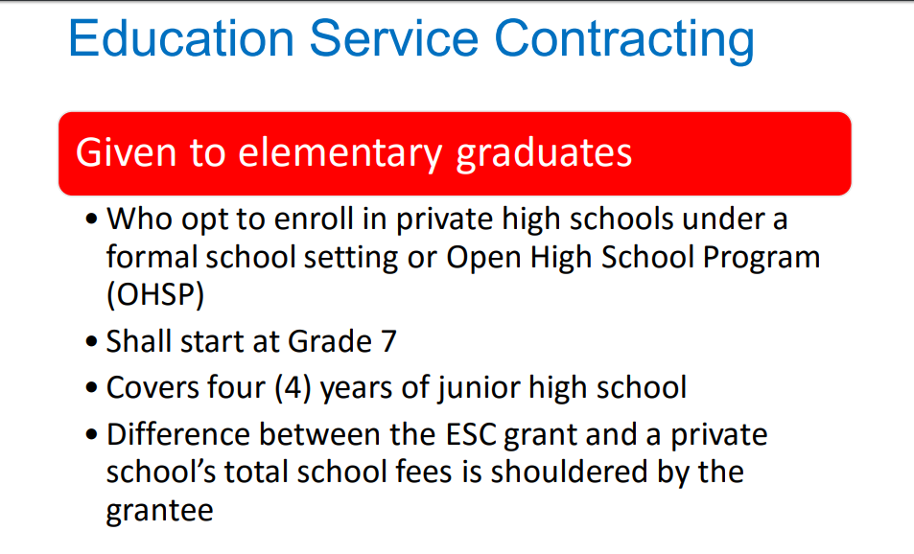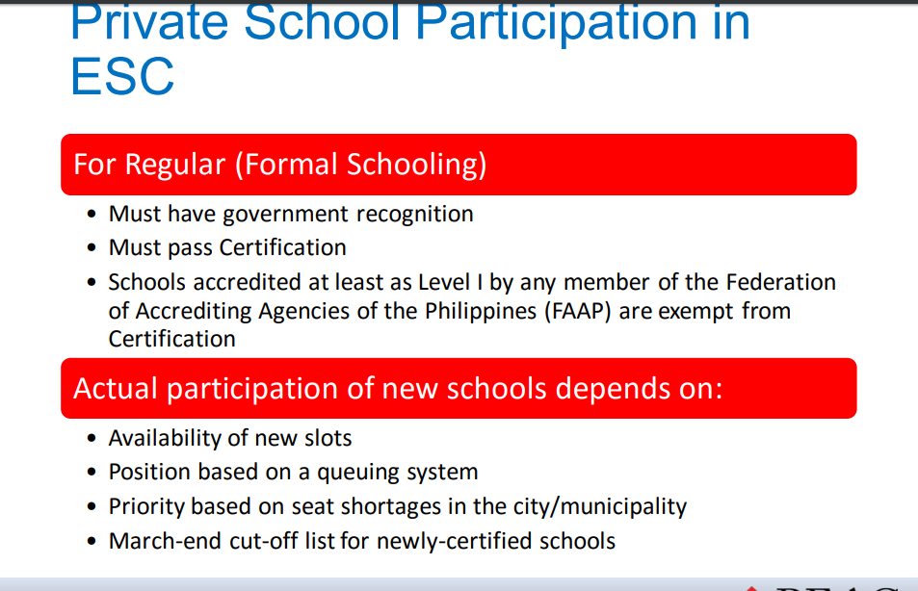

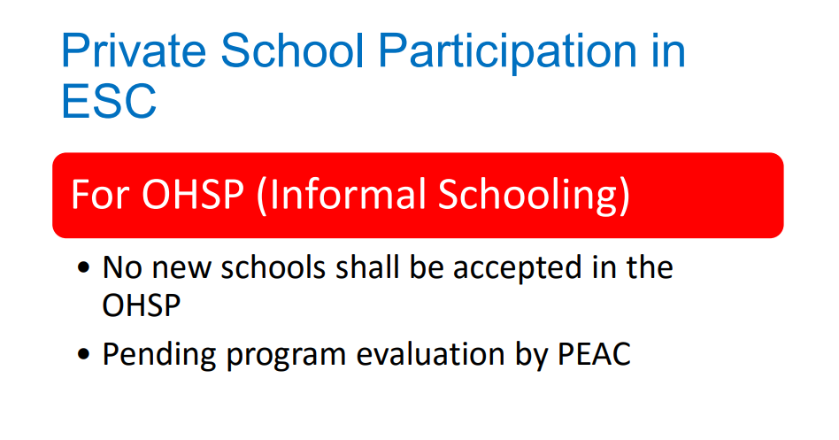
http://www.fape.org.ph/addons/tinymce/editor/media/orientation/2016/ESC%20and%20TSS%20Guidelines.pdf
http://www.deped.gov.ph/sites/default/files/order/2014/DO_s2014_026.pdf

Question # 30.


http://www.deped.gov.ph/sites/default/files/order/2012/DO_s2012_54.pdf
Question # 31.

http://www.deped.gov.ph/sites/default/files/order/2012/DO_s2012_54.pdf
33.
Sustainability in terms of continuous use of the modules and implementation of the four modes of e-IMPACT delivery on programmed teaching, peer group learning, tutoring and self-learning were done at the school level.
https://www.unicef.org/evaldatabase/files/Philippines_ADM_Evaluationl_Philippines-2012-001.pd

34.
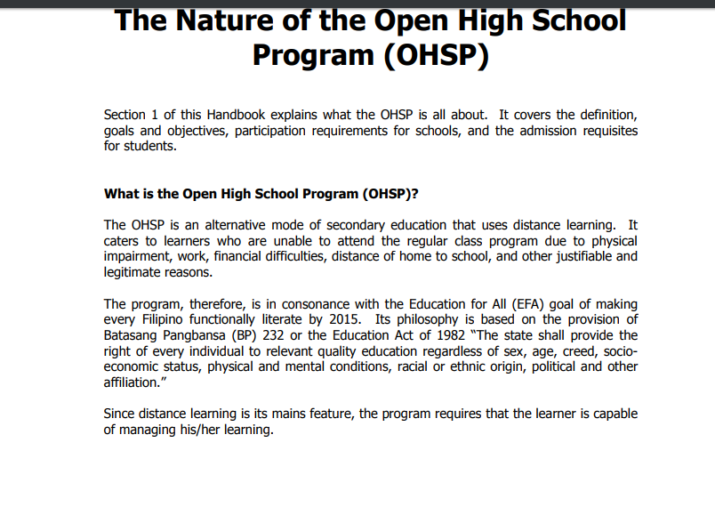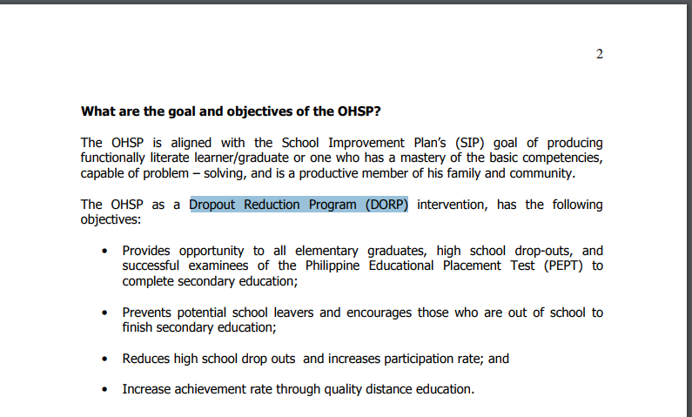

http://www.deped.gov.ph/sites/default/files/Open%20HS%20Program%20Manual.pdf

35. Legal Basis is Deped Order 32, s. 2015
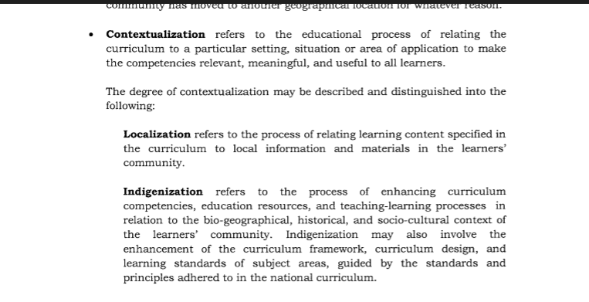
37. Learning Center refers to a physical space to house learning resources and facilities of a learning program for out-of-school youth and adults. It is a venue for face-to-face learning activities and other learning opportunities for community development and improvement of the people’s quality of life. This may also be referred to as “Community Learning Center” authorized or recognized by the DepEd. (RA 10533)
38. A.
It was not implied that schools must be independent of the community. In fact, the school and the community must help each other in order to achieve the goals.
41.
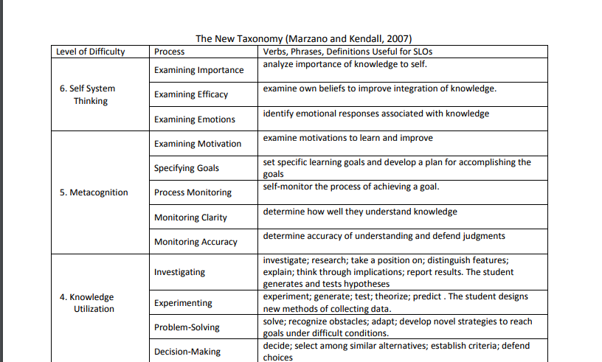

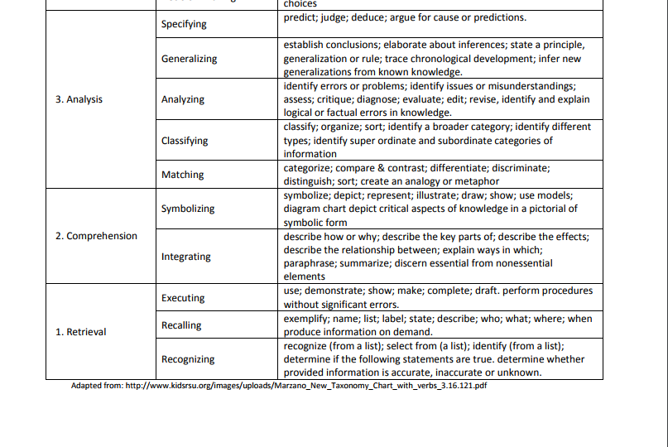
http://earth.callutheran.edu/archived-sites/institutional-research/documents/MarzanoandKendall2007Taxonomy.pdf
42. Answer is A based on the taxonomy of Kendall and Marzano. The question is an analysis of the importance of knowledge to self.
43. Answer is B because it involves process monitoring. B C and D all talks of the process of learning or how did the student learn.
44. Answer is C because multicultural education addresses diversity and discriminatory practices in education.
45. Answer is A. Learners learn best by doing (experiential thinking). Application allows them to use their critical, creative and innovative thinking
46. In a learner centered education, teachers are no longer the sage on the stage who were once deemed as the fountain of information. Teachers are now guides on the side who act as facilitators of learning.

47. Learning to Live Together
In today’s increasingly diverse societies, UNESCO continues to accomplish every day its fundamental humanist mission to support people in understanding each other and working together to build lasting peace. UNESCO also helps to enable people to create and use knowledge for just and inclusive societies.

Yet, lasting peace rests on a complex and fragile web of daily practices embedded in local settings and the most ephemeral encounters that individuals and communities creatively maintain out of the conviction that they constitute the sustainable conditions for living together in dignity and shared prosperity.
At a time of increasing global challenges and threats, such as inequality, exclusion, violence and sectarianism worsened by local tensions and conflicts which undermine humanity’s cohesion, learning to live together among all members of the global community becomes more topical than ever before.
Individuals become interculturally competent through learning and life experience for successful living in the modern complexity of our heterogeneous world and consequently they become prepared to appreciate diversity as well as to manage conflicts in accordance with the values of pluralism and mutual understanding.
https://en.unesco.org/themes/learning-live-together

The Technology Integration Matrix
The Technology Integration Matrix (TIM) provides a framework for describing and targeting the use of technology to enhance learning. The TIM incorporates five interdependent characteristics of meaningful learning environments: active, collaborative, constructive, authentic, and goal-directed. These characteristics are associated with five levels of technology integration: entry, adoption, adaptation, infusion, and transformation. Together, the the five characteristics of meaningful learning environments and five levels of technology integration create a matrix of 25 cells, as illustrated below. Developed by the Florida Center for Instructional Technology (FCIT), the TIM is in its second version.

ENTRY
The teacher begins to use technology tools to deliver curriculum content to students.

TIM: Entry Level of Technology Integration This table contains the extended descriptors for the Entry level on the Technology Integration Matrix (TIM). At the Entry level, typically the teacher uses technology to deliver curriculum content to students. Entry level activities may include listening to or watching content delivered through technology or working on activities designed to build fluency with basic facts or skills, such as drill-and-practice exercises. In a lesson that includes technology use at the Entry level, the students may not have direct access to the technology. Decisions about how and when to use technology tools as well as which tools to use are made by the teacher. Descriptors for typical student activity, teacher activity, and instructional settings for the Entry level are provided below.
Active Learning
Students receive information from the teacher or from other sources. Students may be watching an instructional video on a website or using a computer program for “drill and practice” activities.
The teacher may be the only one actively using technology. This may include using presentation software to support delivery of a lecture. The teacher may also have the students complete “drill and practice” activities on computers to practice basic skills, such as typing.
The setting is arranged for direct instruction and individual seat work. The students may have very limited and regulated access to the technology resources

Collaborative Learning
Students primarily work alone when using technology. Students may collaborate without using technology tools.
The teacher directs students to work alone on tasks involving technology.
The setting is arranged for direct instruction and individual seat work.

Constructive Learning
Students receive information from the teacher via technology.
The teacher uses technology to deliver information to students.
The setting is arranged so that all students can view the teacher’s presentation.

Authentic Learning
Students use technology to complete assigned activities that are generally unrelated to the world beyond the instructional setting.
The teacher assigns work based on a predetermined curriculum unrelated to the students or issues beyond the instructional setting.
Resources available via technology in the instructional setting include primarily textbook supplementary material and reference books or websites, such as encyclopedias.

Goal-Directed Learning
Students receive directions, guidance, and/or feedback via technology. For example, students may work through levels of an application that provides progressively more difficult practice activities.
The teacher uses technology to give students directions and monitor step-by-step completion of tasks. The teacher monitors the students’ progress and sets goals for each student.
The setting includes access to skill-building websites and applications, including the ability to track student progress across levels.

ADOPTION
The teacher directs students in the conventional and procedural use of technology.
At the Adoption level, technology tools are used in conventional ways. The teacher makes decisions about which technology tool to use and when and how to use it. Students exposure to individual technology tools may be limited to single types of tasks that involve a procedural understanding.

Adoption Level Descriptors for Each of the Five Characteristics

Active Learning
Students are using technology in conventional ways and the locus of control is on the teacher.
The teacher controls the type of technology and how it is used. The teacher may be pacing the students through a project, making sure that they each complete each step in the same sequence with the same tool. Although the students are more active than students at the Entry level in their use of technology, the teacher still strongly regulates activities.
The setting is arranged for direct instruction and individual seat work. The students may have very limited and regulated access to the technology resources.

Collaborative Learning
Students have opportunities to use collaborative tools, such as email, in conventional ways. These opportunities for collaboration with others through technology or in using technology are limited, and are not a regular part of their learning.
The teacher directs students in the conventional use of technology tools for working with others.
The setting allows for the possibility of group work, and at least some collaborative technology tools are available.

Constructive Learning
Students begin to utilize technology tools (such as graphic organizers) to build on prior knowledge and construct meaning.
The teacher provides some opportunities for students to use technology in conventional ways to build knowledge and experience. The students are constructing meaning about the relationships between prior knowledge and new learning, but the teacher is making the choices regarding technology use.
Technology tools that allow for building knowledge are available to students for conventional uses on a limited basis.

Authentic Learning
Students have opportunities to apply technology tools to some content-specific activities that are related to the students or issues beyond the instructional setting.
The teacher directs students in the conventional use of technology tools for learning activities that are sometimes related to the students or issues beyond the instructional setting.
The setting includes access to information about community and world events and primary source materials.

Goal-Directed Learning
Students follow procedural instructions to use technology to either plan, monitor, or evaluate an activity. For example, students may begin a K-W-L chart using concept mapping application.
The teacher directs students step by step in the conventional use of technology tools to either plan, monitor, or evaluate an activity. For example, the teacher may lead the class step by step through the creation of a KWL chart using concept mapping software.
The setting includes access to technology tools that allow students to plan, monitor, and evaluate their work.

ADAPTATION
The teacher facilitates students in exploring and independently using technology.

At the Adaptation level, the teacher incorporates technology tools as an integral part of the lesson. While the teacher makes most decisions about technology use, the teacher guides the students in the independent use of technology tools. Students have a greater familiarity with the use of technology tools and have a more conceptual understanding of the tools than students at the Adoption level. They are able to work without direct procedural instruction from the teacher and begin to explore different ways of using the technology tools.

Adaptation Level Descriptors for Each of the Five Characteristics

Active Learning
Students work independently with technology tools in conventional ways. Students are developing a conceptual understanding of technology tools and begin to engage with these tools.
The teacher chooses which technology tools to use and when to use them. Because the students are developing a conceptual and procedural knowledge of the technology tools, the teacher does not need to guide students step by step through activities. Instead, the teacher acts as a facilitator toward learning, allowing for greater student engagement with
Technology tools are available on a regular basis.

Collaborative Learning
Students independently use technology tools in conventional ways for collaboration. Students are developing a conceptual understanding of the use of technology tools for working with others.
The teacher provides opportunities for students to use technology to work with others. The teacher selects and provides technology tools for students to use in collaborative ways, and encourages students to begin exploring the use of these tools.
Desks and workstations are arranged so that multiple students can access technology tools simultaneously.

Constructive Learning
Students begin to use technology tools independently to facilitate construction of meaning. With their growing conceptual understanding of the technology tools, students can explore the use of these tools as they are building knowledge.
The teacher has designed a lesson in which students’ use of technology tools is integral to building an understanding of a concept. The teacher gives the students access to technology tools and guides them to appropriate resources.
Technology tools that facilitate the construction of meaning are available to students for conventional uses.

Authentic Learning
Students begin to use technology tools on their own in activities that have meaning beyond the instructional setting.
The teacher creates instruction that purposefully integrates technology tools and provides access to information on community and world issues. The teacher directs the choice of technology tools but students use the tools on their own, and may begin to explore other capabilities of the tools.
The setting includes access to information outside of school and primary source materials.

Goal-Directed Learning
Students have opportunities to independently use technology tools to facilitate goal-setting, planning, monitoring, and evaluating specific activities. Students explore the use of the technology tools for these purposes.
The teacher selects the technology tools and clearly integrates them into the lesson. The teacher facilitates students independent use of the technology tools to set goals, plan, monitor progress, and evaluate outcomes. For example, in a given project, the teacher may select a spreadsheet program that students use independently to plan and monitor progress. The teacher may provide guidance in breaking down tasks.
The setting includes access to technology tools (such as graphic organizers, calendars, spreadsheet software, and timeline software) for planning, monitoring progress, and evaluating outcomes.

INFUSION
The teacher provides the learning context and the students choose the technology.
At the Infusion level, a range of different technology tools are integrated flexibly and seamlessly into teaching and learning. Technology is available in sufficient quantities to meet the needs of all students. Students are able to make informed decisions about when and how to use different tools. The instructional focus is on student learning and not on the technology tools themselves. For this reason, Infusion level work typically occurs after teachers and students have experience with a particular technology tool. The teacher guides students to make decisions about when and how to use technology.

Infusion Level Descriptors for Each of the Five Characteristics

Active Learning
Students understand how to use many types of technology tools, are able to select tools for specific purposes, and use them regularly.
The teacher guides, informs, and contextualizes student choices of technology tools and is flexible and open to student ideas. Lessons are structured so that student use of technology is self-directed.
Multiple technology tools are available in quantities sufficient to meet the needs of all students.

Collaborative Learning
Technology use for collaboration by students is regular and normal in this setting. Students choose the best tools to use to accomplish their work.
Teacher encourages students to use technology tools collaboratively.
Technology tools that allow for collaboration are permanently located in the setting and are available in sufficient quantities to meet the needs of all students.

Constructive Learning
Students consistently have opportunities to select technology tools and use them in the way that best facilitates their construction of understanding.
The teacher encourages students to use technology tools to make connections to the world outside of the instructional setting and to their lives and interests. The teacher provides a learning context in which students regularly use technology tools and have the freedom to choose the tools that, for each student, best match the task.
The setting includes a variety of technology tools and access to rich online resources that are available in sufficient quantities to meet the needs of all students.

Authentic Learning
Students select appropriate technology tools to complete activities that have a meaningful context beyond the instructional setting. Students regularly use technology tools, and are comfortable in choosing and using the tools in the most meaningful way for each activity.
The teacher creates instruction that purposefully integrates technology tools and provides access to information on community and world issues. The teacher directs the choice of technology tools but students use the tools on their own, and may begin to explore other capabilities of the tools.
The setting provides a variety of technology tools and access to rich online resources, including information outside of the school and primary source materials, that are available in sufficient quantities to meet the needs of all students.

Goal-Directed Learning
Students regularly use technology tools to set goals, plan activities, monitor progress, and evaluate results. The students know how to use, and have access to, a variety of technologies from which they choose. For example, students may choose to write a blog for peer mentoring toward self-selected writing goals.
The teacher creates a learning context in which students regularly use technology tools for planning, monitoring, and evaluating learning activities. The teacher facilitates students’ selection of technology tools.
The setting includes access to a variety of technology tools for planning in sufficient quantities to meet the needs of all students.

TRANSFORMATION
The teacher encourages the innovative use of technology tools. Technology tools are used to facilitate higher order learning activities that may not have been possible without the use of technology.

At the Transformation level, students use technology tools flexibly to achieve specific learning outcomes. The students have a conceptual understanding of the tools coupled with extensive practical knowledge about their use. Students apply that understanding and knowledge, and students may extend the use of technology tools. They are encouraged to use technology tools in unconventional ways and are self-directed in combining the use of various tools. The teacher serves as a guide, mentor, and model in the use of technology. At this level, technology tools are often used to facilitate higher order learning activities that would not otherwise have been possible, or would have been difficult to accomplish without the use of technology.

Transformation Level Descriptors for Each of the Five Characteristics

Active Learning
Students have options on how and why to use different technology tools, and often extend the use of tools in unconventional ways. Students are focused on what they are able to do with the technology. The technology tools become an invisible part of the learning.
The teacher serves as a guide, mentor, and model in the use of technology. The teacher encourages and supports the active engagement of students with technology resources. The teacher facilitates lessons in which students are engaged in higher order learning activities that may not have been possible without the use of technology tools. The teacher helps students locate appropriate resources to support student choices.
The arrangement of the setting is flexible and varied, allowing different kinds of self-directed learning activities supported by various technologies, including robust access to online resources for all students simultaneously.

Collaborative Learning
Students regularly use technology tools for collaboration, to work with peers and experts irrespective of time zone or physical distances.
The teacher seeks partnerships outside of the setting to allow students to access experts and peers in other locations, and encourages students to extend the use of collaborative technology tools in higher order learning activities that may not have been possible without the use of technology tools.
Technology tools in this setting connect to text, voice, and video chat applications and network access has sufficient bandwidth to support the use of these technologies for all students simultaneously.

Constructive Learning
Students use technology to construct and share knowledge in ways that may have been impossible without technology. They have a deep understanding of the technology tools that allows them to explore and extend the use of the tools to construct meaning.
The teacher facilitates higher order learning opportunities in which students regularly engage in activities that may have been impossible to achieve without the use of technology tools. The teacher encourages students to explore the use of technology tools in unconventional ways and to use the full capacity of multiple tools in order to build knowledge.
The setting includes robust access to a wide variety of technology tools, robust access to online resources and communities, and the ability to publish new content online.

Authentic Learning
Students explore and extend the use of technology tools to participate in projects and higher order learning activities that have meaning outside of school. Students regularly engage in these types of activities that may have been impossible to achieve without technology.
The teacher encourages innovative use of technology tools in higher order learning activities that support connections to the lives of the students and the world beyond the instructional setting.
The setting includes technology tools and online resources that allow for student engagement with the local or global communities. A variety of technology tools are available with robust access for all students simultaneously to information outside of the school and primary source materials.

Goal-Directed Learning
Students engage in ongoing metacognitive activities at a level that may have been unattainable without the support of technology tools. Students are empowered to extend the use of technology tools and have greater ownership and responsibility for learning.

The teacher creates a rich learning environment in which students regularly engage in higher order planning activities that may have been impossible to achieve without technology. The teacher sets a context in which students are encouraged to use technology tools in unconventional ways that best enable them to monitor their own learning.
The setting includes access to a wide variety of technology tools and robust access to online resources for all students simultaneously.

Reference for TIM:
https://fcit.usf.edu/matrix/matrix/

